**Rural development in the Common Agricultural Policy: correlations at regional level**

### Jüri Lillemets1, Ants-Hannes Viira2

1,2 Estonian University of Life Sciences

1 jyri.lillemets@emu.ee

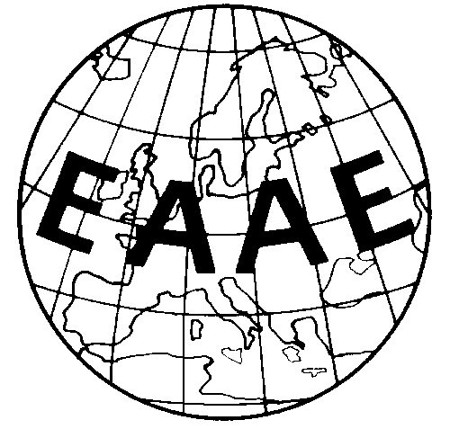

**Paper prepared for presentation for the 8th EAAE PhD student workshop**

June 10 - 12, 2019

Swedish University of Agricultural Sciences

Uppsala, Sweden

*Copyright 2019 by Jüri Lillemets, Ants-Hannes Viira. All rights reserved. Readers may make verbatim copies of this document for non-commercial purposes by any means, provided that this copyright notice appears on all such copies.*

*Balanced territorial development is one of the key objectives of the rural development expenditure of the CAP. However, territorial aspects do not appear to be sufficiently considered in the policy design nor in allocation of funds. We used data on per capita EAFRD expenditures to evaluate correlations between and among NUTS2 regions. Global as well as local measures of spatial autocorrelation demonstrated a high spatial association as payments ten­­­­­d to be above average throughout the eastern part of the EU. The expenditure is increasingly positively associated with small farming, agricultural employment and investments, while relationship with organic production has weakened.*

Keywords: Common Agricultural Policy, rural development, subsidies, spatial autocorrelation

# Introduction

Regionally balanced growth in the EU is promoted from various funds, each of which is focused on a more or less specific area of development. Some of the factors generating this uneven regional development are productivity, transportation infrastructure, technology and knowledge spillovers and factor mobility (Dall’erba, 2005). Management of most of these factors is an essential part of recent rural development policy of the Common Agricultural Policy (CAP) as manifested in the Pillar 2 measures.

Despite that since its inception, the main aim of the CAP has been to ensure sufficient income for farmers and stable supply of food for consumers, goals related to environment and rural communities have become increasingly important. Although some measures of the CAP with territorial characteristics can be traced back to 1970's (Dwyer et al., 2007), it wasn't until the establishment of the Pillar 2 in 2000 as part of the CAP that economic cohesion became an explicit goal of the policy (Garzon, 2006). The implementation of European Agricultural Fund for Rural Development (EAFRD) since 2007 further outlined the CAP expenditure aimed at rural development. Yet, despite a strong territorial rhetoric, it can be argued that territorial aspects have not been seriously considered in the policy design of the CAP nor Pillar 2 in particular (Zasada et al., 2018). These trends suggest an investigation of the territorial distribution of the CAP funds and its relation to regional characteristics.

Some previous attempts at quantifying the relationship between EAFRD expenditure and rural development at regional level cast doubt on the intended focus of the policy (Bakucs et al., 2019, 2018). Due to being based on historical crop yields, payments related to Pillar 1 are inclined to be higher in wealthier regions but a negative correlation between Pillar 2 support and regional income has not been found (Esposti, 2008). It has also been demonstrated that distribution of funds from other regional policies have stronger association with regional disadvantage compared to Pillar 2 (Crescenzi et al., 2011). In their econometric analysis involving spatial component, Camaioni et al. (2014) observed that less rural regions have in fact higher Pillar 2 expenditure intensity.

One of the three policy objectives of the EAFRD funds is "achieving a balanced territorial development of rural and economic communities" (European Parliament and Council of the European Union, 2013). Hence, at least some territorial inequalities in the distribution of these payments can be expected due to focus on disadvantaged regions. It has been demonstrated that as is the case with other structural funds (Becker et al., 2012; Dall’erba, 2005), there is substantial heterogeneity in the regional distribution of EAFRD expenditure (Bonfiglio et al., 2015; Camaioni et al., 2014). As illustrated on Figure 1, the relative amounts of EAFRD payments received per capita in NUTS2 regions between 2007 and 2013 may differ by an order of magnitude.

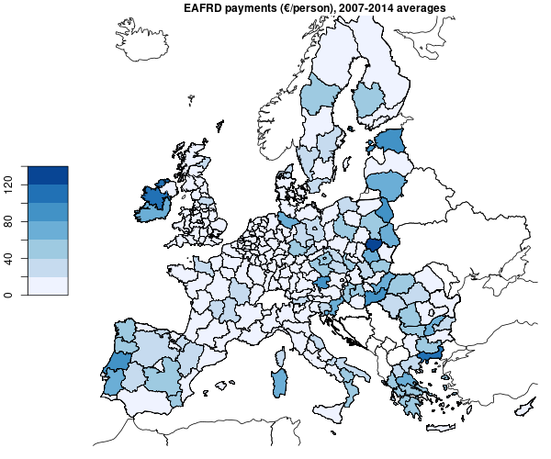

Figure 1. EAFRD payments per capita in NUTS2 regions (averaged annual values of 2007-2014).

Source: Authors’ calculations based on Eurostat and European Commission data.

However, it is unclear what are the actual factors that explain the distribution of funds among these regions. Despite the fact that various schemes for the calculation of the amounts of rural development transfers to countries have been proposed (European Commission, 2011), it is unclear how these amounts are determined. In case of Pillar 2 measures, Member States are relatively free to decide on their deployment of the funds (Ward and Lowe, 2004), thus the allocation of EAFRD funds differs considerably between countries. As a result, it is even more challenging to explain the distribution of EAFRD expenditure at lower levels of aggregation, e.g. NUTS1 or NUTS2 and lower. Furthermore, as Pillar 2 measures are voluntary, the end use of funds is also dependent on the capacity of regions (Bonfiglio et al., 2015) and decisions of individual farmers (Zasada et al., 2018).

The EU regulation 1305/2013 concerning the support for rural development by EAFRD (European Parliament and Council of the European Union, 2013) outlines three objectives of this expenditure: (a) fostering the competitiveness of agriculture; (b) ensuring the sustainable management of natural resources, and climate action; and (c) achieving a balanced territorial development of rural economies and communities including the creation and maintenance of employment. Deducing from this, we expect that EAFRD payments are negatively correlated to GDP but positively correlated to unemployment, small farming, agricultural employment, agricultural investments and organic farming. Due to being part of EU regional policy, we expect EAFRD payments to be positively correlated to other EU structural and investment funds.

In addition to factors characterizing each region, spatial relationships between regions also define the amount of EAFRD payments received. Neighboring regions are likely to be similar as a result of spillover effects but there is also evidence of agglomeration of Pillar 2 payments as rural neighboring regions tend to reduce the intensity of the expenditure (Camaioni et al., 2014). We thus expect that regions receiving higher amount of EAFRD payments are in close proximity of each other while the same is true for regions with low expenditure.

# Data and methods

The data on the CAP rural development subsidies was obtained from the data on European structural and investment funds published by the European Commission. It contains the amount of payments to each NUTS2 region between 1993-2015 from EAGGF and EAFRD but also payments from some other EU structural and investment funds (table 2). Originally, the yearly allocation of the expenditure followed the cycle of payments to Member States. As it is more relevant to examine the actual dates when the real expenditures took place, the data also includes modelled yearly payments (as described by Lo Piano et al., 2017). Modelling included modifying the years of payments so that their distribution regarding the programming period would better follow the actual pattern of expenditures instead of the cycle of reimbursements from the European Commission. We use these modelled payments in our analysis to more accurately compare yearly changes. Data on the variables characterizing NUTS2 regions (table 2) was acquired from Eurostat. Due to the classification of regions used in payment data, the regions accord to NUTS2 2013 classification. Most previous research on EU structural and investment funds has also used the NUTS2 regional level (Crescenzi et al., 2011; Dall’erba, 2005; Dall’erba and Le Gallo, 2008; Esposti, 2007; Mohl and Hagen, 2010), although there are more recent examples of the less aggregated NUTS3 level having been used (Becker et al., 2012; Bonfiglio et al., 2016; Camaioni et al., 2014).

It is likely that the adjustment of the payment variable has a significant effect on the results. It has been argued that in regional comparisons CAP expenditure should not be used as absolute values due to the variation of characteristics of NUTS regions (e.g. agricultural area, population, GDP) even at the same level of aggregation (Bonfiglio et al., 2015, p. 4; Esposti, 2008, p. 25). While NUTS regions are defined in terms of population size, there is still substantial heterogeneity in this respect. Possible adjustments include calculation of CAP expenditure relative to utilized agricultural area (UAA), annual working unit (AWU) in agriculture, gross value added (GVA) in agriculture, GDP or population (per capita). The latter two approaches are more relevant in terms of overall development and have been used in the context of different structural funds (Crescenzi et al., 2011; Dall’erba and Le Gallo, 2008; Mohl and Hagen, 2010). Yet, even calculating expenditure relative to UAA, AWU and GVA may yield very different distributions of payments (Camaioni et al., 2014, pp. 7–9). Due to data limitations we analyze EAFRD payments per capita, i.e. number of inhabitants in a respective region.

Analysis of spatial associations requires the calculation of links between regions which could be represented as a spatial weights matrix. The weights can be obtained by simply taking contiguous neighbors, neighbors up to a certain distance or a certain number of closest neighbors (e.g. Dall’erba and Le Gallo, 2008; Mohl and Hagen, 2010). We use the first of these methods to calculate spatial weights matrix. As argued by Camaioni et al. (2014, p. 15), NUTS3 regions have substantial heterogeneity in terms of size, thus weights based on contiguity are more suitable than distance-based methods. This is also true for NUTS2 classification where centroids of some adjacent regions might be further away from each other compared to some other regions separated by large water bodies. The spatial weights matrix used in the following analysis is illustrated on figure A1.

This matrix is employed in calculation of measures of spatial association. Globally, it is evaluated using Moran’s I statistic. The standard form of Moran’s I (Bivand and Wong, 2018, p. 720) is represented as follows:

$$I=\frac{n}{\sum_{i=1}^{n}{\sum_{j=1}^{n}{w_{i,j}}}}\frac{\sum_{i=1}^{n}{\sum_{j=1}^{n}{w_{i,j}(x_{i}-\overline{x})(x_{j}-\overline{x})}}}{\sum_{j=1}^{n}{{(x_{i}-\overline{x})}^{2}}}, (1)$$

where $x_{i}, i=1, …,n$ is the value of variable $x$ of region $i$, $\overline{x}$ is the mean value of variable $x$, $w$ is the spatial weight matrix, and $\sum_{i=1}^{n}{\sum_{j=1}^{n}{w_{i,j}}}$ then is the sum of all weights. We use row standardized weights, so all the individual weights for a region are equal to $1/n_{j}$, where $n_{j}$ is the total number of contiguous neighbors according to queen contiguity. Thus, Moran’s I indicates whether neighboring regions are similar or different and expresses the magnitudez of this similarity or difference in terms of deviation from the mean. Values range from -1 to 1, respectively indicating negative and positive autocorrelation where the expected value $E\left(I\right)=-1/(n-1)$ is the threshold between the two.

For each region, a local adaption of Moran’s I is also calculated. This is represented by the Local Indicator of Spatial Association as follows (Anselin, 1995):

$$I_{i}=\frac{(x_{i}-\overline{x})}{{(x_{i}-\overline{x})}^{2}/n}\sum_{j}{w_{i,j}(x_{j}-\overline{x})}. (2)$$

The interpretation of local Moran’s I is similar to that of the global Moran’s I, except that in some cases the values do not fall within the -1 to 1 range. Anselin (1995, p. 97) has suggested to use the values as indications of local “hot spots”.

For calculations of global and local spatial association the values of payments per capita are standardized in order to avoid scale dependence as proposed by Anselin (1995, p. 95). This practice has also been applied by Dall’erba (2005). Pseudo p-values are also calculated for these measures of spatial association. We consider a p-value of 0.05 as a threshold for statistical significance.

# Results

## Spatial autocorrelation

The equation 1 and spatial weight matrix defined above was applied to determine global spatial association between NUTS2 regions in terms of per capita EAFRD payments. The value of resulting Moran’s I statistic was 0.458 with expected value of -0.004. With variance of 0.002, the value was statistically significant. This result implies a rather high spatial concentration of EAFRD expenditure. This result can be compared to Crescenzi et al. (2011) who calculated the statistic for per capita Rural Development expenditure of then still ongoing 2007-2013 programming period. Their estimate of the Moran’s I was considerably lower at 0.201. The difference can be explained by different levels of territorial aggregation. As Crescenzi et al. (2011) used country level data for many regions, their estimate is expected to be less precise in terms of capturing the true territorial concentration.

For each region a local measure of spatial association was calculated using the equation 2 above. The results are represented on figure 3. It is important to note that mostly just for regions with the value above 1 was the value also statistically significant. Some areas and countries where the EAFRD expenditure tends to be concentrated can be highlighted: Northern regions of Finland, Baltic States, Eastern Poland, Austria, Hungary, Portugal and Greece. As expected, smaller urban NUTS2 regions are highly negatively correlated with surrounding regions, although the result is not statistically significant.

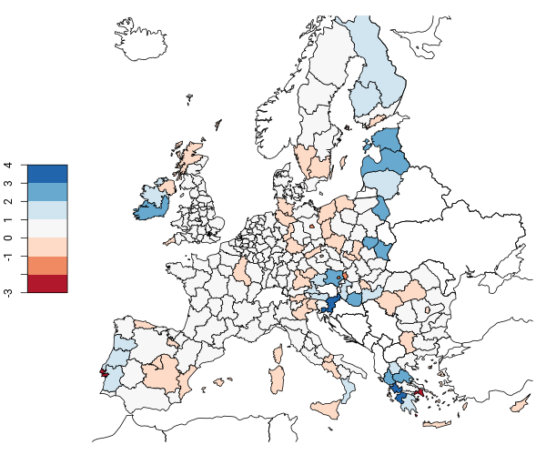

Figure 2. Values of local indicator of spatial association for NUTS2 regions based on standardized EAFRD expenditure per capita (2007-2014 averages). Value above zero means positive correlation with neighboring regions and vice versa.

Source: Authors’ calculations based on Eurostat and European Commission data.

A spatial association also appears when standardized values of EAFRD per capita payments are plotted against their spatial lag, i.e. mean value of neighboring regions in our case (figure 3). Such plot can be divided into four quadrants which are separated by mean values of both variables so that each quadrant expresses a combination of a regions and its neighbors’ value with regard to global mean. Due to the positive skew of the distribution of regional expenditure, most regions are on the bottom left quadrant where payments are lower than average for a region as well as its neighbors. The regions that do not fall into expected quadrants (LL and HH) tend to have lower than average payments themselves but be surrounded by regions with above average payments rather than vice versa.

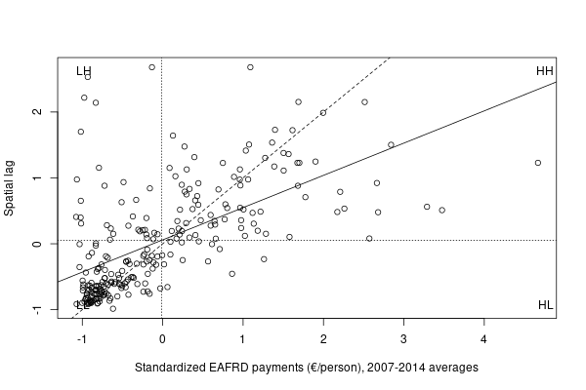

Figure 3. Scatterplot of spatial autocorrelation of NUTS2 regions of 2007-2014 average EAFRD payments per capita. Dotted lines represent mean values, dashed line perfect correlation and solid line is an approximation of Moran’s I.

Source: Authors’ calculations based on Eurostat and European Commission data.

The quadrants in figure 3 can be displayed on a map to better illustrate their location in space (figure 4). Such plot expresses regional differences substantially better compared to just plotting raw values (figure 1). It becomes evident that regions with above average per capita EAFRD regions tend be surrounded by other regions falling into the same category and vice versa. Regions receiving above average per capita EAFRD payments are usually located in the eastern part of the EU but also Iberian Peninsula and Ireland. Some exceptions are more urbanized areas and more particularly Western Poland which is located between more highly supported rest of the Poland and Eastern Germany. These results overall confirm Bonfiglio et al. (2015) in that Pillar 2 (EAFRD) expenditure intensity is higher in Scandinavia and 13 recently joined Member States while these countries receive relatively less payments from Pillar 1, referring to Pillar 2 as a mechanism to compensate some regions for lower Pillar 1 support.

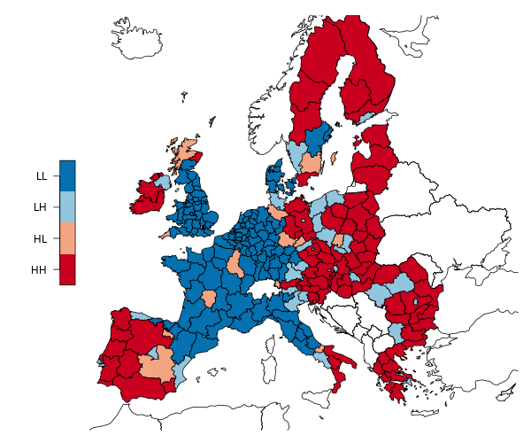

Figure 4. NUTS2 regions classified by their EAFRD payments per capita (2007-2014 averages) relative to global average value and their neighbors’ values. Colors represent expenditures relative to mean value (H – higher, L – lower) of a region itself (first letter) and its neighbors (second letter).

Source: Authors’ calculations based on Eurostat and European Commission data.

Due to substantial reforms during the past decades, rural development support of CAP has become more concentrated, especially after implementation of Pillar 2 in 2000 that introduced a higher territorial focus (Dwyer et al., 2007). Our estimations of territorial concentration of per capita EAFRD expenditure do not confirm this (figure 5). There is no clear trend for the period of 1993-2014 as for most of the years of this period the indicator of spatial association remained between 0.4 and 0.6. Lower values can be explained by transitions of programming periods when payments from previous period were mostly disbursed but payments from new period were not yet paid, resulting in overall lower amount of payments. Our results are not consistent with Crescenzi et al. (2011, pp. 23–24) who estimated Moran’s I of CAP rural development payments to be increasing during the same period and concluded that the policy has an increasing focus on specific areas.

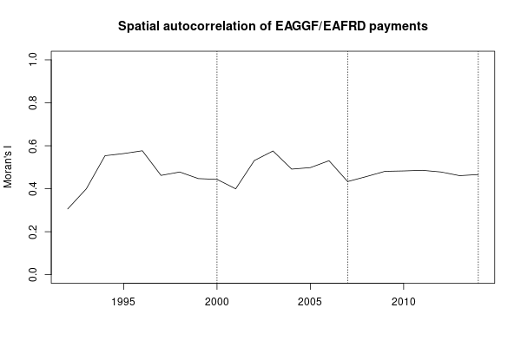

Figure 5. Global spatial autocorrelation (Moran’s I) of NUTS2 regions of EAGGF (1993-2006) and EAFRD (2007-2014) per capita payments in 1993-2014. Dotted lines represent the beginnings of programming periods.

Source: Authors’ calculations based on Eurostat and European Commission data.

## Correlations with regional characteristics

All the relationships between per capita EAFRD expenditure and characteristics of regions have expected direction, although not all correlations are statistically significant (table 1). While the payments do not appear to be related to unemployment, they have a moderate inverse correlation with economic development (GDP per capita). Prominence of small farming seems to be increasingly associated with higher payments. Share of agricultural area owned by small farms is not significantly related to the payments. Correlation with employment in agriculture, forestry and fishery has been increasing rapidly during the 2007-2013 programming period which might be due to enlargement of 2007 that introduced a number of highly agricultural regions. This might also explain the fact that payments are correlated to the share of small agricultural holdings only since 2010. Investments into agriculture, forestry and fishery also indicate an increasing association with the payments. There is reason to expect that these investments are to a large extent induced by the EAFRD expenditure and not the other way around. Finally, the payments are associated with share of organic holdings as well as the share of their area in total agricultural area in a respective region. Somewhat unexpectedly, this correlation has been substantially decreasing over the period, suggesting a decreasing focus of EAFRD payments on organic farming.

Table 1. Correlation between EAFRD payments per capita and various indicators at NUTS2 level. Reported values represent Pearson correlation coefficients (r) and their statistical significance (p). See table A1 for summary statistics.

|  |  |  |  |  |  |  |
| --- | --- | --- | --- | --- | --- | --- |
|  | | | | | | |
|  | **2007** | | **2010** | | **2013** | |
|  | r | p | r | p | r | P |
|  | | | | | | |
| EAFRD payments (€/person) | 1.000 |  | 1.000 |  | 1.000 |  |
| GDP (1000 €/person) | -0.087 | 0.283 | -0.410 | 0.000 | -0.399 | 0.000 |
| Unemployment, ages 15-74 (%) | 0.042 | 0.604 | 0.046 | 0.571 | 0.015 | 0.848 |
| Share, holdings < 2 ha (%) | 0.012 | 0.884 | 0.218 | 0.006 | 0.366 | 0.000 |
| Area, holdings < 2 ha (%) | 0.059 | 0.465 | 0.027 | 0.737 | 0.112 | 0.164 |
| Employment, NACE2 A[1] (%) | 0.252 | 0.002 | 0.588 | 0.000 | 0.701 | 0.000 |
| Investments[2], NACE2 A (%) | 0.411 | 0.000 | 0.563 | 0.000 | 0.573 | 0.000 |
| Share, organic holdings (%) | 0.385 | 0.000 | 0.255 | 0.001 | 0.184 | 0.022 |
| Area, organic holdings (%) | 0.323 | 0.000 | 0.284 | 0.000 | 0.217 | 0.007 |

## Correlations with other EU regional and investment funds

EAFRD payments are positively and statistically significantly correlated to other structural and investment funds (table 2). Whereas the correlation with CF is moderate, EAFRD payments seem to be highly correlated to ERDF and ESF. This is likely so because CF is designed to fund projects in countries with relatively low gross national income, while many of the regions contributing from EAFRD are economically more developed (Northern Europe). It is also noteworthy that there are no temporal trends in any of the correlations.

|  |  |  |  |  |  |  |  |
| --- | --- | --- | --- | --- | --- | --- | --- |
| Table 2. Correlation between EAFRD payments in absolute terms and other EU regional funds at NUTS2 level. Reported values represent Pearson correlation coefficients (r) and their statistical significance (p). See table A2 for summary statistics. | | | | | | | |
|  | **2007** | | **2010** | | **2013** | |
|  | r | p | r | p | r | p |
| EAFRD | 1.000 |  | 1.000 |  | 1.000 |  |
| CF (Cohesion Fund) | 0.227 | 0.027 | 0.432 | 0.000 | 0.361 | 0.000 |
| ERDF (European Regional Development Fund) | 0.639 | 0.000 | 0.657 | 0.000 | 0.675 | 0.000 |
| ESF (European Social Fund) | 0.612 | 0.000 | 0.566 | 0.000 | 0.573 | 0.000 |

# Conclusions and discussion

As a result of reforms of the past few decades, the focus of the CAP on rural development has become considerably more explicit. While targeting less developed rural areas has intrinsically a territorial dimension, some previous research suggests that this has not been sufficiently recognized in the policy design. It has been demonstrated that the allocation of expenditure from EAFRD is not related to indicators of rural development as expected, albeit that a balanced territorial development is one of the objectives of these funds. This motivated the investigation of correlations between regions and some relevant regional characteristics in the context of EAFRD payments per capita.

The units of observation in this analysis were NUTS2 regions, which can be considered as an intermediate level of territorial aggregation. As the comparison with some previous research indicated, this might have had an impact on the results. The regional level used must be considered when interpreting the results to avoid ecological fallacy as the correlations may differ substantially on a more detailed regional level or at the level of individual beneficiaries.

Assessment of spatial association between regions in terms of per capita EARFD payments yielded a rather high estimate of global spatial autocorrelation. This indicated a substantially higher concentration of the expenditure than previously demonstrated. While the consecutive reforms of the policy would suggest that the payments have become territorially more concentrated, our estimates do not indicate neither a clear trend nor a substantial change over the past decades. Some trends, however, emerge in the relationships between per capita EAFRD expenditure and regional development. The payments are negatively correlated with relative GDP but not with unemployment. During the 2007-2013 programming period, the payments have become more positively associated with small farming, agricultural employment and investments, whereas relationship with organic production has weakened. While this can be interpreted as a policy shift from developing ecologically sustainable to more competitive farming, a more likely explanation is the 2007 enlargement that increased the number of agriculturally less developed regions. EAFRD payments are quite highly correlated to other structural and investment funds of the EU.

As argued in some previous anlyses of Pillar 2 expenditure and its relation to regional development (Dall’erba, 2005; Esposti, 2008), there is little if any evidence to expect that larger sums of support would result in increased economic growth. This casts some doubt on the reasoning behind rural development expenditure of the CAP and its objective of achieving a balanced territorial development. It has been demonstrated that Pillar 2 payments are inversely correlated to payments from Pillar 1 (Bonfiglio et al., 2015, p. 6), which are often considered as unfair due to favoring older Member States. The analysis in this paper showed that Pillar 2 expenditure does tend to be higher in new Member States, albeit with some exceptions. This lends support to the existing notions that instead of or in addition to a means for rural development, Pillar 2 functions as an instrument to compensate for unequal Pillar 1 payments.

In addition to this assumption, there are other issues regarding CAP rural development funding worth investigating. While the current paper explored the distribution of payments, providing an explanation to this would be more beneficial. Future inquiries on this matter should also consider Pillar 1 payments and Member State co-financing and more broadly account for various differences between regions.

# References

Anselin, L., 1995. Local Indicators of Spatial Association-LISA. Geographical Analysis 27, 93–115. https://doi.org/10.1111/j.1538-4632.1995.tb00338.x

Bakucs, Z., Fertő, I., Benedek, Z., 2019. Success or Waste of Taxpayer Money? Impact Assessment of Rural Development Programs in Hungary. Sustainability 11, 2158. https://doi.org/10.3390/su11072158

Bakucs, Z., Fertő, I., Varga, Á., Benedek, Z., 2018. Impact of European Union development subsidies on Hungarian regions. European Planning Studies 26, 1121–1136. https://doi.org/10.1080/09654313.2018.1437394

Becker, S.O., Egger, P.H., von Ehrlich, M., 2012. Too much of a good thing? On the growth effects of the EU’s regional policy. European Economic Review 56, 648–668. https://doi.org/10.1016/j.euroecorev.2012.03.001

Bivand, R.S., Wong, D.W.S., 2018. Comparing implementations of global and local indicators of spatial association. TEST 27, 716–748. https://doi.org/10.1007/s11749-018-0599-x

Bonfiglio, A., Camaioni, B., Coderoni, S., Esposti, R., Pagliacci, F., Sotte, F., 2016. Where does EU money eventually go? The distribution of CAP expenditure across the European space. Empirica 43, 693–727. https://doi.org/10.1007/s10663-016-9354-2

Bonfiglio, A., Camaioni, B., Esposti, R., Pagliacci, F., Sotte, F., 2015. Distributional and Re-distributional Patterns of CAP Expenditure through the EU Space. Presented at the 29th ICAE - International Conference of Agricultural Economist “Agriculture in an interconnected world,” Italian Association of Agricultural and Applied Economics (AIEAA), Milan, pp. 1–30.

Camaioni, B., Esposti, R., Pagliacci, F., Sotte, F., 2014. How does space affect the allocation of the EU rural development policy’s expenditure? An econometric assessment.

Crescenzi, R., Filippis, F.D., Pierangeli, F., 2011. In tandem for cohesion? Synergies and conflicts between regional and agricultural policies of the European Union (Discussion Paper No. LEQS Paper No. 40/2011), LSE ‘Europe in Question’ Discussion Paper Series.

Dall’erba, S., 2005. Distribution of regional income and regional funds in Europe 1989–1999: An exploratory spatial data analysis. The Annals of Regional Science 39, 121–148. https://doi.org/10.1007/s00168-004-0199-4

Dall’erba, S., Le Gallo, J., 2008. Regional convergence and the impact of European structural funds over 1989-1999: A spatial econometric analysis. Papers in Regional Science 87, 219–244. https://doi.org/10.1111/j.1435-5957.2008.00184.x

Dwyer, J., Ward, N., Lowe, P., Baldock, D., 2007. European Rural Development under the Common Agricultural Policy’s ‘Second Pillar’: Institutional Conservatism and Innovation. Regional Studies 41, 873–888. https://doi.org/10.1080/00343400601142795

Esposti, R., 2008. Reforming the CAP: An agenda for regional growth? Presented at the 109th EAAE Seminar “The CAP after the Fischler reform: national implementations, impact assessment and the agenda for future reformers,” 1, Viterbo, Italy, p. 45.

Esposti, R., 2007. Regional Growth and Policies in the European Union: Does the Common Agricultural Policy Have a Counter-Treatment Effect? American Journal of Agricultural Economics 89, 116–134. https://doi.org/10.1111/j.1467-8276.2007.00967.x

European Commission, 2011. Common Agricultural Policy towards 2020. Annex 4. (Commission staff working paper).

European Parliament and Council of the European Union, 2013. Regulation (EU) No 1305/2013 of the European Parliament and of the Council of 17 December 2013 on support for rural development by the European Agricultural Fund for Rural Development (EAFRD) and repealing Council Regulation (EC) No 1698/2005, 347.

Garzon, I., 2006. Reforming the common agricultural policy: history of a paradigm change. Palgrave Macmillan.

Lo Piano, S., Chifari, R., Saltelli, A., 2017. Regionalisation of ESIF payments 1989-2015 (No. CCI 2016CE16BAT081).

Mohl, P., Hagen, T., 2010. Do EU structural funds promote regional growth? New evidence from various panel data approaches. Regional Science and Urban Economics 40, 353–365. https://doi.org/10.1016/j.regsciurbeco.2010.03.005

Ward, N., Lowe, P., 2004. Europeanizing rural development? Implementing the CAP’s second pillar in England. International Planning Studies 9, 121–137. https://doi.org/10.1080/1356347042000311730

Zasada, I., Weltin, M., Reutter, M., Verburg, P.H., Piorr, A., 2018. EU’s rural development policy at the regional level—Are expenditures for natural capital linked with territorial needs? Land Use Policy 77, 344–353. https://doi.org/10.1016/j.landusepol.2018.05.053

# Appendix

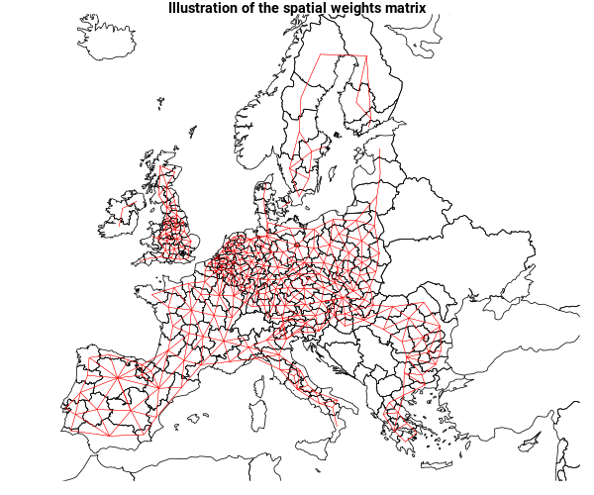

Figure A1. Associations between the centroids of regions that represent spatial weights matrix used in the analysis.

Source: Authors’ calculations.

Table A1. Summary statistics for the variables used for the calculation of correlations in table 1.

|  |  |  |  |  |  |  |  |
| --- | --- | --- | --- | --- | --- | --- | --- |
| **2007** | | | | | | | |
|  | | | | | | | |
| Statistic | N | Mean | St. Dev. | Min | Pctl(25) | Pctl(75) | Max |
|  | | | | | | | |
| EAFRD payments (€/person) | 156 | 24.284 | 28.487 | 0.125 | 6.046 | 31.316 | 164.624 |
| GDP (1000 €/person) | 156 | 25.046 | 12.399 | 2.800 | 16.625 | 32.300 | 77.300 |
| Unemployment, ages 15-74 (%) | 156 | 6.308 | 2.804 | 2.200 | 4.200 | 7.800 | 17.100 |
| Share, holdings < 2 ha (%) | 156 | 29.438 | 27.842 | 0.000 | 4.705 | 53.720 | 98.940 |
| Area, holdings < 2 ha (%) | 156 | 4.015 | 9.438 | 0.000 | 0.076 | 3.961 | 87.565 |
| Employment, NACE2 A (%) | 156 | 7.176 | 7.601 | 0.015 | 2.339 | 9.377 | 46.907 |
| Investments, NACE2 A (%) | 156 | 3.103 | 2.478 | 0.034 | 1.268 | 4.365 | 15.286 |
| Share, organic holdings (%) | 156 | 2.273 | 3.665 | 0.000 | 0.395 | 2.624 | 34.681 |
| Area, organic holdings (%) | 156 | 3.766 | 4.678 | 0.000 | 0.567 | 5.479 | 28.531 |
|  | | | | | | | |

|  |  |  |  |  |  |  |  |
| --- | --- | --- | --- | --- | --- | --- | --- |
| **2010** | | | | | | | |
|  | | | | | | | |
| Statistic | N | Mean | St. Dev. | Min | Pctl(25) | Pctl(75) | Max |
|  | | | | | | | |
| EAFRD payments (€/person) | 156 | 32.319 | 27.868 | 0.007 | 9.834 | 51.317 | 159.899 |
| GDP (1000 €/person) | 156 | 23.942 | 12.040 | 3.100 | 16.475 | 30.550 | 79.200 |
| Unemployment, ages 15-74 (%) | 156 | 9.537 | 4.779 | 3.000 | 6.300 | 11.500 | 29.000 |
| Share, holdings < 2 ha (%) | 156 | 27.617 | 28.102 | 0.500 | 2.740 | 52.552 | 98.384 |
| Area, holdings < 2 ha (%) | 156 | 3.759 | 9.058 | 0.006 | 0.034 | 3.6500 | 83.978 |
| Employment, NACE2 A (%) | 156 | 7.318 | 7.956 | 0.012 | 2.329 | 8.8870 | 48.691 |
| Investments, NACE2 A (%) | 156 | 3.493 | 2.736 | -0.626 | 1.398 | 4.868 | 18.065 |
| Share, organic holdings (%) | 156 | 2.844 | 4.200 | 0.000 | 0.483 | 3.813 | 38.359 |
| Area, organic holdings (%) | 156 | 3.980 | 4.764 | 0.000 | 0.547 | 6.024 | 26.047 |
|  | | | | | | | |

|  |  |  |  |  |  |  |  |
| --- | --- | --- | --- | --- | --- | --- | --- |
| **2013** | | | | | | | |
|  | | | | | | | |
| Statistic | N | Mean | St. Dev. | Min | Pctl(25) | Pctl(75) | Max |
|  | | | | | | | |
| EAFRD payments (€/person) | 155 | 31.481 | 27.204 | 0.014 | 10.015 | 49.058 | 143.559 |
| GDP (1000 €/person) | 155 | 25.101 | 13.078 | 3.600 | 15.800 | 32.350 | 85.300 |
| Unemployment, ages 15-74 (%) | 155 | 11.295 | 6.964 | 3.100 | 6.400 | 15.300 | 36.200 |
| Share, holdings < 2 ha (%) | 155 | 22.962 | 25.920 | 0.000 | 2.212 | 36.533 | 98.592 |
| Area, holdings < 2 ha (%) | 155 | 2.794 | 7.919 | 0.000 | 0.027 | 2.549 | 86.692 |
| Employment, NACE2 A (%) | 155 | 7.025 | 7.494 | 0.023 | 2.089 | 8.904 | 45.100 |
| Investments, NACE2 A (%) | 155 | 4.074 | 3.466 | 0.038 | 1.817 | 5.195 | 22.364 |
| Share, organic holdings (%) | 155 | 3.551 | 4.989 | 0.000 | 0.631 | 4.430 | 41.743 |
| Area, organic holdings (%) | 155 | 5.101 | 6.687 | 0.000 | 0.610 | 7.066 | 40.737 |

Table A2. Summary statistics for the variables used for the calculation of correlations in table 2. Payments are represented as millions of euros.

|  |  |  |  |  |  |  |  |
| --- | --- | --- | --- | --- | --- | --- | --- |
| **2007** | | | | | | | |
|  | | | | | | | |
| Statistic | N | Mean | St. Dev. | Min | Pctl(25) | Pctl(75) | Max |
|  | | | | | | | |
| EAFRD | 270 | 34.078 | 39.346 | 0.102 | 8.971 | 43.070 | 228.875 |
| CF (Cohesion Fund) | 97 | 65.458 | 60.991 | 3.794 | 24.028 | 91.909 | 405.379 |
| ERDF (European Regional Development Fund) | 272 | 76.990 | 124.527 | 0.199 | 11.845 | 84.478 | 863.442 |
| ESF (European Social Fund) | 272 | 41.087 | 41.025 | 0.163 | 17.376 | 50.342 | 396.887 |
|  | | | | | | | |

|  |  |  |  |  |  |  |  |
| --- | --- | --- | --- | --- | --- | --- | --- |
| **2010** | | | | | | | |
|  | | | | | | | |
| Statistic | N | Mean | St. Dev. | Min | Pctl(25) | Pctl(75) | Max |
|  | | | | | | | |
| EAFRD | 270 | 46.960 | 56.525 | 0.009 | 11.081 | 58.799 | 333.917 |
| CF (Cohesion Fund) | 97 | 59.069 | 62.193 | 1.496 | 14.632 | 81.628 | 326.944 |
| ERDF (European Regional Development Fund) | 272 | 78.458 | 115.469 | 0.336 | 8.009 | 107.166 | 883.067 |
| ESF (European Social Fund) | 272 | 29.506 | 37.601 | 0.427 | 9.648 | 35.772 | 387.628 |
|  | | | | | | | |

|  |  |  |  |  |  |  |  |
| --- | --- | --- | --- | --- | --- | --- | --- |
| **2013** | | | | | | | |
|  | | | | | | | |
| Statistic | N | Mean | St. Dev. | Min | Pctl(25) | Pctl(75) | Max |
|  | | | | | | | |
| EAFRD | 270 | 45.659 | 54.555 | 0.017 | 10.980 | 57.092 | 345.399 |
| CF (Cohesion Fund) | 98 | 124.258 | 123.423 | 0.000 | 24.559 | 189.766 | 715.166 |
| ERDF (European Regional Development Fund) | 272 | 106.362 | 163.892 | 0.466 | 9.516 | 149.026 | 987.354 |
| ESF (European Social Fund) | 272 | 42.826 | 48.422 | 0.784 | 10.455 | 57.336 | 447.344 |

1. Agriculture, forestry and fishing
2. Gross Fixed Capital Formation