Stastical report for TEENS feasibility trial

Using simulated data

Olsen MH

13 marts 2021

Table of Contents

# Table 1 - Baseline characteristics

|  |  |  |  |
| --- | --- | --- | --- |
|  | A | B | Overall |
| n | 15 | 15 | 30 |
| dem_age (mean (SD)) | 16.13 (0.83) | 15.64 (0.50) | 15.90 (0.72) |
| dem_gender (%) |  |  |  |
| Female | 6 (40.0) | 5 (33.3) | 11 (36.7) |
| Male | 3 (20.0) | 2 (13.3) | 5 (16.7) |
| Other | 3 (20.0) | 3 (20.0) | 6 (20.0) |
| Transgender | 3 (20.0) | 5 (33.3) | 8 (26.7) |
| dem_nationality (%) |  |  |  |
| Danish | 7 (46.7) | 7 (46.7) | 14 (46.7) |
| Other | 4 (26.7) | 5 (33.3) | 9 (30.0) |
| Western | 4 (26.7) | 3 (20.0) | 7 (23.3) |
| dem_school (%) |  |  |  |
| Boarding school | 3 (20.0) | 4 (26.7) | 7 (23.3) |
| High-school | 3 (20.0) | 5 (33.3) | 8 (26.7) |
| Middle-school | 6 (40.0) | 2 (13.3) | 8 (26.7) |
| No school | 1 ( 6.7) | 2 (13.3) | 3 (10.0) |
| Other | 2 (13.3) | 2 (13.3) | 4 (13.3) |
| dem_parents (%) |  |  |  |
| Divorced | 5 (33.3) | 1 ( 6.7) | 6 (20.0) |
| Married | 7 (46.7) | 6 (40.0) | 13 (43.3) |
| Other | 3 (20.0) | 8 (53.3) | 11 (36.7) |

# Feasibility outcomes

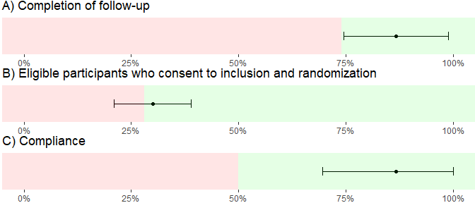

|  |  |  |  |  |
| --- | --- | --- | --- | --- |
| Outcome | Requirement | Fraction | LCL | UCL |
| A) Completion of follow-up | 75% | 87% | 75% | 99% |
| B) Eligible participants who consent to inclusion and randomization | 29% | 30% | 21% | 39% |
| C) Compliance | 51% | 87% | 69% | 100% |

# Exploratory clinical outcomes

## DSHI-Y (primary)

DSHI-Y will be filled out in both groups at baseline and follow-up, and during the intervention for the interventional group. DSHI-Y reflects the number of episodes of NSSI events. The results will be presented as one score.

Summarised results

|  |  |  |  |
| --- | --- | --- | --- |
|  | Overall | A | B |
| n | 30 | 15 | 15 |
| p_dshiy_0 (mean (SD)) | 252.93 (151.56) | 267.53 (161.27) | 238.33 (145.31) |
| p_dshiy_1 (mean (SD)) | 234.67 (157.80) | 234.67 (157.80) | NaN (NA) |
| p_dshiy_2 (mean (SD)) | 191.93 (137.13) | 191.93 (137.13) | NaN (NA) |
| p_dshiy_3 (mean (SD)) | 274.13 (151.58) | 274.13 (151.58) | NaN (NA) |
| p_dshiy_4 (mean (SD)) | 233.87 (129.59) | 233.87 (129.59) | NaN (NA) |
| p_dshiy_5 (mean (SD)) | 258.13 (163.09) | 258.13 (163.09) | NaN (NA) |
| p_dshiy_6 (mean (SD)) | 275.40 (118.82) | 275.40 (118.82) | NaN (NA) |
| p_dshiy_7 (mean (SD)) | 250.00 (150.47) | 250.00 (150.47) | NaN (NA) |
| p_dshiy_8 (mean (SD)) | 272.40 (145.72) | 272.40 (145.72) | NaN (NA) |
| p_dshiy_9 (mean (SD)) | 255.20 (143.65) | 255.20 (143.65) | NaN (NA) |
| p_dshiy_10 (mean (SD)) | 270.33 (111.51) | 270.33 (111.51) | NaN (NA) |
| p_dshiy_11 (mean (SD)) | 265.33 (144.84) | 265.33 (144.84) | NaN (NA) |
| p_dshiy_12 (mean (SD)) | 243.23 (151.38) | 252.07 (149.98) | 234.40 (157.50) |

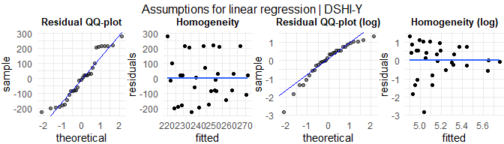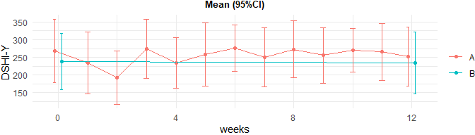

Linear regression

|  |  |
| --- | --- |
|  | p-value |
| DSHI-Y | 0.7297 |

## Kidscreen-10 (secondary)

Kidscreen-10 will be filled out in both groups at baseline and follow-up. Kidscreen-10 has 10 questions where each question generates a score from 1 to 5. The results will be processed using the algorithm below:

* *RASCH PP* = ( 10 = -4.327 ) / ( 11 = -3.206 ) / ( 12 = -2.675 ) / ( 13 = -2.319 ) / ( 14 = -2.049 ) / ( 15 = -1.831 ) / ( 16 = -1.645 ) / ( 17 = -1.483 ) / ( 18 = -1.339 ) / ( 19 = -1.207 ) / ( 20 = -1.085 ) / ( 21 = -0.971 ) / ( 22 = -0.863 ) / ( 23 = -0.760 ) / ( 24 = -0.660 ) / ( 25 = -0.563 ) / ( 26 = -0.468 ) / ( 27 = -0.374 ) / ( 28 = -0.281 ) / ( 29 = -0.187 ) / ( 30 = -0.093 ) / ( 31 = 0.002 ) / ( 32 = 0.100 ) / ( 33 = 0.199 ) / ( 34 = 0.302 ) / ( 35 = 0.409 ) / ( 36 = 0.520 ) / ( 37 = 0.637 ) / ( 38 = 0.760 ) / ( 39 = 0.891 ) / ( 40 = 1.031 ) / ( 41 = 1.183 ) / ( 42 = 1.348 ) / ( 43 = 1.529 ) / ( 44 = 1.732 ) / ( 45 = 1.961 ) / ( 46 = 2.226 ) / ( 47 = 2.545 ) / ( 48 = 2.951 ) / ( 49 = 3.533 ) / ( 50 = 4.703 )

*(points = sub-score)*

The results are presented using two indexes:

* **General HRQoL index** = RASCH PP
* **General HRQoL index international T-values** = (((RASCH PP - 1.2078) / 1.03377) * 10 + 50)

### Results

Summarised results

|  |  |  |  |
| --- | --- | --- | --- |
|  | Overall | A | B |
| n | 30 | 15 | 15 |
| s_kidscreen10_HRQoL_0 (mean (SD)) | 2.15 (1.35) | 1.88 (1.41) | 2.42 (1.27) |
| s_kidscreen10_HRQoL_12 (mean (SD)) | -1.54 (1.45) | -1.69 (1.38) | -1.38 (1.55) |
| s_kidscreen10_HRQoLt_0 (mean (SD)) | 59.11 (13.02) | 56.55 (13.64) | 61.68 (12.28) |
| s_kidscreen10_HRQoLt_12 (mean (SD)) | 23.47 (14.03) | 21.98 (13.33) | 24.96 (15.00) |

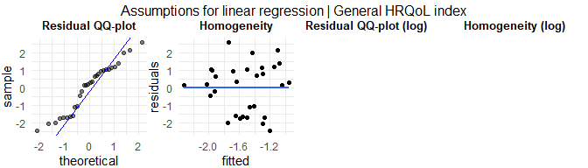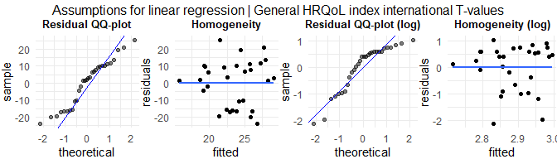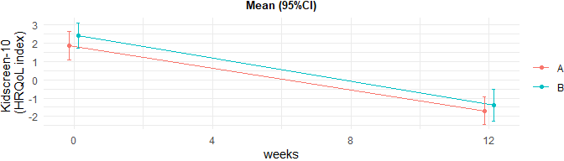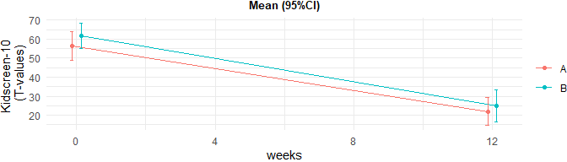

Linear regression

|  |  |
| --- | --- |
|  | p-value |
| General HRQoL index | 0.73489 |
| General HRQoL index international T-values | 0.73489 |

## DASS-21 (secondary)

DASS-21 will be filled out in both groups at baseline and follow-up. DASS-21 has 21 questions where each question generates a score from 0 to 3. The results will be presented as sum-score for three scales:

* **Depression** = Q3 + Q5 + Q10 + Q13 + Q16 + Q17 + Q21
* **Anxiety** = Q2 + Q4 + Q7 + Q9 + Q15 + Q19 + Q20
* **Stress** = Q1 + Q6 + Q8 + Q11 + Q12 + Q14 + Q18

*Q: Question*

### Results

Summarised results

|  |  |  |  |
| --- | --- | --- | --- |
|  | Overall | A | B |
| n | 30 | 15 | 15 |
| s_dass21_depression_0 (mean (SD)) | 9.00 (6.81) | 8.27 (7.33) | 9.73 (6.41) |
| s_dass21_anxiety_0 (mean (SD)) | 11.43 (6.72) | 10.13 (7.27) | 12.73 (6.10) |
| s_dass21_stress_0 (mean (SD)) | 8.67 (5.91) | 8.87 (6.98) | 8.47 (4.85) |
| s_dass21_depression_12 (mean (SD)) | 11.70 (7.26) | 15.53 (5.78) | 7.87 (6.66) |
| s_dass21_anxiety_12 (mean (SD)) | 13.03 (5.90) | 14.40 (6.21) | 11.67 (5.45) |
| s_dass21_stress_12 (mean (SD)) | 9.40 (7.08) | 10.73 (6.66) | 8.07 (7.46) |

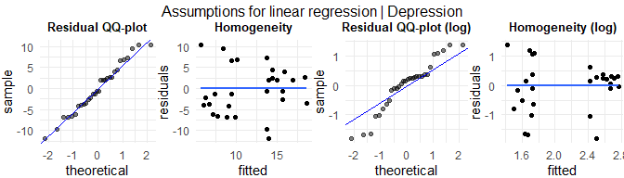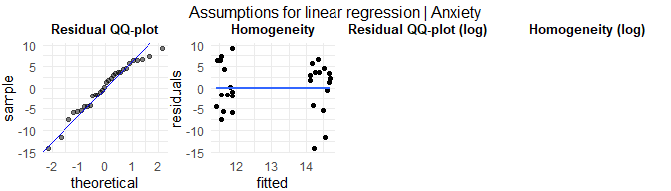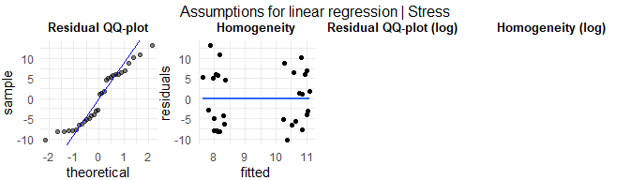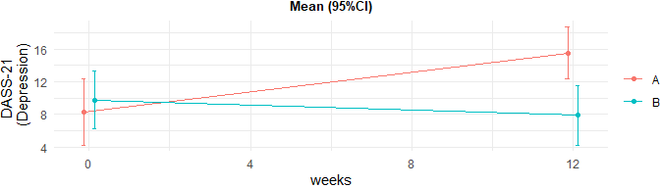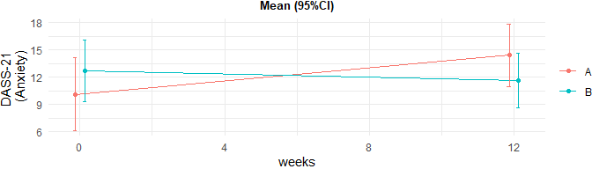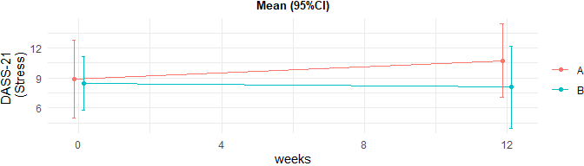

Linear regression

|  |  |
| --- | --- |
|  | p-value |
| Depression | 0.00135 |
| Anxiety | 0.23979 |
| Stress | 0.31659 |

## DERS-16 (further)

DERS-16 will be filled out in both groups at baseline and follow-up, and every week during the intervention for the interventional group. DERS-16 has 16 questions where each question generates a score from 1 to 5. The results will be presented as one sum-score.

### Results

Summarised results

|  |  |  |  |
| --- | --- | --- | --- |
|  | Overall | A | B |
| n | 30 | 15 | 15 |
| e_ders16_0 (mean (SD)) | 44.93 (21.47) | 41.60 (21.79) | 48.27 (21.36) |
| e_ders16_1 (mean (SD)) | 48.53 (20.46) | 48.53 (20.46) | NaN (NA) |
| e_ders16_2 (mean (SD)) | 42.60 (20.19) | 42.60 (20.19) | NaN (NA) |
| e_ders16_3 (mean (SD)) | 53.93 (17.67) | 53.93 (17.67) | NaN (NA) |
| e_ders16_4 (mean (SD)) | 42.53 (18.46) | 42.53 (18.46) | NaN (NA) |
| e_ders16_5 (mean (SD)) | 47.33 (19.26) | 47.33 (19.26) | NaN (NA) |
| e_ders16_6 (mean (SD)) | 50.27 (21.47) | 50.27 (21.47) | NaN (NA) |
| e_ders16_7 (mean (SD)) | 47.40 (20.84) | 47.40 (20.84) | NaN (NA) |
| e_ders16_8 (mean (SD)) | 56.00 (16.02) | 56.00 (16.02) | NaN (NA) |
| e_ders16_9 (mean (SD)) | 43.53 (16.16) | 43.53 (16.16) | NaN (NA) |
| e_ders16_10 (mean (SD)) | 39.53 (18.34) | 39.53 (18.34) | NaN (NA) |
| e_ders16_11 (mean (SD)) | 46.73 (22.23) | 46.73 (22.23) | NaN (NA) |
| e_ders16_12 (mean (SD)) | 47.27 (18.87) | 37.13 (15.28) | 57.40 (16.85) |

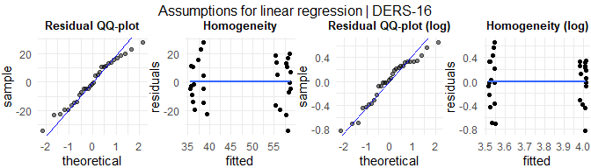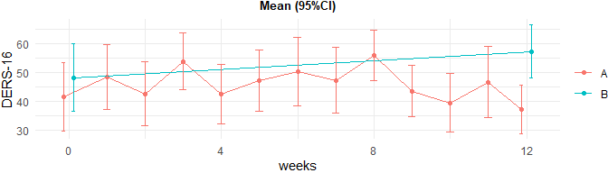

Linear regression

|  |  |
| --- | --- |
|  | p-value |
| DERS-16 | 0.00279 |

## BSL-supplement (further)

BSL-supplement will be filled out in both groups at baseline and follow-up, and every week during the intervention for the interventional group. BSL-supplement has 11 questions where each question generates a score from 0 to 4. The results will be presented as one sum-score.

### Results

Summarised results

|  |  |  |  |
| --- | --- | --- | --- |
|  | Overall | A | B |
| n | 30 | 15 | 15 |
| e_bsl_0 (mean (SD)) | 26.87 (11.09) | 25.20 (11.14) | 28.53 (11.17) |
| e_bsl_12 (mean (SD)) | 20.50 (13.62) | 23.40 (10.71) | 17.60 (15.86) |

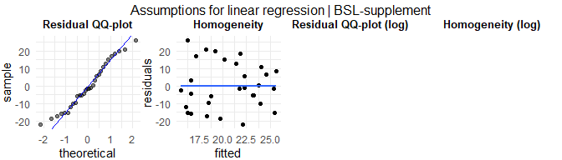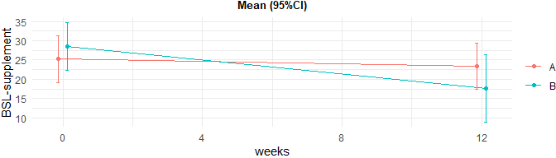

Linear regression

|  |  |
| --- | --- |
|  | p-value |
| BSL-supplement | 0.29844 |

## C-SSRS (further / UNFINISHED)

C-SSRS will be filled out in both groups at baseline and follow-up, and every week during the intervention for the interventional group. C-SSRS has 16 questions where each question generates different score. The results will be presented as sum-scores for three scales:

* **Ideation** = Q1a + Q1b + Q1c + Q1d + Q1e?
* **Severity** = Q2a + Q2b + Q2c + Q2d?
* **Behaviour** = Q3 + Q4 + Q5a + ?

## CCNES-APP (further)

CCNES-APP will be filled out in both groups only at follow-up. CCNES-APP has 9 main questions with 6 subquestions (a to f) for each. Each subquestion genertes a score from 1 to 7. The results will be presented as mean-score for six scales:

* **Distress reaction** = ( Q1a + Q2d + Q3f + Q4d + Q5a + Q6b + Q7f + Q8a + Q9d ) / 9
* **Punitive reactions** = ( Q1e + Q2f + Q3b + Q4c + Q5e + Q6c + Q7b + Q8e + Q9c ) / 9
* **Expressive encouragment** = ( Q1b + Q2c + Q3e + Q4f + Q5b + Q6d + Q7e + Q8b + Q9e ) / 9
* **Emotion-focused reactions** = ( Q1c + Q2b + Q3c + Q4a + Q5c + Q6f + Q7d + Q8c + Q9a ) / 9
* **Problem-focused reactions** = ( Q1f + Q2e + Q3a + Q4b + Q5f + Q6e + Q7a + Q8f + Q9b ) / 9
* **Minimization reactions** = ( Q1d + Q2a + Q3d + Q4e + Q5d + Q6a + Q7c + Q8d + Q9f ) / 9

*Q: Question*

### Results

Summarised results

|  |  |  |  |
| --- | --- | --- | --- |
|  | Overall | A | B |
| n | 30 | 15 | 15 |
| e_ccnesapp_distress_12 (mean (SD)) | 3.39 (0.96) | 3.41 (1.15) | 3.37 (0.77) |
| e_ccnesapp_punitive_12 (mean (SD)) | 3.65 (0.95) | 3.57 (1.13) | 3.73 (0.75) |
| e_ccnesapp_expressive_12 (mean (SD)) | 3.26 (0.97) | 3.28 (1.04) | 3.23 (0.94) |
| e_ccnesapp_emotion_12 (mean (SD)) | 3.72 (0.97) | 3.40 (1.05) | 4.05 (0.79) |
| e_ccnesapp_problem_12 (mean (SD)) | 3.49 (0.94) | 3.78 (0.96) | 3.21 (0.87) |
| e_ccnesapp_minimization_12 (mean (SD)) | 3.45 (1.04) | 3.36 (1.13) | 3.55 (0.96) |

Mann-Whitney U test

|  |  |  |
| --- | --- | --- |
|  | Estimate (95% Confidence interval) | p-value |
| Distress reaction | 0.1 (-0.6-0.7) | 0.7871 |
| Punitive reactions | -0.1 (-1.1-0.6) | 0.7869 |
| Expressive encouragment | 0.1 (-0.7-0.9) | 0.7868 |
| Emotion-focused reactions | -0.7 (-1.3-0.1) | 0.0925 |
| Problem-focused reactions | 0.6 (-0.1-1.3) | 0.0966 |
| Minimization reactions | -0.1 (-1-0.6) | 0.6478 |

## CCNES-A (further)

CCNES-A will be filled out in both groups at baseline and follow-up. CCNES-A has 9 main questions with 6 subquestions (a to f) for each. Each subquestion genertes a score from 1 to 7. The results will be presented as mean-score for six scales:

* **Distress reaction** = ( Q1a + Q2d + Q3f + Q4d + Q5a + Q6b + Q7f + Q8a + Q9d ) / 9
* **Punitive reactions** = ( Q1e + Q2f + Q3b + Q4c + Q5e + Q6c + Q7b + Q8e + Q9c ) / 9
* **Expressive encouragment** = ( Q1b + Q2c + Q3e + Q4f + Q5b + Q6d + Q7e + Q8b + Q9e ) / 9
* **Emotion-focused reactions** = ( Q1c + Q2b + Q3c + Q4a + Q5c + Q6f + Q7d + Q8c + Q9a ) / 9
* **Problem-focused reactions** = ( Q1f + Q2e + Q3a + Q4b + Q5f + Q6e + Q7a + Q8f + Q9b ) / 9
* **Minimization reactions** = ( Q1d + Q2a + Q3d + Q4e + Q5d + Q6a + Q7c + Q8d + Q9f ) / 9

*Q: Question*

### Results

Summarised results

|  |  |  |  |
| --- | --- | --- | --- |
|  | Overall | A | B |
| n | 30 | 15 | 15 |
| e_ccnesa_distress_12 (mean (SD)) | 3.65 (0.93) | 3.49 (0.98) | 3.81 (0.88) |
| e_ccnesa_punitive_12 (mean (SD)) | 3.63 (1.13) | 3.46 (0.97) | 3.79 (1.28) |
| e_ccnesa_expressive_12 (mean (SD)) | 3.08 (0.92) | 3.23 (1.01) | 2.94 (0.84) |
| e_ccnesa_emotion_12 (mean (SD)) | 3.68 (1.11) | 3.81 (1.14) | 3.55 (1.09) |
| e_ccnesa_problem_12 (mean (SD)) | 3.47 (0.91) | 3.43 (0.97) | 3.51 (0.88) |
| e_ccnesa_minimization_12 (mean (SD)) | 3.64 (1.02) | 3.46 (1.07) | 3.82 (0.97) |

Mann-Whitney U test

|  |  |  |
| --- | --- | --- |
|  | Estimate (95% Confidence interval) | p-value |
| Distress reaction | -0.4 (-1-0.1) | 0.1398 |
| Punitive reactions | -0.3 (-1.2-0.6) | 0.575 |
| Expressive encouragment | 0.3 (-0.4-0.9) | 0.3831 |
| Emotion-focused reactions | 0.3 (-0.7-0.9) | 0.506 |
| Problem-focused reactions | -0.1 (-0.8-0.7) | 0.7711 |
| Minimization reactions | -0.3 (-1.2-0.5) | 0.4182 |

## NEQ (further / UNFINISHED)

NEQ will be filled out in both groups only at follow-up. NEQ has 20 questions, where every question has 5 sub-question. The results will be presented as sum, mean and standard deviations:

* **Frequency negative effects** = Q1a + Q2a + Q3a + Q4a + Q5a + Q6a + Q7a + Q8a + Q9a + Q10a + Q11a + Q12a + Q13a + Q14a + Q15a + Q16a + Q17a + Q18a + Q19a + Q20a *(Score from 0 to 1)*
* **Frequency negative effects from treatment** = Q1c + Q2c + Q3c + Q4c + Q5c + Q6c + Q7c + Q8c + Q9c + Q10c + Q11c + Q12c + Q13c + Q14c + Q15c + Q16c + Q17c + Q18c + Q19c + Q20c *(Score from 0 to 1)*
* **Frequency negative effects from other circumstances** = Frequency negative effects - Frequency negative effects from treatment
* **Frequency Factor 1 (Symptoms) from treatment** = …
* **Frequency Factor 2 (Quality) from treatment** = …
* **Frequency Factor 3 (Dependency) from treatment** = …
* **Frequency Factor 4 (Stigma) from treatment** = …
* **Frequency Factor 5 (Hopelessness) from treatment** = …

## WAI-SR (further)

WAI-SR will be filled out in both groups at baseline and follow-up, and every week during the intervention for the interventional group. WAI-SR has 12 questions where each question generates a score from 1 to 7. The results will be presented as one sum-score.

### Results

Summarised results

|  |  |  |  |
| --- | --- | --- | --- |
|  | Overall | A | B |
| n | 30 | 15 | 15 |
| e_waisr_0 (mean (SD)) | 48.73 (20.54) | 41.93 (17.81) | 55.53 (21.39) |
| e_waisr_1 (mean (SD)) | 52.60 (21.18) | 52.60 (21.18) | NaN (NA) |
| e_waisr_2 (mean (SD)) | 53.07 (22.25) | 53.07 (22.25) | NaN (NA) |
| e_waisr_3 (mean (SD)) | 52.87 (22.27) | 52.87 (22.27) | NaN (NA) |
| e_waisr_4 (mean (SD)) | 37.87 (23.56) | 37.87 (23.56) | NaN (NA) |
| e_waisr_5 (mean (SD)) | 43.80 (19.49) | 43.80 (19.49) | NaN (NA) |
| e_waisr_6 (mean (SD)) | 40.33 (21.62) | 40.33 (21.62) | NaN (NA) |
| e_waisr_7 (mean (SD)) | 52.53 (23.83) | 52.53 (23.83) | NaN (NA) |
| e_waisr_8 (mean (SD)) | 59.47 (17.26) | 59.47 (17.26) | NaN (NA) |
| e_waisr_9 (mean (SD)) | 53.73 (19.45) | 53.73 (19.45) | NaN (NA) |
| e_waisr_10 (mean (SD)) | 46.87 (23.50) | 46.87 (23.50) | NaN (NA) |
| e_waisr_11 (mean (SD)) | 47.53 (22.91) | 47.53 (22.91) | NaN (NA) |
| e_waisr_12 (mean (SD)) | 46.40 (17.63) | 42.93 (16.99) | 49.87 (18.16) |

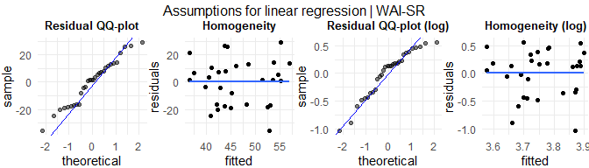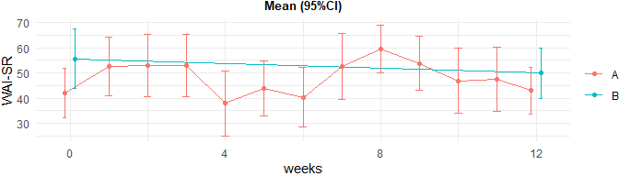

Linear regression

|  |  |
| --- | --- |
|  | p-value |
| WAI-SR | 0.61025 |

## SDQ (further)

SDQ will be filled out in both groups only at baseline. SDQ has 30 questions where the 25 first will be included for calculation. Each of these question generates a score from 0 to 2. The results will be presented as sum-score for 7 scales, and the total sum-score:

* **Prosocial** = Q1 + Q4 + Q9 + Q17 + Q20
* **Emotion** = Q3 + Q8 + Q13 + Q16 + Q24
* **ADHD** = Q2 + Q10 + Q15 + ( 2 - Q21 ) + ( 2 - Q25 )
* **CD** = Q5 + ( 2 - Q7 ) + Q12 + Q18 + Q22
* **Companion** = Q6 + ( 2 - Q11 ) + ( 2 - Q14 ) + Q19 + Q23
* **Externalising** = CD + ADHD
* **Internalising** = Emotion + Companion
* **Sum** = Emotion + ADHD + Companion + CD

### Results

Summarised results

|  |  |  |  |
| --- | --- | --- | --- |
|  | Overall | A | B |
| n | 30 | 15 | 15 |
| e_sdq_emotion_0 (mean (SD)) | 4.53 (3.18) | 5.13 (2.80) | 3.93 (3.51) |
| e_sdq_adhd_0 (mean (SD)) | 5.40 (3.27) | 4.93 (3.22) | 5.87 (3.36) |
| e_sdq_companion_0 (mean (SD)) | 4.43 (3.32) | 3.13 (3.02) | 5.73 (3.17) |
| e_sdq_cd_0 (mean (SD)) | 6.20 (2.95) | 6.80 (2.76) | 5.60 (3.11) |
| e_sdq_prosocial_0 (mean (SD)) | 5.37 (2.82) | 5.13 (3.36) | 5.60 (2.26) |
| e_sdq_externalising_0 (mean (SD)) | 12.40 (5.90) | 13.60 (5.51) | 11.20 (6.22) |
| e_sdq_interalising_0 (mean (SD)) | 8.97 (4.61) | 8.27 (4.68) | 9.67 (4.59) |
| e_sdq_sum_0 (mean (SD)) | 20.57 (6.02) | 20.00 (5.26) | 21.13 (6.83) |

Mann-Whitney U test

|  |  |  |
| --- | --- | --- |
|  | Estimate (95% Confidence interval) | p-value |
| Prosocial | 0 (-3-2) | 0.6904 |
| Emotion | 1 (-1-4) | 0.2969 |
| ADHD | -1 (-4-1) | 0.403 |
| CD | 1 (-1-4) | 0.2861 |
| Companion | -3 (-6-0) | 0.0253 |
| Externalising | 2 (-2-8) | 0.2861 |
| Internalising | -1 (-5-2) | 0.4535 |
| Sum | -2 (-5-4) | 0.5321 |

## ECR-RC (further)

ECR-RC will be filled out in both groups only at baseline. ECR-RC has 12 questions where each of these question generates a score from 1 to 7. The results will be presented as sum-score for two scales:

* **Anxiety items** = ( Q1 + Q2 + Q3 + Q4 + Q5 + Q6 ) / 6
* **Avoidance items** = ( Q7 + Q8 + Q9 + ( 8 - Q10 ) + ( 8 - Q11 ) + ( 8 - Q12 ) ) / 6

### Results

Summarised results

|  |  |  |  |
| --- | --- | --- | --- |
|  | Overall | A | B |
| n | 30 | 15 | 15 |
| e_ecrrc_anxiety_0 (mean (SD)) | 3.65 (0.91) | 3.67 (0.89) | 3.63 (0.95) |
| e_ecrrc_avoidance_0 (mean (SD)) | 3.63 (0.98) | 3.50 (0.88) | 3.75 (1.09) |

Mann-Whitney U test

|  |  |  |
| --- | --- | --- |
|  | Estimate (95% Confidence interval) | p-value |
| Anxiety items | 0.1 (-0.6-0.9) | 0.5886 |
| Avoidance items | -0.3 (-0.9-0.6) | 0.5063 |