**Readme - Team Sidetracker**

**Installation**

The Sidetracker.apk needs to be loaded on to a device or virtual machine running Android version 4.4 or higher. Below are the instructions on how to setup Android 4.4 on Virtualbox. Please note a Nexus 4 virtual device was used for testing and development. It is recommended you use a Nexus 4. Any other devices could cause issues with the dialog.

1. Download and install [VirtualBox](https://www.virtualbox.org/wiki/Downloads) and download the Android 4.4 iso from [here](http://sourceforge.net/projects/android-x86/files/Release%204.4/android-x86-4.4-r1.iso/download)

2. Launch **Virtual Box** and click on **New**. When the Create New Virtual Machine window pops up, click on **Next**.

3. Name your virtual machine, choose**Linux as operating system**, in the Version dropdown menu, choose **Linux 2.6**. Click on **Next** to continue.

[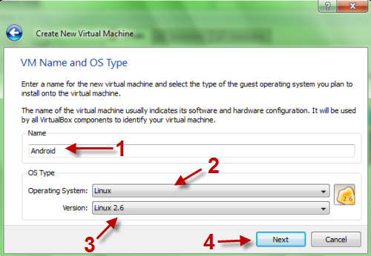](http://www.tech-recipes.com/wp-content/uploads/9-1-2010-9-37-06-PM.png)

4. In the next step, you have to set **base memory size**. **1024MB** is enough. Click on **Next** to jump to next step.

5. Choose **Create new hard disk** and click on **Next**. A new window will pop up, click on **Next->Dynamically expanding storage->Next->Name your vdi file, set its size (about 300mb is enough)->Next->Finish->Finish.**

**[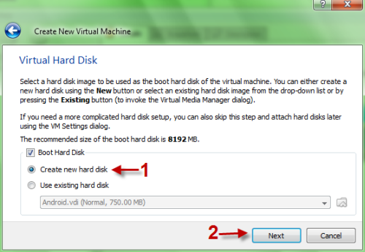](http://www.tech-recipes.com/wp-content/uploads/9-1-2010-9-37-57-PM.png)**

**[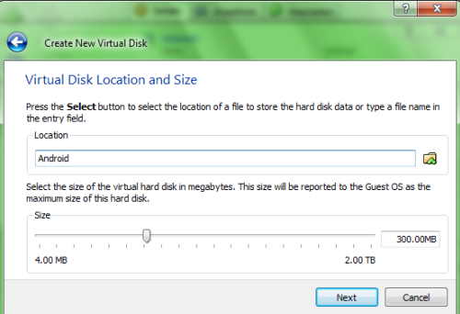](http://www.tech-recipes.com/wp-content/uploads/9-2-2010-2-45-37-PM.png)**

6. Now back to program’s main interface, **right-click** on your new machine and choose **Settings**.

[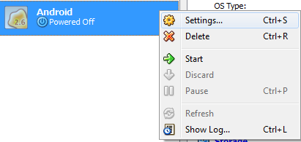](http://www.tech-recipes.com/wp-content/uploads/9-1-2010-9-39-56-PM.png)

7. In the new pop up window, go to **Network option**, click on **Advanced** and set **Adapter type** to**PCnet-FAST III**. Click on**OK** to save setting. (**This step is very important! If you skip this step, your android machine may not be connected to internet, so we can’t download apps and surf the web**)

[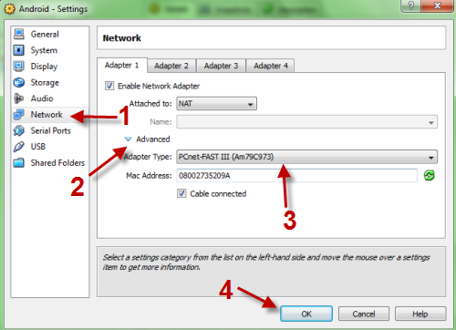](http://www.tech-recipes.com/wp-content/uploads/9-1-2010-9-40-20-PM.png)

8. Go to **Storage option->click on Emty disk->click on Folder icon on the right->choose Add->Point it to your Android iso file->Select-> Hit OK**to save.

[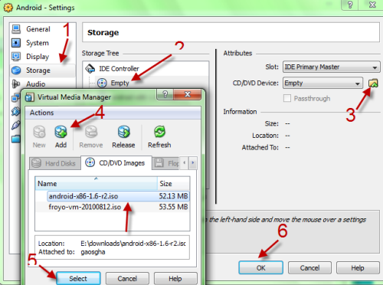](http://www.tech-recipes.com/wp-content/uploads/9-3-2010-8-34-58-AM.png)

9. Click on **Start**to lauch your android machine. If you face any warning, simply press**Enter** to skip it. Choose **Live CD – Run Android – x86 without installing** at the boot sceen.

[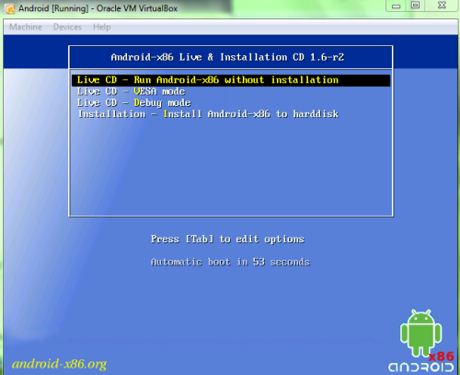](http://www.tech-recipes.com/wp-content/uploads/9-1-2010-9-42-58-PM.png)

10. When you got into Android OS, go to **Machine->Disable mouse intergration** to use mouse inside Android OS. (When you use this function, you can not use other applications. If you want to interact with applications, simply press the host key (default is **Right-Ctrl**) to bring back the normal mouse)

[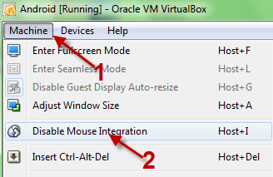](http://www.tech-recipes.com/wp-content/uploads/9-1-2010-9-45-32-PM.png)

11. Go to **Main menu->Settings->Applications->Check on Unknow sources->OK** to save all settings. This will let you install apps from unkown sources.

12.To allow Android Debug Bridge (adb) connect to Android Virtual Machine, still on the **Settings** page, click **Network**, under **adapter 1** tab, click **Port Forwarding** button, enter **5555** into host and guest's port number and **OK**.

[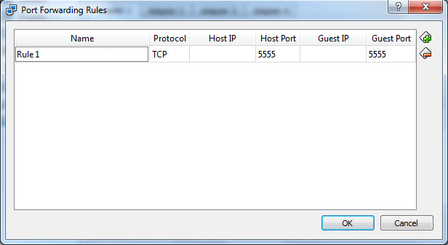](http://1.bp.blogspot.com/-EqDJ7N-fj6c/TvdyfAPSlHI/AAAAAAAAAxo/-unAJPN_5MA/s1600/port+forwarding.jpg)

**Installing Sidetracker.apk using adb**

1. Find the folder where **adb.exe** is located. For example: c:\android-sdk-windows/platform-tools. Place the Sidetracker.apk inside that folder.
2. Press **Shift key + right click** on Android-v4 folder, then click **Open command window here**.
3. To connect adb to Android Virtual Machine, enter this command: *adb connect localhost*
4. Adb has connected to Android Virtual Machine, I can now install Android Terminal Emulator by this command: *adb install Sidetracker.apk*
5. If you get the error "more than one device and emulator", use this to install: adb -s localhost:5555 install term.apk

Now the Sidetracker app should be installed onto the virtual android device.