CREATIVE DIRECTOR
Personal
Resume 2017
LV
吕武欢

EMAIL
LV.JERRY@HOTMAIL.COM

PHONE
13524130601
OVER 10 YEARS EXPERIENCES OF WORKING IN 4A AGENCY

BIRTH YEAR:1985 MARRIED REGISTED RESIDENCE: ZHEJIANG

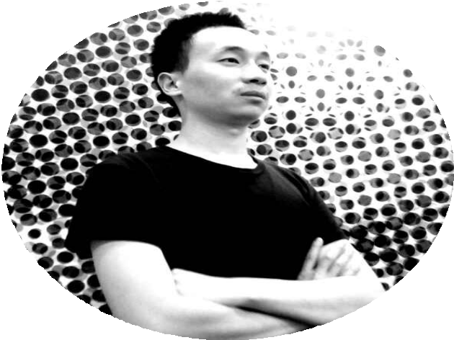
Jerry Lv has full of passion and responsibility like to face working pressure and challenge. He has very good creative concept and always can carry out accordingly. He has the experience of making out excellent layout work and net work.

With him understanding of branding, consumer behaviors (on and offline), website development process, usability design, He is always keen to explore ways to leverage opportunities in the digital landscape for clients. He has demonstrated impressive teamwork and management skills in this role, while also maintaining him ability to handle projects independently, from strategy and idea to execution.

Jerry has demonstrated that he is excellent at serving both international clients and local clients, handling projects ranging from online interactive websites, banner ad, viral marketing, and new media design. He has over 10 years experiences of working in 4A Agency.

CREATIVE DIRECTOR
Personal
LVResume 2017
JERRY

EMAIL
LV.JERRY@HOTMAIL.COM

PHONE
13524130601
OVER 10 YEARS EXPERIENCES OF WORKING IN 4A AGENCY

BIRTH YEAR:1985 MARRIED
REGISTED RESIDENCE: ZHEJIANG




WORKING EXPERIENCE
Nov 2017 - P resent
ISOBAR SHANGHAI
TITLE: CREATIVE DIRECTOR
SERVICE CLIENT: NIPON TENCENT DIANPING PINGAN
SERVICE CLIENT: FORD LANDROVER HUAWEI HSBC JINJIANG-HOTEL ETC......
SENIOR ART DIRECTOR(2011-2013) / GROUP HEAD(2012-2014) / ASSOCIATE CREATIVE DIRECTOR(2015-2016) / CREATIVE DIRECTOR (2016-2017)
WUNDERMAN BEIJING
TITLE: ART DIRECTOR (2009-2010) /
Sep 2009- Oct 2017
May 2008 -Sep 2009
JWT BEIJING
TITLE: ART DIRECTOR
SERVICE CLIENT: NOKIA SHELL
Sep 2006 -May 2008
MCCANN BEIJING
TITLE: SENIOR DESIGNER
SERVICE CLIENT: MICROSOFT INTEL NESTLE

EDU CATION
华中师范大学 CENTRAL CHINA NORMAL UNIVERSITY

BACHELOR OF ARTS (B.A.) VISUAL COMMUNICATION

