**Seed fates of four rainforest tree species in the fragmented forests of Anamalais in the southern Western Ghats, India**

**Authors:** Abhishek Gopal1,2*, Divya Mudappa2, TR Shankar Raman2, Rohit Naniwadekar2

**Affiliations:** 1Post-Graduate Programme in Wildlife Biology and Conservation, Wildlife Conservation Society-India, National Centre for Biological Sciences, GKVK Campus, Bangalore 560 065, Karnataka, India  2 Nature Conservation Foundation, 1311, “Amritha”, 12th Main, Vijayanagar 1st Stage, Mysore 570 017, Karnataka, India

**\*Corresponding Author**

Email –[abhishekgopal1993@gmail.com](mailto:abhishekgopal1993@gmail.com);

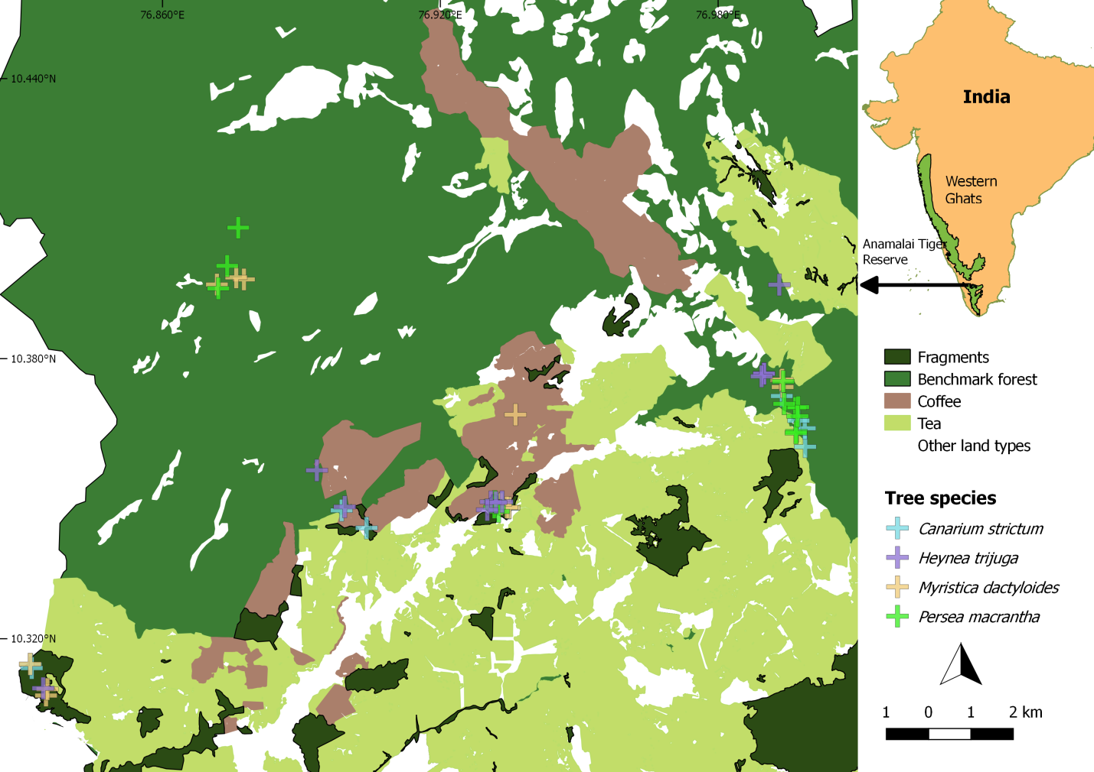

**Supplementary Figure 1** The map of the Valparai plateau and the adjoining Anmalai Tiger Reserve with the major land use types are shown.Also shown are the locations of trees under which seed plots were placed in fragment and benchmark forests. The classified base maps were taken from Wordley et al. (2015).

**Supplementary Table 1** List of locations of the seed plots, number of days monitored and number of trap-nights.

|  |  |  |  |  |  |  |  |  |
| --- | --- | --- | --- | --- | --- | --- | --- | --- |
| **Tree species** | **Tree id** | **Location** | **Type** | **CT** | **Lat** | **Long** | **Num days** | **Trap-nights** |
| *Canarium strictum* | CAST01 | Iyerpadi-Akkamalai | Fragment | N | 10.36008 | 76.99823 | 70 | na |
| *Canarium strictum* | CAST02 | Manamboli | Benchmark | N | 10.34327 | 76.90340 | 72 | na |
| *Canarium strictum* | CAST03 | Manamboli | Benchmark | Y | 10.34706 | 76.89804 | 72 | 35 |
| *Canarium strictum* | CAST04 | Old Valparai | Fragment | Y | 10.34817 | 76.93220 | 70 | 40 |
| *Canarium strictum* | CAST05 | Old Valparai | Fragment | Y | 10.34842 | 76.93261 | 70 | 37 |
| *Canarium strictum* | CAST06 | Iyerpadi-Akkamalai | Benchmark | N | 10.36405 | 76.99817 | 67 | na |
| *Canarium strictum* | CAST07 | Iyerpadi-Akkamalai | Benchmark | Y | 10.36570 | 76.99683 | 70 | 28 |
| *Canarium strictum* | CAST08 | Iyerpadi-Akkamalai | Fragment | N | 10.37099 | 76.99324 | 70 | na |
| *Canarium strictum* | CAST09 | Candura | Fragment | N | 10.31439 | 76.83073 | 156 | na |
| *Canarium strictum* | CAST10 | Candura | Fragment | Y | 10.31367 | 76.83093 | 162 | 65 |
| *Canarium strictum* | CAST11 | Old Valparai | Fragment | Y | 10.34732 | 76.93409 | 151 | 62 |
| *Myristica dactyloides* | MYDA01 | Candura | Fragment | N | 10.30776 | 76.83397 | 40 | na |
| *Myristica dactyloides* | MYDA02 | Iyerpadi-Akkamalai | Benchmark | Y | 10.37292 | 76.99343 | 34 | 6 |
| *Myristica dactyloides* | MYDA03 | Iyerpadi-Akkamalai | Benchmark | N | 10.37436 | 76.99316 | 14 | na |
| *Myristica dactyloides* | MYDA04 | Iyerpadi-Akkamalai | Benchmark | N | 10.37450 | 76.99337 | 15 | na |
| *Myristica dactyloides* | MYDA05 | Old Valparai | Fragment | Y | 10.34742 | 76.93420 | 27 | 20 |
| *Myristica dactyloides* | MYDA06 | Old Valparai | Fragment | Y | 10.34750 | 76.93374 | 14 | 5 |
| *Myristica dactyloides* | MYDA07 | Candura | Fragment | Y | 10.31451 | 76.83060 | 9 | 9 |
| *Myristica dactyloides* | MYDA08 | Candura | Fragment | N | 10.30914 | 76.83428 | 40 | na |
| *Myristica dactyloides* | MYDA09 | Old Valparai | Fragment | Y | 10.34822 | 76.93243 | 9 | 9 |
| *Myristica dactyloides* | MYDA10 | Varuttuparai | Fragment | N | 10.36735 | 76.93570 | 28 | na |
| *Myristica dactyloides* | MYDA11 | Panathiar | Benchmark | Y | 10.39561 | 76.87139 | 27 | 27 |
| *Myristica dactyloides* | MYDA12 | Panathiar | Benchmark | Y | 10.39667 | 76.87724 | 24 | 24 |
| *Myristica dactyloides* | MYDA13 | Panathiar | Benchmark | Y | 10.39712 | 76.87558 | 24 | 24 |
| *Persea macrantha* | PEMA01 | Old Valparai | Fragment | N | 10.34749 | 76.93105 | 24 | na |
| *Persea macrantha* | PEMA02 | Old Valparai | Fragment | Y | 10.34663 | 76.93193 | 24 | 16 |
| *Persea macrantha* | PEMA03 | Old Valparai | Fragment | N | 10.34878 | 76.93113 | 44 | na |
| *Persea macrantha* | PEMA04 | Iyerpadi-Akkamalai | Fragment | N | 10.36337 | 76.99635 | 42 | na |
| *Persea macrantha* | PEMA05 | Iyerpadi-Akkamalai | Fragment | N | 10.36305 | 76.99626 | 42 | na |
| *Persea macrantha* | PEMA06 | Iyerpadi-Akkamalai | Benchmark | Y | 10.37412 | 76.99358 | 42 | 42 |
| *Persea macrantha* | PEMA07 | Iyerpadi-Akkamalai | Benchmark | N | 10.36842 | 76.99613 | 36 | na |
| *Persea macrantha* | PEMA08 | Iyerpadi-Akkamalai | Benchmark | Y | 10.36859 | 76.99677 | 42 | 23 |
| *Persea macrantha* | PEMA09 | Iyerpadi-Akkamalai | Benchmark | N | 10.36665 | 76.99661 | 42 | na |
| *Persea macrantha* | PEMA10 | Iyerpadi-Akkamalai | Benchmark | N | 10.36932 | 76.99375 | 42 | na |
| *Persea macrantha* | PEMA11 | Panathiar | Benchmark | Y | 10.39478 | 76.87170 | 31 | 31 |
| *Persea macrantha* | PEMA12 | Panathiar | Benchmark | Y | 10.39960 | 76.87364 | 31 | 32 |
| *Persea macrantha* | PEMA13 | Panathiar | Benchmark | Y | 10.40777 | 76.87607 | 32 | 4 |
| *Heynea trijuga* | HETR01 | Old Valparai | Fragment | Y | 10.34872 | 76.93271 | 66 | 4 |
| *Heynea trijuga* | HETR02 | Iyerpadi-Akkamalai | Benchmark | Y | 10.37586 | 76.98943 | 59 | 9 |
| *Heynea trijuga* | HETR03 | Iyerpadi-Akkamalai | Benchmark | Y | 10.37579 | 76.98943 | 52 | 18 |
| *Heynea trijuga* | HETR04 | Old Valparai | Fragment | Y | 10.34870 | 76.93027 | 138 | 34 |
| *Heynea trijuga* | HETR05 | Old Valparai | Fragment | Y | 10.34856 | 76.93138 | 53 | 33 |
| *Heynea trijuga* | HETR06 | Iyerpadi-Akkamalai | Benchmark | Y | 10.37523 | 76.98890 | 34 | 7 |
| *Heynea trijuga* | HETR07 | Candura | Fragment | Y | 10.30932 | 76.83337 | 23 | 7 |
| *Heynea trijuga* | HETR08 | Old Valparai | Fragment | Y | 10.34699 | 76.92949 | 109 | 54 |
| *Heynea trijuga* | HETR09 | Andiparai | Fragment | N | 10.39484 | 76.99285 | 27 | na |
| *Heynea trijuga* | HETR10 | Manamboli | Benchmark | Y | 10.34783 | 76.89871 | 14 | 7 |
| *Heynea trijuga* | HETR11 | Manamboli | Benchmark | N | 10.35568 | 76.89274 | 14 | na |

**Supplementary Table 2** Overall visitation trends of different seed predators on the focal tree species in descending order.

|  |  |  |  |
| --- | --- | --- | --- |
| **Tree species** | **Common species** | **Scientific name** | **Number of visits** |
| *Canarium strictum* | Jungle-striped squirrel | *Funambulus tristriatus* | 80 |
| *Canarium strictum* | Indian muntjac | *Muntiacus muntjak* | 49 |
| *Canarium strictum* | Sahyadris forest rat | *Rattus satarae* | 37 |
| *Canarium strictum* | Indian spotted chevrotain | *Moschiola indica* | 15 |
| *Canarium strictum* | Malabar spiny dormouse | *Platacanthomys lasiurus* | 2 |
| *Canarium strictum* | Murid sp1 | Murid sp1 | 1 |
| *Canarium strictum* | Rattus sp_unid | Rattus sp_unid | 1 |
| *Heynea trijuga* | Sahyadris forest rat | *Rattus satarae* | 306 |
| *Heynea trijuga* | Indian spotted chevrotain | *Moschiola indica* | 57 |
| *Heynea trijuga* | Murid sp1 | Murid sp1 | 7 |
| *Heynea trijuga* | Indian muntjac | *Muntiacus muntjak* | 6 |
| *Heynea trijuga* | Jungle-striped squirrel | *Funambulus tristriatus* | 3 |
| *Heynea trijuga* | Murid sp2 | Murid sp2 | 3 |
| *Heynea trijuga* | Wild pig | *Sus scrofa* | 2 |
| *Heynea trijuga* | Indian porcupine | *Hystrix indica* | 1 |
| *Heynea trijuga* | Rattus sp_unid | *Rattus sp_unid* | 1 |
| *Myristica dactyloides* | Jungle-striped squirrel | *Funambulus tristriatus* | 98 |
| *Myristica dactyloides* | Malabar spiny dormouse | *Platacanthomys lasiurus* | 74 |
| *Myristica dactyloides* | Indian muntjac | *Muntiacus muntjak* | 21 |
| *Myristica dactyloides* | Sahyadris forest rat | *Rattus satarae* | 15 |
| *Myristica dactyloides* | Indian spotted chevrotain | *Moschiola indica* | 11 |
| *Myristica dactyloides* | Indian porcupine | *Hystrix indica* | 6 |
| *Persea macrantha* | Sahyadris forest rat | *Rattus satarae* | 75 |
| *Persea macrantha* | Indian spotted chevrotain | *Moschiola indica* | 15 |
| *Persea macrantha* | Jungle-striped squirrel | *Funambulus tristriatus* | 11 |
| *Persea macrantha* | Indian porcupine | *Hystrix indica* | 5 |
| *Persea macrantha* | Indian muntjac | *Muntiacus muntjak* | 4 |
| *Persea macrantha* | Malabar spiny dormouse | *Platacanthomys lasiurus* | 1 |
| *Persea macrantha* | Wild pig | *Sus scrofa* | 1 |

**Supplementary Table 3**. The estimates of GLMM with a poisson error structure examining the influence of forest type on the visitations of seed predators. The coefficients and the associated 95% lower and upper confidence limit (LCL & UCL) for the different parameters and the conditional and the marginal*R2* of the models are shown.

|  |  |  |  |  |  |  |
| --- | --- | --- | --- | --- | --- | --- |
| **Model** | **Parameter** | **Estimates** | **LCL** | **UCL** | **Marginal *R2*** | **Conditional *R2*** |
| Overall visitations | Intercept | −1.89 | −2.64 | −1.19 | 0.01 | 0.95 |
| Type: Fragment | 0.24 | −0.40 | 0.89 |



**Supplementary Figure** **2.** Shown are the seed fates with respect to seed size and forest type for the four tree species. (A) Proportion of seeds predated by vertebrate seed predators, (B) proportion of seeds predated by invertebrate seed predators, and (C) proportion of seeds removed. The diamonds represent the mean values and boxplots represent the medians and the quartiles with the whiskers indicate 1.5 times the interquartile range.

**Supplementary Table 4.** The estimates of linear model examining the influence of forest type on displacement of seeds with respect to tree species. *Canarium strictum* was excluded as only 3 seeds were moved in the benchmark forests. Parameter coefficients whose 95% lower and upper confidence limit (LCL & UCL) do not overlap zero have been highlighted in bold.

|  |  |  |  |  |
| --- | --- | --- | --- | --- |
| **Model** | **Parameter** | **Estimates** | **LCL** | **UCL** |
| *Myristica dactyloides* | Intercept | 1.18 | 0.48 | 1.88 |
| Type: Fragment | 0.26 | −0.78 | 1.31 |
| *Heynea trijuga* | Intercept | 2.78 | 2.30 | 3.27 |
| Type: Fragment | **−1.25** | **−1.95** | **−0.54** |
| *Persea macrantha* | Intercept | 0.72 | 0.21 | 1.24 |
| Type: Fragment | **0.90** | **0.15** | **1.66** |

**Reference**

Wordley, C. F., Sankaran, M., Mudappa, D., & Altringham, J. D. (2015). Landscape scale habitat suitability modelling of bats in the Western Ghats of India: Bats like something in their tea. *Biological Conservation*, 191, 529–536. https://doi.org/10.1016/j.biocon.2015.08.005