**Draft genome sequence of *Maricaulis maris* DSM 4734 isolated from filtered polluted sea water**

**Authors**

Chioma Chibukoa, Elias Figueiredoa, Sebastian Lepea, Melanie Riveraa, Joseph Sadaa, Tricia A. Van Laara

**Affiliations**

1. Department of Biological Sciences, CaliforniaState University, Stanislaus, Turlock, California, USA

**Running title**

*Draft genome sequence Maricaulis maris DSM 4734 isolated from filtered polluted sea water*

**Corresponding author’s email address**

Address correspondence to Tricia A.Van Laar, tvanlaar@csustan.edu.

**Abstract**

Here, we report the genome of *Maricaulis maris* DSM 4734 isolated from filtered polluted seawater. The whole genome was 3568848 bp long, with a GC content of 63.14%, and resistance to 12 antibiotics.

**Announcement**

*Maricaulis maris* is a rod-shaped, gram-negative, oligotrophic bacterium found in seawater and marine environments. The genome was studied to understand how bacteria change morphologically due to environmental stimuli. This process is known as differentiation, and *M. maris*was chosen due to the high predictability of differentiation processes in *M. maris (*[*1*](https://www.zotero.org/google-docs/?JL8HLi)*). M. maris* is the type strain and was isolated from filtered polluted seawater collected from various locations across the Pacific Ocean, including Washington state and the California coast. After the seawater was incubated for two months, a surface film formed. Bacteria were collected from this surface film and were cultured at 30℃ on a medium of peptone, yeast extract, and agar. *M. maris* is a prosthecate bacterium, meaning it has appendages called prosthecae or stalks that are an extension of the cell membrane and act as a holdfast, aiding in adhesion [(1)](https://www.zotero.org/google-docs/?VCXUdC). 16s rRNA gene sequencing was used to classify the isolate as *M. maris* (NCBI Accession Number: GCA_003634045) ([2](https://www.zotero.org/google-docs/?JL8HLi)).

All genomes were sequenced at the DOE Joint Genome Institute (JGI) using Illumina  
technology. An Illumina standard shotgun library was constructed and sequenced using the  
Illumina HiSeq–2000 1TB platform, which generated 5,660,802 reads with a read type of 2x151  
bp. The Raw Illumina sequence was filtered for quality using BBTools per SOP 1061. 200 base  
pairs were trimmed from the sequence at all contig ends, and the contigs were discarded if the  
length was less than 1 kbp or the read coverage was less than 2. There was a total number of  
5,712,362 raw sequence reads resulting in 862,566,662 bp. After trimming, the final draft  
assembly contained 3,568,848 bp. The software used for the genome assembly includes  
BBTools, which was used to remove known process artifacts and contaminants and left  
10,000,000 subsample reads. SPAdes (spades/3.10.1) was used to read the subsamples.  
Prodigal was then used to predict coding sequences on each scaffold, and the output protein  
sequences were aligned to NCIB using LAST. The annotation was standard according to the  
JGI Microbial Genome Annotation Pipeline ([2](https://www.zotero.org/google-docs/?JL8HLi)). The genome was complete with a contamination  
value of 0.19 ([3](https://www.zotero.org/google-docs/?JL8HLi)).

|  |  |
| --- | --- |
| **Feature** | **Finding** |
| Length (bp) | 3568848 |
| Status | Complete |
| No. of Scaffolds | 12 |
| Scaffold N50 | 2236752 |
| Average fold coverage (x) | 241.69 |
| GC content (%) | 63.14% |
| No. of genes | 3413 |
| No. of protein-coding genes | 3360 |
| No. of rRNAs | 5 |
| No. of tRNAs | 43 |

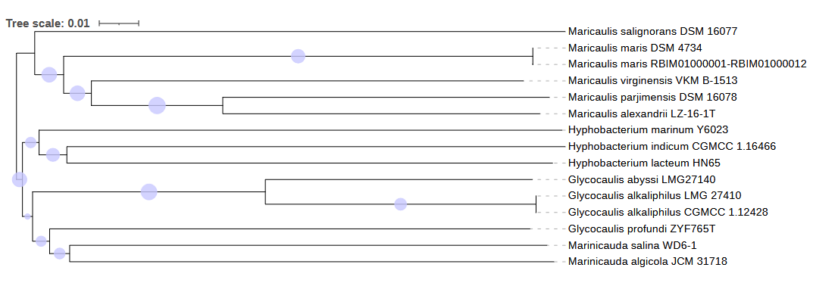

Figure 2. Tree inferred with FastME 2.1.6.1 [7] from GBDP distances calculated from genome sequences. The branch lengths are scaled in terms of the GBDP distance formula d5. The numbers above the branches are GBDP pseudo-bootstrap support values > 60 % from 100 replications, with an average branch support of 77.4 %. The tree was rooted at the midpoint [8].

To determine whether or not *Maricaulis maris* has antibiotic resistance, the Comprehensive Antibiotic Resistance Database (CARD) version 4.0.0 was used [(4)](https://www.zotero.org/google-docs/?lo05lc). It was determined that our isolate is resistant to numerous amount of Antibiotics, including macrolide, aminoglycoside, aminocoumarin, tetracycline, glycylcycline, fluoroquinolone, penicillin β-lactam, peptide, carbapenem, diaminopyrimidine, phenicol, and nitroimidazole. Finally, we identified a secondary metabolite production using antiSMASH version 7.0 and found that *M. maris* could produce an antibiotic [(5)](https://www.zotero.org/google-docs/?uPq1S5). There is a presence of a well-structured terpene biosynthetic gene cluster between 85,917- 106,734bp.

**Acknowledgments**

Thank you to JGI for their support of undergraduate education and research experiences at the California State University system through their “Adopt-a-Genome” project, allowing undergraduate students to take the lead on manuscript preparation.

The work proposal DOI: <https://doi.org/10.46936/10.25585/60001024>) conducted by the U.S. Department of Energy Joint Genome Institute (<https://ror.org/04xm1d337>), a DOE Office of Science User Facility, is supported by the Office of Science of the U.S. Department of Energy operated under contract no. [DE-AC02-05CH11231](https://www.sciencedirect.com/science/article/pii/S2666979X22001665#gs1).

**References**

[1. Abraham W-R, Strömpl C, Meyer H, Lindholst S, Moore ERB, Christ R, Vancanneyt M, Tindall BJ, Bennasar A, Smit J, Tesar M. 1999. Phylogeny and polyphasic taxonomy of Caulobacter species. Proposal of Maricaulis gen. nov. with Maricaulis maris (Poindexter) comb. nov. as the type species, and emended description of the genera Brevundimonas and Caulobacter. Int J Syst Evol Microbiol. Microbiology Society.](https://www.zotero.org/google-docs/?JL8HLi)

[2. Huntemann M, Ivanova NN, Mavromatis K, Tripp HJ, Paez-Espino D, Palaniappan K, Szeto E, Pillay M, Chen I-MA, Pati A, Nielsen T, Markowitz VM, Kyrpides NC. 2015. The standard operating procedure of the DOE-JGI Microbial Genome Annotation Pipeline (MGAP v.4). Stand Genomic Sci 10:86.](https://www.zotero.org/google-docs/?JL8HLi)

[3. Chklovski A, Parks DH, Woodcroft BJ, Tyson GW. 2023. CheckM2: a rapid, scalable and accurate tool for assessing microbial genome quality using machine learning. Nat Methods 20:1203–1212.](https://www.zotero.org/google-docs/?JL8HLi)

[4. Alcock BP, Huynh W, Chalil R, Smith KW, Raphenya AR, Wlodarski MA, Edalatmand A, Petkau A, Syed SA, Tsang KK, Baker SJC, Dave M, McCarthy MC, Mukiri KM, Nasir JA, Golbon B, Imtiaz H, Jiang X, Kaur K, Kwong M, Liang ZC, Niu KC, Shan P, Yang JYJ, Gray KL, Hoad GR, Jia B, Bhando T, Carfrae LA, Farha MA, French S, Gordzevich R, Rachwalski K, Tu MM, Bordeleau E, Dooley D, Griffiths E, Zubyk HL, Brown ED, Maguire F, Beiko RG, Hsiao WWL, Brinkman FSL, Van Domselaar G, McArthur AG. 2023. CARD 2023: expanded curation, support for machine learning, and resistome prediction at the Comprehensive Antibiotic Resistance Database. Nucleic Acids Res 51:D690–D699.](https://www.zotero.org/google-docs/?JL8HLi)

[5. antiSMASH 7.0: new and improved predictions for detection, regulation, chemical structures and visualisation | Nucleic Acids Research | Oxford Academic. https://academic.oup.com/nar/article/51/W1/W46/7151336?login=true. Retrieved 16 April 2025.](https://www.zotero.org/google-docs/?JL8HLi)