Based on the feedback the CTO has provided across several executive interviews, here is a guide for candidates on what she prioritizes and looks for in a successful candidate:
• Hands-on Technical Depth: The CTO consistently pushes beyond high-level strategy. She is looking for leaders who remain deeply connected to the "how." She wants to see that you understand the specific AI models being used, the orchestration layers, and the code-level implementation details rather than just speaking in generalities about "agentic solutions."
How, AI.
I am evaluating Opera AI at four implementation levels. First, the model layer: which Gemini or task-specific model each agent uses and how inference is configured. Second, the orchestration layer: how ADK performs classification, skill selection, clarification loops, session management, and tool execution. Third, the code layer: the API routes, agent factories, skill registry, MCP clients, schemas, retry handling, and persistence boundaries. Fourth, the runtime layer: deployment configuration, authentication, tracing, latency, error handling, and production evaluation. My goal is to trace one real provider workflow from HTTP request through model and tool calls to human confirmation and final business action, rather than describe Opera only as an agentic platform.
- Which model and prompt version are being deployed?
- Which evaluation dataset was executed?
- Did quality, grounding, security, latency, and cost checks pass?
- Were tool and schema changes tested?
- Can the release be rolled back?
- Can a production response be reconstructed?
- “I see Opera AI as more than an agent product roadmap. The leadership responsibility is to make it an engineering system. That means providing standard templates for agents, skills, models, MCP tools, security, and logging. It means requiring feature branches, pull requests, code-owner reviews, automated tests, security scans, and controlled production approvals.
- On the MLOps side, I would version the model, prompt, skill, schema, tool, and container together. Any change should go through an evaluation dataset, regression tests, a lower environment, production approval, and post-deployment monitoring. Opera already shows several of these practices through its shared architecture, pull-request reviews, production deployment gates, secret governance, unit testing, and Splunk latency and error monitoring.
- My leadership focus would be to make those practices consistent across every Opera agent and repository. Success is not just launching more agents. Success is knowing that every agent is reviewable, testable, secure, observable, reproducible, and safe to operate in production.”

• SDLC & Engineering Rigor: She prioritizes candidates who have a strong background in Software Development Life Cycle (SDLC) management. She values leaders who establish engineering standards, code review practices, and rigorous MLOps deployment patterns—not just those who focus on the product roadmap.
PR reviews, templates, reusable CICD, write functions to track token utilization, use audit tools of arize to track each step and failed steps can be revoked. Show cost per call
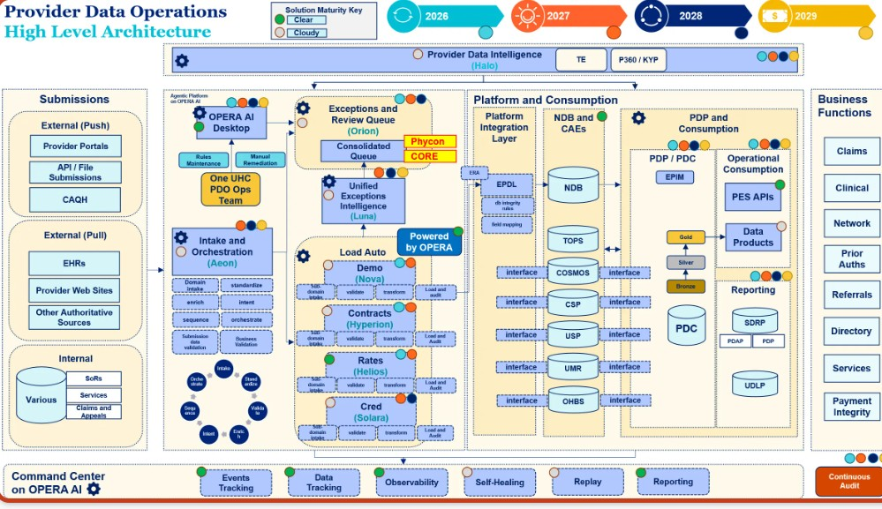
“For AI systems, code review must include more than Python or JavaScript. We also review prompts, model settings, skill definitions, schemas, MCP permissions, fallback behavior, and human-control points.”
• Specific Domain Expertise (Healthcare & Life Sciences): She looks for a clear understanding of the regulated ecosystems she operates in. Whether it’s Epic EHR integration, HIPAA compliance, or GxP-regulated workflows, she wants to see that you aren’t just applying general AI knowledge but can apply it safely and effectively within these complex constraints.
- What patient or provider data is being exposed to the model
- How data is masked, encrypted, and audited
- Role-based access controls
- Data retention and deletion policies
- Human approval requirements before sensitive actions
It must be explainable, auditable, and compliant
Grounding against approved enterprise data
- Confidence scoring
- Hallucination detection
- Human-in-the-loop approvals
- Versioned prompts and skills
- Explainability of why a decision was made
- Integration:
- Epic
- Cerner
- Health information exchanges
- Claims systems
- Provider credentialing systems
- Care management platforms
- Gdx:
- Every change is traceable
- Testing is documented
- Validation evidence is maintained
- Deployment approvals are controlled
- Audit records are retained
"Which model, prompt, skill, and configuration produced this result?"

• Consultative & Collaborative Communication: She appreciates a consultative approach. She values leaders who can translate complex healthcare AI opportunities into secure, scalable, and production-ready architectures and who can effectively align technical solutions with client objectives. Avoid "consultancy speech" that lacks depth; be direct, specific, and clear.
Develop products, with business outcomes measured upfront, performance test to make sure scalable, observable, pass responsible AI, and red-teaming
• Proof of Concept vs. Production Readiness: The CTO looks for candidates who can distinguish between a demo/POC and a real-world, production-grade deployment. Be prepared to explain how you handle scale, performance, cost-efficiency (e.g., token efficiency), and long-term maintenance rather than just creating demos to secure funding.
Scalability, throughputs, fallout, model choices with skills to identify intentions, traceability (api first approach, deterministic workflow, not agentic AI)
Max retry, timeout, fallout handling, intent clarification, safety, feature selection.
Agentic AI, when to use react, or plan and execute, how to coordinate between multiple agents.
Goal clarification, set up guardrails, tools, path, hilt. Confidence level.
Advice for Candidates
- Be Specific About Your Stack: When discussing AI tools and models, avoid vague terms like "orchestrators." Be ready to name the specific models you’ve implemented and explain why you chose them.
Used ADK, gemini-2.5-pro for real tasks, Gemini 2.5 Flash-Lite for doc extraction and intent classification
- Demonstrate "Player-Coach" Capability: Emphasize your ability to lead teams while maintaining your ability to contribute to architecture or code patterns directly. She values leaders who have their "hands on the keyboard" to some degree.
Make system design decisions, set up templates, architecture on advanced rag, agentic AI design patterns, aidlc with agents of agents, knowledge graph, data governance, data retention approaches.
- Prepare for Hard Technical Questions: Anticipate questions on specific implementation strategies—such as token optimization, guardrails for conversational flows, or how you integrate with existing EHR systems like Epic.
Show diagram for Rosemap and tapestry
4. Connect AI to Business Outcomes: While technical depth is critical, keep the business impact in mind. The CTO wants to see that you can drive workflow optimization, improve operational efficiency (e.g., 25–35% improvements), and handle the reality of clinical resistance.
10% VPH, 75% to 90% accuracy, automation, 2 weeks TAT to 4 days
- Be Ready to Discuss the "Why": Beyond just knowing "how" to build something, be prepared to justify your architectural choices, particularly regarding model selection (cost vs. performance) and safety guardrails in highly regulated environments.
Situation | Recommended pattern
Open-ended investigation | ReAct
Complex goal with changing tasks | Plan-and-execute
Stable regulated process | Deterministic workflow
Several distinct business specialties | Orchestrator plus specialized agents
Simple API call or business rule | Regular code, not an agent
High-impact healthcare update | Deterministic controls plus human approval

