Building a Wazuh-Linked DoS/DDoS Telemetry Dataset Lab for an Explainable XDR Prototype
Technical Report
Role: Lab and system pipeline builder
Official batch: training-batch-20260607T132426Z
Final clean release: coding-fest-2026-xdr-dataset-training-batch-20260607T132426Z-clean.zip
Scope: Lab build, Wazuh-linked telemetry collection, dataset export, validation, and packaging

Table of Contents
Table of Contents 2
1. Executive Summary 3
2. Project Scope and My Responsibility 3
3. My Contribution 3
4. Architecture Overview 4
5. Environment and Tools 5
6. Lab Build Process 5
7. Scenario Design 6
8. Automation Workflow 7
9. Dataset Generation Process 7
10. Wazuh Evidence Export Process 8
10.1 Exporter Issue Found 9
10.2 Exporter Fix 9
11. Dataset Outputs 10
12. Final Clean Package 11
13. Reproduction Instructions 12
13.1 Start and Check the Lab 12
13.2 Synchronize Wazuh Agent Manager IP 12
13.3 Generate a Small Scenario Run 12
13.4 Cache, Verify, and Export One Run 12
13.5 Run a Dataset Batch 12
13.6 Export Wazuh Evidence 13
13.7 Build Dataset Outputs 13
13.8 Validate Key Counts 13
14. Problems Encountered and Fixes 13
15. Results and Validation 14
16. Known Limitations 15
17. Portfolio Reflection 16
18. Future Work 16

1. Executive Summary
This report documents my completed contribution to the Coding Fest 2026 Explainable AI-Driven XDR/SIEM lab: building and automating a controlled, Wazuh-linked telemetry dataset pipeline for application-layer DoS/service-stress research. The work produced a reproducible lab workflow that starts from controlled traffic generation, preserves raw local and Wazuh evidence, builds feature tables and windowed datasets, validates the outputs, and packages a clean portable dataset release.
The final output is a Wazuh-linked dataset package for the official batch training-batch-20260607T132426Z. It contains 300 tabular run-level rows, 798 windowed rows, 300 model-ready run-level rows, and 299 raw verified-run evidence folders. The raw evidence count is intentionally 299 because benign-20260607T132426Z-043 was incomplete and excluded from raw evidence packaging. Clean supervised training should use rows where is_clean_supervised_training_candidate == True.
This report does not claim that final ML model training, SOC dashboard development, causal graph reasoning, or LLM SOC report generation were completed. Those are future or teammate-owned project stages. The completed contribution documented here is the lab/data-generation foundation that makes those later stages possible.

2. Project Scope and My Responsibility
The broader project is an incident-centric XDR/SIEM research prototype for SOC workflows. Wazuh provides the telemetry and alerting substrate, while later custom components are intended to support normalization, incident correlation, AI detection, explainability, causal reasoning, response guidance, and analyst workflow.
My completed responsibility was narrower and concrete:
- Build the local Multipass-based lab environment.
- Configure the DB/Auth/Web application stack and structured logging.
- Add Wazuh manager, dashboard, archive logging, and endpoint agents.
- Generate controlled labelled telemetry for benign and DoS/service-stress scenarios.
- Verify local evidence windows and export per-run raw evidence.
- Export Wazuh archive and alert evidence into verified-run folders.
- Build dataset quality summaries, feature tables, windowed datasets, and model-ready run-level outputs.
- Package a clean release that is portable and suitable for teammate handoff.
Out of scope for this report:
- Completed ML model training or evaluation.
- Final dashboard or production SOC case workflow.
- Implemented causal graph reasoning.
- Implemented LLM SOC report generation.
- True distributed DDoS collection with multiple visible source IPs.
- Malware/Sysmon endpoint telemetry.

3. My Contribution
My contribution was primarily telemetry engineering and reproducible dataset preparation. I translated the project's XDR/SIEM idea into a working evidence-generation and packaging workflow. The output is not just a set of CSV files; it is a traceable dataset package where tabular rows link back to local service logs and Wazuh-collected evidence.
Key deliverables:
Deliverable | Completed contribution
Lab foundation | Multipass Ubuntu VMs for DB, Auth, Web, and Wazuh roles
App telemetry | FastAPI Auth/Web services, nginx, PostgreSQL tables, structured JSON logs
Wazuh linkage | Wazuh manager/indexer/dashboard, agents, archive logging, localfile collection
Controlled scenarios | Benign, LightDos, AttackerHostLightDos traffic with labels and metadata
Evidence export | Local log slices and Wazuh archive/alert slices per verified run
Dataset builders | Quality summary, ML feature table, windowed dataset, model-ready run-level output
Clean release | Portable ZIP with old evidence removed and laptop-specific paths removed

4. Architecture Overview
The lab uses four Multipass Ubuntu VMs connected through bridged networking. The automation resolves current DHCP addresses dynamically rather than assuming historical IPs.
VM | Role | Main services and evidence
`web-server` | Primary HTTP target | FastAPI web app, nginx reverse proxy, `/home/ubuntu/web-lab/logs/webapp.log`, `/var/log/nginx/access.log`
`auth-server` | Login/API evidence source | FastAPI Auth API, `/home/ubuntu/auth-lab/logs/auth.log`
`db-server` | Backend dependency | PostgreSQL database `xdr_lab`, tables `users`, `login_attempts`, `web_events`
`wazuh-server` | SIEM/XDR evidence collector | Wazuh manager, indexer, dashboard, Filebeat, archives, alerts

The data pipeline is:
Controlled scenario execution
-> Auth/Web/nginx logs
-> Wazuh archives and alerts
-> local log cache
-> verification by metadata window
-> verified-run raw evidence folders
-> Wazuh evidence slicing
-> dataset quality summary
-> ML feature table
-> windowed dataset
-> model-ready run-level dataset
-> clean portable release package
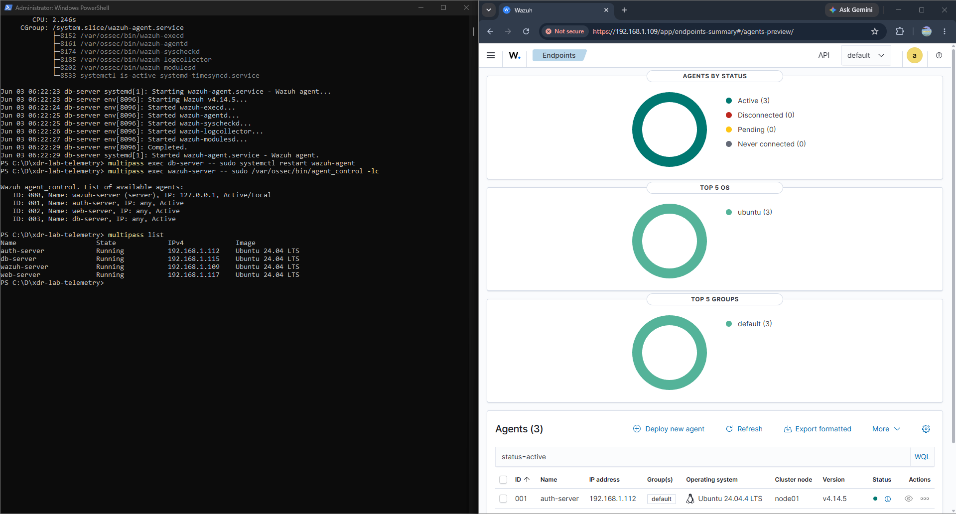
Figure 1. Active Wazuh agents and Multipass lab topology
Figure 1 explanation: This screenshot shows Wazuh reporting three active endpoint agents and the Multipass VM list containing auth-server, db-server, web-server, and wazuh-server. It supports the lab architecture and Wazuh agent setup sections.

5. Environment and Tools
Category | Tools used
Host environment | Windows host, PowerShell automation
Virtualization | Multipass Ubuntu VMs with bridged DHCP networking
Web/application stack | FastAPI, nginx, Python virtual environments
Database | PostgreSQL database `xdr_lab`
SIEM/XDR layer | Wazuh manager, indexer, dashboard, Filebeat, endpoint agents
Dataset automation | PowerShell scripts under `scripts\`
Evidence outputs | CSV, JSON, JSONL-style Wazuh slices, log slices, Markdown summaries

The key operational decision was to keep the lab log-centric and Wazuh-linked. Packet capture was deliberately excluded from this stage. The dataset focuses on server-side logs, web application logs, nginx logs, Wazuh archives, Wazuh alerts, and windowed behavior features.

6. Lab Build Process
The lab began with a Multipass DB/Auth/Web foundation. PostgreSQL was installed on db-server; Auth and Web services were built as FastAPI applications; nginx was configured as the public reverse proxy for the web app. The services wrote structured JSON logs so that later scripts could verify and transform the evidence reliably.
The lab then added Wazuh:
- A dedicated wazuh-server VM was created with enough resources for Wazuh manager, indexer, dashboard, and Filebeat.
- Wazuh agents were installed on auth-server, web-server, and db-server.
- Wazuh archive logging was enabled.
- Custom localfile collection was configured so Wazuh could collect application and nginx evidence.
- The dashboard and endpoint agent status were manually checked.
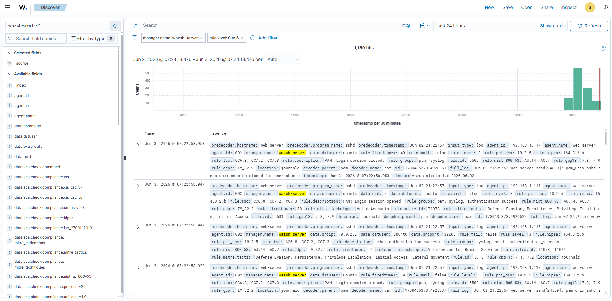
Figure 2. Wazuh Discover evidence view
Figure 2 explanation: This screenshot shows Wazuh Discover populated with Wazuh alert records. It demonstrates that the Wazuh stack was collecting and indexing events. The visible records are mostly background authentication/system context, which is useful as SIEM evidence context but not treated as the ground-truth DoS label.

7. Scenario Design
The final dataset uses a binary high-level ML label:
Scenario | Main label | Meaning
`Benign` | `Benign` | Normal lab activity and hard-negative benign web activity
`LightDos` | `DoS_DDoS` | Controlled script-generated light HTTP service-stress traffic
`AttackerHostLightDos` | `DoS_DDoS` | Windows-host single-source HTTP service-stress / DoS traffic

LightDos and AttackerHostLightDos map to DoS_DDoS, but this must be described carefully. The current evidence is mostly controlled application-layer single-source DoS/service-stress. It is not a complete real-world DDoS benchmark, and AttackerHostLightDos should not be called true distributed DDoS unless victim logs show multiple visible source IPs.
The generator includes guardrails:
- DoS-style activity is bounded and rate-limited.
- The request cap is controlled by script parameters and metadata.
- Multi-source DDoS-like behavior is guarded and not used for the final official dataset.
- SQLi-style testing, when present in earlier lab work, uses safe logged strings against /search, not destructive exploitation.

8. Automation Workflow
The workflow is implemented as PowerShell scripts in scripts\.
Script | Purpose
`start-and-check-lab.ps1` | Starts/checks lab VMs, resolves dynamic IPs, repairs app config targets, checks services and health endpoints
`generate-controlled-telemetry.ps1` | Generates labelled Benign, LightDos, AttackerHostLightDos, and other controlled lab scenario telemetry
`cache-lab-logs.ps1` | Transfers Auth/Web/nginx logs into `exports\log-cache` for local processing
`verify-log-output.ps1` | Reads run metadata and verifies expected evidence inside padded log windows
`export-lab-logs.ps1` | Creates per-run verified raw evidence folders under `exports\verified-runs`
`run-dataset-batch.ps1` | Coordinates repeated scenario runs, health checks, log caching, verification, and local evidence export
`sync-wazuh-agent-manager-ip.ps1` | Updates endpoint Wazuh agents when the manager IP changes
`export-wazuh-evidence.ps1` | Exports Wazuh archive/alert slices for one run
`export-wazuh-evidence-for-batch.ps1` | Original batch Wazuh exporter
`export-wazuh-evidence-for-batch-fast.ps1` | Fast batch exporter that caches/decompresses Wazuh sources once
`build-dataset-quality-summary.ps1` | Builds per-run quality and feature preview CSV/JSON
`build-ml-feature-table.ps1` | Builds run-level ML feature CSV/JSON, optionally with raw content
`build-windowed-dataset.ps1` | Builds 5-second windowed rows for timeline/stage work
`build-model-ready-dataset.ps1` | Builds leakage-reduced model-ready run-level dataset

The batch runner performs this sequence for each planned run:
- Run a lab health check unless skipped.
- Generate one labelled telemetry run.
- Cache local logs.
- Verify the run using local cached logs and run metadata.
- Export verified local evidence.
- Continue to the next run even if one run fails, recording the result in the manifest.

9. Dataset Generation Process
The official final batch is:
training-batch-20260607T132426Z
The batch manifest records:
Parameter | Value
Scenarios | `Benign`, `LightDos`, `AttackerHostLightDos`
Runs per scenario | 100
Total planned runs | 300
Intensities | Low, Medium, High
Randomization | Enabled
Request delay | 300 ms
Local export padding | 5 seconds
Inter-run delay | 30 seconds
Batch status | `completed_with_failures`

The status completed_with_failures is expected because one benign run, benign-20260607T132426Z-043, failed verification/export and was intentionally excluded from raw evidence.
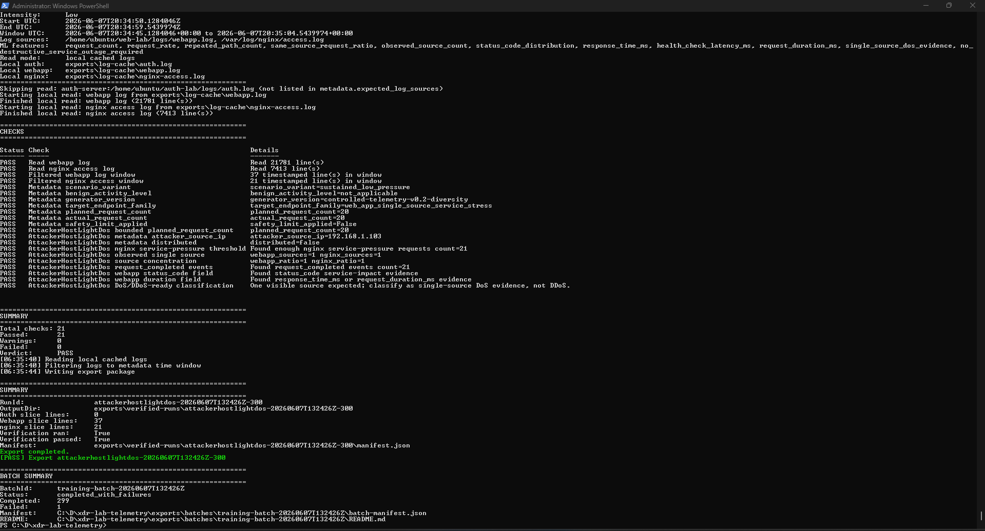
Figure 3. Official batch completion and verified export summary
Figure 3 explanation: This screenshot shows the official batch finishing with Completed: 299, Failed: 1, and status completed_with_failures. It supports the explanation for why the tabular dataset has 300 rows while the raw evidence folder contains 299 completed run folders.

10. Wazuh Evidence Export Process
Wazuh evidence was exported after local verified-run evidence existed. Each complete verified-run folder received:
- wazuh-archives-slice.json
- wazuh-alerts-slice.json
- wazuh-evidence-summary.json
The Wazuh evidence summary includes counts by agent, log location, decoder, alert rule, and other Wazuh context. This makes it possible to trace a dataset row back to both the original service log slice and Wazuh-collected/enriched evidence.
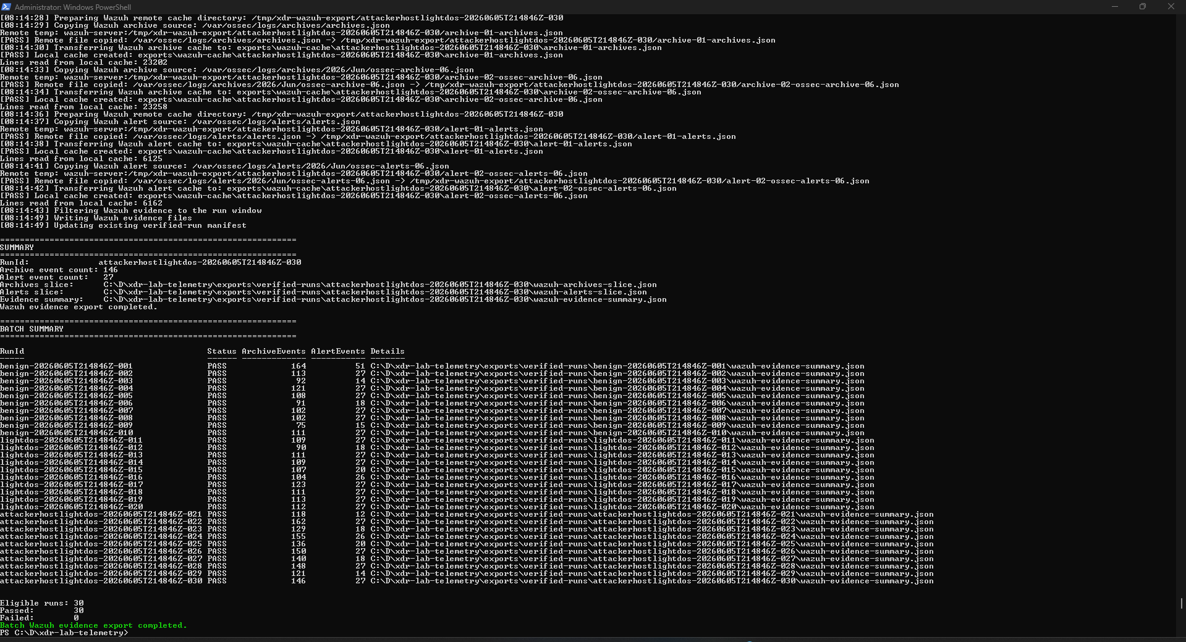
Figure 4. Wazuh evidence export summary from a validation batch
Figure 4 explanation: This screenshot shows Wazuh evidence export producing archive and alert counts per run. It is from a validation batch rather than the final 300-row batch, but it illustrates the same export mechanism used before the final rebuild.

10.1 Exporter Issue Found
During the official dataset repair phase, Wazuh evidence initially appeared to be missing for some runs. Symptoms included:
No readable Wazuh archive JSON source was found
archive_event_count = 0
alert_event_count = 0
This was misleading. Wazuh did contain the evidence, but the exporter was not finding the correct source files and date windows.
Root causes:
Problem | Impact
Older Wazuh archives/alerts were stored as compressed `.json.gz` files | Exporter looked mostly for active `.json` files and missed evidence
Wazuh top-level timestamps used local `+1000` time while run windows were UTC | Evidence for UTC 2026-06-07 runs could live in Wazuh local-date files for 2026-06-08

10.2 Exporter Fix
The Wazuh exporter was fixed to:
- Include active Wazuh files and dated archive/alert files.
- Support compressed .json.gz archive and alert files.
- Use remote gzip -dc to decompress candidate files.
- Include both UTC-date candidates and Wazuh local +1000 date candidates.
- Normalize +1000 timestamps to UTC.
- Filter Wazuh events into each padded run window.
- Keep output format compatible with downstream dataset builders.
The fast exporter, export-wazuh-evidence-for-batch-fast.ps1, was then created to avoid repeatedly copying and decompressing the same Wazuh files for every run. It caches/decompresses source files once and filters all target run windows locally.
Final Wazuh coverage check result:
Scenario | Wazuh summary coverage
Benign | 99 present, 1 missing known incomplete run
LightDos | 100 present
AttackerHostLightDos | 100 present

Attack-side Wazuh evidence coverage was complete. Only benign-20260607T132426Z-043 was missing.

11. Dataset Outputs
The official outputs are organized under exports\.
Output folder | Purpose
`exports\batches` | Batch manifests and batch README files
`exports\verified-runs` | Raw local and Wazuh evidence per verified run
`exports\dataset-quality` | Per-run quality summary CSV/JSON
`exports\ml-features` | Run-level feature table CSV/JSON and raw-content variants
`exports\windowed-datasets` | 5-second windowed dataset CSV/JSON and build summary
`exports\model-ready` | Leakage-reduced run-level model-ready CSV/JSON and data dictionary
`exports\dataset-releases` | Final release folders and ZIP packages

Important official files:
File | Role
`exports\batches\training-batch-20260607T132426Z\batch-manifest.json` | Source-of-truth run manifest
`exports\dataset-quality\training-batch-20260607T132426Z-quality-summary.csv` | Per-run evidence and quality summary
`exports\ml-features\training-batch-20260607T132426Z-features.csv` | Full run-level feature table
`exports\ml-features\training-batch-20260607T132426Z-features-with-raw-content.csv` | Feature table with raw evidence text for audit/review
`exports\windowed-datasets\training-batch-20260607T132426Z-windows.csv` | 5-second windowed dataset
`exports\model-ready\training-batch-20260607T132426Z-model-ready-run-level.csv` | Primary leakage-reduced run-level handoff file
`exports\model-ready\training-batch-20260607T132426Z-data-dictionary.md` | Model-ready column dictionary

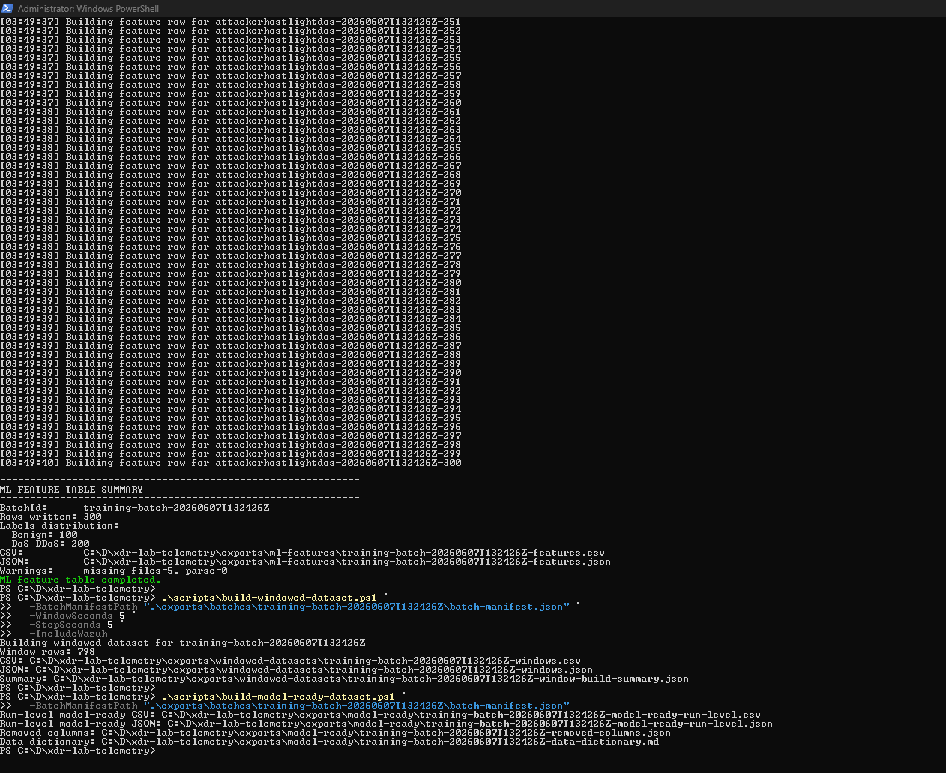
Figure 5. Official feature, windowed, and model-ready dataset build summaries
Figure 5 explanation: This screenshot shows the final official batch rebuild: 300 ML feature rows, 798 windowed rows, and generation of the model-ready run-level outputs. It contains local paths, so it should be cropped if used in a public portfolio layout.

12. Final Clean Package
The final clean package is:
exports\dataset-releases\coding-fest-2026-xdr-dataset-training-batch-20260607T132426Z-clean.zip
The package contains:
Package folder | Contents
`batch-manifest` | Official batch manifest
`ml-features` | Feature table CSV/JSON
`model-ready` | Model-ready run-level dataset and data dictionary
`quality-summary` | Quality summary CSV/JSON
`windowed-dataset` | Windowed dataset CSV/JSON
`raw-evidence\verified-runs` | 299 complete verified-run raw evidence folders
`README.md` | Package notes and usage guidance

Clean package validation:
Check | Result
Expected raw evidence folders | 299
Actual raw evidence folders | 299
Missing expected folders | 0
Extra old/test folders | 0
`benign-20260607T132426Z-043` raw evidence | Excluded
`C:\D\xdr-lab-telemetry` absolute path matches | 0
`C:\\D\\xdr-lab-telemetry` escaped path matches | 0
`raw-evidence\exports-original` path matches | 0
Clean ZIP size | About 5.86 MB

The first packaging attempt copied too much from exports\verified-runs, including old/test runs, and contained laptop-specific absolute paths. The clean release fixed this by using the official manifest as the source of truth, copying only the official complete run folders, excluding benign-043, and rewriting relevant paths to package-relative locations.

13. Reproduction Instructions
These commands are based on the actual repository scripts. They assume the lab VMs already exist and are under the user's control.

13.1 Start and Check the Lab
cd "C:\D\xdr-lab-telemetry"
.\scripts\start-and-check-lab.ps1
Quick health check without generating a linked login test:
.\scripts\start-and-check-lab.ps1 -SkipLinkedEvidenceTest

13.2 Synchronize Wazuh Agent Manager IP
Preview:
.\scripts\sync-wazuh-agent-manager-ip.ps1 -WhatIf
Apply:
.\scripts\sync-wazuh-agent-manager-ip.ps1

13.3 Generate a Small Scenario Run
.\scripts\generate-controlled-telemetry.ps1 -Scenario Benign -Rounds 1
.\scripts\generate-controlled-telemetry.ps1 -Scenario LightDos -Rounds 1 -Intensity Low
.\scripts\generate-controlled-telemetry.ps1 -Scenario AttackerHostLightDos -Rounds 1 -Intensity Low -Randomize

13.4 Cache, Verify, and Export One Run
.\scripts\cache-lab-logs.ps1
.\scripts\verify-log-output.ps1 -MetadataPath "exports\<run-id>-metadata.json" -UseLocalLogs
.\scripts\export-lab-logs.ps1 -MetadataPath "exports\<run-id>-metadata.json" -RunVerification

13.5 Run a Dataset Batch
Example small batch:
.\scripts\run-dataset-batch.ps1 `
-Scenarios Benign,LightDos,AttackerHostLightDos `
-RunsPerScenario 3 `
-Intensities Low,Medium `
-Randomize `
-InterRunDelaySeconds 30
The official 300-run batch followed the same pattern with 100 runs per scenario.

13.6 Export Wazuh Evidence
Original batch exporter:
.\scripts\export-wazuh-evidence-for-batch.ps1 `
-BatchManifestPath "exports\batches\<batch-id>\batch-manifest.json" `
-TimePaddingSeconds 10
Fast exporter used for official repair/completion work:
powershell.exe -NoProfile -ExecutionPolicy Bypass -File .\scripts\export-wazuh-evidence-for-batch-fast.ps1 `
-BatchManifestPath .\exports\batches\training-batch-20260607T132426Z\batch-manifest.json

13.7 Build Dataset Outputs
.\scripts\build-dataset-quality-summary.ps1 `
-BatchManifestPath ".\exports\batches\training-batch-20260607T132426Z\batch-manifest.json"
.\scripts\build-ml-feature-table.ps1 `
-BatchManifestPath ".\exports\batches\training-batch-20260607T132426Z\batch-manifest.json"
.\scripts\build-windowed-dataset.ps1 `
-BatchManifestPath ".\exports\batches\training-batch-20260607T132426Z\batch-manifest.json" `
-WindowSeconds 5 `
-StepSeconds 5 `
-IncludeWazuh
.\scripts\build-model-ready-dataset.ps1 `
-BatchManifestPath ".\exports\batches\training-batch-20260607T132426Z\batch-manifest.json"

13.8 Validate Key Counts
Expected official counts:
Output | Expected count
Batch manifest runs | 300
ML feature CSV rows | 300
Windowed dataset rows | 798
Model-ready run-level rows | 300
Raw verified-run folders in clean release | 299

14. Problems Encountered and Fixes
Problem | Impact | Fix or handling
Multipass DHCP changed VM IPs | App and Wazuh configs could point to stale addresses | Health/check scripts dynamically resolve IPs and repair configs
Multipass or Wazuh instability during long exports | `multipass list` hang, `wazuh-server Running N/A`, SSH timeout | Documented recovery sequence; wait for Wazuh IP and SSH before export
Wazuh evidence falsely appeared as zero | Archive/alert evidence missing from summaries despite existing in Wazuh | Added `.json.gz` support, local timezone date candidates, UTC conversion
Per-run Wazuh export was slow | Same Wazuh sources copied/decompressed repeatedly | Added fast batch exporter with one-time cache/decompression
First package copied old raw evidence folders | Package contained non-official test/old runs | Rebuilt package using official batch manifest as source of truth
First package leaked laptop-specific paths | Teammate portability risk | Rewrote package paths to package-relative locations
`benign-20260607T132426Z-043` incomplete | Raw evidence folder missing | Kept documented, excluded from raw evidence, marked non-clean for supervised training
Background Wazuh events appear in evidence windows | Wazuh summaries include journald/PAM/SSH/sudo context | Preserve provenance; do not treat Wazuh alerts as ground-truth labels

15. Results and Validation
Final official validation results:
Metric | Result
Batch manifest runs | 300
Benign run-level rows | 100
DoS_DDoS run-level rows | 200
ML feature rows | 300
Windowed dataset rows | 798
Model-ready run-level rows | 300
Clean supervised candidates | 299
Raw verified-run folders | 299
Wazuh summaries in raw evidence | 299
Total sampled Wazuh archive events across summaries | 55,508
Total sampled Wazuh alert events across summaries | 8,169
Clean ZIP size | About 5.86 MB

Label distribution:
Main label | Rows
`Benign` | 100
`DoS_DDoS` | 200

Scenario distribution:
Scenario | Rows
`Benign` | 100
`LightDos` | 100
`AttackerHostLightDos` | 100

The clean release is portable and manifest-aligned. The 300 tabular rows plus 299 raw evidence folders is expected and documented, not a packaging bug.
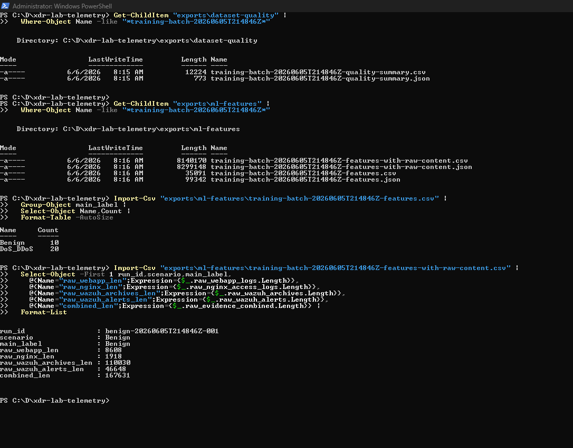
Figure 6. Earlier feature and raw-content output validation
Figure 6 explanation: This screenshot shows a smaller earlier dataset feature-output validation and raw-content length checks. It is useful as process evidence showing how feature artifacts and raw evidence contents were inspected before the final official rebuild.

16. Known Limitations
This dataset is useful and reproducible, but it should be described honestly:
- It is log-centric and Wazuh-linked, not packet-level DDoS traffic.
- The DoS_DDoS class currently represents controlled application-layer DoS/service-stress.
- AttackerHostLightDos is single-source service-stress and should not be overclaimed as true DDoS.
- Wazuh alerts are contextual evidence, not ground-truth labels.
- Background Wazuh events such as PAM, SSH, sudo, journald, and system activity can appear in evidence windows.
- benign-20260607T132426Z-043 is incomplete and excluded from raw evidence.
- ML model training and evaluation are outside this report.

17. Reflection
This work strengthened my practical understanding of telemetry engineering for cybersecurity systems. The main lesson was that dataset quality depends as much on evidence handling, reproducibility, and validation as it does on traffic generation.
Key skills demonstrated:
- Building a multi-VM cybersecurity lab with Multipass.
- Configuring FastAPI, nginx, PostgreSQL, and Wazuh in a realistic evidence pipeline.
- Designing controlled benign and attack-like telemetry safely.
- Creating PowerShell automation that can be explained and rerun.
- Preserving raw evidence and provenance for later analysis.
- Debugging time-window, timezone, compression, and packaging issues.
- Producing model-ready and windowed datasets without losing traceability.
- Packaging a clean release for teammate handoff.
The strongest professional outcome is the reproducible path from controlled lab scenario to verified local evidence, Wazuh evidence, feature rows, windowed rows, model-ready rows, and a portable release ZIP.

18. Future Work
The following work should be treated as future direction, not completed contribution in this report:
Future work | Purpose
ML model training and evaluation | Train baseline and improved classifiers using the model-ready dataset
Stage and evidence labelling | Add weak/human-reviewed labels for burst onset, sustained pressure, service stress, and evidence roles
True multi-source DDoS collection | Use multiple visible source IPs in victim logs before claiming distributed coverage
Dashboard integration | Surface incidents, evidence, and model outputs in the final SOC-facing application
Causal/storyline graph | Link evidence into a structured incident narrative
SOC report generation | Generate analyst-facing summaries after evidence and model layers are validated
Stronger degradation metrics | Add clearer evidence for service degradation, failed health checks, severe latency, or 5xx behavior

