The Experiment Report of Machine Learning

December 12, 2017

Grade:
Undergraduate

Student ID:
201530612002

Supervisor:
Qingyao Wu

Author:
Longkang Li

SUBJECT: SOFTWARE ENGINEERING

SCHOOL: SCHOOL OF SOFTWARE ENGINEERING

Linear Regression, Linear Classiﬁcation and Gradient Descent

Abstract— This report is mainly to illustrate the experiment of logistic regression, linear classification and stochastic gradient descent (SGD)

INTRODUCTION
Logistic regression and linear classification are the two of most fundamental machine learning models,The model of logistic regression is a nonlinear model, Stochastic gradient
descent(SGD), an improved version of traditional GD, accelerates the process reaching the solution,We implement SVM on big data sets.

METHODS AND THEORY
Logistic Regression and Stochastic Gradient Descent
- Load the training set and validation set.
- Initialize logistic regression model parameters, you can consider initializing zeros, random numbers or normal distribution.
- Select the loss function and calculate its derivation, find more detail in PPT.
- Calculate gradient G toward loss function from partial samples.
- Update model parameters using different optimized methods(NAG, RMSProp, AdaDelta and Adam).
- Select the appropriate threshold, mark the sample whose predict scores greater than the threshold as positive, on the contrary as negative. Predict under validation set and get the different optimized method loss${ L}_{NAG}$, ${ L}_{RMSProp}$, ${ L}_{AdaDelta}$ and ${ L}_{Adam}$.
- Repeat step 4 to 6 for several times, and drawing graph of ${ L}_{NAG}$，${ L}_{RMSProp}$，${ L}_{AdaDelta}$ and ${ L}_{Adam}$ with the number of iterations.

Linear Classification and Stochastic Gradient Descent
- Load the training set and validation set.
- Initialize SVM model parameters, you can consider initializing zeros, random numbers or normal distribution.
- Select the loss function and calculate its derivation, find more detail in PPT.
- Calculate gradient G toward loss function from partial samples.
- Update model parameters using different optimized methods(NAG, RMSProp, AdaDelta and Adam).
- Select the appropriate threshold, mark the sample whose predict scores greater than the threshold as positive, on the contrary as negative. Predict under validation set and get the different optimized method loss ${ L}_{NAG}$，${ L}_{RMSProp}$，${ L}_{AdaDelta}$and ${ L}_{Adam}$..
- Repeat step 4 to 6 for several times, and drawing graph of ${ L}_{NAG}$，${ L}_{RMSProp}$，${ L}_{AdaDelta}$and ${ L}_{Adam}$. with the number of iterations.

Experiment
Logistic Regression:
Loss function: $-\frac{1}{m}[\sum_{i=1}^{m}{y^{\left(i\right)}\log{h_{θ}\left(x^{\left(i\right)}\right)}}+(1-y^{\left(i\right)})\log{(1-h_{θ}\left(x^{\left(i\right)}\right))]}$
Derivatives: $-\frac{1}{m}\sum_{i=1}^{m}{α(h_{θ}\left(x^{\left(i\right)}\right)-y^{\left(i\right)})x^{(i)}}$

Linear Classification
Loss function: hingeloss $\frac{{\left\|w\right\|}^{2}}{2}+C\sum_{i=1}^{n}{\max{(0,1-y_{i}\left(x_{i}w+b\right))}}$
Derivatives: $g_{t}=\left\{\begin{aligned}w+C\sum_{i=1}^{n}{-x_{i}^{T}y_{i} 1-y_{i}\left(x_{i}w+b\right)≥0} \\ w 1-y_{i}\left(x_{i}w+b\right)<0\end{aligned}\right.$

NAG:
$$g_{t}=∇J\left(θ_{t-1}\right)$$
$$v_{t}=γv_{t-1}+ηg_{t}$$
$$θ_{t}=θ_{t-1}-v_{t}$$
RMSProp
$$g_{t}=∇J\left(θ_{t-1}\right)$$
$$G_{t}=γG_{t}+\left(1-γ\right)g_{t}⊙g_{t}$$
$$θ_{t}=θ_{t-1}-\frac{η}{\sqrt{G_{t}+ϵ}}⊙g_{t}$$
AdaDelta
$$g_{t}=∇J\left(θ_{t-1}\right)$$
$$G_{t}=γG_{t}+\left(1-γ\right)g_{t}⊙g_{t}$$
$$∆θ_{t}=-\frac{\sqrt{∆_{t-1}+ϵ}}{\sqrt{G_{t}+ϵ}}⊙g_{t}$$
$$θ_{t}=θ_{t-1}+∆θ_{t}$$
$$∆_{t}=γ∆_{t-1}+(1-γ)∆θ_{t}⊙∆θ_{t}$$
Adam
$$g_{t}=∇J\left(θ_{t-1}\right)$$
$$m_{t}=β_{1}m_{t-1}+\left(1-β_{1}\right)g_{t}$$
$$G_{t}=γG_{t}+\left(1-γ\right)g_{t}⊙g_{t}$$
$$α=η\frac{\sqrt{1-γ^{t}}}{1-β^{t}}$$
$$θ_{t}=θ_{t-1}-α\frac{m_{t}}{\sqrt{G_{t}-ϵ}}$$

PARAMETER:

NAG：iter_num=2000
learning_rate=0.002

RMSProp：g=0
iter_num=2000
learning_rate=0.1

AdaDelta：g=0.0
delta=0.003
iter_num=2000

Adam:g=0.0
learning_rate=0.1
iter_num=2000

CODE:
RegressionExperiment:

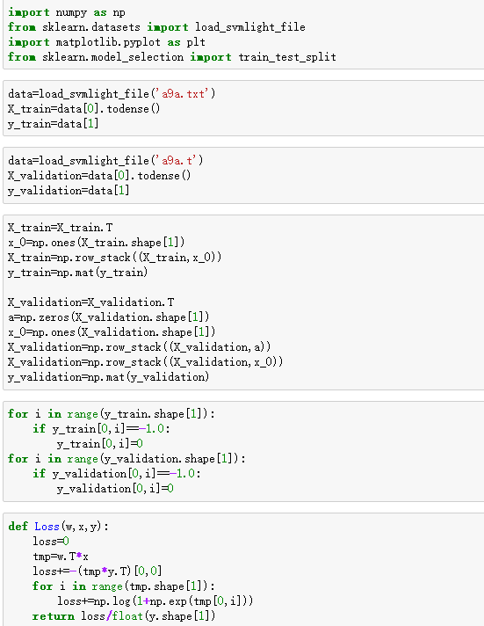
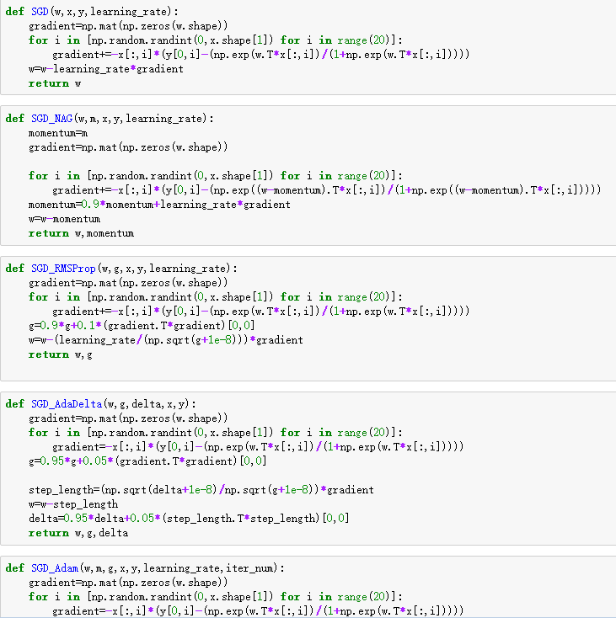
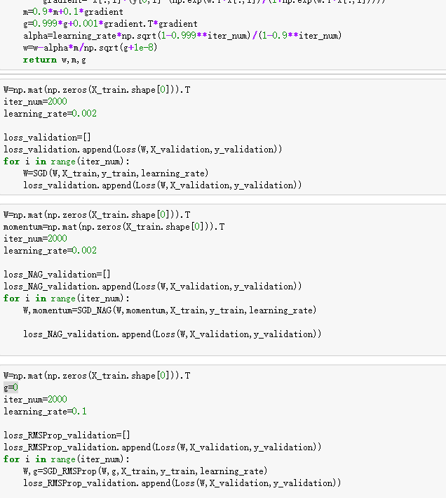
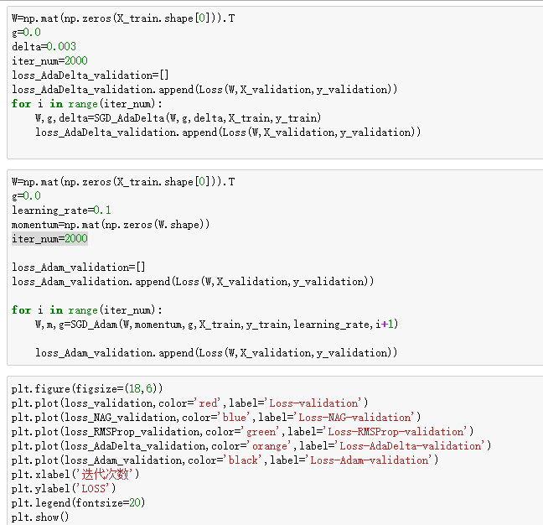
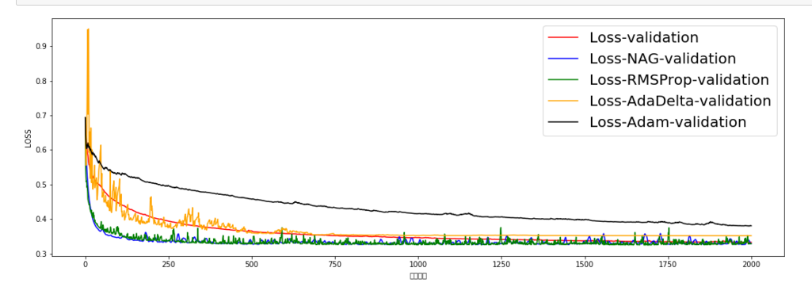
ClassificationExperiment：
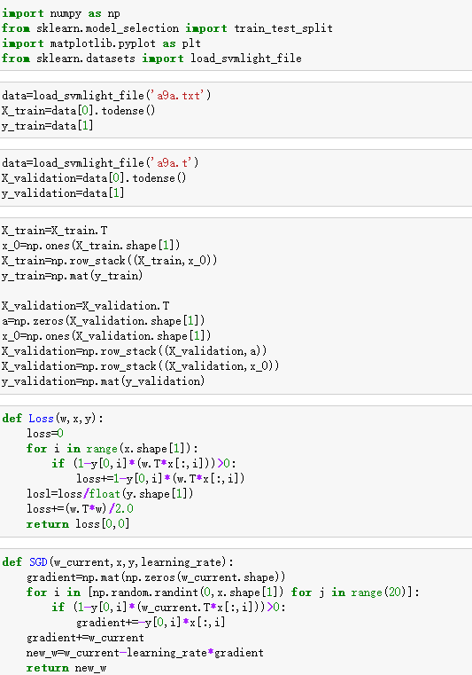
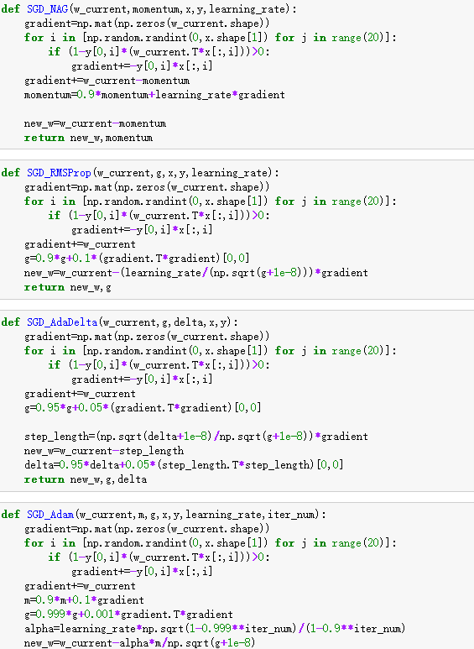
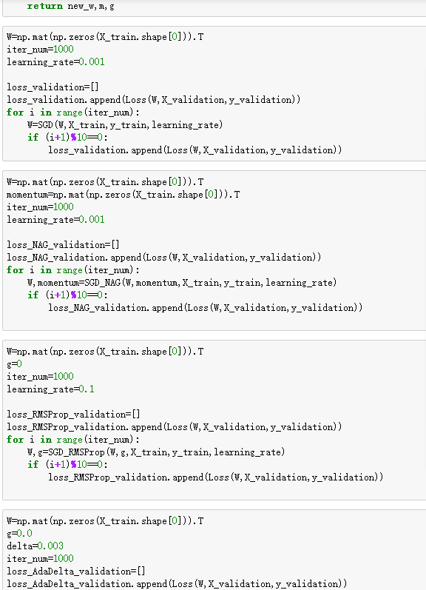
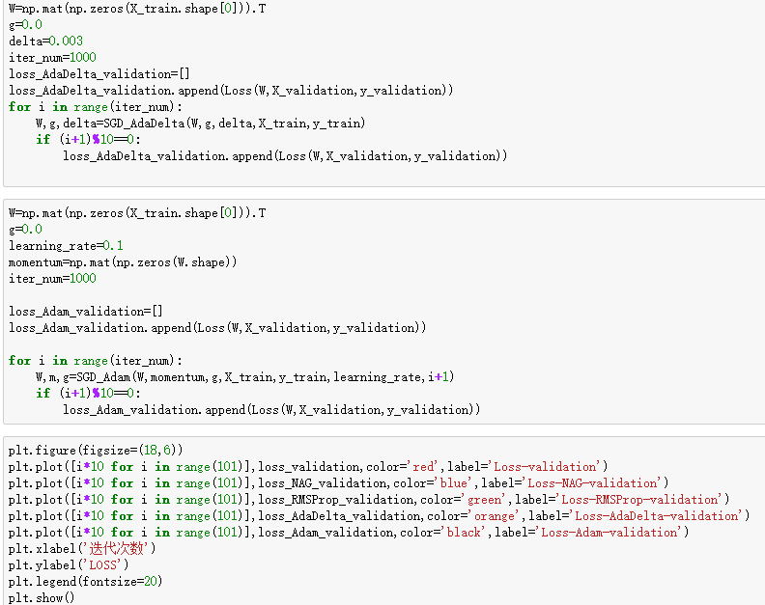
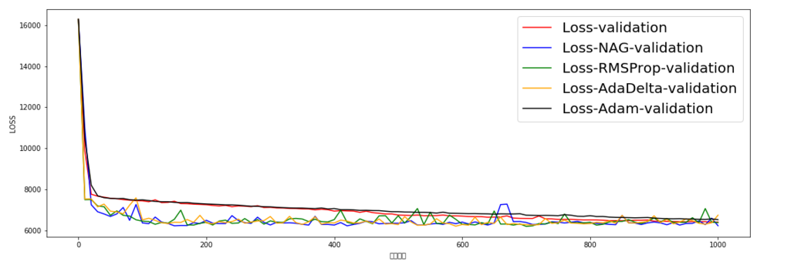

conclusion

SGD run quicker than GD. SGD choose one example to compute the gradient to represent the whole gradient. So SGD can improve the algroithm speed. But learning curve using SGD will get some fluctuations, because we may choose the noise as training data. To avoid the noise, we randomly choose a part of data to compute the gradient.

