How to Install SolidWorks with a Wright State University Account

**Introduction**

These instructions explain how to install SolidWorks on a computer, given that the user has a Wright State University (WSU) account. SolidWorks allows for 3D modeling and design and is used frequently by mechanical engineers. By having a WSU account, a user can access a free version of SolidWorks that allows him to start creating 3-dimensional designs quickly and easily.

**Parts Required**

The items required for this installation are as follows:

* A computer with at least 16 GB of RAM and 20 GB of available storage
* An internet connection
* An internet browser
* A Wright State University WINGS account

**Notes**

* This instruction manual assumes you have never installed SolidWorks on your device before. If you have, you will need to uninstall any pre-existing versions of SolidWorks on your computer before following this guide.
* If you are a Wright State University student, your WINGS account username should be 7 digits, with the format “w###[your initials]”. If you are unsure of your username, contact the WSU help desk.

**Directions**

1. Obtain a SolidWorks serial number through WSU Engineering department.
   1. Go to <https://people.wright.edu/craig.baudendistel> in your preferred internet browser. (This is the profile for Craig Baudendistel a professor of Mechanical & Materials Engineering at WSU.)

Figure 1

* 1. Click on the “Install Solidworks” link under the “Important Links” heading as shown in Figure 1 below. A screenshot of a computer

     Description automatically generated

1. Obtain your Student Download Serial Number.
   1. Enter your WSU WINGS account username and password in the prompt that your browser give you. (See Figure 2 below) A screenshot of a computer screen

      Description automatically generated

Figure 2

* 1. Make a written note (either physically or on your device) of the 24-character serial number supplied on the next page. You will need this serial number later.

**Warning:** Do not just copy the serial number to your clipboard. You will not be able to paste it when it is needed in a future step.

1. Fill out license information.
   1. Go to <https://www.solidworks.com/SEK> in a separate tab in your browser.
   2. Fill out your contact information in the first four boxes supplied. (Figure 3)

**NOTE:** Filling out the lower right box is optional, but if you decide to fill it out, select “Student” from the drop-down.

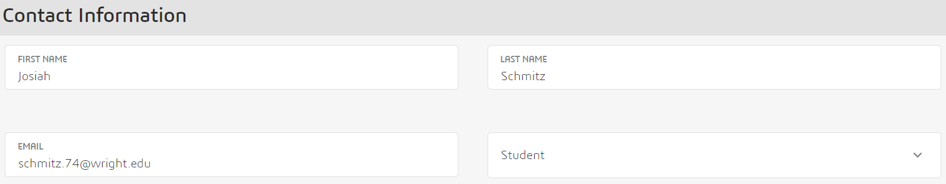

Figure 3

* 1. Select “Yes” under “I already have a Serial Number that starts with 9020”
  2. Verify that “2024” is already selected under “SOLIDWORKS version”. (See Figure 4 below)

**Warning:** Be sure to verify that all information is correct before proceeding to the next step. Otherwise, you may have trouble with the installation. 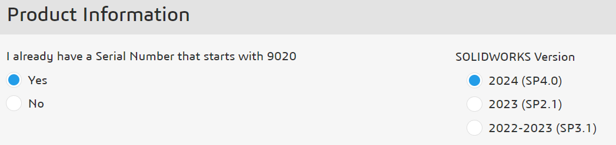

Figure 4

1. Finalize the download request.
   1. Click the “Request Download” button at the bottom of the page.
   2. Click “Accept and Continue” after the Terms of Use Agreement on the next page as shown in Figure 5.

Figure 5

1. Download the installation setup executable.
   1. Click “Download” on the next page.
   2. Choose where to download the setup application to on your computer.
   3. Open the program when it is finished downloading.

**NOTE:** You may get a pop-up requesting to unzip the necessary files for installation like the one in Figure 6. If you would like to unzip the files to specific directory other than the default one, click “Browse” and select the directory you want. Otherwise, click “Unzip”.

Figure 6

1. Enter installation information.
   1. Verify the “Install on this computer” option is selected on the first page of the installation manager, then click “Next”.
   2. Input the 24-character serial number you noted earlier into the boxes under the “3D Design” heading in Figure 7, then click “Next”.

**NOTE:** Each box holds only 4 characters, so copying and pasting the serial number does not work.

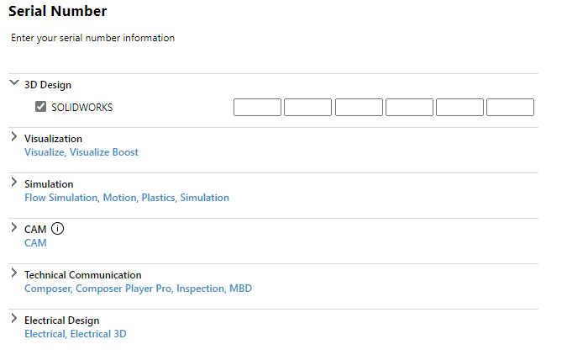

Figure 7

1. Select “Download and Install”. (See Figure 8)

**NOTE:** If you have a VPN running on your computer, you will need to disable it to allow the files to automatically download.

**WARNING:** All the options under each heading will be automatically selected by the installation manager. Only change them if you are already familiar with the SolidWorks installation process. A screenshot of a computer

Figure 8

1. Select “Finish” on the “Installation is Complete” page after SolidWorks finishes downloading and installing. (See Figure 9 below)

**WARNING:** Depending on your device, you may be requested to stop certain processes before clicking “Retry” to continue your installation. This is required to finish the installation process, so verify that those processes are not critical for your device to function before stopping them and clicking “Retry”. You can restart them as soon as the installation is complete.

Figure 9

1. Activate your SolidWorks license.
   1. Run SolidWorks.
   2. Click “Next” after verifying the first option is selected when brought to “SOLIDWORKS Product Activation”.
   3. Click “Select All”, supply your email address in the “Contact Information” box, and click “Next”. (See Figure 10)

**NOTE:** Use the same email address as in Step 4b.

* 1. Click “Finish” and “Accept” to accept the license agreement.

Figure 9

1. Run SolidWorks again and enjoy your 3D-modeling experience!

Figure 10

**Conclusion**

Congratulations on successfully installing SolidWorks! This will be a useful tool for any 3D-modeling or design tasks you hope to achieve in the future. If this is your first time using SolidWorks, you can access the “Learn” tab from the initial welcome screen to access a variety of tutorials and training to start your SolidWorks journey.

**Troubleshooting**

Most issues that you might encounter during the installation process are covered in the warnings and notes sections throughout the installation guide. For other resources on issues that you may encounter unexpectedly, refer to the official SolidWorks Troubleshooting page at <https://help.solidworks.com/2024/english/Installation/install_guide/c_troubleshooting_overview.htm?verRedirect=1>.