Josiah Schmitz
Professor Darron Johnson
CEG-4420
December 7, 2025
Module 15 Assignment – PCB Analysis
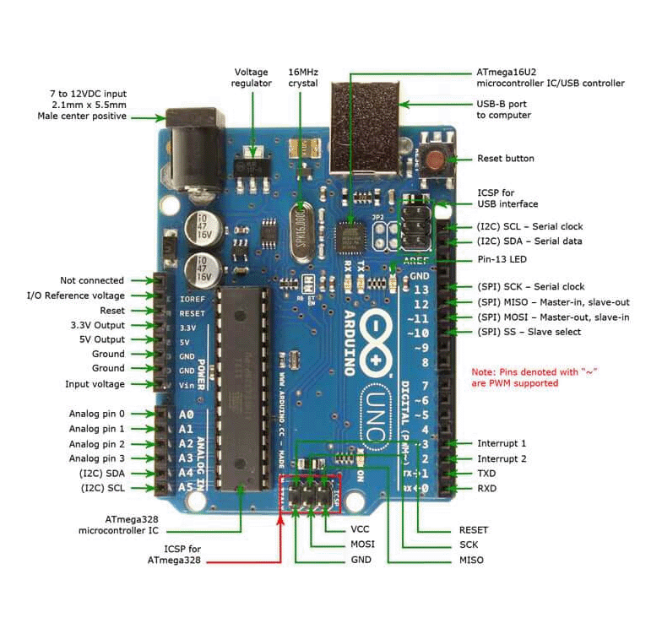
Arduino Uno Circuit Board (from jameco.com)

Potential Attack Surfaces:
- One major attack surface would be the traces on the board. Any of the traces connected to the USB port (top right of diagram) are liable to carry sensitive data, depending on the use case of the PCB. If an attacker manages to probe a trace connected to the USB port, they could read (and potentially alter) any data be transmitted to and from the USB device, compromising the security of the system.
- Another attack surface could be the GPIO pins (right edge of diagram). If an attacker can manage to connect a device to said pins, he can wreak all kinds of havoc on the system. He could potentially find a way to flash the device, altering the way the PCB operates for his benefit.
- A third attack surface might be the clock (SCK) on the PCB (bottom middle of diagram). If an attacker can interrupt the traces to/from the clock or install firmware to the device that alters the clock’s functionality, he could cause the machine to miss important instructions. This opens up a whole array of possibilities for how to exploit the machine.

