10/02/2026
Josiah Schmitz
Embedded Systems ADC Homework
A. Introduction
GPIO are pins on circuit boards that can take a variety of both input and output signals to allow external devices to communicate with the circuit board. ADC (Analog-to-Digital Conversion) is a type of input that takes some form of analog values and converts them to a digital (binary) value, allowing a wide range of potential values to be interpreted as a simple 0 or 1. A push button is a type of switch that can break or initiate a circuit via pushing the button. LDRs are a sensor whose electrical resistance correlates negatively to the intensity of a light source.
B. Experiment Setup
There are four primary components in the design: an ESP32 circuit board, a push button switch, an LED (with a resistor), and an LDR sensor. The LDR and the push button are acting as input sources to the system, connected on GPIO pins 34 and 19, respectively, with the LDR drawing power from the ESP32. The LED is connected to GPIO 32 through a 300-ohm resistor and is controlled by the input of the LDR and the activation/deactivation of the push button.
C. Code Explanation
Below is the primary while-loop running on the system:
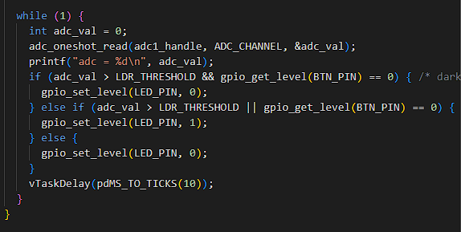
The system reads in the value of the push button and the ADC value (from the LDR). It then tests two main conditions. If the ADC’s value is above the pre-determined LDR threshold (1000 in this case) while the push button is pressed down, the LED turns off. Alternatively, if the ADC’s value is above the LDR threshold or the push button is pressed (excluding the previous scenario), then the LED turns on. Otherwise, the LED is turned off by default.
D. Observations
When the push button is pressed in Part A, it toggles the LED state. This means that if the LED is turned on when the button is pressed, it turns off and vice versa. When the LDR is covered to reduce the light intensity below the pre-determined level in Part B, the LED turns on. In Section 5, when the LDR is covered and the push button is pressed, the LED turns off.
E. Conclusion
The experiment demonstrated how to inter-connect multiple different input/control sources to an ESP32 board and have them simultaneously control an LED. ADC functionality was also demonstrated by having the LED’s state determined by the LDR’s read intensity being above/below a certain analog value.
Critical Thinking
- The pull-up resistor helps eliminate undefined behavior with the switch by having the input pin connected to the switch default to a high value (1) when there is no direct input to the pin. Otherwise, the value will be floating in an indeterminate state.
- The delay in the while loop is necessary to prevent the while loop from continuing while the button is changing. Otherwise, the signals from the button will be read too quickly and cause unintended behavior with the LED’s state.
- It would require either a much higher or lower light intensity to change the LED’s state. For example, increasing the threshold by a significant amount would make it much easier for the LED to turn on.
- You could use any type of pressure-sensitive sensor or temperature sensor that reads analog values.

