10/03/26
Josiah Schmitz
Lab 5: PCB Layout, Routing & Gerber Export
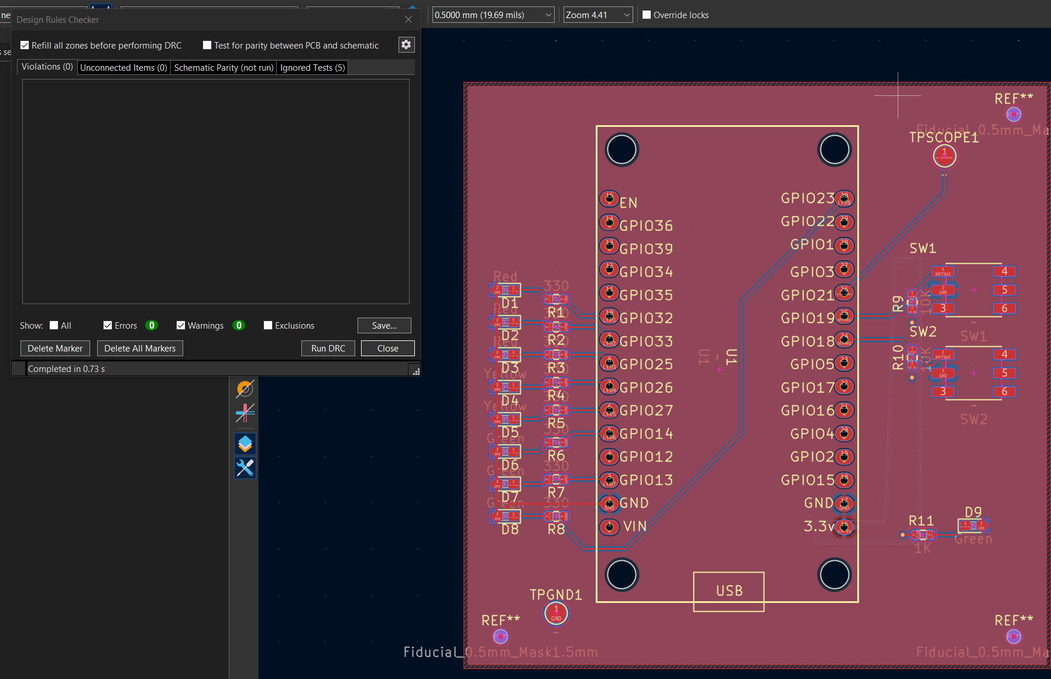
Completed Board and DRC Result
Critical Thinking Questions
- It’s useful for keeping track of your board’s specs for your own sake so you don’t make mistakes down the road by forgetting the value of a resistor or something similar. It also ensures that your board is physically possible to manufacture in the first place and you aren’t assigning nonsensical values to your parts.
- It reduces visual complexity of the design so you don’t have a million wires crossing all over each other. The ground pour specifically also helps to reduce ground noise and potential electromagnetic interference in the PCB.
- Because the Edge.Cuts layer defines the actual physical boundary of the board. If the rectangle was drawn on the Silkscreen layer, the board would not have a physical boundary at all.
- It keeps the pours from acting like a heat sink and soaking up all the heat when soldering the pads onto the board. Without the thermal reliefs, the joints themselves wouldn’t warm up enough to ensure a proper connection.
- They are useful in determining the orientation of the board. By having several fiducials around the edge (typically 3), we can quickly determine the relative orientation of the board around a center axis. Placing a fiducial in or near the center would be nearly useless as the fiducial wouldn’t change positions much (if at all) when rotating the board, so the orientation might look very similar regardless.
- These layers are necessary when traces need to be manufactured into the board, such as in our case. They aren’t necessary if you plan to hand-solder the entire board without the need for assembly by the fab house.
- The Gerber format is the standard because it splits the design across so many layers. This allows manufacturers to analyze and manufacture the board layer by layer, ensuring correct fabrication.

