Josiah Schmitz
Embedded Systems
HW 5 – Priority Encoder
Block Diagram
16 Input Signals
Even Priority Logic
Odd Priority Logic

H-Block Logic
4-Bit Output
VALID
Even Signals (I₁₄, I₁₂, I₁₀…)
Odd Signals (I₁₅, I₁₃, I₁₁…)
H-Block Logic
Even 8-to-3 Encoder
Odd 8-to-3 Encoder

Even VALID
Odd VALID
VALID
OR
Enable Odd Output
Enable Even Output
OR
OUTPUT
Simulation Waveform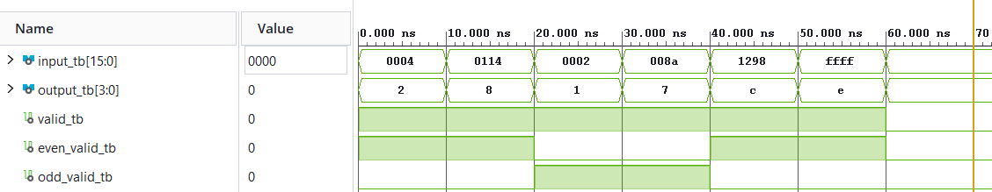
Results:
The results are as expected. All of the even/odd selections and outputs match the project description. In the cases where only even inputs or both even and odd inputs are active, the output selects the highest active even input (test cases 1, 2, 5, and 6). In the cases where only odd inputs are active, the highest active odd input is selected (test cases 3 and 4). When no inputs are active, the ‘valid’ output is 0 and 0 is returned as the primary output (test case 7).

