Josiah Schmitz
Embedded Systems
Homework 3
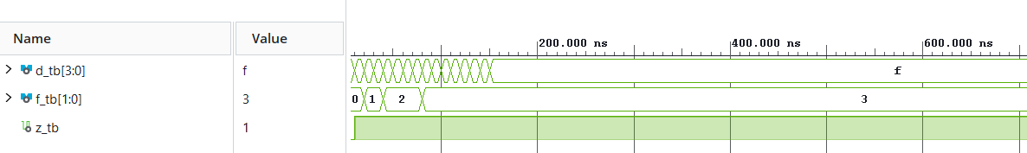
Priority Encoder

The priority encoder worked properly. By simulating an increasing ‘d’, we can see that ‘f’ takes on the value of the highest bit position that is a ‘1’ value in ‘d’. So when ‘d’ is 0001, ‘f’ is 0, and when ‘d’ is 1001 (x9), ‘f’ is 3. Additionally, ‘z’ is only 0 when ‘d’ is 0000.
4x1 Adder
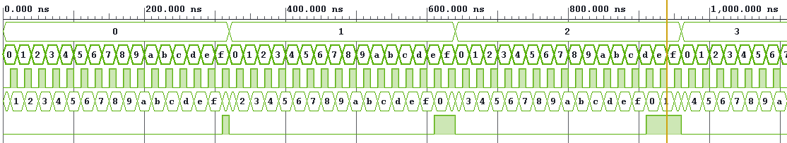

The 4x1 adder also worked properly. Here I have both ‘a’ and ‘b’ constantly increasing to test all values of ‘cin’, ‘s’, and ‘cout’. We can see ‘cin’ (3rd row) fluctuating between 0 and 1, causing ‘s’ to equal ‘a’ + ‘b’ ± 1 depending on the value of ‘cin’. ‘cout’ is consequently only 1 when there is a carry over 1 when the value of ‘s’ flows over into another bit.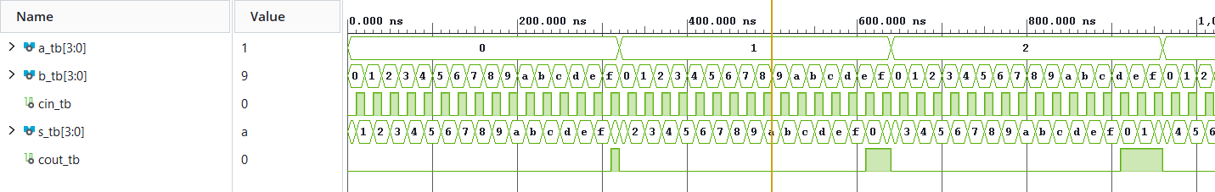
16-bit Adder

The 16-bit adder worked properly as well. It had essentially the exact same function as the 4x1, just with a higher bit-count, so there is not much to cover.
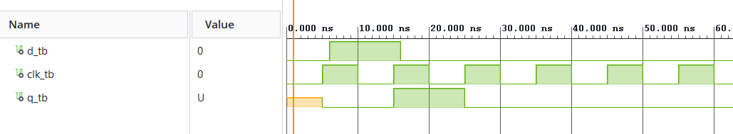
D Flip-Flop

The D Flip-Flop worked as expected. As the waveform shows, when given a value ‘d’, the flip-flop stores that value for one clock cycle before releasing it and being given a new value. This held value is shown by ‘q’, which represents the 1-bit memory of the flip-flop.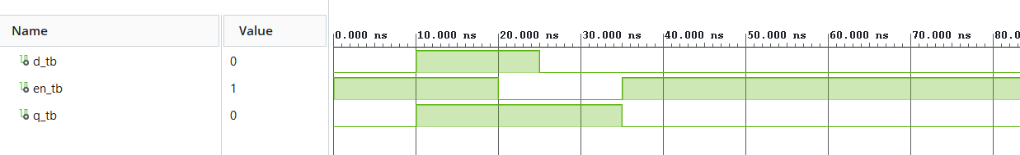
D Latch

The D Latch also works as expected. Instead of the value of the latch being based on a clock cycle, it is instead controlled by the value of ‘en’ (enable). As the waveform above shows, ‘q’ only takes the value of ‘d’ when ‘en’ is set to 1. ‘q’ cannot change values again until ‘en’ has been switched off and back on again and the new value of ‘d’ can be read. 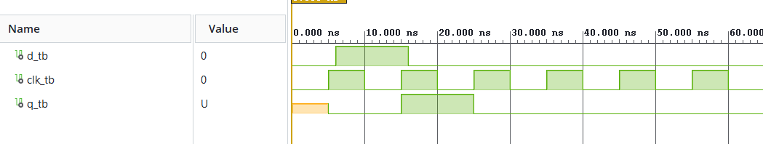
D Flip-Flop (Rising)

There is not much to say about the Rising D Flip-Flop, as it has the exact same function as a standard D Flip-Flop, which can be seen by the identical waveforms above.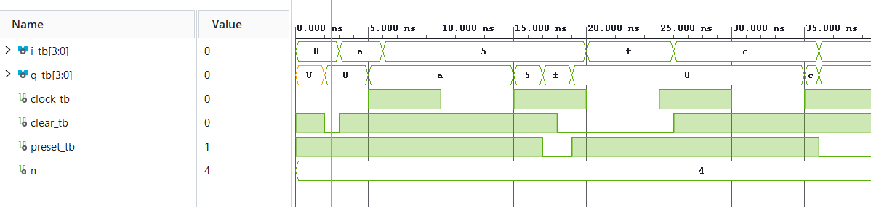
4-Bit Register

The 4-Bit Register worked properly as well. When ‘i’ is set to arbitrary values (as shown above), ‘q’ takes those values on the rising edge of a new clock cycle. When ‘preset’ is low, it sets all bits in the register to 1, as can be seen with the sudden change of ‘q’ to x0f after 15 ns. When ‘clear’ is low, it sets all bits to 0, which is shown just before 20 ns. However, ‘preset’ takes precedence over ‘clear’, which is why ‘q’ is x0f at 18 ns and not x00. 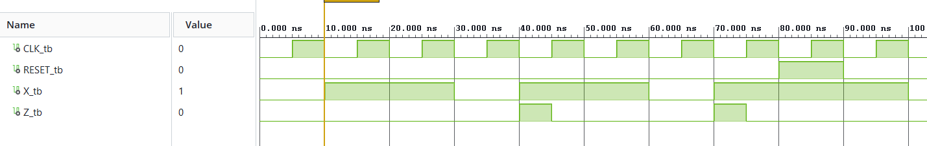
Sequence Recorder

The sequence recorder was a success. The sequence recorder is supposed to output 1 from ‘Z’ whenever the sequence ‘1101’ has appeared in ‘X’ over the last four clock cycles. We see this successfully occur at 40 ns and 70 ns, after ‘1101’ has occurred. When ‘RESET’ is switched to 1, it clears the state machine, meaning that the sequence needs another four clock cycles to work, regardless of what values were previously input.

