Josiah Schmitz
Embedded Systems
Lab 4: Component Footprints
The only footprints I had to manually build were the 0603 resistor, the TL2233 push-button switch, and the Lite-On LED. See below.
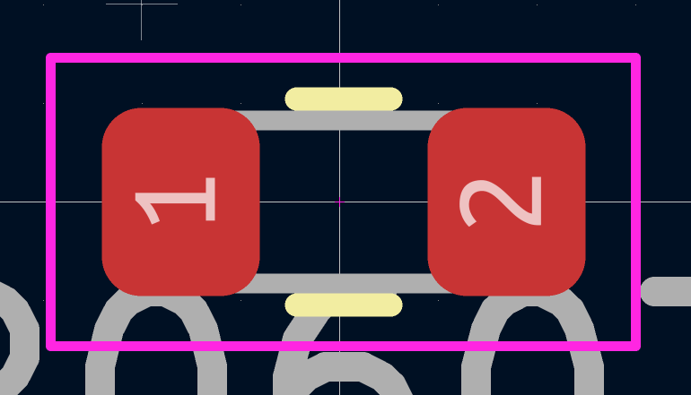
0603 Resistor
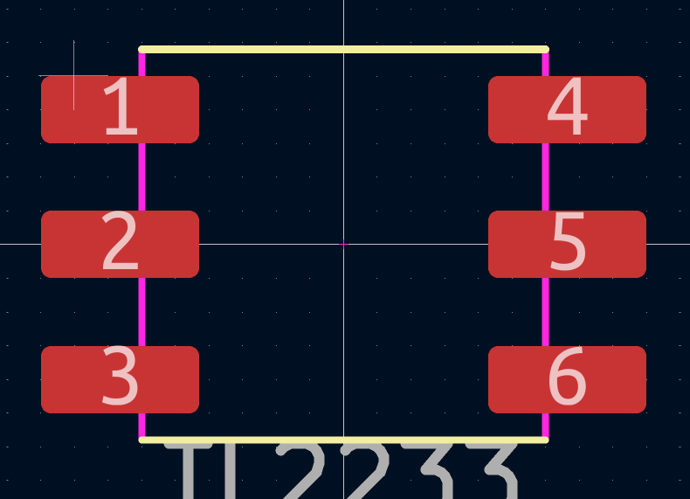
TL2233 Push-Button Switch

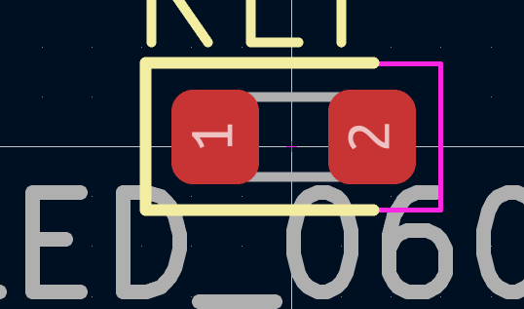
Lite-On LED

Resistor Pad-Dimension Table
(mm) | Pad 1 | Pad 2
Pad Height | 1.0 | 1.0
Pad Width | 0.7 | 0.7
X Position | -0.7 | 0.7
Y Position | 0.0 | 0.0

Reference Link: https://www.ttelectronics.com/TTElectronics/media/ProductFiles/Application-Note/TN006-Recommended-Layouts-for-SMD-Resistors.pdf

Switch Pad-Dimension Table
(mm) | Pad 1 | Pad 2 | Pad 3 | Pad 4 | Pad 5 | Pad 6
Pad Height | 1.0 | 1.0 | 1.0 | 1.0 | 1.0 | 1.0
Pad Width | 2.35 | 2.35 | 2.35 | 2.35 | 2.35 | 2.35
X Position | -3.325 | -3.325 | -3.325 | 3.325 | 3.325 | 3.325
Y Position | -2.0 | 0.0 | 2.0 | -2.0 | 0.0 | 2.0

Reference Link: https://www.ttelectronics.com/TTElectronics/media/ProductFiles/Application-Note/TN006-Recommended-Layouts-for-SMD-Resistors.pdf

LED Pad-Dimension Table
(mm) | Pad 1 | Pad 2
Pad Height | 0.7 | 0.7
Pad Width | 0.95 | 0.95
X Position | -0.6 | 0.6
Y Position | 0.0 | 0.0

Reference Link: https://www.ttelectronics.com/TTElectronics/media/ProductFiles/Application-Note/TN006-Recommended-Layouts-for-SMD-Resistors.pdf

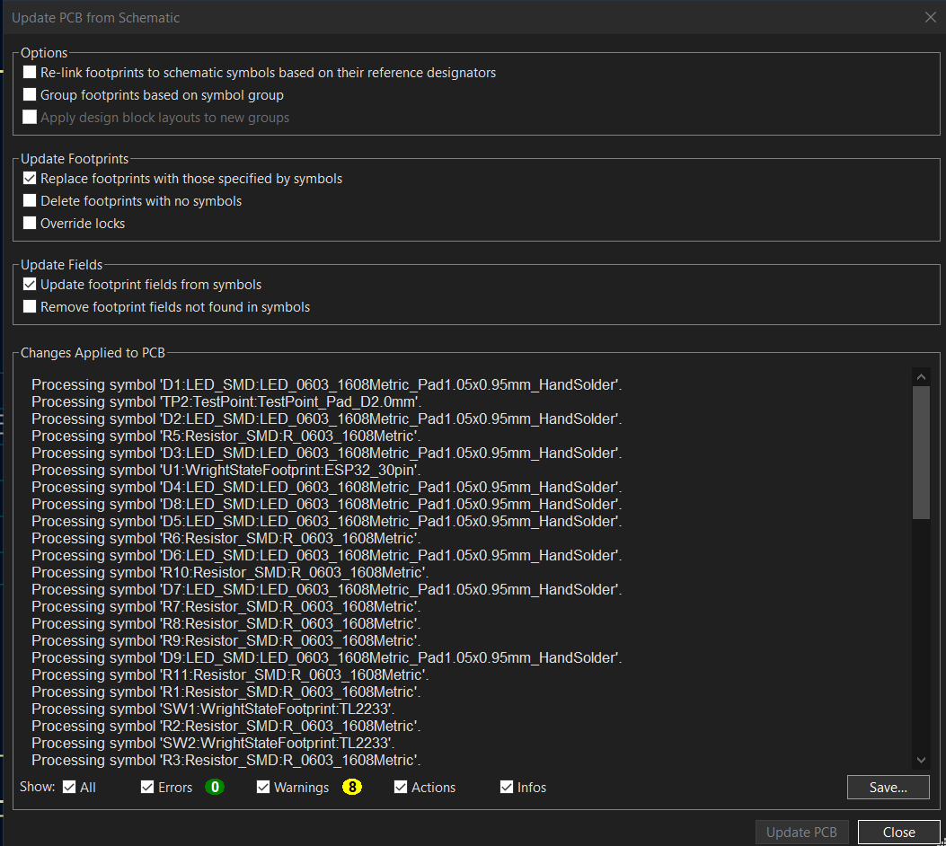
‘Update PCB from Schematic’ Dialog

