Josiah Schmitz
Lab 3: ESP32 GPIO KiCAD Schematic
Finished Schematic
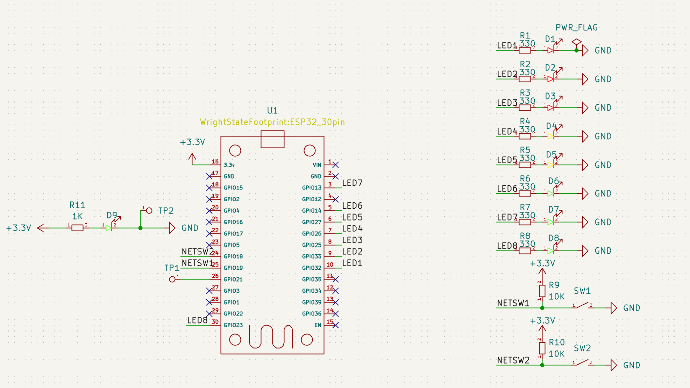
GPIO Pin-Assignment Table
Part | Pin Assignment | Justification
LED 1 | GPIO 32 | Input/output pin
LED 2 | GPIO 33 | Input/output pin
LED 3 | GPIO 25 | Input/output pin
LED 4 | GPIO 26 | Input/output pin
LED 5 | GPIO 27 | Input/output pin
LED 6 | GPIO 14 | Input/output pin
LED 7 | GPIO 13 | Input/output pin
LED 8 | GPIO 23 | Input/output pin
NETSW 1 | GPIO 19 | Input/output pin
NETSW 2 | GPIO 18 | Input/output pin
TP 1 | GPIO 21 | Serial pin
TP 2 | GND | Ground pin for reference

ERC Result
