09/04/2026
Josiah Schmitz
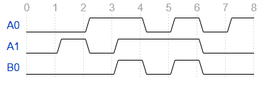
Embedded Systems Homework 1
Time | A0 | A1 | B0
0 | 0 | 0 | 0
1 | 0 | 1 | 0
2 | 1 | 0 | 0
3 | 1 | 1 | 1
4 | 0 | 1 | 0
5 | 1 | 1 | 1
6 | 0 | 0 | 0
7 | 1 | 0 | 0
1.1. 1.2.

1.3. Rises: 3 and 5; Falls: 4 and 6
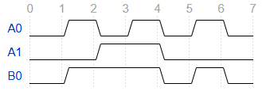
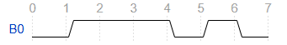
1.4. B0 has two pulses because it has two total pairs of rising and falling events.
2.1. 2.2.

2.3. Rises: 1 and 5; Falls: 4 and 6
2.4. An OR gate causes an output to be high if one or both of its inputs are high. So B0 ends up being high when either A0 or A1 is high.
3.1. B0 = (~A0 ∧ A1) ∨ (A0 ∧ ~A0)
A0 | A1 | B0
0 | 0 | 0
0 | 1 | 1
1 | 0 | 1
1 | 1 | 0
3.2.

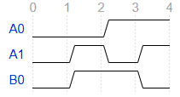
3.3.

3.4. B0 = 1 during time intervals 1 and 2
4.1. A rising event on B0
4.2. A falling event on B1
4.3. B0 becomes 1
4.4. B0 becomes 0
4.5. A signal event is any time when a signal changes between 0 and 1 (rising and falling events). A pulse is an interval where a signal changes from 0 to 1 and back to 0 again.
0 | 0 | 0
0 | 1 | 1
1 | 0 | 0
1 | 1 | 0
5.1. A1 A0 Expected B0

5.2. It’s insufficient because there are 4 total input combinations, so all four can and should be manually tested to ensure code correctness.
5.3. A1 = 0 and A0 = 0, and A1 = 1 and A0 = 1
5.4.
0x00
wait 100 ms
assert 0x00
0x01
wait 100 ms
assert 0x01
0x02
wait 100 ms
assert 0x00
0x03
wait 100 ms
assert 0x00

6.1. The || should be &&.
6.2. B0 = A0 && A1;
6.3. A1 = 1 and A0 = 0
6.4. For A0 ∧ A1, this input combination should result in B0 = 0. However, when the line of code is B0 = A0 || A1, this input combination will result in B0 = 1.
6.5. An assertion is used to test if the actual output of code matches the expected output of the code as intended by the developer.

For Part 7, see attached files.

Part 8
Systematic testing is necessary for embedded systems for the same reasons it is for almost all software-based systems. Systematic testing ensures that the output of an embedded system’s program matches what the developer of said system intended. Without it, there is no easy way to ensure that the system functions as it should. Testing all practical inputs is not practical for larger systems because the number of possible inputs increases exponentially as the number of bits in the system increases. This would require an immense amount of computational power to test all combinations of larger systems.

