Variational Autoencoder (VAE) Tutorial on the Wine Dataset
Github link:

Introduction
Let’s dive into variational autoencoders (VAEs) using the classic Wine dataset. If you’re new to VAEs, they’re a type of generative model that learns to compress high-dimensional data into a smaller, structured latent space. Unlike basic autoencoders, VAEs put some rules on that compressed space, which makes it possible to smoothly move around, sample new points, and get better at understanding what’s really going on in the data. People use VAEs for things like reducing dimensionality, spotting outliers, and creating new data. In this walkthrough, we’ll see how a VAE picks up patterns from the Wine dataset—a collection of chemical measurements from three types of wine. My goal here is to break down what VAEs do, how they learn, and what their results actually mean. We’ll look at how the loss changes during training, what the latent space looks like, how well the model reconstructs data, how it compares to PCA, and what happens when we move around in the latent space. By the end, you’ll get how to use VAEs with structured numerical data and how to make sense of their outputs, both visually and with numbers.

Background on Variational Autoencoders (VAEs)
A VAE has three parts: an encoder, a decoder, and a bit of mathematical trickery called the reparameterization trick. The encoder takes your data and spits out two vectors—the mean and log-variance—which describe a Gaussian blob in the latent space. With the reparameterization trick (from Kingma & Welling, 2014), you can sample points from this blob without messing up the gradients needed for training. The decoder then tries to reconstruct the original data from those samples. Training a VAE means maximizing something called the Evidence Lower Bound (ELBO). This comes down to two pieces: reconstruction loss (you want the output to look like the input) and KL divergence (you want the latent space to stay close to a standard normal distribution). Thanks to this setup, VAEs can interpolate, sample, and generate in ways plain autoencoders just can’t.

Dataset and Preprocessing
The Wine dataset has 178 examples, each with 13 numerical features—things like alcohol content, different types of chemicals, and so on. These features need to be normalized so the neural network doesn’t get confused by wildly different scales. There are three wine classes in the target variable. Here, we standardize the features using z-score normalization before sending them into the VAE.

Methodology
For this tutorial, the VAE uses a two-dimensional latent space. That makes it easy to visualize what’s going on. The encoder squeezes the 13 wine features down to two numbers for the mean and two for the log-variance. The decoder tries to rebuild all 13 features from a sampled latent vector. We train for 200 epochs, keeping an eye on both training and validation loss the whole time. After that, we dig deeper: compare with PCA, look at reconstruction errors, break down loss components, and check out what happens as we move around in the latent space.
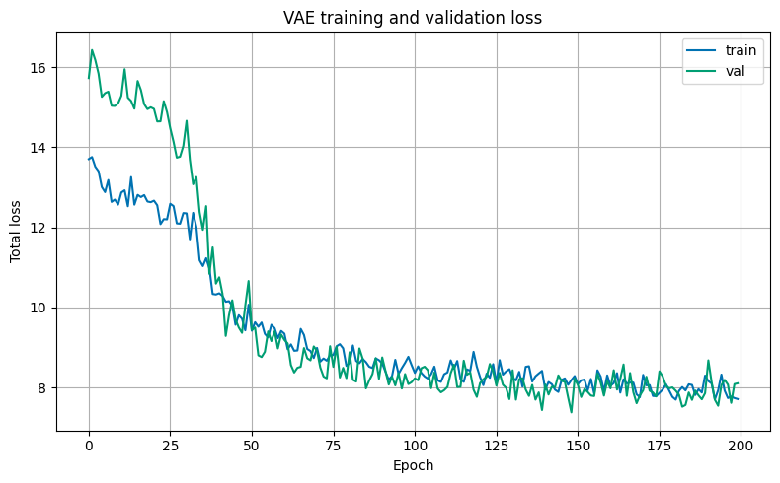
Figure 1: VAE Training and Validation Loss
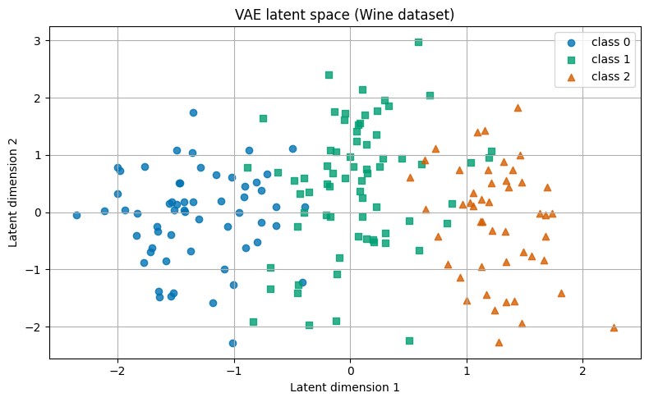
Figure 2: Latent Space Learned by the VAE
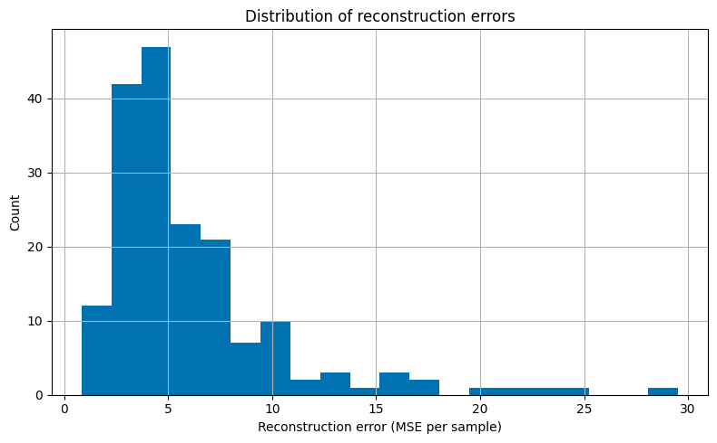
Figure 3: Distribution of Reconstruction Errors
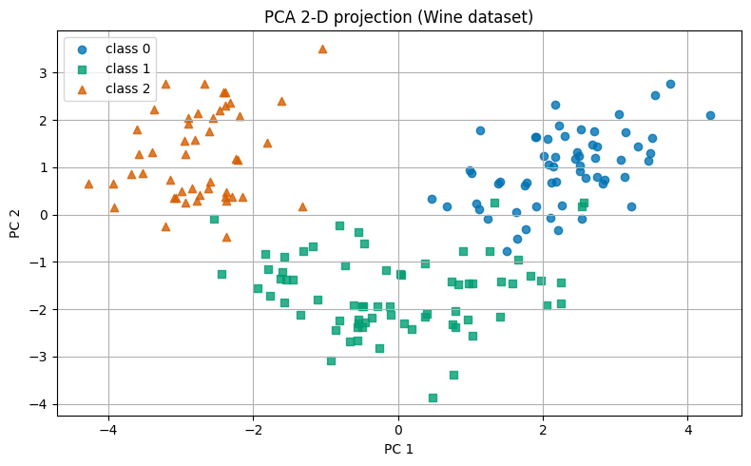
Figure 4: PCA 2‑D Projection for Comparison
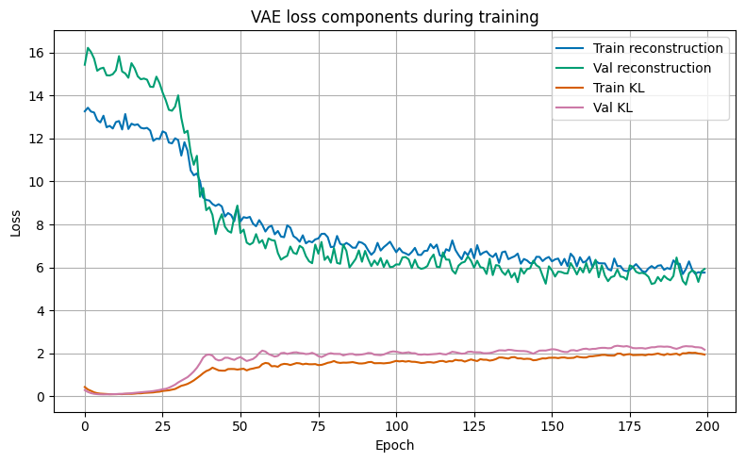
Figure 5: Reconstruction vs KL Divergence Loss Components
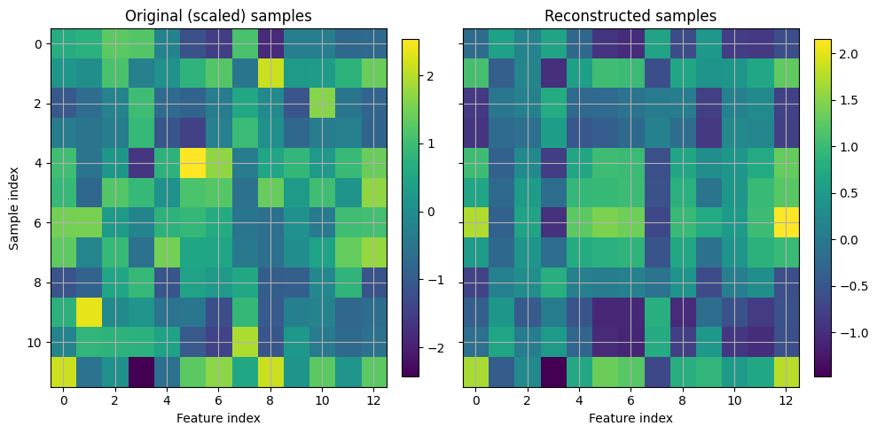
Figure 6: Original vs Reconstructed Samples
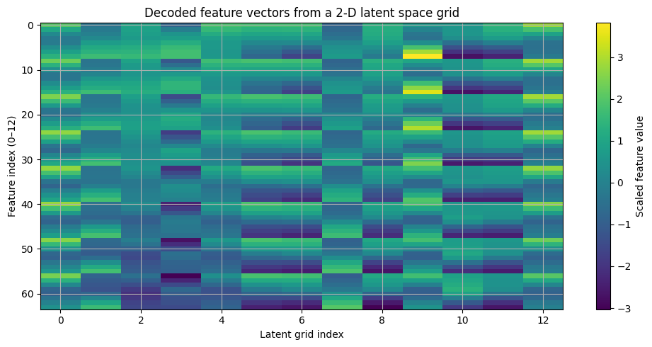
Figure 7: Latent Space Traversal Grid

Results
The VAE picked up a clear, structured latent space that separates the three wine types. The training and validation losses settled down nicely—no sign of overfitting. When we plot the latent space, the classes pull apart in a way that shows the VAE found meaningful patterns. Most reconstruction errors are small, but a few samples are trickier to nail down. When we compare with PCA, the VAE’s latent space catches more complex, nonlinear relationships, while PCA just finds straight lines. The breakdown of KL and reconstruction losses shows a steady balance between compressing the data and keeping the details. Moving around in the latent space gives smooth, logical changes in decoded features. That means the VAE’s learned manifold isn’t just well-structured—it’s also easy to interpret.

Discussion
These results show that VAEs do a great job at finding hidden structure in numerical data. Compared to PCA, a VAE is more flexible and gives you a neater, continuous latent space. Even with just two latent dimensions, the VAE holds onto the key patterns in the wine features. KL divergence regularization is essential—it stops the latent space from collapsing and keeps transitions between samples smooth and meaningful. The way decoded features change as you move through the latent space really brings this to life. All in all, the VAE is a strong tool for dimensionality reduction, data exploration, and generating new samples from structured datasets like this one.

Conclusion

This tutorial walked through the full process of using a VAE on the Wine dataset, from prepping the data to interpreting the results. Along the way, we saw how VAEs learn, how to track their progress, and how to judge what they’ve discovered. If you’re working with structured numerical data, VAEs open up a lot of possibilities for discovery and creativity. References
- Kingma, D.P. & Welling, M. (2014). Auto-Encoding Variational Bayes.
- Jolliffe, I.T. (2002). Principal Component Analysis.
- Goodfellow, I., Bengio, Y., & Courville, A. (2016). Deep Learning.

