IWS Enrollment Interfaces

Test Plan

Version 3.0

Revision History

|  |  |  |  |
| --- | --- | --- | --- |
| **Date** | **Version** | **Description** | **Author** |
| 6/15/2013 | 1.0 | Initial Test Plan Proposal | Shri Amin |
| 7/01/2013 | 2.0 | Update plan to include readiness for Morneau Shepell testing/ Sprint 7 tasks | Shri Amin |
| 7/16/2013 | 3.0 | Include update to approach and test schedule at Enrollment Upsert Sprint 7 | Shri Amin  Dave Smolensky |
|  |  |  |  |

Table of Contents

1 Introduction

1.1 Purpose

1.2 Scope

1.3 Intended Audience

1.4 Document Terminology and Acronyms

1.5 References

2 Test Approach

2.1.2 Functional Tests

2.1.3 Non-Functional Tests

3 External Dependencies

4 Target Test Items

4.1 New Test Cases

4.2 Regression Test Cases

5 Deliverables

6 Test Data

6.1.1 Test Data Requirements

6.2.2 Data Conversion Requirements

7 Entry and Exit Criteria

7.1.1 Testing Entry Criteria

7.1.2 Testing Exit Criteria

8 Responsibilities, Staffing, and Training Needs

8.1.1 People and Roles

8.2.2 Staffing and Training Needs

9 Iteration Test Plan

9.1.1 Test Schedule

9.1.2 Milestones

9.1.3 Risks

9.1.4 Assumptions

# 

# 1 Introduction

## *1.1 Purpose*

The purpose of the Test Plan is to:

* Identify which types of tests and when they will be conducted for this workstream; as well as to justify those that are not being conducted.
* Identify the items that must be targeted by the tests.
* List the deliverable elements of the test project.
* Identify the required resources and provide an estimate of the test efforts.

## *1.2 Scope*

This Test Plan addresses the testing needs of On Exchange and Off Exchange IWS Enrollment Interfaces.

## *1.3 Intended Audience*

The audience for the Test Plan is:

* Project Team
* DevOps/System Administrators
* SalesForce Development Team
* Morneau Shepell Integration Team

## *1.4 Document Terminology and Acronyms*

|  |  |
| --- | --- |
| **Acronym/Term** | **Definition** |
| MS | *Morneau Shepell* |
| SF | *SalesForce* |
| IWS | *Independent Worker Services* |
| VI | *Vendor Integration* |

## 

## *1.5 References*

This subsection provides a list of the documents referenced elsewhere within this document.

|  |  |
| --- | --- |
| **Document** | **Version** |
| [Enrollment Recon Use Case](https://drive.google.com/a/freelancersunion.org/?tab=mo#folders/0B5ppxcQQqnwOQVZpMGZlYXE3UkU) | *V1.1* |
| [Enrollment real-time upsert use case](https://drive.google.com/a/freelancersunion.org/?tab=mo#folders/0B5ppxcQQqnwOQVZpMGZlYXE3UkU) | *V1.4.2* |
| [Group real-time upsert use case](https://drive.google.com/a/freelancersunion.org/?tab=mo#folders/0B5ppxcQQqnwOQVZpMGZlYXE3UkU) | *V1.3* |
| [Enrollment Service Design Document](https://drive.google.com/a/freelancersunion.org/?tab=mo#folders/0Byjl8YPG5ltzNXlkaWc4SVJDTnM) | *V0.0* |
| [Enrollment Test Cases and Data](https://docs.google.com/a/freelancersunion.org/spreadsheet/ccc?key=0Al5OTCqqn5ZPdGRpNXZ2QTRSTVMxMXNOUmowS09DMVE#gid=0) | *V1.2* |
| [Enrollment Transaction Cases](https://drive.google.com/a/freelancersunion.org/?tab=mo#folders/0B5ppxcQQqnwOeG9tM0x2X1R1Z1U) | *V1 /V2* |
| [Test Matrix for Enrollment Fields](https://docs.google.com/a/freelancersunion.org/spreadsheet/ccc?key=0Asx6AQzfDKM4dF92V1BfM3pSQmZkcnVKZ0h3VUZuZVE#gid=0) | *V1* |

2 **Test Approach**

***2.1.1 Test Approach***

*This is our test approach for the IWS Enrollment WorkStream. The diagram below shows the various types of testing that needs to occur and the teams involved*

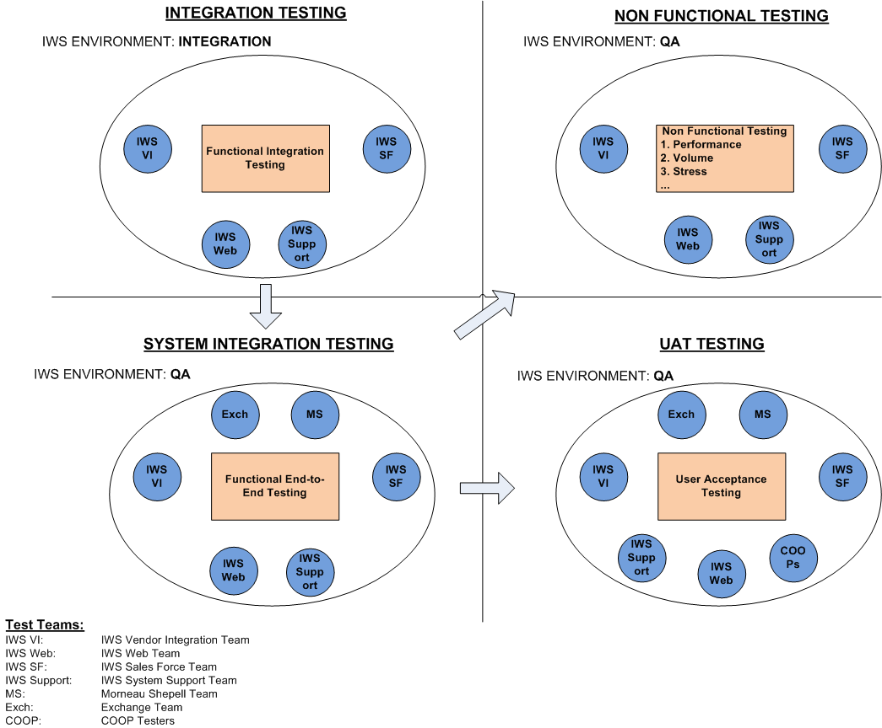

### 

### 

### **2.1.2 Functional Tests**

*The table below indicates which functional tests will be conducted during this iteration.*

|  |  |
| --- | --- |
| **Test** | **Inclusion / Exclusion** |
| **Unit Test** | Tests created by developers & run on local development environments |
| **Integration Test** | Functional system tests run on an integrated environment with other IWS development teams  Functional tests, regression tests, and smoke tests apply  See section 4.1 for a list of functional tests |
| **System Integration Test** | Cross-team functional tests, includes testing with Morneau Shepell & Exchange systems  End-to-end tests, regression tests, and smoke tests apply  Basic connectivity between IWS and Morneau Shepell is a type of smoke test  See section 4.1 and 4.2 for a list of functional and regression tests |
| **User Acceptance Test** | Verfies that the overall system is working for all users, includes testing with COOP  User acceptance takes the place of functional testing. Smoke tests are effective  See section 4.1 and 4.2 for a list of functional and regression tests |

### 

### **2.1.3 Non-Functional Tests**

*The table below indicates which non-functional tests will be conducted during this iteration.*

|  |  |
| --- | --- |
| **Non Functional Test** | **Description** |
| **Security Tests** | See section 4.1 for the list of non-functional security tests |
| **Performance Tests** |  |
| Application Performance Test | This type of test will be automated.  Performance can be measured various ways:  1. SOAP response time  2. Time to upsert enrollment data to various endpoints  SQS performance can be inferred |
| Volume//Load Test | Automated tests  See section 4.1 for the list of non-functional performance/volume tests |
| **Supportability Tests** |  |
| Compatibility Test | Not an issue from client-side unless we change schema – if we change schema Morneau Shepell must be given a new WSDL |
| Installation Test | NA |
| User Configuration | Support Morneau Shepell during the integration effort |
| **Conversion Tests** | NA |

***2.1.4 Test Environment***

|  |  |  |
| --- | --- | --- |
| **Environment** | **Service Endpoint** | **Test** |
| IWS Development | localhost | Unit testing |
| IWS Integration | http://esb1-integration.fuwt.net/enrollment  http://esb2-integration.fuwt.net/enrollment | Integration testing |
| IWS QA | http://esb1-qa.fuwt.net/enrollment | System Integration User Acceptance Non-functional testing |
| IWS Prod/Pre-prod | TBD | Smoke test |

# 3 External Dependencies

The planned testing has dependencies on the following external system:

* Morneau Shapell - Sender of real-time enrollment data for on and off exchange Enrollment Upserts
* Exchange - Initiates the flow of on-exchange enrollment data sent by Morneau Shepell
* SaleForce DB – Downstream IWS Enrollment Upsert service endpoint. SF staging area receives a copy of the enrollment data prior to upload to SF contact db

|  |  |  |
| --- | --- | --- |
| **Test Type** | **System** | **Dependencies** |
| *[E.g.: Unit, Performance, Usability, etc.]* | *[Name of the external system]* | *[Describe the dependencies.].* |
| Integration Test | IWS->SF Upsert | SalesForce staging and post-staging areas (NY, NJ, OR) |
| System Integration Test | Morneau Shepell -> IWS Enrollment Service | Morneau Shepell is sending the real-time enrollment data using a pre-determined SOAP message format |
| UAT | Exchange -> Morneau Shepell -> IWS Enrollment Service  COOP -> Morneu Shepell -> IWS Enrollment Service | Users on the Exchange and COOPs initiate the enrollment process. Morneau Shepell sends real-time enrollment data to IWS Enrollment service |

# 

# 4 Target Test Items

## *4.1 New Test Cases*

*The table below identifies those test requirements that have been identified as targets for testing for this iteration.*

|  |  |  |
| --- | --- | --- |
| **Test Case** | **Use Case ID** | **Test Type** |
| *[Name of test case, as identified in the Test Case Script -* [*Enrollment_Test_Cases_sprint7*](https://docs.google.com/a/freelancersunion.org/spreadsheet/ccc?key=0Al5OTCqqn5ZPdGRpNXZ2QTRSTVMxMXNOUmowS09DMVE#gid=0)*]* | *[As indicated in the Use Case Doc. -* [*Enrollment Real-time Upsert UseCase v1.4.2*](https://drive.google.com/a/freelancersunion.org/?tab=mo#folders/0B5ppxcQQqnwOQVZpMGZlYXE3UkU)*]* | *[E.g.: Unit, Performance, Usability, etc.]* |
| **Individual Enrollment** |  |  |
| single-subscriber upsert | Base Scenario 1,  Validation Scenario 6,  Main Flow | *Functional Tests* |
| single-subscriber + 1 dependent upsert | Base Scenario 2, 9  Validation Scenario 7, 30 | *Functional Tests* |
| single-subscriber + 2 dependent upsert | Base Scenario 2 | *Functional Tests* |
| single-subscriber + 3 dependent upsert | Base Scenario 2 | *Functional Tests* |
| subscriber + responsible person upsert | Base Scenario 3, 4  Validation Scenario 24 | *Functional Tests* |
| subscriber + 2 responsible person upsert | Validation Scenario 24 | *Functional Tests* |
| subscriber + responsible person + 1 dependent upsert | Base Scenario 5, 10 | *Functional Tests* |
| subscriber + responsible person + 2 dependent upsert | Base Scenario 5 | *Functional Tests* |
| update/add subscriber info (user-id, address, etc) | Validation Scenario 22 | *Functional Tests* |
| update/add responsible person info (user-id, address, etc) |  | *Functional Tests* |
| update/add dependent info (user-id, address, etc) |  | *Functional Tests* |
| terminate single-subscriber policy | Validation Scenario 25,27 | *Functional Tests* |
| terminate subscriber w/responsible policy |  | *Functional Tests* |
| terminate a subscriber + dependent policy | Validation Scenario 26 | *Functional Tests* |
| terminate subscriber address | Validation Scenario 23 | *Functional Tests* |
| terminate responsible person address | Validation Scenario 23 | *Functional Tests* |
| terminate dependent address | Validation Scenario 23 | *Functional Tests* |
| ODS tenant test (Individual) |  | *Functional Tests* |
| SF tenant test (Individual) |  | *Functional Tests* |
| audit test - TBD | Validation Scenario 28, 29 | *Functional Tests* |
|  |  |  |
| **New DB Record Tests (Individual)** |  |  |
| update subscriber-number | Validation Scenario 14 | *Functional Tests* |
| update subscriber_effective_date | Validation Scenario 14 | *Functional Tests* |
| update policy_number | Validation Scenario 14 | *Functional Tests* |
| update policy_effective_date | Validation Scenario 14 | *Functional Tests* |
|  |  |  |
| **Group Tests** |  |  |
| group upsert | Validation Scenario 8 | *Functional Tests* |
| terminate group | Validation Scenario 9 | *Functional Tests* |
| Single-subscriber w/group info | Base Scenario 6 | *Functional Tests* |
| Subscriber + 1 dependent w/group info | Base Scenario 7, 11 | *Functional Tests* |
| Subscriber + responsible person w/group info | Base Scenario 8 | *Functional Tests* |
| update group |  | *Functional Tests* |
| ODS tenant Test (Group Upsert) |  | *Functional Tests* |
| SF tenant Test (Group Upsert) |  | *Functional Tests* |
|  |  |  |
| **System Tests/Stress/Volume/Load & Performance/Security** |  |  |
| 5000 new single-subscriber upserts |  | *Non-functional Test* |
| update 5000 single-subscriber upserts |  | *Non-functional Test* |
| 5000 new family upserts |  | *Non-functional Test* |
| update 5000 family upserts |  | *Non-functional Test* |
| send 5000 new group upserts |  | *Non-functional Test* |
| update 5000 group upserts |  | *Non-functional Test* |
| Security Test - TBD |  | *Non-functional Test* |
|  |  |  |
| **Edge Cases** |  |  |
| Send minimal enrollment data |  | *Functional Tests* |
| Force schema validation failures |  | *Functional Tests* |
| ODS is offline |  | *Functional Tests* |
| SF staging is offline | Flow EF2 | *Functional Tests* |
| SF DB is offline | Flow EF3 | *Functional Tests* |
| SQS is offline | Flow EF3 | *Functional Tests* |
| change node sequence |  | *Functional Tests* |
| Repeat SOAP message elements |  | *Functional Tests* |
| Missing SOAP message elements |  | *Functional Tests* |
| remove non-terminated subscriber address |  | *Functional Tests* |
| remove non-terminated dependent |  | *Functional Tests* |
| remove non-terminated dependent address |  | *Functional Tests* |
| No subscriber upsert | Validation Scenario 1 | *Functional Tests* |
|  |  |  |
| **Schema Validation / Business Logic** |  |  |
| Date Field Test | Validation Scenario 15 | *Functional Tests* |
| underage subscriber w/o responsible person | Validation Scenario 3 | *Functional Tests* |
| underage subscriber w/ 1 dependent | Validation Scenario 4 | *Functional Tests* |
| Different dependent effective date | Validation Scenario 5 | *Functional Tests* |
|  |  |  |

## *4.2 Regression Test Cases*

## *These test cases must be executed during this iteration in order to verify that existing aspects of the system have not been adversely impacted by the deliverables of this iteration.*

|  |  |  |
| --- | --- | --- |
| **Test Case** | **Test Case ID** | **Test Type** |
| *Will be run on the integration environment*  *We don’t have any regression tests for Sprint 7* |  |  |
|  |  |  |
|  |  |  |

# 

# 

# 5 Deliverables

*The following deliverables will be updated and/or created during this iteration.*

*[Delete rows for any deliverables that are not required for this project. Modify text as required.]*

|  |  |  |
| --- | --- | --- |
| **Test** | **Created / Updated?** | **Owner** |
| **Test Strategy** | Complete | IWS Team |
| **Test Plan (for next iteration)** | Updated | IWS QA Team  Shri Amin |
| **Test Environment Configuration** | QA Environment - created  Integration Environment - created | IWS Team  Aaron Oboh |
| **Test Cases / Manual Test Scripts** | In progress | IWS QA Team  Shri Amin |
| **Automated Test Scripts** | In progress | IWS QA Team  Shri Amin |
| **Test Data** | In progress | IWS QA Team, Morneau Shepell |
| **Test Log/Results** | Mule Log snippet & xUnit results | IWS QA Team |
| **Test Evaluation Summary** | NA | IWS QA Team |
| **Defects** | Jira tickets | All stakeholders |
| **Change Requests** | Created as needed. | All stakeholders |
| **Change Request Log** | Created as needed. | Dave Smolensky |
|  |  |  |

# 6 Test Data

## *6.1.1 Test Data Requirements*

*The table below summarizes the data that is required for execution of testing during this iteration.*

*[These data needs should have been identified on a general basis in the Test Strategy document. This section identifies the specific needs, sources and owners of the data.]*

|  |  |  |
| --- | --- | --- |
| **Test Type** | **Data Source** | **Owner** |
| Integration Test | Data is created by the IWS QA Team | IWS QA Team |
| Non-functional Test | Data is created by IWS QA Team | IWS QA Team |
| System Integration Test | Morneau Shapell will provide the test data | Morneau Shepell |
| UAT | Morneau Shapell will provide the test data | Morneau Shepell |

## *6.2.2 Data Conversion Requirements*

*There are no data conversions from a testing perspective*

# 7 Entry and Exit Criteria

## *7.1.1 Testing Entry Criteria*

Testing for this iteration may begin when the following conditions are true:

* The necessary test environment has been properly established for the types of tests to be conducted during this iteration. Refer to the Test Environment Configuration document for further details about the environment.
* The necessary test data, as described in the “Test Data” section, has been generated and/or made available.
* The requirements correlating to the “Target Test Items” have been implemented.

## *7.1.2 Testing Exit Criteria*

This Test Plan will be considered complete when the following conditions are true:

* All of the identified test cases have been executed and the results recorded. The Test Evaluation Summary will indicate if and why any tests were not completed.
* Any critical feedback from Morneau Shepell is received and recorded.
* All defects have been recorded into JIRA.

# 8 Responsibilities, Staffing, and Training Needs

This section indicates how many and which resources are required to fulfill the testing roles, as described in the Test Strategy, for this iteration.

## *8.1.1 People and Roles*

*This table shows the staffing requirements for the test effort for this iteration.*

|  |  |  |
| --- | --- | --- |
| **Role** | **Minimum Resources Recommended**  **(# of full-time resources)** | **Resources** |
| Test Manager | 1 | Dave Smolensky |
| Test Analyst | 1 | Satish Indukuri |
| Test Designer | 2 | Shri Amin/ Vineela Juturu |
| Tester(s) | 2 | IWS Team: Shri Amin/ Vineela Juturu  MS Integration Team |
| Database Administrator, Database Manager | 1 | Nsikak Akpakpan/Janet Yerokhinia |

## *8.2.2 Staffing and Training Needs*

This section outlines how to approach staffing and training the test roles for this iteration.

*NA*

# 9 Iteration Test Plan

## 

## *9.1.1 Test Schedule*

*The following is the schedule for testing is is our test schedule for the IWS Enrollment WorkStream:*

|  |  |  |  |  |
| --- | --- | --- | --- | --- |
| **Test** | **Test Cycle/**  **Iteration** | **Team** | **Start** | **End** |
| Integration | 1 | IWS VI | 4/30 | 5/14 |
| Integration | 2 | IWS VI | 5/15 | 6/3 |
| Integration | 3 | IWS VI | 6/3 | 7/1 |
| Integration | 4 | IWS VI | 7/8 | 7/22 |
| Integration | 5 | IWS VI, IWS SF | 7/22 | 8/10 |
| System Integration Test – Enrollment Upsert | 1 (Oregon) | IWS VI, MS | 7/18 | 8/1 |
| System Integration Test | 2 (NY) | IWS VI, MS, IWS SF | TBD | TBD |
| System Integration Test | 3 (NJ) | IWS VI, MS, IWS SF | TBD | TBD |
| Non Functional Test |  | IWS VI | 8/15 | 8/22 |
| UAT |  |  | TBD | TBD |

## *9.1.2 Milestones*

The project plan for this iteration must consider the following milestones:

* MS Oregon Testing begins July 18, 2013
* Batch & Recon Development Complete – 8/22
* Open Health Exchange – 10/1

## *9.1.3 Risks*

Test-related risks are tracked in the project Risk List. Additional project risks for this iteration are as follows:

* Scope of the testing effort is not understood
* Changing system requirements or priorities
* Testing environment is unsatisfactory for cross-team testing
* Insufficient resources

## *9.1.4 Assumptions*

|  |  |  |
| --- | --- | --- |
| **Assumption** | **Impact of assumption being incorrect** | **Owner** |
| Test data is shared from Morneau Shepell to IWS | IWS Team needs to generate test data | Shri Amin |
| All operational code exists on the integration & qa environments (code patches, etc) | MS and QA testing is less effective | Tech team/ Devs/QA |
| SF integration is completed | The system is not fully functional / SF testing is minimal | Dave Smolensky |
| No new architectural changes (schema changes, etc) | possible change to project scope | Michael Chernyak |