We have all read and watched the required material

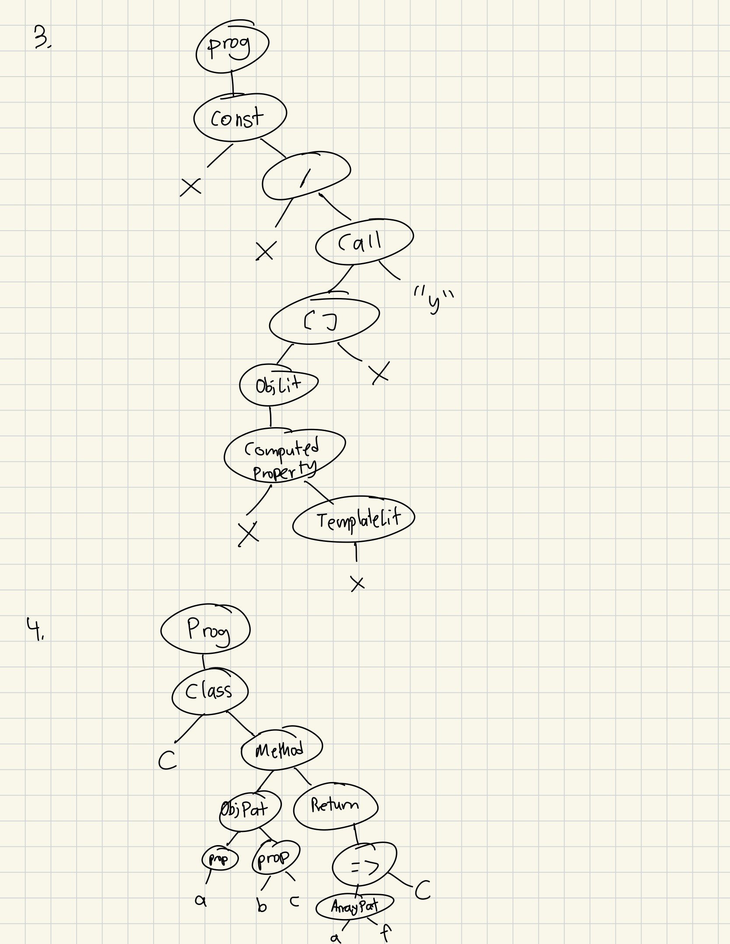

5. a.

Exp = Exp "+" Term | Exp "-" Term | Term

Term = Term "*" Factor | Term "/" Factor | Term "%" Factor | Factor

Factor = Primary "**" Factor | Primary

Primary = "-" Primary | num | id | " (" Exp ")"

b.

Exp = "-"? (Exp "+" Term | Exp "-" Term | Term)

Term = Term "*" Factor | Term "/" Factor | Term "%" Factor | Factor

Factor = Primary "**" Factor | Primary

Primary = num | id | " (" Exp ")"

c.

Exp = Exp "+" Term | Exp "-" Term | Term

Term = Term "*" Factor | Term "/" Factor | Term "%" Factor | Factor

Factor = Primary "**" Factor | "-"? Primary

Primary = num | id | " (" Exp ")"

6.

Astro_plus {

Program = StmtNoBreak+

StmtNoBreak = id "=" Exp ";" --assign

| "print" Exp ";" --print

| IfStmtNoBreak

| WhileStmt

Stmt = id "=" Exp ";" --assign

| "print" Exp ";" --print

| IfStmt

| WhileStmt

| BreakStmt

BreakStmt = break ";" --break

WhileStmt = while Exp Block

IfStmtNoBreak = if Exp BlockNoBreak else (BlockNoBreak)?

| if Exp BlockNoBreak else IfStmtNoBreak

IfStmt = if Exp Block else (Block)?

| if Exp Block else IfStmt

BlockNoBreak = "{" StmtNoBreak* "}"

Block = "{" Stmt* "}"

Exp = Condition ("<=" | "<" | "==" | "!=" | ">" | "=>") Condition --binary

| Condition

Condition = Condition ("+" | "-") Term --add

| Term

Term = Term ("*" | "/" | "%") Factor --binary

| Factor

Factor = Primary "**" Factor --power

| "-" Primary --negate

| Primary

Primary = id

| numeral

| "(" Exp ")" --parens

numeral = digit+ ("." digit+)? (("E"|"e") ("+"|"-")? digit+)?

idchar = letter | digit | "_"

print = "print" ~idchar

while = "while" ~idchar

if = "f" ~idchar

else = "else" ~idchar

break = "break" ~idchar

keyword = print | while | if | else | break

id = ~keyword letter idchar*

comment= "//" (~"\n" any)* --line

| "/*" (~"*/" any)* "*/" --bracketed

space += comment

}