
Advanced OOP in Java
Computer Science

Faculty for Computer Science and Engineering
Frankfurt University of Applied Sciences

Submitted at
23.11.2025

Supervisor: Prof. Ghadi Mahmoudi, Frankfurt University of Applied Sciences
Real-Time Traffic Simulation in SUMO with Java
submitted by Group 4
Lars Michael Keppler, Samuel Justin Bons, Ali Ajib, Abel Solyom

Einsatz eines Flux-Kompensators für Zeitreisen mit einer maximalen Höchstgeschwindigkeit von WARP 7
Vorgelegt von
Max Mustermann

Declaration of Authorship
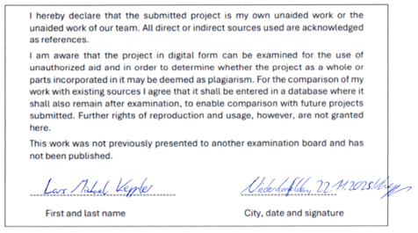
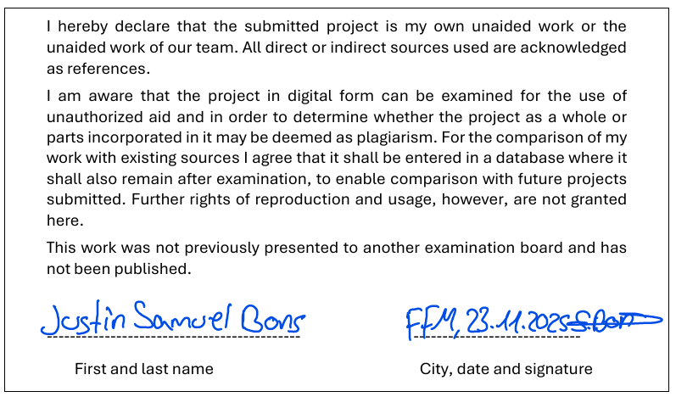

Content
Content iii
1 Introduction 1
2 Current state of the project 3
3 Program structure 3
3.1 Classes 3
3.2 UML Diagram 5
4 Goals and timetable 3

Appendix iv

Introduction
The following is the documentation for our project in advanced object orientation using Java as of 27th November 2025.

Current state of the project
So far, we have reached the following milestones:
- GUI Mockup
- Running connection to SUMO
- TraaS Wrapper
- Statistics foundation
- UML Diagram
- Design ideas
- Documentation

Program structure

Classes
These are our current classes. For information, see Javadoc.
- Launcher
- Main
- Connection
- TraciConnect
- MapSumoConfig
- GUI
- myVehicle
- VehicleManagement
- Statistik

UML Diagram
We’ve decided to follow a MVC design pattern:
- Model class (M)
- View class (V)
- Controller class (C)
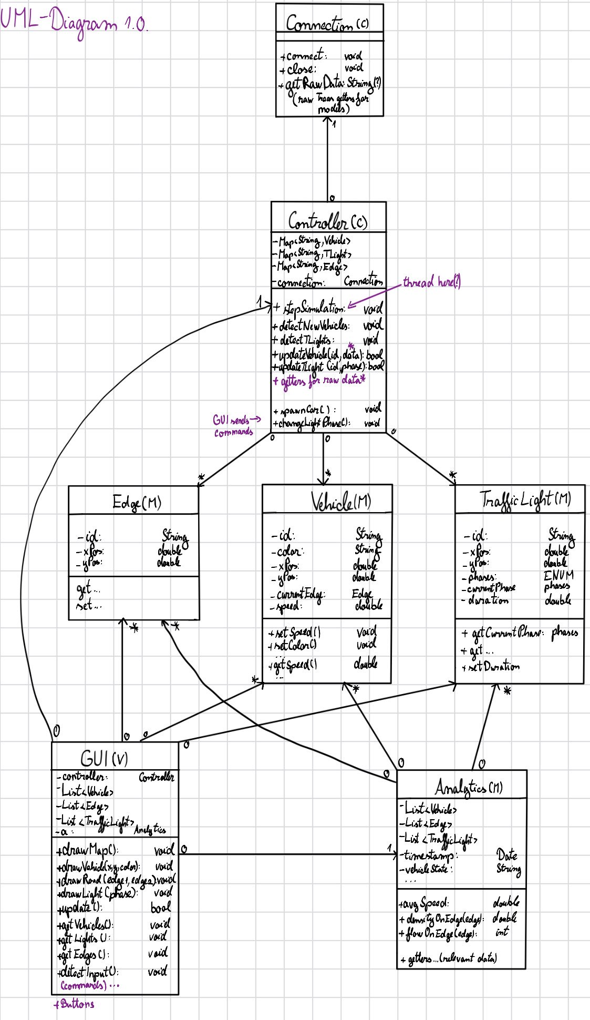
Figure 3.2: The current UML diagram for our project

Goals and timetable
The team is working iteratively and keeping track of milestones within a shared Excel Spreadsheet.

Future goals include:
- GUI Integration
- Further statistics functionality
- Clean Code

The team sees a lot of complications with the live GUI integration.

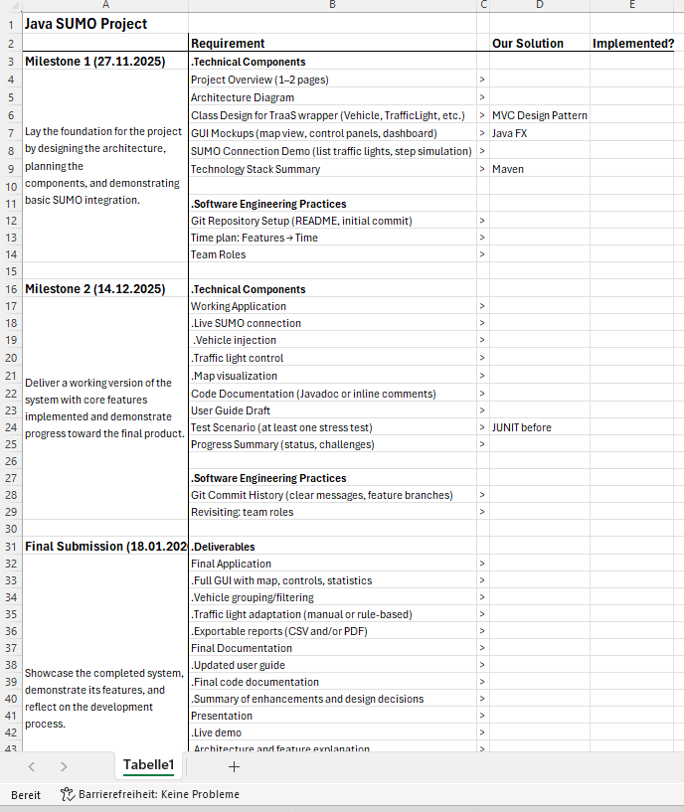
Figure 4.1: Team’s internal milestone documentation

Appendix

