1. Develop a project planning for a Tetris Gaming App for AR glasses. Draw a Gantt
chart with project activities and dependencies. Plan timings and milestones.
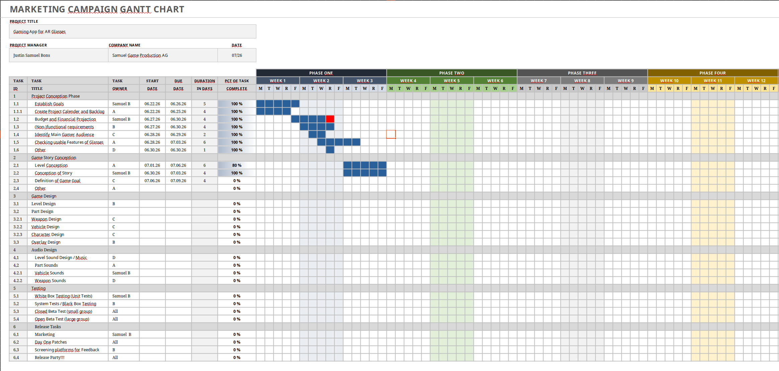
Used Template given in Lecture: https://www.smartsheet.com/content/gantt-chart-examples

Milestone 1: Finishing Project Planning,
Milestone 2: Basic Game Conception finished
Milestone 3: Game Design finished
Milestone 4: Open Beta Test Phase finished
Milestone 5: Release

Dependent

2. Estimate the costs of this project and explain your rationale. For which price
would you sell your software for? Explain why.

+ 648.000€ - Team salary per year (6000€ Brutto – 9Team Members)
(Average is 56.800€ in Germany (https://germantechjobs.de/en/salaries/GameDev/all/all))
+ 100.000€ - My salary per year
+ 32.000€ - Software Licenses
+ 23.000€ - Office Supplies
+ 15.000€ - Team Learning Projects
+ 10.000€ - Other costs
--------
~ 828.000€

→ Depending on the expected revenue of the Game I would sell it for roughly 2Mio.-3Mio.€ - this would cover all costs of the development and finance a new project in the same and even bigger size. This is also because the AR Glasses market for Games is probably relatively small and much revenue over a longer period of time is therefor not expected.

3. How would you staff the project to achieve the minimal time to market?
I would build a team off around 10persons – if the staff has some capabilities already in the segment of Game Design, this should be enough for a small Game (which I think of here) and would also significantly drop the cost of the project and the overhead of managing a big team. I would try to bring all team members into all segments of the development process to counter the effects of Conways law and to have a good and harmonic environment.

4. Which software development process would you use? Explain why.
We follow the Scrum Process with defining a Project Backlog and fulfilling the project tasks in individual sprints and evaluating these sprints. This enables us to constantly revisit the state of the Game and check if we are still meeting the deadline / to alter the upcoming tasks in such a way, that we can be ready at the deadline. Especially in the light of an AR Glasses software I think this is perfectly fitting, due the fact, that this is a relatively new technology, where the performance and the working between software and hardware have to be checked regularly.

5. Your project is already over time and over budget. Describe 5 options to finish the
project?
1) Cutting non-functional requirements, which are not critical for the system and can be delivered afterwards
2) Focusing manpower on main functionalities to get system to a running delivery state
3) Using Incremental Releasing instead of Big Band Releasing → More features after time
4) Working sequential tasks in parallel
5) Ask for more funding lol

