1. Explain how the number of defects remaining in your software at delivery affects
the product support. Draw a chart illustrating the correlation.
The number of defects and the affects on the product support are strongly correlated. If at delivery state 10% of the software has deffects, this will also produce an enormous number of support requests and overhead for the development team as its focus is on resolving these issues.

2. Give 5 arguments for and against developers testing their own programmes.
FOR:
- No „getting familiar“ period with the code → dev. Can directly start screening
- Unwanted outcomes can be fixed faster, as the dev. Knows the behaviour of the Code the best
- Dev. Can program more dynamically → code a fragment, test it and code further, without have to wait for a test
- Ownership and Accoutability is strengthend

AGAINST:
- Dev. Might be biased and test the code not sufficently
- There might be problems, which need outside perspective, since the dev. Has not encoutered them before
- Dev. May play down the severity of faulty outcomes
- Knowledge transfer is blocked → for the dev. Who would have gotten new perspective and for the audit devs. For getting to know the code of the team members.
- Testing may get skipped if deadline is already over and dev. Is stressed

3. Create equivalence classes for testing the software from Exercise 6. Generate
corresponding test cases. Implement them as unit tests.

4. What is regression testing?
Regression testing: Testing features of the software, which already got verified in the past if they still performs as expected in the software after a change → e.g. after a bug fix or a software enhancement

5. Draw an illustration of the term black box testing and white box testing and
describe the difference.
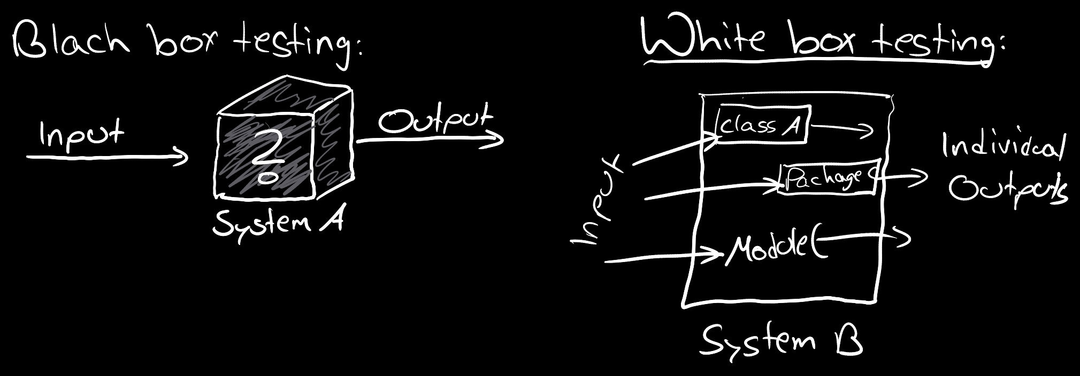
BlackBox Testing: The whole system is tested, without looking (or even knowing of) the different system parts. It is checked, if a system does in its completness the wanted Output, in Comparison to check the individual parts of the system

WhiteBox Testing: Is the twin brother of BlackBox Testing, but in this Testing Strategy, we know and check all subparts of a system and check the individual outputs of these subsystems. If they all bring the desired output, the whole system should bring also the dedicated Output.

