3. How would you redesign you application using the mentioned cloud services.
Draw a re-iterated cloud architecture for your application.

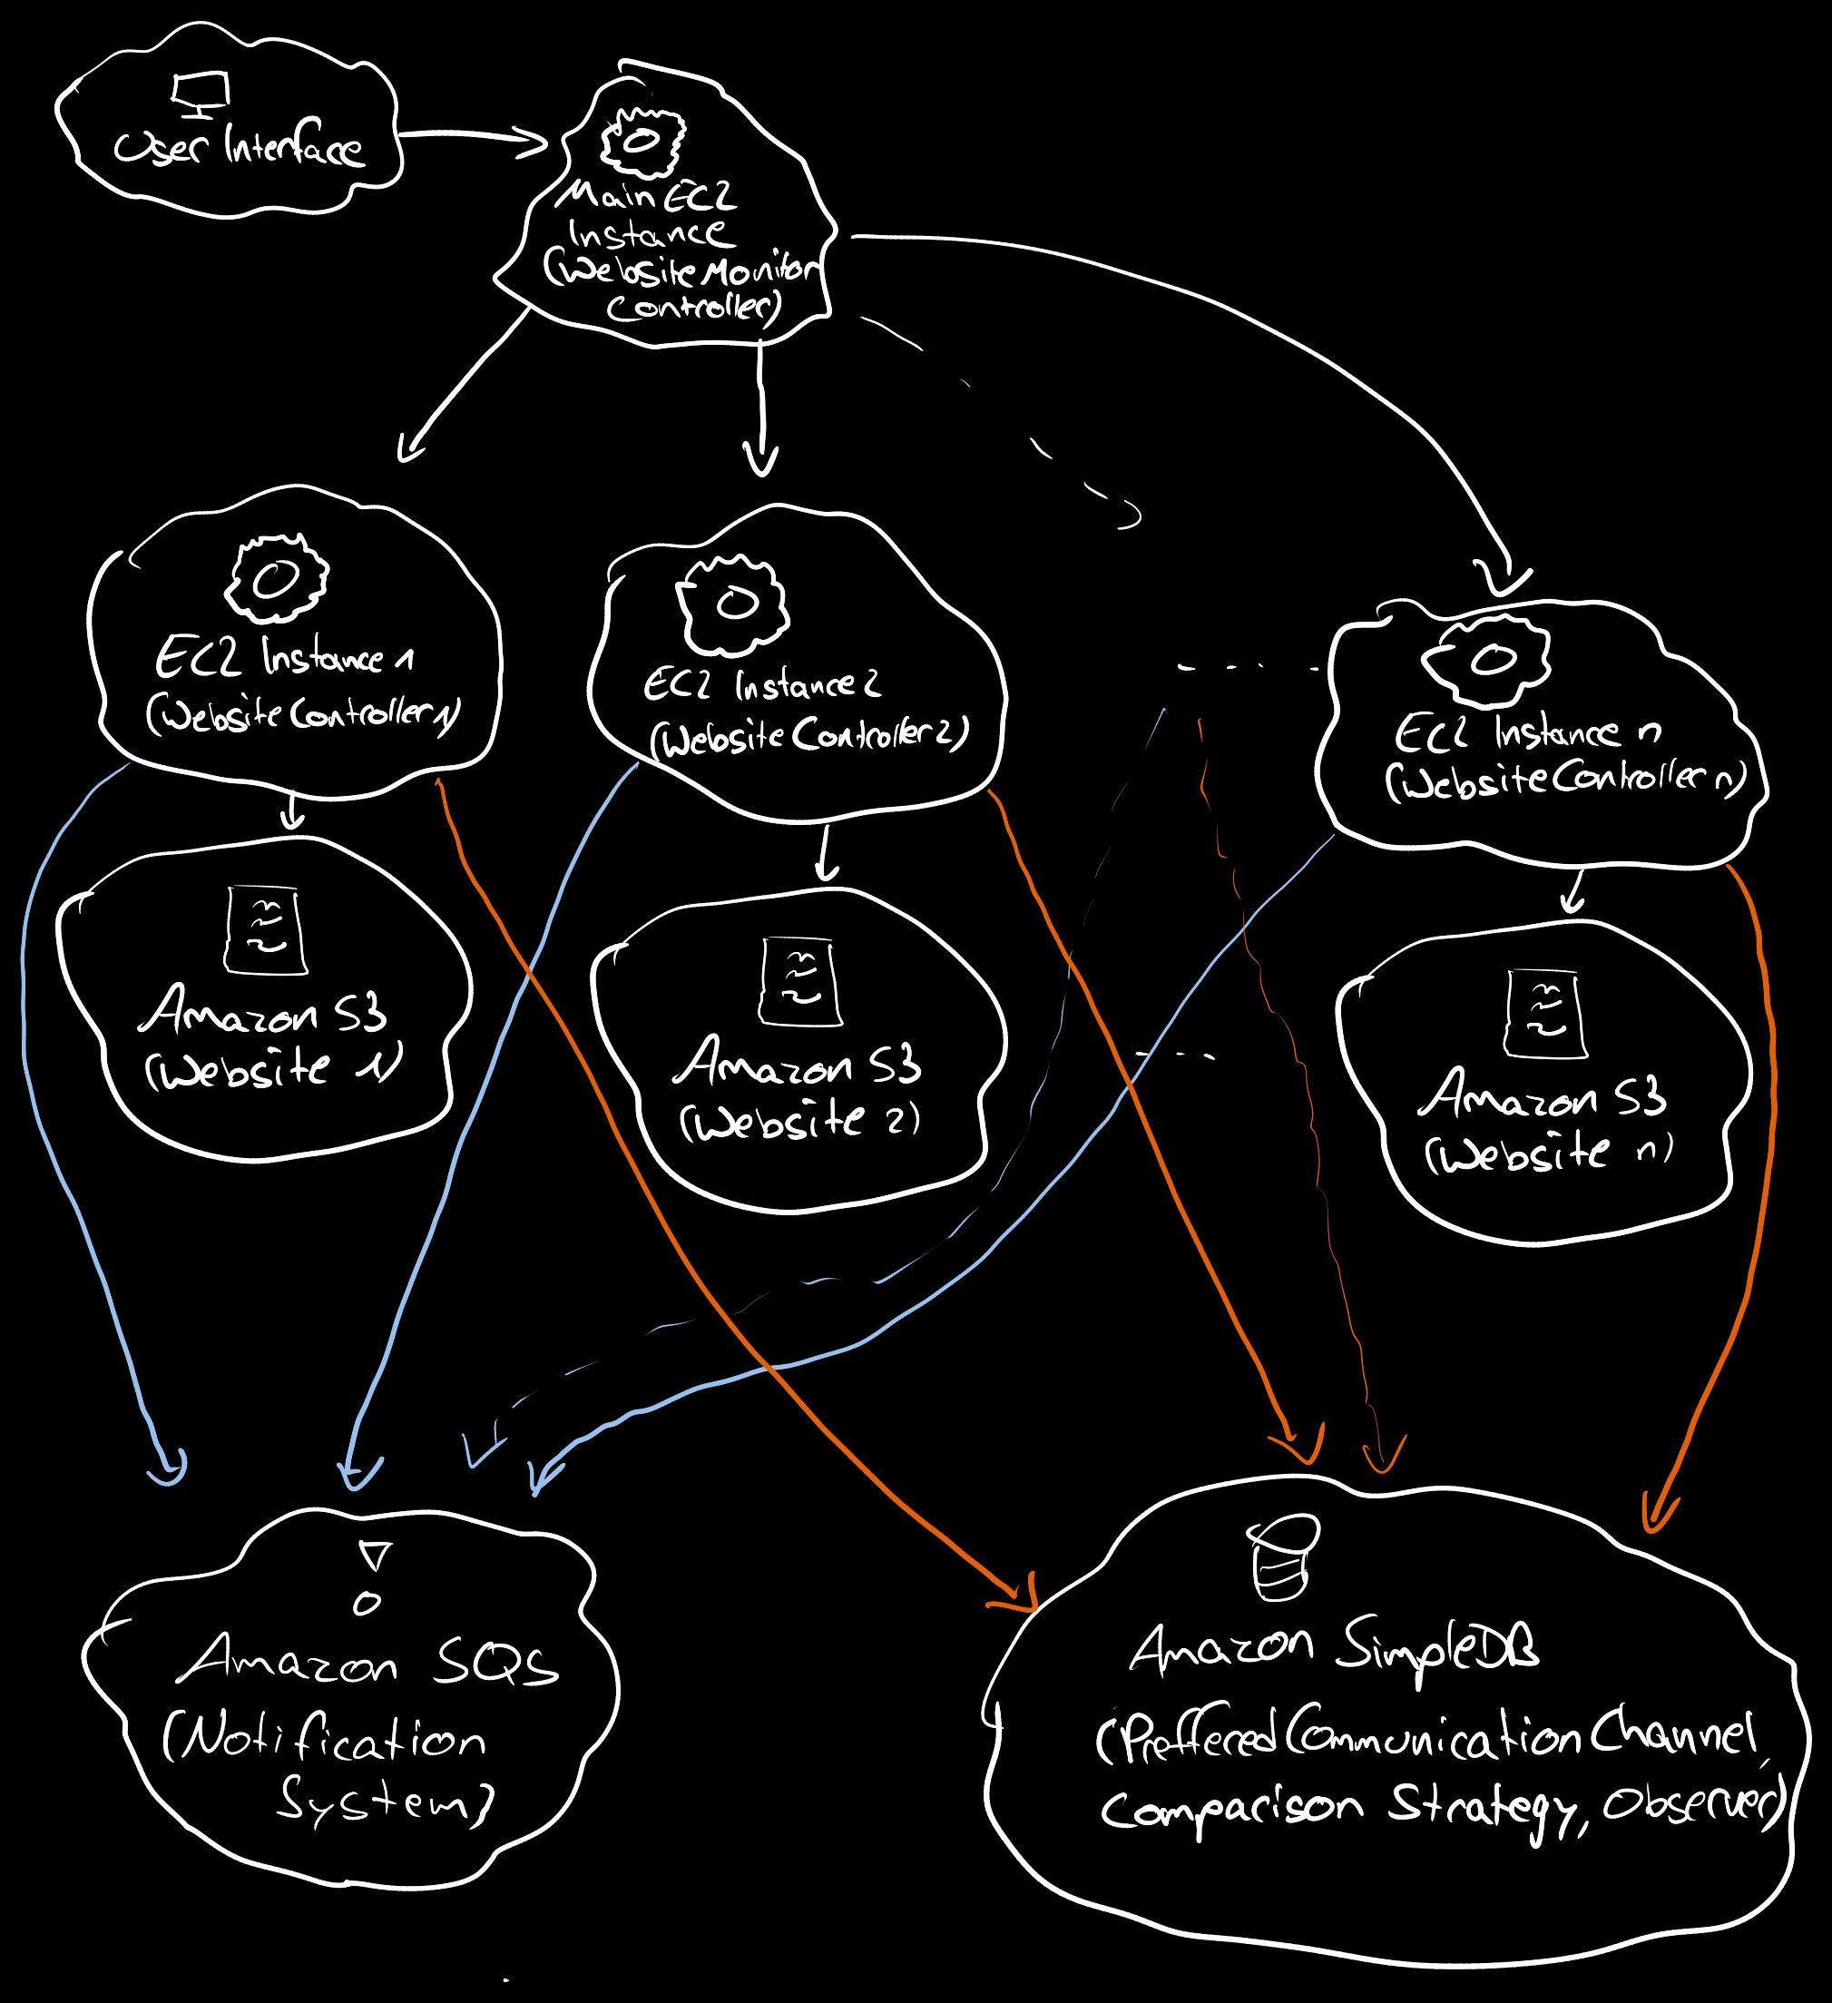
4. Identify a specific programming task that an AI-assisted coding tool fails to solve
correctly. Document the original query and the suggested solution. Provide an
explanation of why the solution is incorrect.

I stumbled upon a quite easy task, in which AI still frequently fails.
Prompt: „Write a simple Python loop to remove all even numbers from the list [1, 2, 2, 3, 4].“

Suggested Code:
numbers = [1, 2, 2, 3, 4]
for num in numbers:
if num % 2 == 0:
numbers.remove(num)
print(numbers)

Why this is false: The generated code will fail, bacause it treats the list as static while iterating, but Python uses an index counter, that increments by 1 on every single turn of the loop. When you remove an element, the entire list shifts to the left, but the loop counter moves forward anyway. This causes the loop to skip elements → Output will be [1,2,3]

→ I tested it with the free Plan Version of ChatGPT (OpenAI). The first time it got it right and even explicitly mentioned the problem of the code above, but already after the first try in a second prompt, it made the wrong code, which is interesting for such an easy problem.

