Task 3: Docker Container for Website Monitor:
Dockerfile:
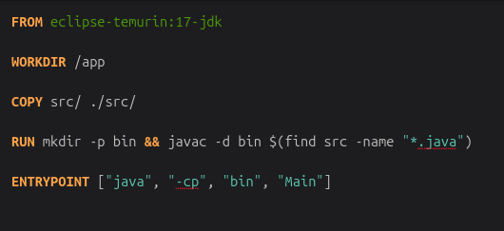

Docker Build and Output of Website-Monitor:
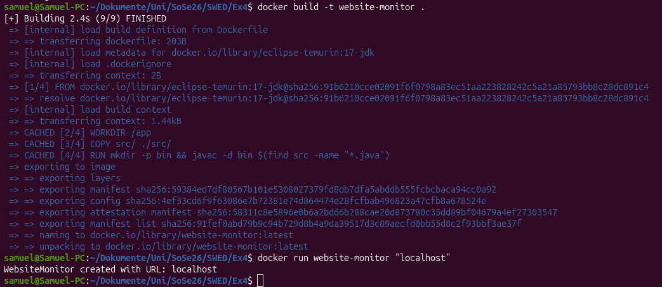

Task 6: Exam Question:
Exam Question:
"a) Explain the core purpose of the Factory Method Pattern. Create a UML class diagram illustrating its structure and analyze how implementing this pattern affects the overall project architecture.
b) Compare the Factory Method Pattern with the Abstract Factory Pattern. Clearly state the structural and conceptual differences between them."
Mail to Prof. Lokaiczyk:
