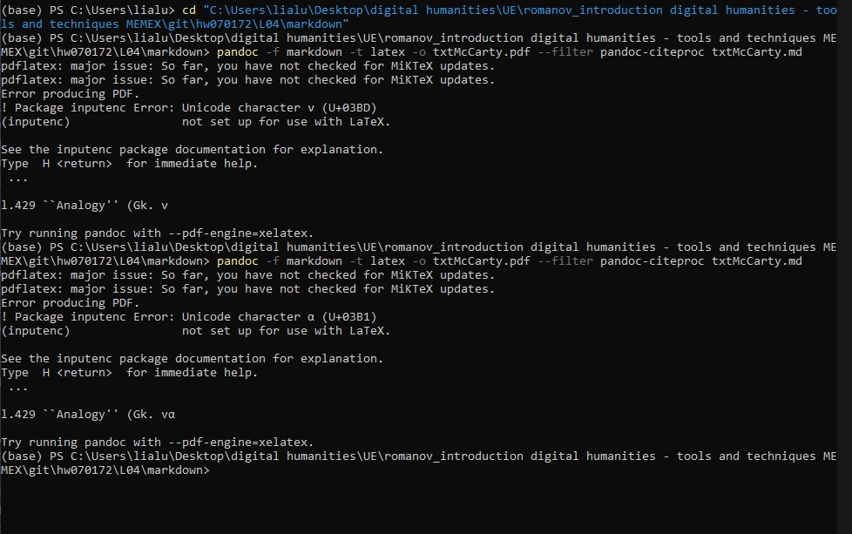

Pandoc has problems with Greek letters (vαλoγα) while converting to PDFs  
Line 90: A diagram (Gk. διγραμμα,

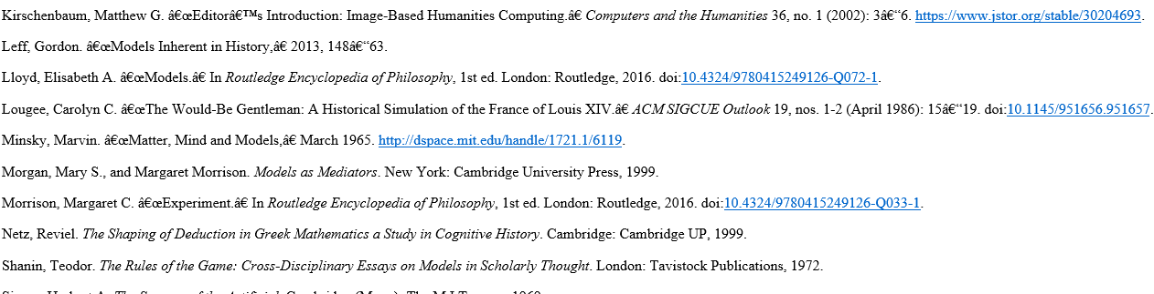

Special characters in html file.