OutFile "REG_MULTI_SZ_writer.exe"
Name "REG_MULTI_SZ"

!define HKEY_LOCAL_MACHINE 0x80000002
!define KEY_ALL_ACCESS 0xF003F
!define REG_OPTION_VOLATILE 0x00000001L
!define GENERIC_WRITE 0x20006

!define RegCreateKey "Advapi32::RegCreateKeyA(i, t, i) i"
!define RegCreateKeyEx "Advapi32::RegCreateKeyExA(i, t, i, i, i, i, i, i, i) i"

####### Edit this!
!define SUB_KEY "SOFTWARE\SuperRed\Products\AuditClient\InstallSate"
####### Stop editing

Section "Write"
System::Call "*(i) i (0) .r0"
; System::Call "${RegCreateKey}(${HKEY_LOCAL_MACHINE},'${SUB_KEY}',r0) .r3"
System::Call "${RegCreateKeyEx}(${HKEY_LOCAL_MACHINE},'${SUB_KEY}',0,0,1,${KEY_ALL_ACCESS},0, r0,0) .r3"
;RegCreateKeyEx(HKEY_LOCAL_MACHINE, xPath, 0, NULL, REG_OPTION_VOLATILE, KEY_ALL_ACCESS, NULL, &hKey, NULL);

SectionEnd

附件1
NSIS调用win32 API（）
网址：http://blog.csdn.net/china_jeffery/article/details/78917306
（也可以是其他dll提供的导出接口）需要通过System::Call来调用，调用语法如下：
System::Call PROC [( PARAMS ) [RETURN [? OPTIONS]]]
- 1
每个参数由三个值组合而成: 类型、源、目标。注意是每个参数都是由三个值组合而成。
类型：可以是一个整数，一个字串，等等。
源： 就是参数值的源，可以是一个 NSIS 变量(0、1、$INSTDIR)，NSIS 堆栈，一个具体的值(5、”test”，等等)或空(NULL)。
目标： 就是调用返回后的参数值，可以是 NSIS 变量，NSIS 堆栈或空(意味着该输出不需要)。如果不需要源或目标的话可以用一个句点表示(.)。
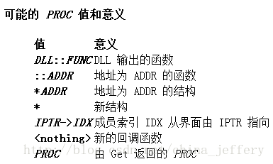
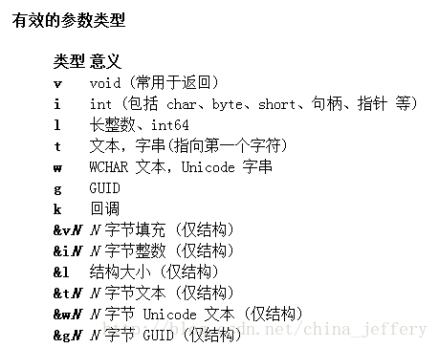
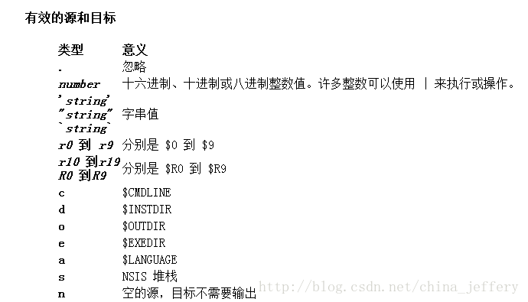
详细介绍可以参考官方文档:
http://nsis.sourceforge.net/Docs/System/System.html

● 实例
- 调用win32 API： int AddFontResource(LPCTSTR lpszFilename);
System::Call "GDI32::AddFontResource(t'$FONTS\${fontFilename}') i.r0"
# 返回值保存在$0

或者
System::Call "GDI32::AddFontResource(t'$FONTS\${fontFilename}') i.s"
Pop $R9
# 将返回值保存在NSIS堆栈中，使用Pop弹出到指定变量
- 1
- 2
- 3
- 4
- 5
- 6
- 7
- 调用win32 API：BOOL WINAPI GetWindowRect(HWND hWnd, LPRECT lpRect);
# 使用*来声明一个新的结构，和RECT一样4个成员都是int
# 常用结构已经在"${NSISDIR}\Examples\System\System.nsh"声明
System::Call "*(i0,i0,i0,i0) i.r1"
System::Call "User32::GetWindowRect(i$HWNDPARENT, i$1)"
System::Call "*$1(i.r4,i.r5,i.r6,i.r7)"

附件2
写入REG_MULTI_SZ字符串的函数
https://nsis-dev.github.io/NSIS-Forums/html/t-172312.html

OutFile "REG_MULTI_SZ_writer.exe"
Name "REG_MULTI_SZ"
ShowInstDetails show
!define HKEY_CLASSES_ROOT 0x80000000
!define HKEY_CURRENT_USER 0x80000001
!define HKEY_LOCAL_MACHINE 0x80000002
!define HKEY_USERS 0x80000003
!define HKEY_PERFORMANCE_DATA 0x80000004
!define HKEY_PERFORMANCE_TEXT 0x80000050
!define HKEY_PERFORMANCE_NLSTEXT 0x80000060
!define HKEY_CURRENT_CONFIG 0x80000005
!define HKEY_DYN_DATA 0x80000006
!define KEY_QUERY_VALUE 0x0001
!define KEY_SET_VALUE 0x0002
!define KEY_CREATE_SUB_KEY 0x0004
!define KEY_ENUMERATE_SUB_KEYS 0x0008
!define KEY_NOTIFY 0x0010
!define KEY_CREATE_LINK 0x0020
!define REG_NONE 0
!define REG_SZ 1
!define REG_EXPAND_SZ 2
!define REG_BINARY 3
!define REG_DWORD 4
!define REG_DWORD_LITTLE_ENDIAN 4
!define REG_DWORD_BIG_ENDIAN 5
!define REG_LINK 6
!define REG_MULTI_SZ 7
!define RegCreateKeyEx "Advapi32::RegCreateKeyA(i, t, i) i"
!define RegSetValueEx "Advapi32::RegSetValueExA(i, t, i, i, t, i) i"
!define RegCloseKey "Advapi32::RegCloseKeyA(i) i"
####### Edit this!
!define SUB_KEY "SYSTEM\CurrentControlSet\Services\Apache2(SSL)\Parameters"
!define VALUE "ConfigArgs"
!define DATA "-f c:\apache2\conf\httpd.conf"
####### Stop editing
Section "Write"
StrCpy $0 ""
StrCpy $1 ""
StrCpy $2 ""
StrCpy $3 ""
SetPluginUnload alwaysoff
System::Call "*(i) i (0) .r0"
System::Call "*(i) i (0) .r1"
System::Call "*(i) i (0) .r2"
System::Call "${RegCreateKeyEx}(${HKEY_LOCAL_MACHINE},'${SUB_KEY}',r0) .r3"
;${RegCreateKeyEx}(root key,sub key,subkey handle)
StrCmp $3 0 write
MessageBox MB_OK|MB_ICONSTOP "Can't write registry key! ($3)"
Goto done
write:
; System::Call "*$0(&i4 .r4)"
System::Call "${RegSetValueEx}(r0,'${VALUE}',0,${REG_MULTI_SZ},'${DATA}',29) .r3"
;${RegSetValueEx}(subkey handle,value name,must be zero,value type,value data,lenght of data)
StrCmp $3 0 done
MessageBox MB_OK|MB_ICONSTOP "Can't set key value! ($3)"
Goto done
done:
System::Free $2
System::Free $1
StrCmp $0 0 noClose
System::Call "${RegCloseKey}(r0)"
noClose:
SetPluginUnload manual
System::Free $0
SectionEnd

