## CIS 320 Documents

**System Requirements**

The system requirements is a precise list of inputs that can be used for further analysis. Essentially, it ultimately leads to the design of the system. Each requirement is a statement of what the system must do, or a characteristic it must have. Both functional and nonfunctional requirements are listed below. Functional requirements are ones that relate directly to what the system has to perform, or specific information it needs to contain. Nonfunctional requirements are behavior-specific properties.

**Functional**

1. The system shall allow the administrative users to automatically generate reports.
2. The system shall accept user donations.
3. The system shall increase data security.
4. The system shall allow for multiple data access points.
5. The system shall have user roles, which shall allow a volunteer/user/worker to log in and out of certain areas in the system.
6. The system shall digitize work processes more efficiently and quickly.
7. The system shall be able to enroll victims and offenders based on cases received from the court.
8. The system shall accept updates to the stored information.
9. The system shall accept and store information from forms and templates such as the willingness to participate and the outcomes of the conferences.
10. The system shall enroll and store donor information for future fundraising purposes.
11. The system shall accept volunteer forms.
12. The system shall assist the user in generating reports.

**Non-Functional**

1. The system shall be easy for non-technical users to use.
2. The system shall be scalable.

# Person

|  |  |  |  |  |
| --- | --- | --- | --- | --- |
| **Column Name** | **Optional** | **Format** | **Length** | **Description** |
| ID | N | INT | 11 | Auto-generated identification number |
| FirstName | N | VARCHAR | 20 | This person’s first name |
| MiddleInitial | Y | CHAR | 1 | This person’s middle initial |
| LastName | N | VARCHAR | 35 | This person’s last name |
| DateOfBirth | N | DATETIME | 7 | The date that this person was born |
| Gender | N | CHAR | 1 | The Gender of this person |
| StreetAddress | N | VARCHAR | 20 | Street address this person lives on |
| City | N | VARCHAR | 20 | City this person lives in |
| State | N | VARCHAR | 2 | State this person lives in |
| ZipCode | N | INT | 11 | Zip code of the area this person lives |
| Email | Y | VARCHAR | 40 | Email address associated with this person |

# Victim

|  |  |  |  |  |
| --- | --- | --- | --- | --- |
| **Column Name** | **Optional** | **Format** | **Length** | **Description** |
| ID | N | INT | 11 | Auto-generated identification number |
| PersonID | N | INT | 11 | Person ID of the person that this victim inherits from |
| GuardianID | Y | INT | 11 | Guardian ID of the guardian that is associated with this victim |

# 

# 

# Offender

|  |  |  |  |  |
| --- | --- | --- | --- | --- |
| **Column Name** | **Optional** | **Format** | **Length** | **Description** |
| ID | N | INT | 11 | Auto-generated identification number |
| OffenderNumber | N | VARCHAR | 10 | Offender Number that is used by the court system |
| PersonID | N | INT | 11 | Person ID of the person that this offender inherits from |
| GuardianID | N | INT | 11 | Guardian ID of the guardian that is associated with this offender |

# Donor

|  |  |  |  |  |
| --- | --- | --- | --- | --- |
| **Column Name** | **Optional** | **Format** | **Length** | **Description** |
| ID | N | INT | 11 | Auto-generated identification number |
| PersonID | N | INT | 11 | Person ID of the person that this donor inherits from |
| TypeID | N | INT | 11 | Type ID of the type of donor that this is |

# 

# 

# InternalUser

|  |  |  |  |  |
| --- | --- | --- | --- | --- |
| **Column Name** | **Optional** | **Format** | **Length** | **Description** |
| ID | N | INT | 11 | Auto-generated identification number |
| PersonID | N | INT | 11 | Person ID of the person that this internal user inherits from |
| TypeID | N | INT | 11 | Type ID of the type of user that this is |
| Password | N | HASH | 15 | Hashed password used for logging into the CMS |

# GuardianList

|  |  |  |  |  |
| --- | --- | --- | --- | --- |
| **Column Name** | **Optional** | **Format** | **Length** | **Description** |
| ID | N | INT | 11 | Auto-generated identification number |
| PersonID | N | INT | 11 | Person ID (which can be interpolated down to an offender or victim) of the individual associated with this guardian |
| GuardianID | N | INT | 11 | Guardian ID of the guardian that is associated with this person |

# Guardian

|  |  |  |  |  |
| --- | --- | --- | --- | --- |
| **Column Name** | **Optional** | **Format** | **Length** | **Description** |
| ID | N | INT | 11 | Auto-generated identification number |
| PersonID | N | INT | 11 | Person ID of the person that this Guardian inherits from |

# Type

|  |  |  |  |  |
| --- | --- | --- | --- | --- |
| **Column Name** | **Optional** | **Format** | **Length** | **Description** |
| ID | N | INT | 11 | Auto-generated identification number |
| Title | N | VARCHAR | 15 | Name of this type |

# Donation

|  |  |  |  |  |
| --- | --- | --- | --- | --- |
| **Column Name** | **Optional** | **Format** | **Length** | **Description** |
| ID | N | INT | 11 | Auto-generated identification number |
| DonorID | N | INT | 11 | Donor ID of the donor who submitted this donation |
| TypeID | N | INT | 11 | Type ID of the type of donation this is |
| Amount | N | DOUBLE | 22 | The amount donated |
| EventID | Y | INT | 11 | Event ID of the event associated with this donation |

# Event

|  |  |  |  |  |
| --- | --- | --- | --- | --- |
| **Column Name** | **Optional** | **Format** | **Length** | **Description** |
| ID | N | INT | 11 | Auto-generated identification number |
| Title | N | VARCHAR | 30 | Title of this event |
| Date | N | DATETIME | 7 | Date that this event will take place on |
| Description | Y | VARCHAR | 200 | Description of this event |

# 

# EventAttendee

|  |  |  |  |  |
| --- | --- | --- | --- | --- |
| **Column Name** | **Optional** | **Format** | **Length** | **Description** |
| ID | N | INT | 11 | Auto-generated identification number |
| EventID | N | INT | 11 | Event ID of the event associated with this donor |
| DonorID | N | INT | 11 | Donor ID of the donor associated with this event |

# Document

|  |  |  |  |  |
| --- | --- | --- | --- | --- |
| **Column Name** | **Optional** | **Format** | **Length** | **Description** |
| ID | N | INT | 11 | Auto-generated identification number |
| Location | N | VARCHAR | 200 | The actual directory location of the document in the server |
| CaseID | Y | INT | 11 | Case ID of the case associated with this document |

# 

# 

# Case

|  |  |  |  |  |
| --- | --- | --- | --- | --- |
| **Column Name** | **Optional** | **Format** | **Length** | **Description** |
| ID | N | INT | 11 | Auto-generated identification number |
| DateOfReferral | N | DATETIME | 7 | The date that this case was referred to RJL |
| ReferralNumber | N | INT | 11 | The referral number of the case |
| CourtDate | N | DATETIME | 7 | The court date assigned to the case |
| DateOfFinalConf | Y | DATETIME | 7 | The date that the final conference was conducted |
| Status | N | BOOLEAN | 1 | The status of the case |
| ClosureDate | Y | DATETIME | 7 | The date that the case was closed |

# CaseCharges

|  |  |  |  |  |
| --- | --- | --- | --- | --- |
| **Column Name** | **Optional** | **Format** | **Length** | **Description** |
| ID | N | INT | 11 | Auto-generated identification number |
| CaseID | N | INT | 11 | Case ID of the case associated with this charge |
| ChargeID | N | INT | 11 | Charge ID of the charge associated with this case |

# 

# 

# Charge

|  |  |  |  |  |
| --- | --- | --- | --- | --- |
| **Column Name** | **Optional** | **Format** | **Length** | **Description** |
| ID | N | INT | 11 | Auto-generated identification number |
| Description | Y | VARCHAR | 200 | Description of this charge |

# Code

|  |  |  |  |  |
| --- | --- | --- | --- | --- |
| **Column Name** | **Optional** | **Format** | **Length** | **Description** |
| ID | N | INT | 11 | Auto-generated identification number |
| Code | N | VARCHAR | 20 | The actual code used |
| TypeID | N | INT | 11 | Type ID of what type of code this is |

# ChargeCodes

|  |  |  |  |  |
| --- | --- | --- | --- | --- |
| **Column Name** | **Optional** | **Format** | **Length** | **Description** |
| ID | N | INT | 11 | Auto-generated identification number |
| ChargeID | N | INT | 11 | Charge ID of the charge associated with this code |
| CodeID | N | INT | 11 | Code ID of the code associated with this charge |

# 

# 

# CaseVictimsAndOffenders

|  |  |  |  |  |
| --- | --- | --- | --- | --- |
| **Column Name** | **Optional** | **Format** | **Length** | **Description** |
| ID | N | INT | 11 | Auto-generated identification number |
| CaseID | N | INT | 11 | Case ID of the case associated with this individual |
| PersonID | N | INT | 11 | Person ID (which can be interpolated down to an offender or victim) of the individual associated with this case |

# Note

|  |  |  |  |  |
| --- | --- | --- | --- | --- |
| **Column Name** | **Optional** | **Format** | **Length** | **Description** |
| ID | N | INT | 11 | Auto-generated identification number |
| Description | Y | VARCHAR | 5000 | The actual content of the note |

# EventNotes

|  |  |  |  |  |
| --- | --- | --- | --- | --- |
| **Column Name** | **Optional** | **Format** | **Length** | **Description** |
| ID | N | INT | 11 | Auto-generated identification number |
| EventID | N | INT | 11 | Event ID of the event associated with this note |
| NoteID | N | INT | 11 | Note ID of the note associated with this event |

# 

# CaseNotes

|  |  |  |  |  |
| --- | --- | --- | --- | --- |
| **Column Name** | **Optional** | **Format** | **Length** | **Description** |
| ID | N | INT | 11 | Auto-generated identification number |
| CaseID | N | INT | 11 | Case ID of the case associated with this note |
| NoteID | N | INT | 11 | Note ID of the note associated with this case |

**Design Procedure for Security Concerns and Non-Functional Requirements**

**Operational Requirements:** Specify the operating environment in which the system must perform and how those might change over time.

Areas:

- Technical Environment Requirements: Special hardware, software, and network requirements imposed by business requirements.

- Salesforce has all the necessary servers needed to access the data. The personnel at Restorative Justice of Louisville will need laptops in order to access the internet and therefore, the system as well.

- System Integration Requirements: The extent to which the system will operate with other systems.

- The system will just need the ability to be functional with the end users. It will need to be accessed via the Internet. The users, via the Internet, will be able to log in to the system.

- Portability Requirements: The extent to which the system will need to operate in other environments.

- This system will be able to be accessed from home. As long as there is Internet connection, someone can log-in to the system with the proper credentials. With Salesforce, the system is completely portable, with apps for tablets and mobile devices.

-Maintainability Requirements:Expected business changes to which the system should be able to adapt.

- An increase in number of cases is foreseeable. The system will be scalable in order to accommodate for this increase.

**Performance Requirements:** Focus on performance issues, such as response time, capacity, and reliability.

Areas:

- Speed Requirements: The time within which the system must perform its functions.

- The speed of the system should be virtually instant. All the hardware that is concerned with the speed of the system is with Salesforce. If there are any issues with that, it should be directed to them.

- Capacity Requirements: The total peak and number of users and the volume of data expected.

- The number of users depends on which Salesforce package is used. The “Group” package allows for up to 5 users. The “Professional” package allows for an unlimited amount of users.

- Availability and Reliability Requirements: The extent to which the system will be available to the users and the permissible failure rate due to errors.

- Since the data is in the cloud and is constantly being backed up, there are no reasons why the users should not be able to access the case management system at any point.

**Security Requirements:** Prevent problems.

Areas:

- System Value Estimates: Estimated business value of the system and its data.

- The average U.S. data breach costs the business $200 per record lost. Salesforce would cost about $25 per month. With a complete loss of information, the company would lose the ability to write grants, which would have them losing out on $56,000.

- Access Control Requirements: Limitations on who can access what data.

- The system would allow for the System Administrator to have complete access to the data. Access will then be divided up among facilitators, case managers, etc. Many of the edits these people would make will have to be approved of by the System Administrator. The System Administrator is the only one allowed to delete any information. Every person in the system will be equipped with a username and password in order to log-in.

- Encryption and Authentication Requirements: Defines what data will be encrypted and where and whether authentication will be needed for user access.

-Authentication will be needed for all users. This is a prerequisite for logging into the system. Data is encrypted, as well as any links that are needed for transportation of data.

- Virus Control Requirements: Requirements to control the spread of viruses.

- Salesforce is a very secure software program. Firewalls surround the network, and all of the data is backed up. Anti-virus software is included, and physical intrusions are monitored 24 hours per day.

**Cultural and Political Requirements:** Specific to the countries in which the system will be used.

Areas:

Customization Requirements: Specification of what aspects of the system can be changed by local users.

- The System Administrator has the ability to change any necessary information. Any other user has to have any changes they make approved by the System Administrator before they are instituted.

Legal Requirements: The laws and regulations that impose requirements on the system.

- Information on the clients must stay confidential according to state and federal laws. The system must be secure in order to assure that no unauthorized personnel are able to access these data.

**Gantt Chart**

This chart shows the schedule for the final part of this systems analysis and design project. The final tasks due are the Iteration 5 deliverables, Elaboration Spec deliverables, and the Elaboration Spec’s presentation.

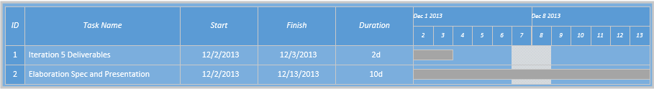

Physical Architecture Design

This section gives a simple diagram of the system architecture for Restorative Justice’s future case management system. The hardware that will be used by RJL will be the laptops and desktops of the employees and the one laptop RJL currently owns. From these laptops and desktops the employees and facilitators will access a Salesforce site via the web. There will be no need to install software on the computers for the case management system because Salesforce runs in the cloud. Salesforce will store RJL’s data on one of their servers and RJL will access their data via an internet connection. RJL’s public website will continue to be hosted by WordPress. This makes it easy for RJL because all they need to be concerned with maintaining and purchasing are their work computers.

Restorative Justice Louisville

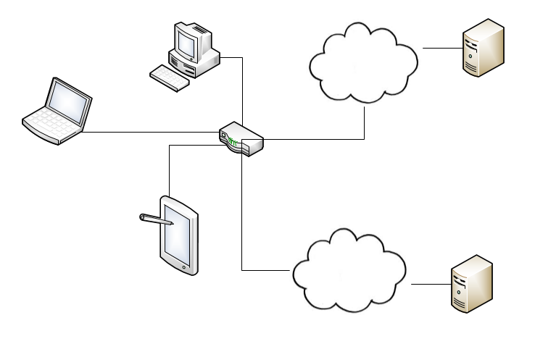

WordPress Website

SalesForce Website

WordPress Server

SalesForce

Server

Personal Tablet

RJL Laptop

Router

Personal PC

**Use Case Diagram**

The use case diagram shows our high risk use cases encased in the developing case management system for Restorative Justice of Louisville. External to the system we have listed the users. The lines between the use cases and users represent who can interact with what use cases.

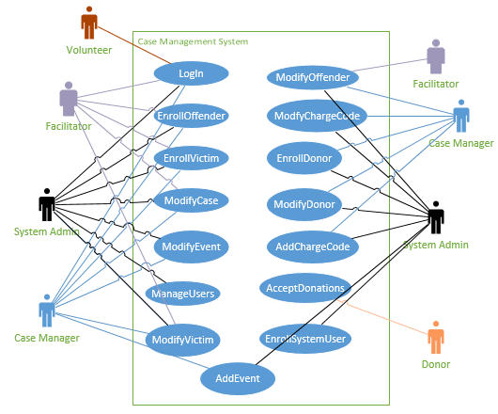

Notes

1. The primary actor will input all information provided about the offender. Primary actor will type in the offender’s first and last name, date of birth, gender, address, race, phone number, and any guardians associated
2. New offender is added to the system

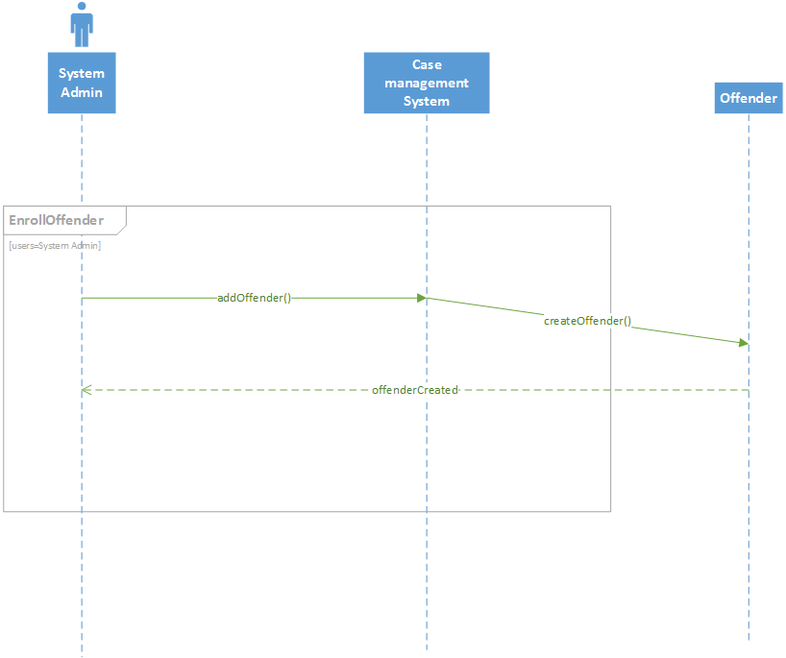

Notes

1. The primary actor will modify information related to an offender
2. The primary actor will edit the phone number
3. Changes will be saved to the system

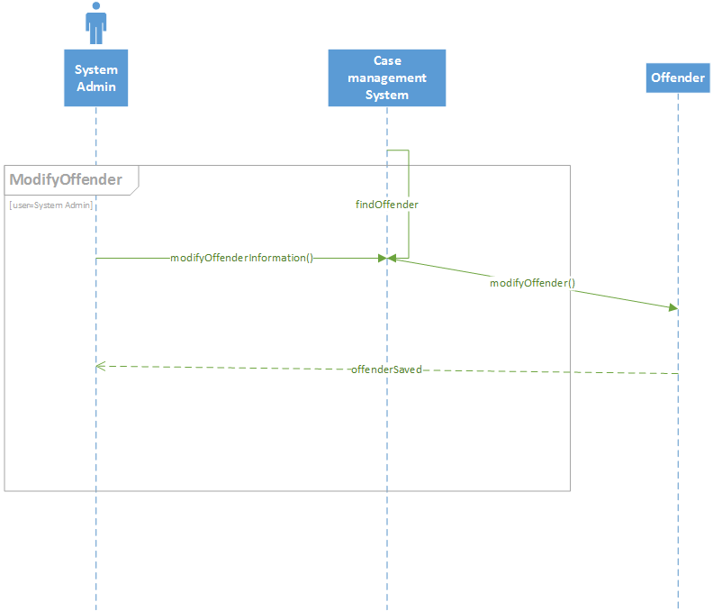

Notes

(1) The primary actor will choose to delete an offender

(2) The offender will be deleted from the system

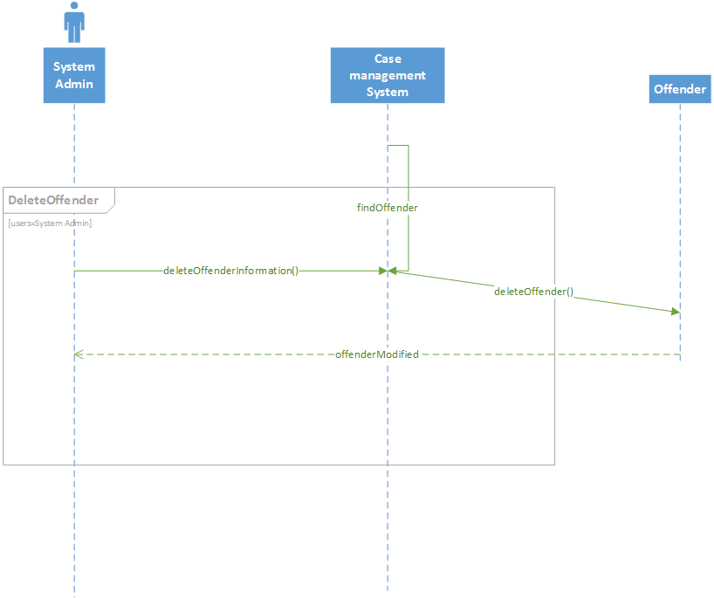

Notes

(1) The primary actor will request access to the case management system using a userName and password

(2) The system will check the sent credentials against the database

(2a) If the credentials are valid, the user is notified and allowed to access the system

(2b) If the credentials are not valid, the user is notified

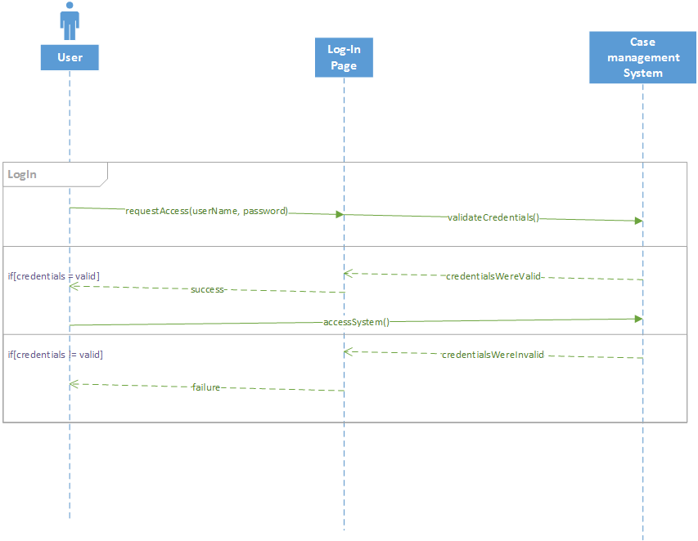

Offenders WND

The WND and prototypes below realize the AddOffender, ModifyOffender and DeleteOffender use cases. In the case management system, selecting the “Offenders” tab will go to a list of offenders. From this page, you can select “Add New,” which will open up a new page to enter the information pertaining to a person of type offender; or “Edit” and “Delete” which will open up a form that returns to the updated Offenders page.

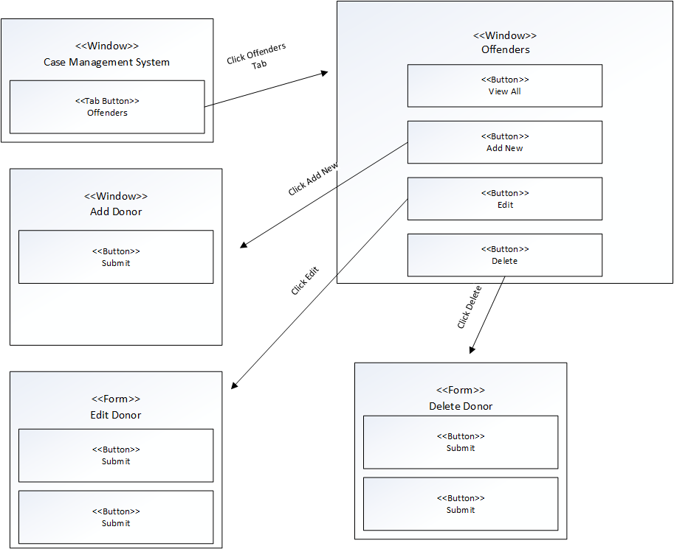

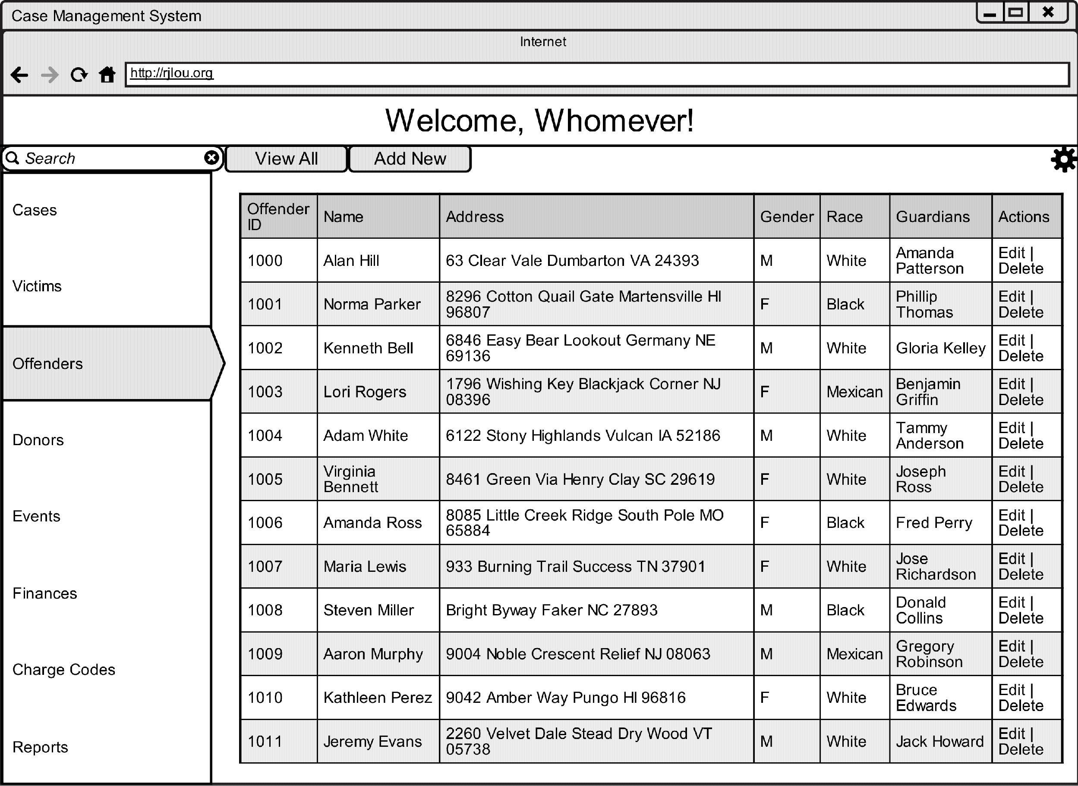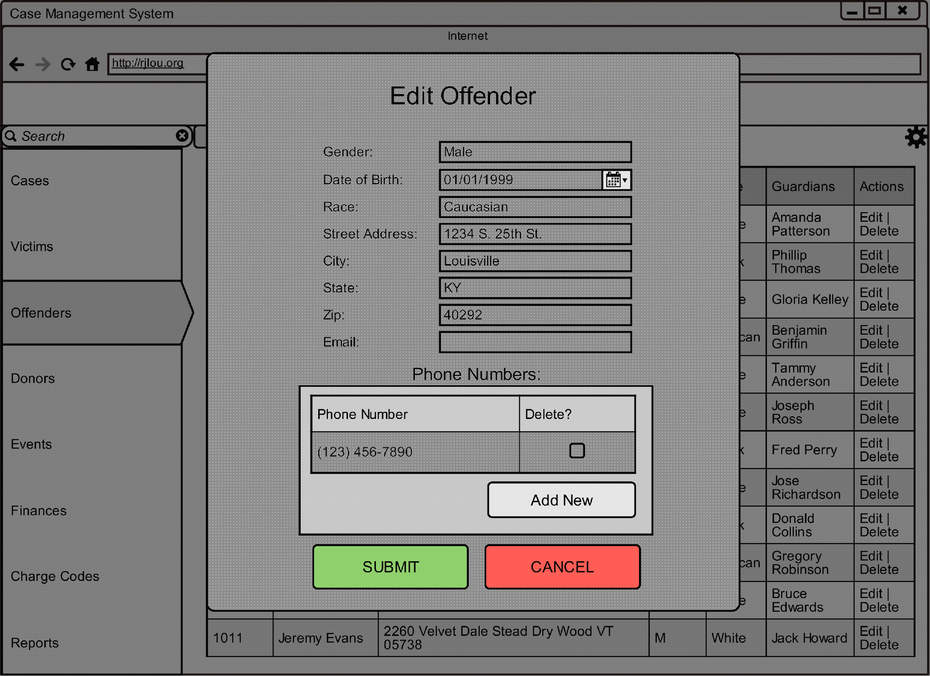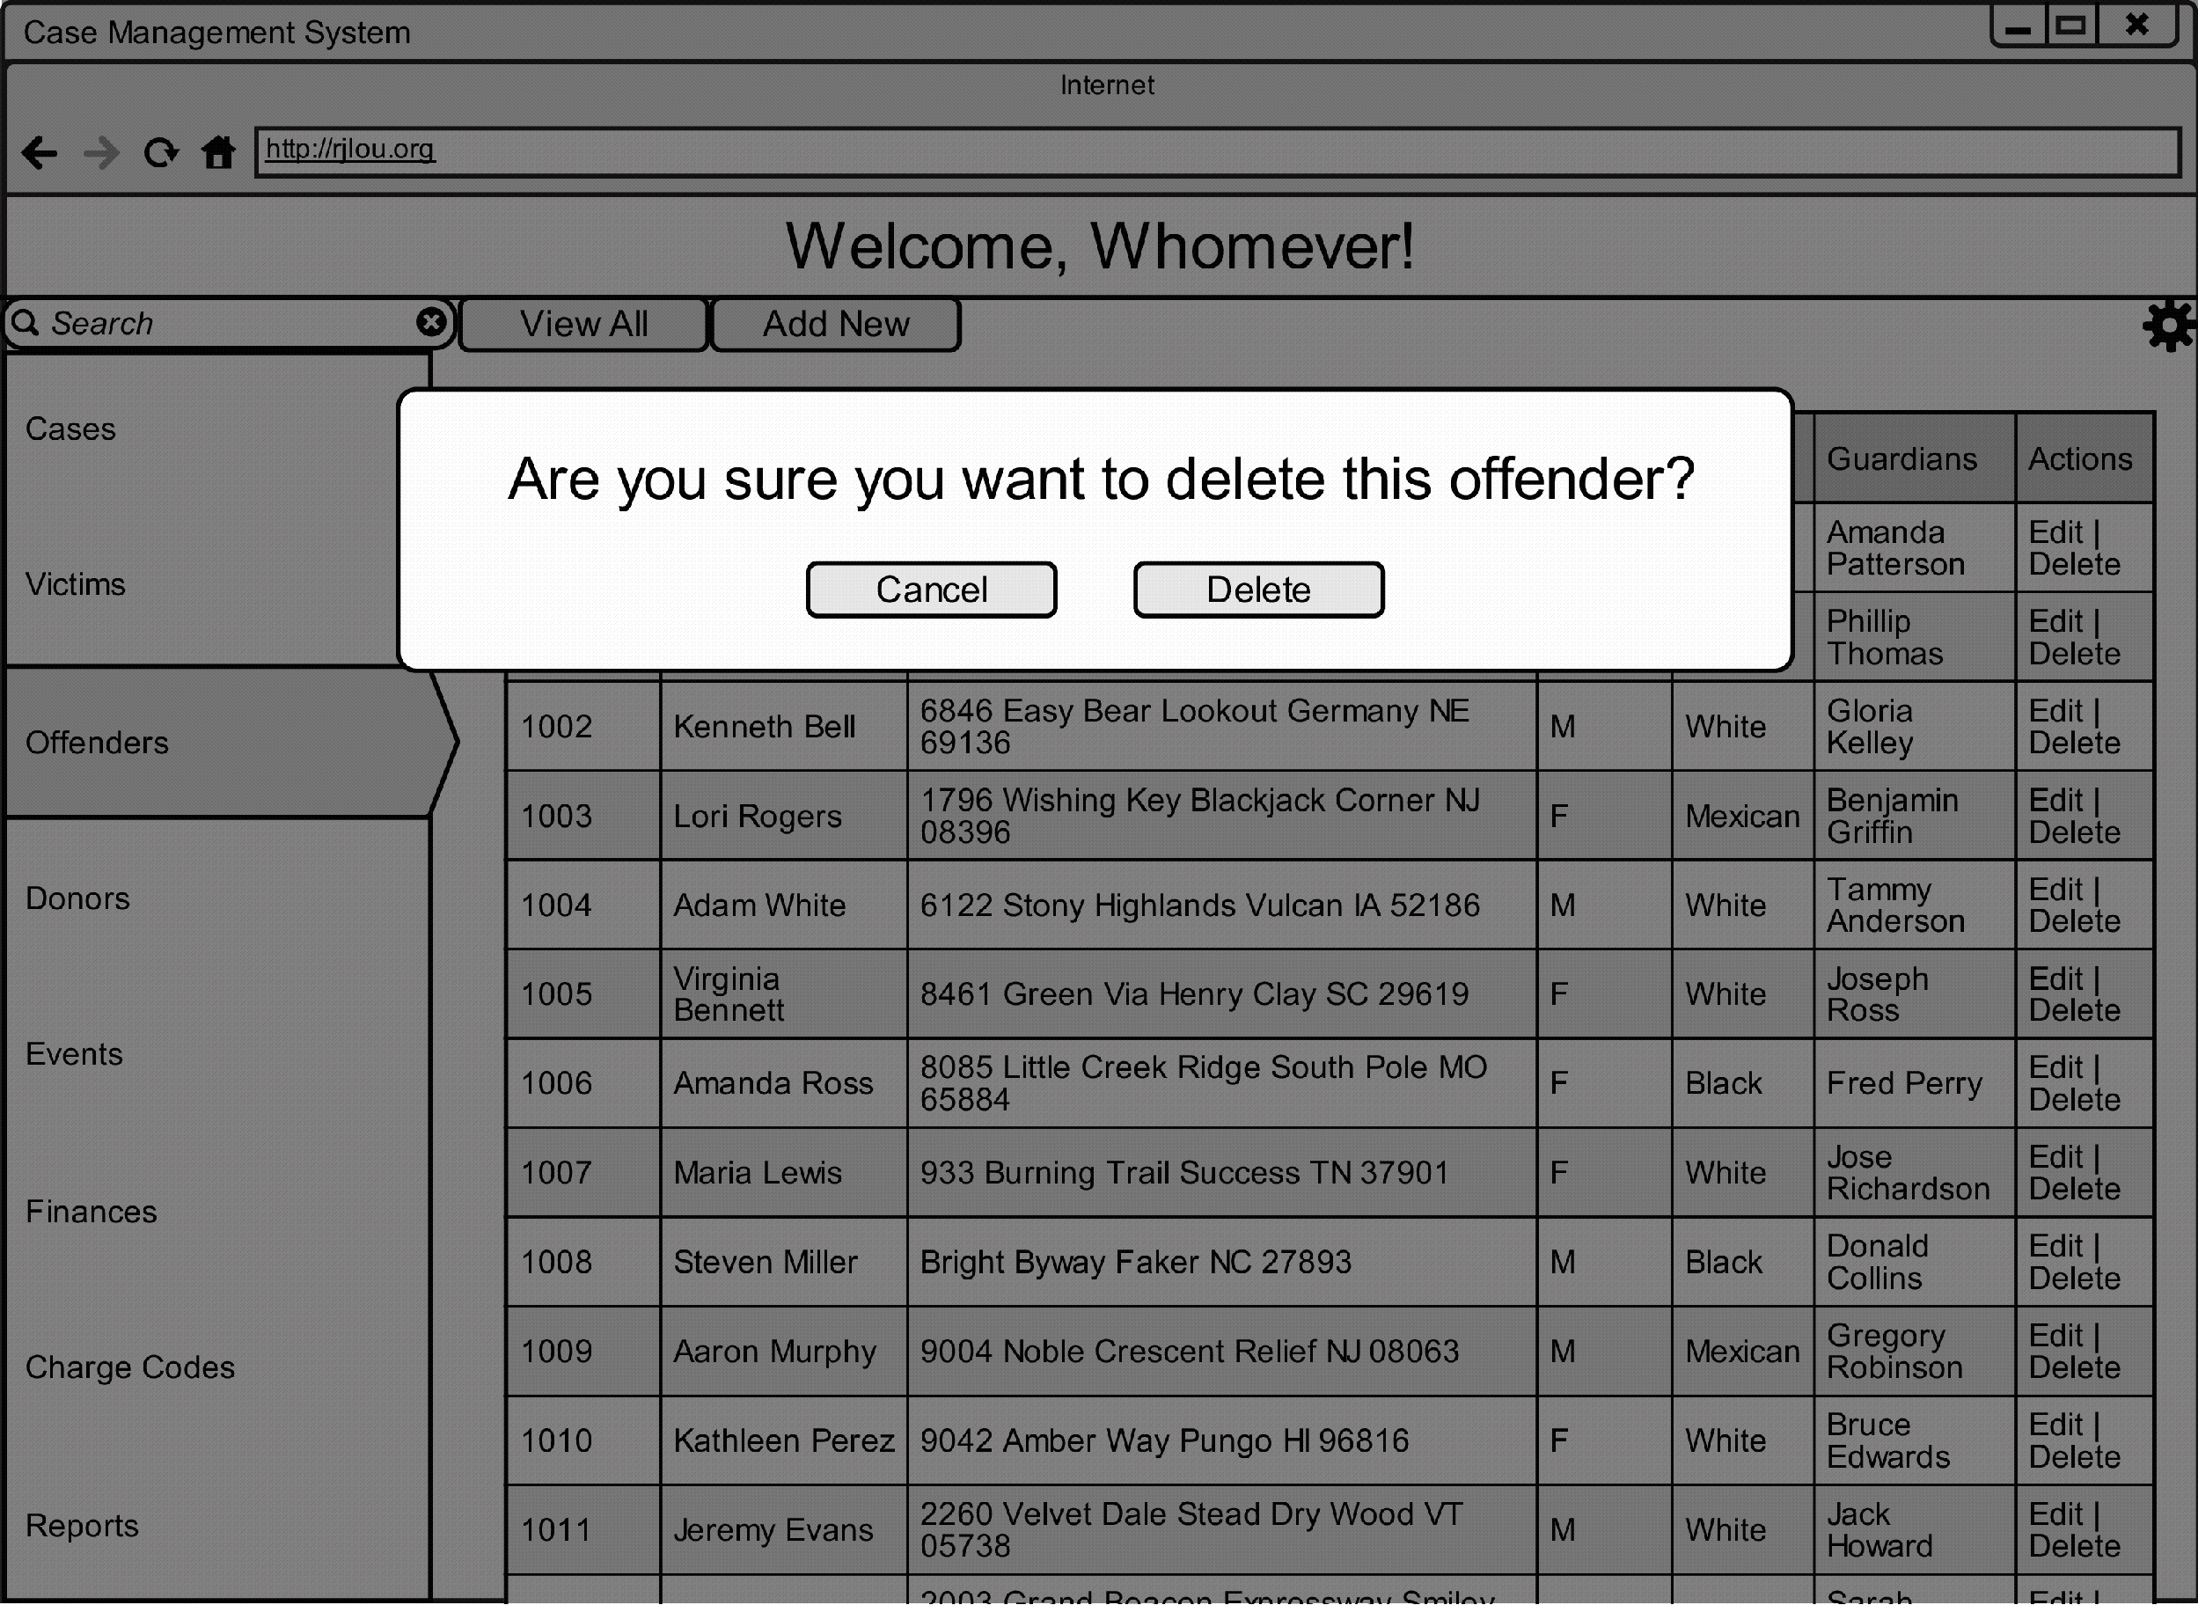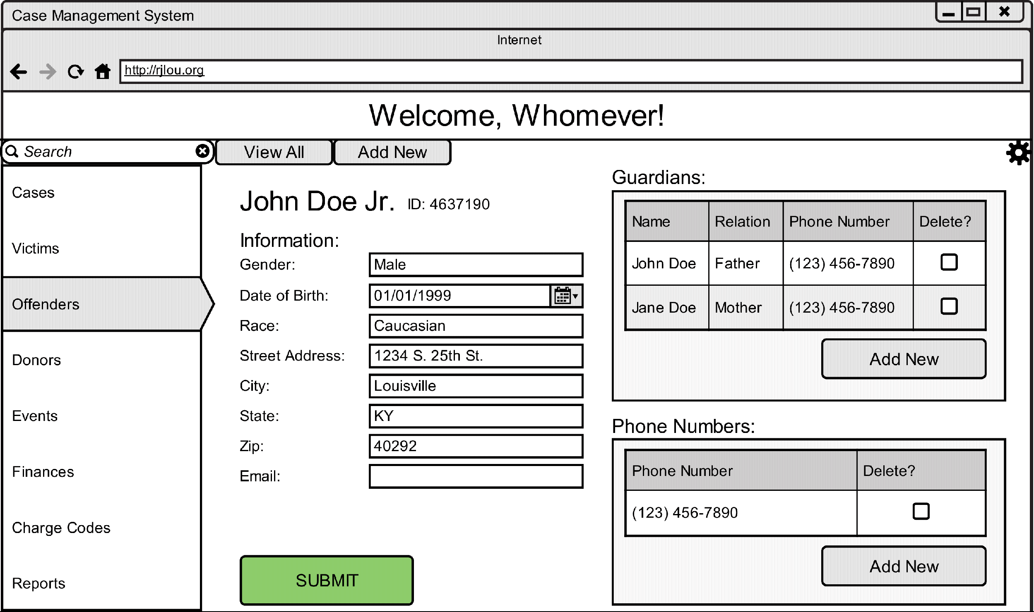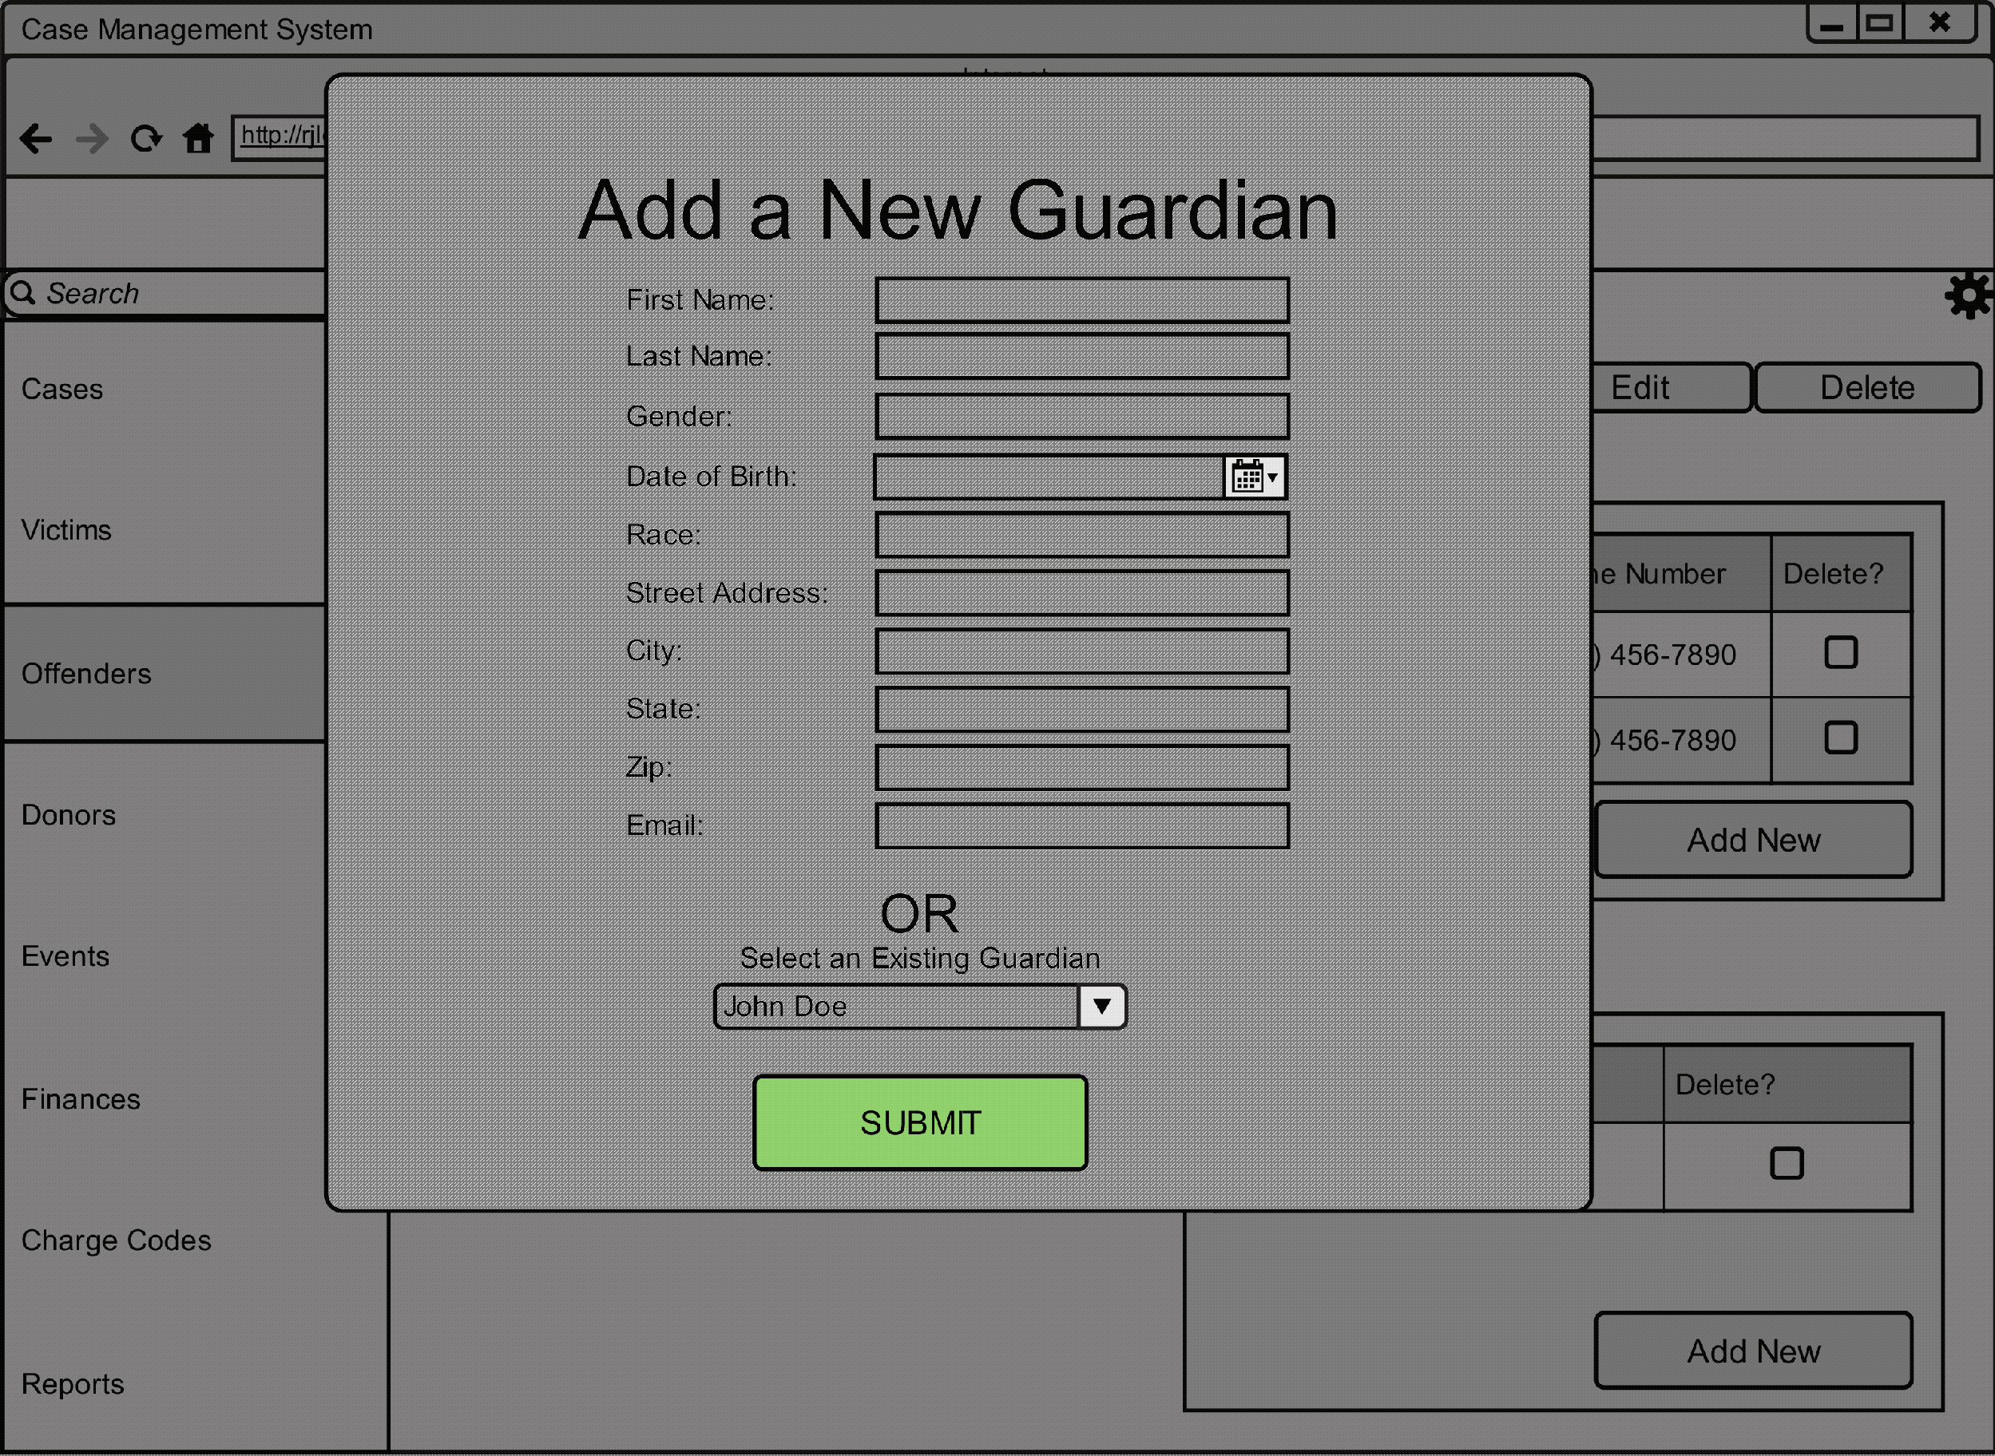

Log In WND

The above WND and prototypes realize the LogIn use case. Before you can access the case management system, you must first navigate to the Log In page, through which you must enter your login credentials. If your credentials are rejected, you will be redirected to the login page with a prompt to re-enter your credentials or contact someone for help; otherwise, you will be allowed into the case management system.

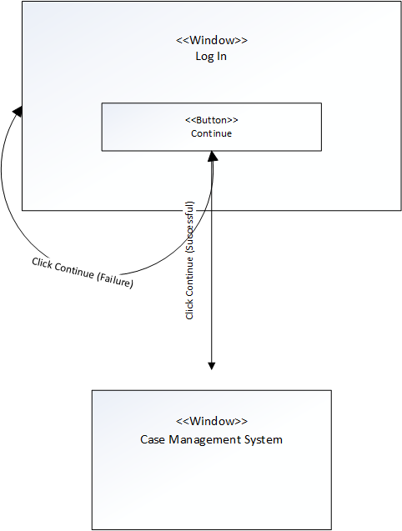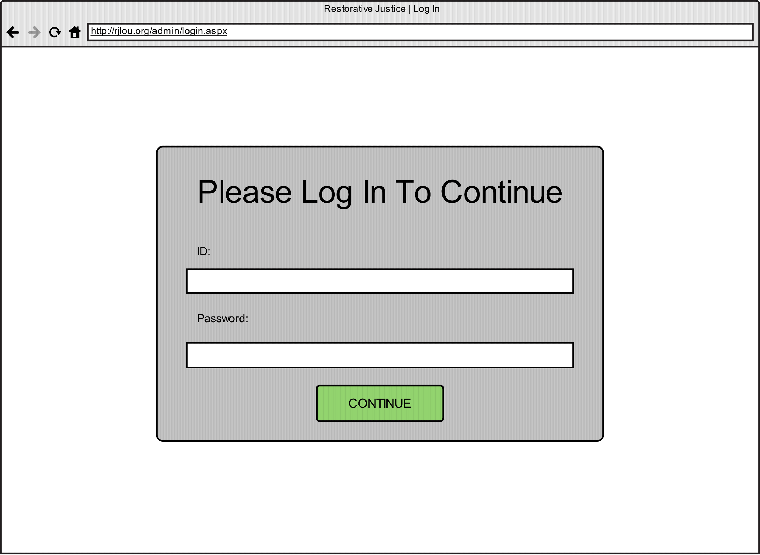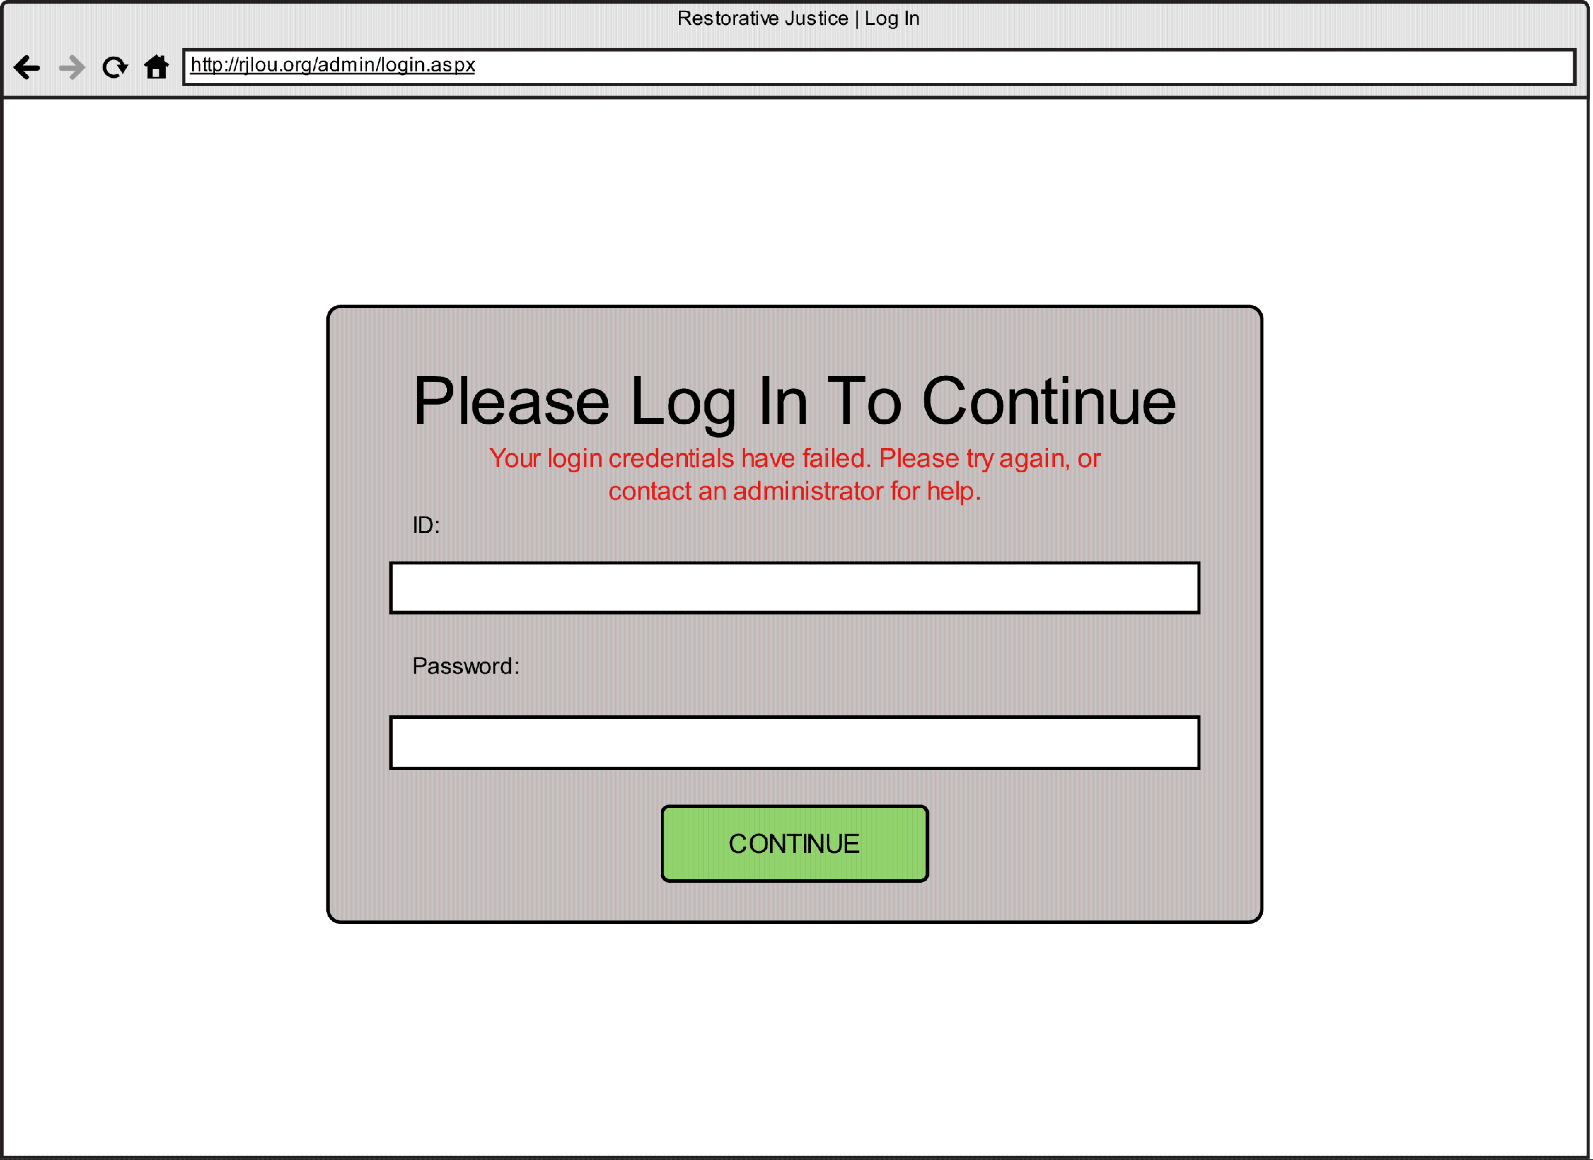

**Use Case Specification: ModifySystemUser**

1. **ModifySystemUser**

**Brief Description**System Administrator should be able to modify any information in connection with the Users of the case management system such as the facilitators and case managers.

**Flow of Events**

**Basic Flow**   
1. The use case starts when the System Admin accesses a User file

2. If the User file needs to be modified

2.1 Primary actor chooses to “edit”

2.2 The primary actor modifies information as needed such as Name, Address, Phone Number, Gender, Employment Status, Job Title, etc

2.3 The User selects “save” to confirm the information will be edited and saved, or “cancel” to exit out of the message box without any edits made.

3. The User information is updated in the system.

4. The use case ends.

**Alternative Flows**

None

1. **Special Requirements**

The user must have internet connection.

1. **Pre-conditions**

The user must be logged in.

1. **Post-conditions**

The user information will be up to date in the system.

1. **Extension Points**

None

**Use Case Specification: ModifyCase**

1. **ModifyCase**

**Brief Description**System Administrator should be able to modify any information in connection with the Case

**Flow of Events**

**Basic Flow**   
1. The use case starts when the User accesses a Case

2. If the Case file needs to be modified

2.1 Primary actor chooses to “edit”

2.2 The primary actor modifies information as needed such as Case Number, Victims, Offenders, Charges, dates, etc

2.3 The User selects “save” to confirm the case will be edited and saved, or “cancel” to exit out of the message box without any edits made.

3. The case is updated in the system.

4. The use case ends.

**Alternative Flows**

None

1. **Special Requirements**

The user must have internet connection.

1. **Pre-conditions**

The user must be logged in.

1. **Post-conditions**

This case will be up to date in the system.

1. **Extension Points**

None

**Use Case Specification: ModifyVictim**

1. **ModifyVictim**

**Brief Description**

Modify an existing victim and his or her information.

1. **Flow of Events**

**Basic Flow**

1. The use case starts when a primary actor is notified that victim information needs to be modified, and then the primary actor logs in.

2. Primary actor uses search to locate the victim file in question.

3. Primary actor chooses the edit option.

4. Primary actor makes necessary changes to any of the victim’s stored attributes.

5. Primary actor selects the save changes option.

6. If primary actor is the System Admin

  6.1 Victim information is automatically updated to the system and a message box tells

       the user that it’s been updated.

7. If primary actor is the Case Manager or Facilitator

  7.1 Victim information is updated after System Admin verifies pending changes to the

         victim file, and so a message box notifies the user of the needed approval.

8. Use case ends.

**Alternative Flows**

None

1. **Special Requirements**

**User must have Internet connection.**

**3.2 User must be logged onto website**

1. **Pre-conditions**

**User must be logged onto website.**

4.2 **User must be a System Administrator, Case Manager, or Facilitator.**

1. **Post-conditions**

**Victim information is updated.**

1. **Extension Points**

**None**

**Use Case Specification: GenerateReport**

1. **GenerateReport**

**Brief Description**

Create a report for a certain time period.

1. **Flow of Events**

**Basic Flow**

1. Use case starts when a primary actor needs to create a report, and then the primary actor logs in.

2. Primary actor will click on the “reports” tab..

3. Primary actor will specify the time constraints.

4. Primary actor will click on the “generate” button.

5. The system will open a new window with the report.

6. Use case ends.

**Alternative Flows**

None

1. **Special Requirements**

**3.1 User must have Internet connection.**

**3.2 User must be logged onto website**

1. **Pre-conditions**

**User must be logged onto website.**

4.2 **User must be a System Administrator.**

1. **Post-conditions**

**A report will be created in a new window.**

1. **Extension Points**

**None**

**Use Case Specification: EnrollVictim**

1. **EnrollVictim**

**Brief Description**

Store a new victim and his/her information.

1. **Flow of Events**

**Basic Flow**

1. Use case starts when a primary actor needs to add a victim to a case, and then the primary actor logs in.

2. Primary actor will input all information provided by the courts regarding the new victim.

3. Primary actor will type in victim’s first and last name, date of birth, gender, race, phone number 1, phone number 2, street address, city, state, and zip code.

4. Primary actor will also type in the first name, last name, and relation of  two different guardians for the victim.

5. Primary actor will select “Add Victim”.

6. If primary actor is the System Admin

6.1 New victim is automatically added to the system.

7. If primary actor is the Case Manager or Facilitator

7.1 New victim is added after System Admin verifies pending addition to the system.

8. Use case ends.

**Alternative Flows**

None

1. **Special Requirements**

**User must have Internet connection.**

**3.2 User must be logged onto website**

1. **Pre-conditions**

**User must be logged onto website.**

4.2 **User must be a System Administrator or Case Manager.**

1. **Post-conditions**

**A victim is added to the system.**

1. **Extension Points**

**None**

**Use Case Specification: DeleteVictim**

1. **DeleteVictim**

**Brief Description**

Delete a victim file.

1. **Flow of Events**

**Basic Flow**

1. The use case starts when a primary actor is notified that a victim’s file needs to be deleted, and then the primary actor logs-in.

2. The primary actor locates the victim file through search function.

3. Primary actors selects option to delete file.

  3.1 Message box appears to double check that the user wants to delete the file.

  3.2 Primary actor chooses delete option again to delete the file or else they choose

        cancel.

5. Use case ends.

**Alternative Flows**

None

1. **Special Requirements**

**User must have Internet connection.**

**3.2 User must be logged onto website**

1. **Pre-conditions**

**User must be logged onto website.**

4.2 **User must be a System Administrator.**

1. **Post-conditions**

**Victim’s file is deleted.**

1. **Extension Points**

**None**

|  |
| --- |
| **System Request—Restorative Justice of Louisville System Project** |

|  |  |
| --- | --- |
| **Project Sponsor:** | Executive Director—Libby Mills |
| **Business Need:** | Increase in ability to handle cases  Case management system  Improve information sharing  Increase donor relations  Increase monetary donations  Update event information for donors  Better organization for donor and volunteer  information and outreach  Method to generate useful reports |
| **Business Requirements:** | Database for volunteer, donor and grant organization information  Case management system to organize and store cases digitally with remote access  Online, secure services for employee and  volunteers to access case information  Volunteer online sign-up forms  Different donation service |
| **Business Value** | Save 3.55% on flat rate fees on donations  Time shall be saved using new system  Case system that helps handle 25% more of the juvenile complaints in KY’s districts  Handling more cases allows more  opportunities to save $72,000 per child in  correctional facilities  Handling more cases allows more opportunities to save $42,000 court costs per child in traditional court system  At a 30% Grant acceptance rate, each extra hour spent writing for a grant could yield $700 in additional revenue. |
| **Special Issues or Constraints:** | Volunteers have varying levels of technical  experience with computers  Budget limited to grant/donation funds  System design needed by the end of the  semester  Implementation of system limited to the Spring semester |

Restorative Justice Louisville

Vision (Small Project)

Version 2.0

Revision History

|  |  |  |  |
| --- | --- | --- | --- |
| **Date** | **Version** | **Description** | **Author** |
| 09/16/2013  9/28/2013  10/20/2013 | 1.0  2.0  3.0 | Filled out all fields  Edit and update fields  Finalized Vision Document for Delivery to the client | Zach Woodward  Mike Voltmer  Anna Kelley  Anna Kelley  Tommy Qualls  Michael Voltmer  Tommy Qualls |

Table of Contents

1. Introduction

1.1 References

2. Positioning

2.1 Problem Statement

2.2 Product Position Statement

3. Stakeholder and User Descriptions

3.1 Stakeholder Summary

3.2 User Summary

3.3 User Environment

3.4 Summary of Key Stakeholder or User Needs

3.5 Alternatives and Competition

4. Product Overview

4.1 Product Perspective

4.2 Assumptions and Dependencies

5. Product Features

6. Other Product Requirements

7. Feasibility Analysis

Appendix

1. Cost-Benefit Analysis Spreadsheet

Vision (Small Project)

# Introduction

Restorative Justice Louisville (henceforth referred to as RJL) needs a more efficient way to communicate electronically within their business, as well as with the clients they will be meeting. They need to organize all their information online in a database, rather than having paper folders. A better website could include ways to increase the number of donors and volunteers, as well as relations with those people. Currently, the business is only able to handle 80 cases per year due to their constraints. A more efficient program would help save the taxpayers money, as well as further achieve their goal as a non-profit program.

## References

IT Assessment Report by Oliver Ray, 21 April 2013 provided by Restorative Justice of Louisville

IT Assessment Report by Michael Pryor, 22 April 2013 provided by Restorative Justice of Louisville

IT Assessment Report by Mike Stratton, 22 April 2013 provided by Restorative Justice of Louisville

# Positioning

## Problem Statement

|  |  |
| --- | --- |
| The problem of | Inefficient organization with all business forms  Inefficient organization with all information |
| affects | RJL itself  The clients of RJL  The government  Society |
| the impact of which is | Inability to only see so many clients per year  An inefficient allocation of time  Money is lost |
| a successful solution would be | A re-organization of the website  Building databases for the organization  Creating a new system process(s) |

## Product Position Statement

|  |  |
| --- | --- |
| For | RJL |
| Who | Needs a way to organize and access information remotely and securely while creating a more efficient allocation of time use. |
| The website and database | Is an online product that utilizes web infrastructure |
| That | Stores all of their client, victim, donor, volunteer, case manager, admin, facilitator, and grant funding organizations information, as well as facilitated improved relations with all-of-the-above, which would improve their business model |
| Unlike | A re-organization of their paper and folder information |
| Our product | Saves space in the workspace, and is able to query data allowing to generate better more useful reports, both for internal and external purposes. It will also allow for remote access to case information, to be accessed securely and with limited/defined roles(admin, volunteer… ect) |

# Stakeholder and User Descriptions

## Stakeholder Summary

|  |  |  |
| --- | --- | --- |
| **Name** | **Description** | **Responsibilities** |
| Executive Director | Libby Mills, the primary stakeholder, who does most of the work required by RJL | Leads the organization, hires new employees, makes most business decisions |
| Board | This is the group of stakeholders who analyzes the value of RJL | Holds the Executive Director and Organization responsible for using funding properly |
| Taxpayers | This is a collective group of stakeholders who pay taxes every year based on the government’s need |  |

## User Summary

|  |  |  |  |
| --- | --- | --- | --- |
| **Name** | **Description** | **Responsibilities** | **Stakeholder** |
| Executive Director | Primary end user of the system | Use the system to fill out forms and make contact with various individuals, create reports | Self, victims and offenders involved in a case, the board |
| Facilitators | Primary end user of the system(may have restricted access) | Use the system to fill out forms and make contact with various individuals | Self, victims, offenders and case managers who are involved in a case |
| Case Managers/Intern | Primary end user of the system(may have restricted access) | Create, Maintain and Organize each case, directing the facilitators | Self, victims, offenders and facilitators who are involved in a case |
| Donor | Front-End User(no log in access) | Donates Money | Self,RLJ |
| Volunteer | Front-End User(no log in access) | Donates Time | Self,RJL |
| General Public | Front End Users(No log in access) | May Vary | Self,RJL |

## User Environment

The users interact with a mostly-paper environment, with some contact over the phone involved as well. The only online method of sending documents that is currently accepted is PDFs over email.

## 

## Summary of Key Stakeholder or User Needs

|  |  |  |  |  |
| --- | --- | --- | --- | --- |
| **Need** | **Priority** | **Concerns** | **Current Solution** | **Proposed Solutions** |
| Process Forms | High | Timeliness of processing and completeness of information | Executive Director manually processes each individual form and contact information | Allow forms to be accessed online, and have a method of processing forms and storing valuable information from them |
| Manage Reports | Low | None | Excel spreadsheet is used to compile numbers for use in a report | Compile all valuable information from a stored database, and use it to build reports |
| Share Information | High | Users need permission to view information because of security concerns | Executive Director sends e-mails, and any forms are physically exchanged | Online database to hold information and forms that stores the information and allows different people (with permission) to access the information from various places |
| Improve donor and volunteer relations | Low | Information should be secure and complete | There is not a formal way to collect the information through their third-party donation service website RJL uses | There could be a form or small step in the donation process to collect donor information to store in an online database |

## Alternatives and Competition

The only alternatives are to accept the proposed solution, or to continue with the current solution. As this is a not-for-profit organization whose sole purpose is to benefit society, there are no competitors in the field, only other organizations that provide similar services. If RJL had enough funds in the future, the y may have another opportunity in the future to seek help from others to improve their technological processes.

# Product Overview

## Product Perspective

RJL’s data, contact information, and case information could be stored in an online database or source. An online system could be accessed by many users, facilitators and the Executive Director, from many points. A system could have an area to create reports from certain information collected.

## Assumptions and Dependencies

The features stated in the Vision document are wholly and completely dependent on RJL having things such as a computer, an internet connection, and a general understanding of how to use a content management system. The vision document assumes that a computer and internet connection will always be present, and that content management training can be provided if sufficient knowledge is not already present.

# Product Features

**Access online database**

Any permitted user could be able to access the online database from any computer.

**Create reports**

RJL could easily create and print reports of various financial and social aspects of the organization.

**Enroll victims/offenders**

RJL could collect and store the contact information of those involved in the case.

**Record Status**

The system could document parts of the case

**Update Information**

The system could allow for updating any case and contact information.

**Log-In Abilities**

For the online database of information, there could a sort of log-in system to ensure that only permitted users may see the information.

**Enroll Donors and Manage Relations**

RJL could collect and store the contact information of those who have donated to RJL so they can later use the information again for public relations.

**Write Grants**

RJL may be able to adopt use of template or partially populated templates to cut down on time spent writing grants.

**Accept/Process Donations**

RLJ could use PayPal to accept and process donations

**Manage Donations**

RJL could use a database to save data and retrieve/query for use in reports.

# Other Product Requirements

**Technical experience**

Volunteers have varying levels of technical experience with computers, and may require training on certain aspects of the system.

**Budget**

Budget constraints are limited to grant and donation funds.

**Time**

System design must be completed by the end of the semester.

**7. Feasibility Analysis**

**Technical – Can We Build it?**

**Familiarity with functional areas: Less familiarity creates more risk**

·         We feel like fact that this project is to be considered a “small project” in the realm of IT Projects.

·         We feel confident in understanding the current system process’ that are performed to start and complete a case, step by step.

**Familiarity with technology – Less familiarity creates more risk**

·         There is a risk that implementing a WEB based system into the organization in that has volunteers who have issues using e-mail

**Project Size**

·         Small – Low risk

**Compatibility – Low risk – Easy Integration/Transition**

·         Although there is currently a system of handling cases, there is need for a more decentralized, more efficient system.  This brings about more complexity, which brings risk.  That being said, we believe that the current system could be changed in many ways in which the end-user would notice little change if any at all.

·         We believe we can create a system that is easy to integrate, and transition from old to new.

**Economic Feasibility (Cost Benefit) – Should We Build It?**

*You can find a complete Cost-Benefit Analysis Spreadsheet with ROI in *Table 1.1* of *Appendix A*.

**Benefits**

1.       *Increased donations by 10% (modest assumption)* - Using PayPal to decrease per transaction cost by 3.55% we make a modest assumption that the convenience of paying thru PayPal (convenient because it is reputable) may in itself increase donations, we will assume a 10% increase in donations.

2.       *Increased Grant Revenue* – Decreasing per case processing time from 8 hours to 5 by automating many current manual process by which most are filling out papers and scanning documents. With 3 grants at $53,000 gross and taking around 7.5 hours writing time to write towards a grant, if every grant was accepted each hour RJL writes for a grant would be worth about $2,400.

Taking a modest estimate, assume RJL has a 30% acceptance rate, each hour they spend writing for a grant would be worth around $700. Using the extra 1.5 hours extra per case, $700 an hour assuming 30% acceptance @ 80 Cases year, the total revenue could be around $56,000, at the current pace.  Adding a worker and increasing the number of cases by double could increase your grant revenues by over $100,000, in our estimates.

**Costs**

Developmental Costs

1.        *Labor* – Assume a labor cost of $30,000 to build and implement the new system (one time flat fee)

Operational Costs

1.       *Supplies* – Estimating RJL uses $350 worth of supplies every year from their receipts.

2.       *Software* – Sales force is the main CMS software that will cost $25 per month or $300 every year.

3.       *Labor* – Hiring a DBA at the going rate of $37/hour (according to BLS.gov). Assume there is a need for 2 hours of upkeep every 2 weeks.  48 hours total per year at $37 per hour

**5 Year ROI = 498.53%** (see Table 1.1 in Appendix A)

*\*Reference Appendix A for a Cost-Benefit Analysis Spreadsheet*

**Organizational Feasibility – If we built it will they come?**

**Project Champion -** Libby Mills

**Senior Management** - Libby Mills

**Users** – Senior Management, Caseworkers, Volunteers

**Other Stakeholders** - Juvenile Offender, Victim Society

**Is the Project strategically aligned with the business? –** We believe that this project will work great for RJL and help them to accomplish their goals.

**Appendix A**

**Table 1.1**

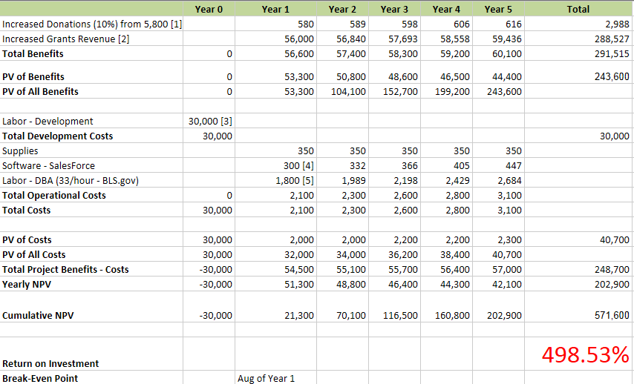

**Initial Architecture Considerations**

Initial Architecture Considerations provide descriptions and representations of system architecture options. The Design Viewpoint gives the considerations for how we envision the new system, what it must do to meet the requests of Restorative Justice Louisville and Libby Mills. We have included all the functions the new case management system will provide to increase RJL’s business value. The Realization Viewpoint specifies which product we would like to implement. We recommend Salesforce as the new case management system because we believe it will meet all the system requirements and will be able to meet all the expectations we have put forth in the Design Viewpoint.

**Design Viewpoint:**

The new system should store case information on the cloud to provide both data security and ease of access. The system should manage user roles so that volunteers and other users have access only to appropriate information. The new system should accept entries by case such as personal information, contact information, and the crime involved. Each case should be able to be updated as needed by the volunteer facilitators and by Libby Mills. The system should be able to generate reports, from the stored information, which Libby Mills will present to the Board of Directors. The system should also be capable of accepting donations and keeping records of donor information so they can be contacted for future fundraising. The system should digitize RJL’s record keeping so in order to save time that can be better spent handling more cases.

**Realization Viewpoint:**

We recommend a cloud based system such as **Salesforce** so that RJL will not have to purchase any new hardware or software. A product like Salesforce guarantees 24/7 access and allows users to access the site from their mobile devices. Salesforce also provides a guarantee for the security of the information stored using their products. Salesforce offers gift processing, grants management, and giving tracking which can help RJL fundraise more effectively. Salesforce allows organization members and volunteers to access the information they need from anywhere and can manage user roles to restrict access to sensitive information. The members and volunteers of RJL can update the information stored via Salesforce ensuring each case is up to date. Salesforce has the ability to generate reports which Libby Mills would be able to share with the Board or use for writing grants. Salesforce provides all the functionality that is critical for RJL to adopt in order to improve efficiency and grow to handle more cases. Salesforce also donates 10 Enterprise Edition licenses, which normally cost $125 /user/ month, to non profit organizations for free. Since Salesforce can be used to meet RJL’s system requirements, the first ten licenses are free, and it requires no new hardware or software we highly recommend that RJL adopt a Salesforce system.

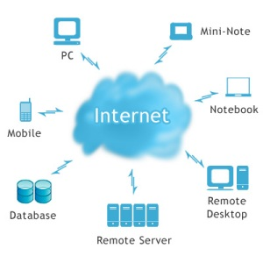

Caption: This diagram represents a simple cloud computing model. It demonstrates the ability to interact with the the case management system and database, which will be hosted by Salesforce, from remote locations via mobile devices. There will be no need for special software, the entire case management system will be accessible via the internet.

**Risk Analysis**

This analysis is used to identify the riskiness of different areas in the design of a new system for RJL to use.

Before each table, there is a short explanation that describes how the team defined high or low level risk for either use cases (found in the first table) or architectural considerations and other miscellaneous areas (found in the second table). The use cases detail business processes and activities of the new system. Architectural considerations refer to aspects of how the system would be set up, such as using the Internet to store information. Any other areas that do not fall under use cases or architectural considerations contain items found from the Vision Document that should be analyzed.

At the end of the analysis, there is a short explanation that details how our team would address high or low level risks.

**Criteria for assessing use case risk:**

When assigning risk levels to use cases, we consider how much of a negative effect on other business processes would be caused by an error in that particular use case. For example, an error in the “Modify Offender Information” use case could cause issues and negative effects in the offender’s entire case since the case is very dependent on enrolling the offender properly.

|  |  |
| --- | --- |
| **Use Case** | **Risk Level** |
| Update Website | High |
| Submit Interest Form Via Website | Low |
| Log In | High |
| Enroll offender | High |
| Modify Offender Information | High |
| Delete Offender Information | Low |
| Enroll Victim | High |
| Modify Victim Information | High |
| Delete Victim Information | Low |
| Document parties willingness to participate | High |
| Assign case to facilitators | Low |
| Document outcomes of conferences | High |
| Allow remote access | High |
| Create Reports | Low |
| Enroll donor | High |
| Modify Donor Information | High |
| Accept donations | High |
| Manage user roles | High |
| Enter Volunteer Information | Low |
| Modify Volunteer Information | High |
| Delete Volunteer Information | Low |
| Populate Forms | High |
| Create Master List of UOR codes used by Restorative Justice | Low |
| Override Changes Made by Facilitators | High |
| Add Grant Organizations | Low |
| Modify Grant Organization Information | High |
| Track User Activity | High |

**Criteria for assessing other risk areas:**

Similarly to the use case risk analysis, we assessed risk of all other non-use case areas based on how much errors and mistakes in an area would negatively affect an offender/victim’s case and the business processes surrounding that.

|  |  |
| --- | --- |
| **Vision Document Items / Architecture Considerations** | **Risk Level** |
| Knowledge of To-Be System Users | High |
| Security | High |
| Cloud Computing | Low |
| Scalability | High |

**Addressing risks during the iterations of the Elaboration Phase:**

Since some areas have been identified as high risk, it is of utmost importance to pay close attention when moving further into the To-Be system design. It would be worthwhile to do extra analyzation of how the high risk areas connect and interact with the business processes and other areas described above. These areas should be clear in their descriptions and details that provide an understand of how it fits into a larger business process. If there are any areas that require clarification or a better understanding it is also important to pose any relevant questions to the Executive Director, Libby Mills, in order to gain the required knowledge and information to handle the high risk areas.