Install python: (I did this all on windows, so if its something is diff on mac good luck)

1. check to see if python is already installed
   * type 'python' in your command prompt

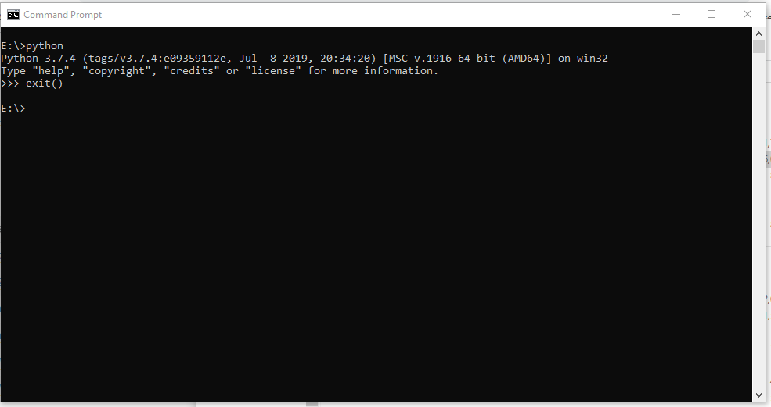

* + if you don’t get something like this, its not installed
  + If you do, you can type ‘exit()’ to get out of it and now jump to step 6

1. pick installer download from bottom of this page:
   * https://www.python.org/downloads/release/python-374/
   * if you want to try 3.8 u can get that download from the "Downloads" tab at the top under the log

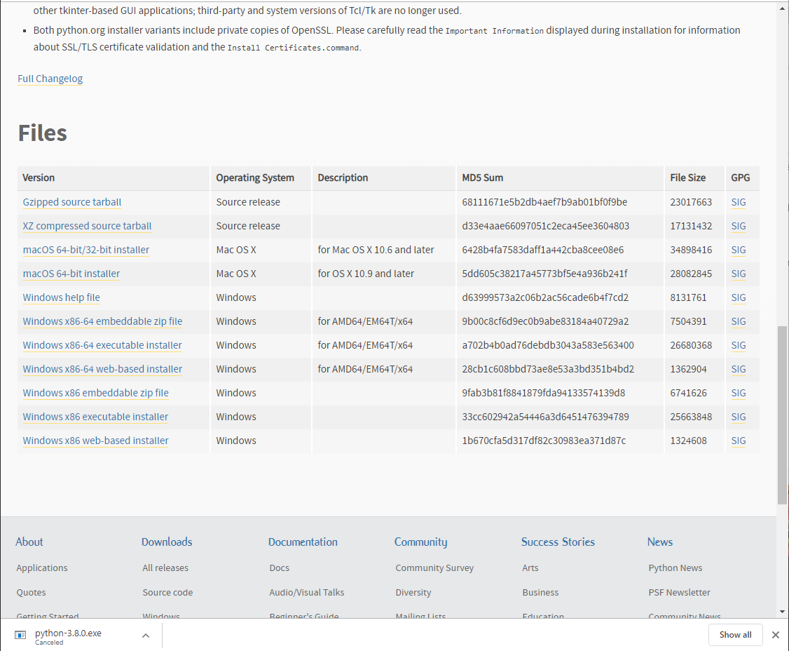

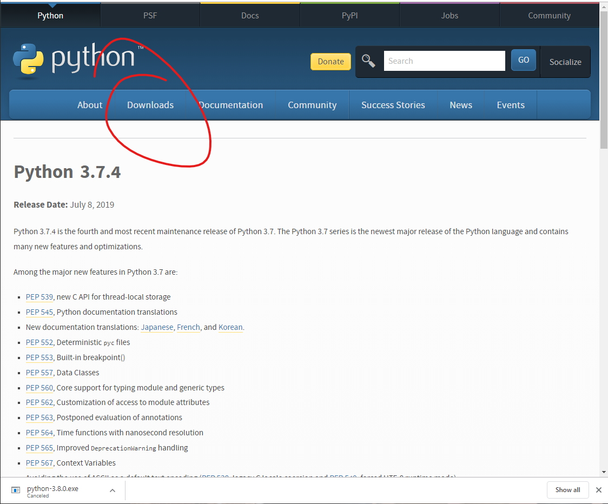

1. run the installer
   * check 'Add Python 3.7 to PATH'
   * then click 'Install Now'

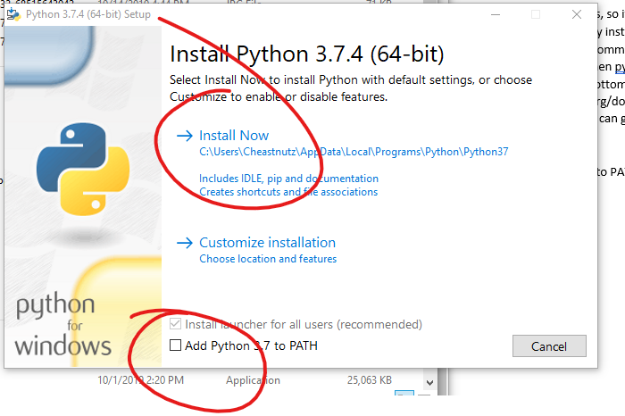

1. Now you should be able to type ‘python’ in your command prompt and get the good stuff
2. To run a python program type ‘python’ followed by the name of the file.
3. Install pip and matplotlib with these commands:

> python -m pip install -U pip

> python -m pip install -U matplotlib

1. Now you can run lab05.py and get graph pop-ups

