**Exercise 1: Inventory Management System**

1. **Understand the Problem:**

* Explain why data structures and algorithms are essential in handling large inventories.

Efficient data structures and algorithms are crucial for handling large inventories because they allow for fast data retrieval, insertion, deletion, and updates. This efficiency is essential for maintaining real-time inventory levels, tracking product details, and managing stock efficiently.

* Discuss the types of data structures suitable for this problem.
  + - * **ArrayList:** Good for indexed access, but insertion and deletion can be slow due to shifting elements.
* **HashMap:** Provides average O(1) time complexity for insertions, deletions, and lookups, making it suitable for inventory management.

1. **Setup:**

Code for the IMS is attached. Filename: InventoryManagementSystem.java

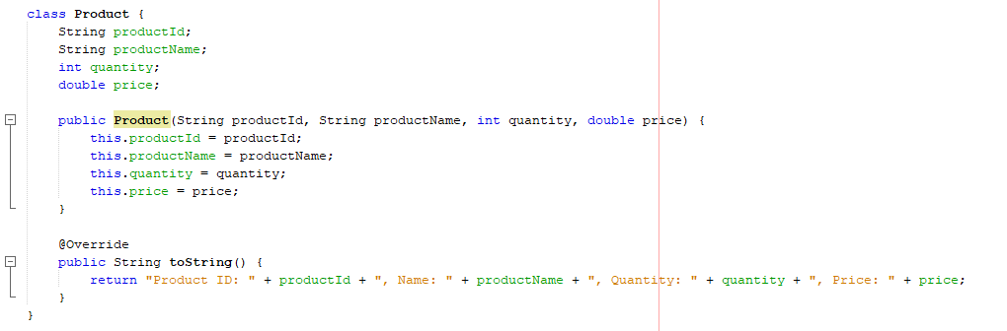

1. **Implementation:**

**Output**:

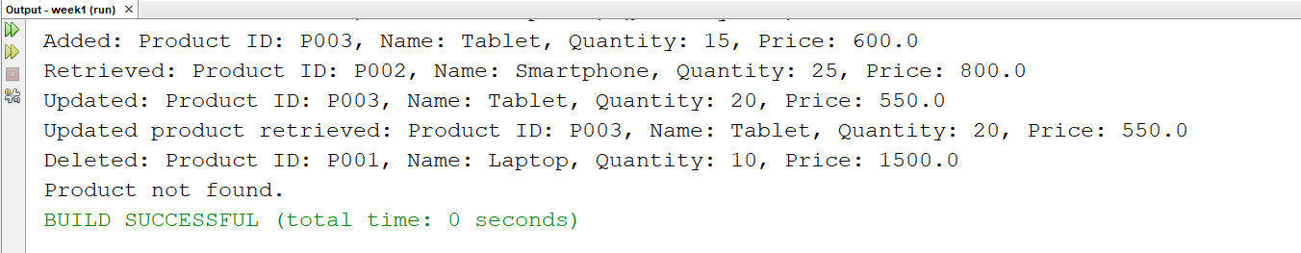

1. **Analysis:**
   * Analyze the time complexity of each operation (add, update, delete) in your chosen data structure.

* **Add Product:** O(1) average time complexity.
* **Update Product:** O(1) average time complexity.
* **Delete Product:** O(1) average time complexity.
  + Discuss how you can optimize these operations

**Optimization:** Using a HashMap ensures O(1) average time complexity for these operations. The key optimization strategy is to use hash-based data structures for efficient lookups and modifications.

**Exercise 2: E-commerce Platform Search Function**

1. **Understand Asymptotic Notation:**
   * Explain Big O notation and how it helps in analyzing algorithms.

**Big O notation** is aconcept used to describe the performance or complexity of an algorithm. It gives an upper bound on the time (or space) required by an algorithm as a function of the input size. This notation helps in understanding the scalability and efficiency of an algorithm by focusing on its asymptotic behavior.

How Big O Notation Helps in Analyzing Algorithms:

1. **Scalability:** Big O notation helps us understand how an algorithm's performance changes as the input size grows. This is crucial for predicting the algorithm's behavior with large datasets.
2. **Comparison:** It allows us to compare the efficiency of different algorithms. For example, an algorithm with a time complexity of O(n) is generally more efficient than one with a complexity of O(n^2) for large inputs.
   * Describe the best, average, and worst-case scenarios for search operations.

**Linear Search**

* **Best Case:** O(1)

The target element is found at the first position.

* **Average Case:** O(n)

The target element is located somewhere in the middle of the list, and on average, half of the elements need to be checked.

* **Worst Case:** O(n)

The target element is found at the last position or not found at all, requiring a check of all elements.

**Binary Search**

* **Best Case:** O(1)

The target element is found at the middle position on the first check.

* **Average Case:** O(logn)

The target element is located after several divisions of the list, with the number of divisions proportional to the logarithm of the list size.

* **Worst Case:** O(logn)

The target element is found after the maximum number of divisions, requiring logn comparisons.

1. **Setup:**

Code for the implementation is attached. Filename: ProductSearch.java

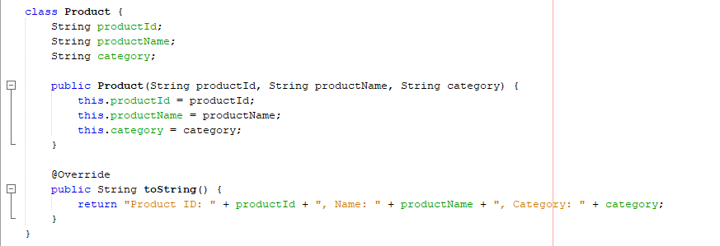

1. **Implementation:**

**Output:**

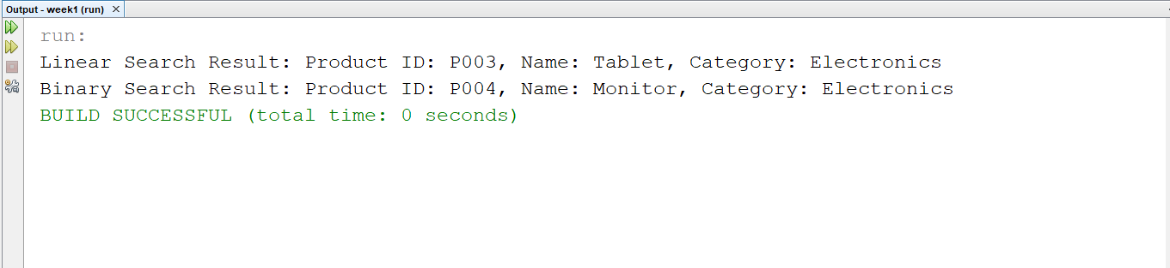

1. **Analysis:**
2. Compare the time complexity of linear and binary search algorithms.

**Linear Search**

* **Best Case:** O(1)
* **Average Case:** O(n)
* **Worst Case:** O(n)

**Binary Search**

* **Best Case:** O(1)
* **Average Case:** O(logn)
* **Worst Case:** O(logn)

1. Discuss which algorithm is more suitable for your platform and why.

Binary search is more suitable for large, sorted datasets due to its logarithmic time complexity.

**Exercise 3: Sorting Customer Orders**

1. **Understand Sorting Algorithms:**
   * Explain different sorting algorithms (Bubble Sort, Insertion Sort, Quick Sort, Merge Sort).

**1. Bubble Sort**

* **Description:** Bubble Sort is a simple comparison-based sorting algorithm. It repeatedly steps through the list, compares adjacent elements, and swaps them if they are in the wrong order. This process is repeated until the list is sorted.
* **Process:**
  + Compare each pair of adjacent elements.
  + Swap them if they are in the wrong order.
  + Repeat the process for all elements until no more swaps are needed.
* **Time Complexity:**
  + **Best Case:** O(n) (when the list is already sorted)
  + **Average Case:** O(n^2)
  + **Worst Case:** O(n^2)

**2. Insertion Sort**

* **Description:** Insertion Sort builds the sorted array one item at a time. It takes each element from the input and finds the correct position within the sorted part of the array.
* **Process:**
  + Start with the second element.
  + Compare it with the elements in the sorted part of the array.
  + Insert it into the correct position.
  + Repeat for all elements.
* **Time Complexity:**
  + **Best Case:** O(n) (when the list is already sorted)
  + **Average Case:** O(n^2)
  + **Worst Case:** O(n^2)

**3. Quick Sort**

* **Description:** Quick Sort is a highly efficient sorting algorithm based on the divide-and-conquer principle. It selects a 'pivot' element and partitions the array into two sub-arrays: elements less than the pivot and elements greater than the pivot. It recursively sorts the sub-arrays.
* **Process:**
  + Choose a pivot element from the array.
  + Partition the array into two sub-arrays around the pivot.
  + Recursively apply the same process to the sub-arrays.
* **Time Complexity:**
  + **Best Case:** O(nlogn)
  + **Average Case:** O(nlogn)
  + **Worst Case:** O(n^2) (when the pivot selection is poor)

**4. Merge Sort**

* **Description:** Merge Sort is a stable, comparison-based sorting algorithm that uses the divide-and-conquer principle. It divides the array into two halves, sorts them recursively, and then merges the sorted halves.
* **Process:**
  + Divide the array into two halves.
  + Recursively sort each half.
  + Merge the sorted halves back together.
* **Time Complexity:**
  + **Best Case:** O(nlogn)
  + **Average Case:** O(nlogn)
  + **Worst Case:** O(nlogn)

1. **Setup:**

Code for the implementation is attached. Filename: OrderSort.java

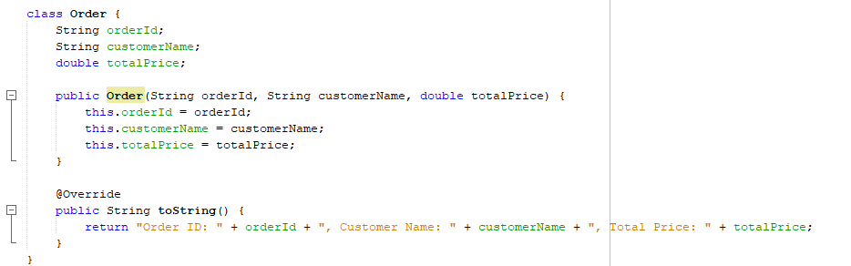

1. **Implementation:**

**Output:**

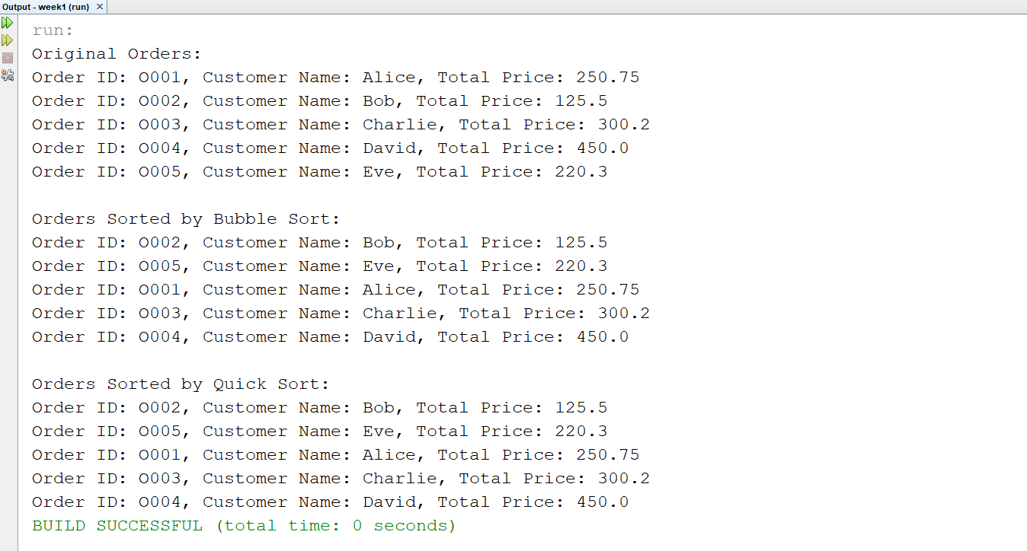

1. **Analysis:**
   * Compare the performance (time complexity) of Bubble Sort and Quick Sort.

**Bubble Sort**

* **Best Case:** O(n)
  + Occurs when the array is already sorted. The algorithm makes one pass through the array without swapping any elements.
* **Average Case:** O(n^2)
  + The algorithm makes multiple passes through the array, performing swaps to move elements into the correct order.
* **Worst Case:** O(n^2)
  + Happens when the array is sorted in reverse order. Each element needs to be swapped on every pass through the array.

**Quick Sort**

* **Best Case:** O(nlogn)
  + Occurs when the pivot element always divides the array into two equal halves. This results in a balanced partition.
* **Average Case:** O(nlogn)
  + On average, the pivot element divides the array into reasonably balanced partitions, resulting in efficient sorting.
* **Worst Case:** O(n^2)
  + Happens when the pivot element consistently divides the array into very unbalanced partitions (e.g., always selecting the smallest or largest element as the pivot in an already sorted array). However, this can be mitigated by using good pivot selection strategies like picking a random pivot or the median.
  + Discuss why Quick Sort is generally preferred over Bubble Sort.
  1. **Efficiency:**
* **Quick Sort:** On average, Quick Sort operates in O(nlogn) time, which is significantly more efficient than Bubble Sort's O(n^2). For large datasets, this difference is substantial.
* **Bubble Sort:** It has a quadratic time complexity in the average and worst cases, making it impractical for large datasets.
  1. **Scalability:**
* **Quick Sort:** Handles large datasets more effectively due to its divide-and-conquer strategy, reducing the problem size with each recursive call.
* **Bubble Sort:** As the dataset size increases, the number of comparisons and swaps grows quadratically, leading to poor scalability.

3. **Practical Performance:**

* **Quick Sort:** Often performs faster in practice compared to other O(nlogn) algorithms like Merge Sort, especially for large datasets, because of its in-place sorting nature and lower constant factors.
* **Bubble Sort:** Rarely used in practice for large datasets due to its inefficiency and high number of swaps required.

**Exercise 4: Employee Management System**

1. **Understand Array Representation:**
   * Explain how arrays are represented in memory and their advantages.

**1. Memory Layout:**

* **Contiguous Block of Memory:**
  + Arrays are stored as a contiguous block of memory locations. This means that the elements of an array are stored sequentially in adjacent memory addresses.
* **Element Access:**
  + Each element in the array can be accessed directly using its index. The memory address of an element can be computed using a base address and the index.

**2. Index Calculation:**

* **Base Address:**
  + The base address is the memory location where the array starts.
* **Element Size:**
  + The size of each element depends on the data type (e.g., 4 bytes for int, 8 bytes for double).
* **Index Formula:**
  + To access an element at index i, the address can be calculated as:

Address=Base Address+(i×Element Size)

**Advantages of Arrays**

1. **Direct Access:**
   * Arrays provide **constant-time** access to elements via indexing O(1), allowing quick retrieval and modification of values.
2. **Memory Efficiency:**
   * Arrays use contiguous memory allocation, which helps in reducing overhead associated with dynamic memory allocation and can lead to better cache performance due to spatial locality.
3. **Simplicity:**
   * The fixed-size structure of arrays simplifies implementation and management, making it easy to allocate and access memory.
4. **Predictable Performance:**
   * Operations like access, update, and traversal have predictable time complexity O(1) for access, O(n) for traversal), which can simplify performance analysis.
5. **Support for Multi-dimensional Arrays:**
   * Arrays can be used to create multi-dimensional structures (e.g., 2D matrices) by extending the concept of linear arrays, making them versatile for complex data representations.
6. **Setup:**

Code for the implementation is attached. Filename: EmployeeManagementSystem.java

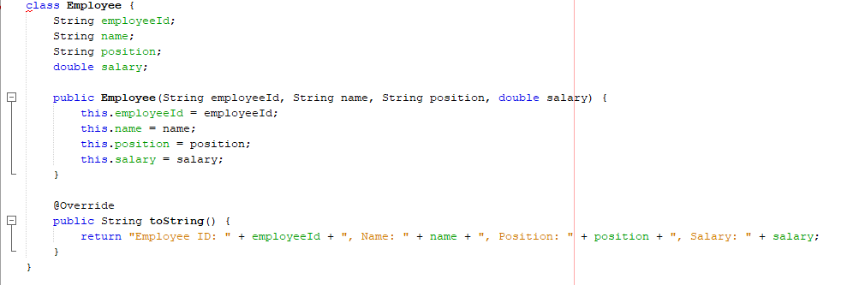

1. **Implementation:**

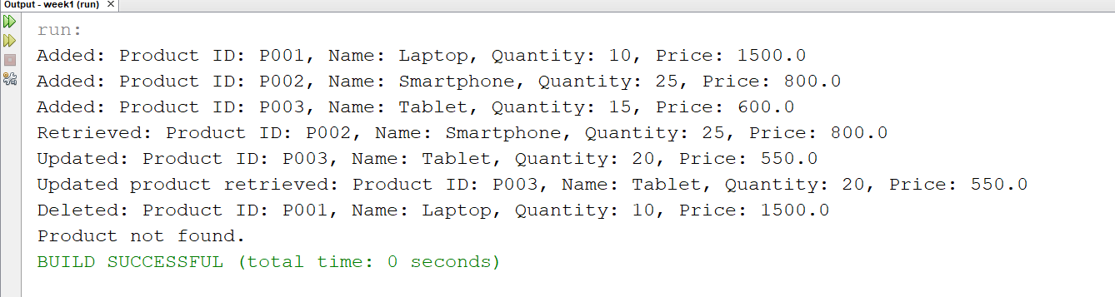

1. **Analysis:**
   * Analyze the time complexity of each operation (add, search, traverse, delete).

* **Add Operation:**
* **Time Complexity:** O(1)(Average Case)
* **Explanation:** Adding an employee involves placing the employee at the end of the array. If there is space, this operation is performed in constant time. If the array is full, this implementation does not handle resizing; it assumes that space is always available. If resizing were needed, the complexity would involve creating a new array and copying elements, which would be O(n).
* **Search Operation:**
* **Time Complexity:** O(n)
* **Explanation:** Searching for an employee by ID involves scanning through the entire array until the employee is found or the end of the array is reached. In the worst case, you may have to check every element, making the time complexity linear.
* **Traverse Operation:**
* **Time Complexity:** O(n)
* **Explanation:** Traversing the array involves iterating over all elements to print their details. This requires examining each element once, resulting in linear time complexity.
* **Delete Operation:**
* **Time Complexity:** O(n)
* **Explanation:** Deleting an employee involves searching for the employee (which is O(n)) and then shifting elements to fill the gap left by the deleted employee. Shifting elements is also linear in the worst case.
  + Discuss the limitations of arrays and when to use them.

**Limitations of Arrays**

1. **Fixed Size:**
   * Arrays have a fixed size that is determined at the time of creation. If the array becomes full, you cannot add more elements without creating a new, larger array and copying the existing elements. This limitation can be addressed by using dynamic data structures such as ArrayList in Java, which automatically resizes.
2. **Insertion and Deletion Complexity:**
   * Arrays require shifting elements when inserting or deleting elements, particularly when modifying elements in the middle. This results in O(n) complexity for these operations, making arrays less efficient compared to other data structures like linked lists, which offer O(1) insertion and deletion if you have a reference to the node.
3. **Memory Allocation:**
   * Large arrays may require a contiguous block of memory. If the system does not have enough contiguous memory, it can be challenging to allocate a large array, leading to potential allocation failures.
4. **Wasted Space:**
   * If an array is allocated with more space than needed, the extra space remains unused, potentially leading to wasted memory. This can be mitigated by dynamically resizing data structures like ArrayList.
5. **Limited Flexibility:**
   * Arrays do not offer advanced operations like dynamic resizing, efficient searching, or sorting beyond the basic linear algorithms provided by the language. For these features, other data structures such as HashMap (for fast lookups) or TreeMap (for sorted data) are more appropriate.

**When to Use Arrays**

1. **When the Size is Known and Fixed:**
   * Use arrays when you know the size of the dataset in advance and do not need to resize dynamically. Arrays are suitable for applications where the dataset size is constant or changes infrequently.
2. **For Efficient Index-Based Access:**
   * Arrays are ideal for situations where you need efficient index-based access and quick retrieval of elements by index. They provide constant-time access, making them suitable for scenarios where fast access is critical.
3. **For Simple Data Structures:**
   * Arrays work well for simple data structures like stacks or queues, where the operations are primarily related to the end of the structure (e.g., push, pop).
4. **When Memory Efficiency is a Concern:**
   * If memory overhead is a concern and you do not need dynamic resizing, arrays are a good choice because they have minimal overhead compared to more complex data structures.

**Exercise 5: Task Management System**

1. **Understand Linked Lists:**

Linked lists are data structures that consist of nodes, where each node contains data and a reference (or link) to the next node in the sequence. There are several types of linked lists, each with different characteristics and use cases. The most common types are Singly Linked Lists and Doubly Linked Lists.

**1. Singly Linked List**

* **Structure:**
  + Each node contains two parts:
    1. **Data:** The value or information stored in the node.
    2. **Next:** A reference (or pointer) to the next node in the list.
  + The list starts with a reference to the first node, known as the **head**.
  + The last node's next reference is null, indicating the end of the list.
* **Operations:**
  + **Traversal:** To access elements, you start at the head and follow the next references until you reach the end.
  + **Insertion:** Can be done at the beginning, end, or middle of the list. Inserting at the beginning involves updating the head reference.
  + **Deletion:** Removing a node requires updating the next reference of the preceding node to skip over the node being removed.

**2. Doubly Linked List**

* **Structure:**
  + Each node contains three parts:
    1. **Data:** The value or information stored in the node.
    2. **Next:** A reference to the next node in the list.
    3. **Prev:** A reference to the previous node in the list.
  + The list has two references:
    1. **Head:** Points to the first node.
    2. **Tail:** Points to the last node.
  + The prev reference of the head node and the next reference of the tail node are null.
* **Operations:**
  + **Traversal:** Can be performed in both directions (from head to tail and from tail to head).
  + **Insertion:** Can be done at the beginning, end, or middle. Updating both next and prev references is required.
  + **Deletion:** Involves updating both next and prev references of adjacent nodes to remove a node from the list.

1. **Setup:**

Code for the implementation is attached. Filename: SinglyLinkedList.java

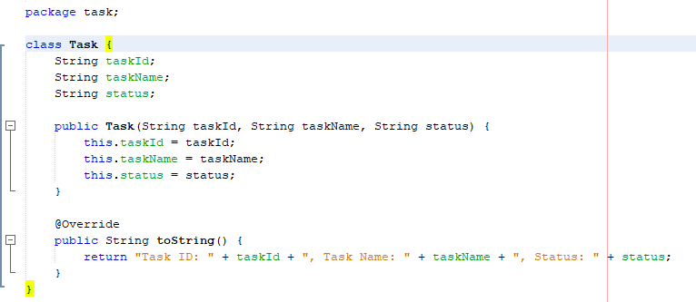

1. **Implementation:**

**Output:**

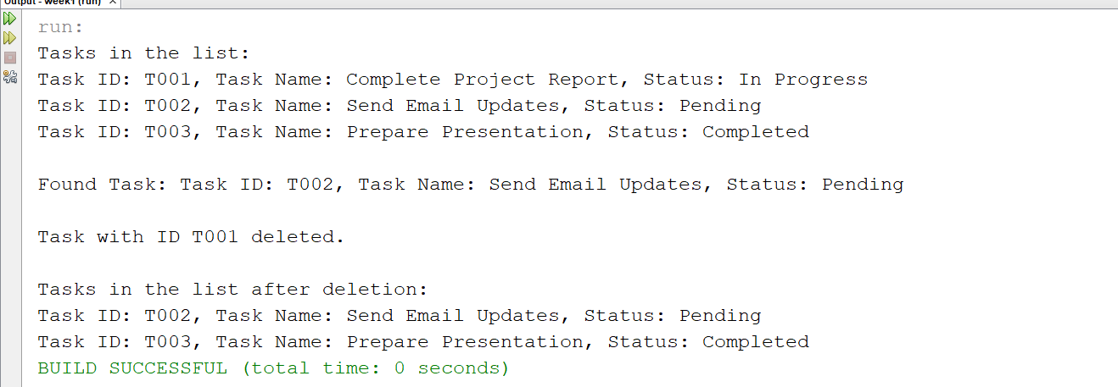

1. **Analysis:**
   * Analyze the time complexity of each operation.
2. **Add Operation:**

* **Operation:** Adding a task to the end of the list.
* **Time Complexity:** O(n)
  + **Explanation:** In the worst case, you may need to traverse the entire list to find the end before you can add the new task. If you maintain a reference to the tail (last node) of the list, adding a new node can be done in O(1) time.

1. **Search Operation:**

* **Operation:** Searching for a task by taskId.
* **Time Complexity:** O(n)
  + **Explanation:** In the worst case, you might need to traverse the entire list to find the node with the matching taskId. Each node is checked sequentially.

1. **Traverse Operation:**

* **Operation:** Traversing the list to print all tasks.
* **Time Complexity:** O(n)
  + **Explanation:** Every node in the list is visited once to print its information, resulting in linear time complexity.

1. **Delete Operation:**

* **Operation:** Deleting a task by taskId.
* **Time Complexity:** O(n)
  + **Explanation:** To delete a node, you first need to find it, which takes O(n) time. Once the node is found, removing it involves adjusting pointers, which is O(1). Thus, the overall time complexity is O(n) due to the search phase.
  + Discuss the advantages of linked lists over arrays for dynamic data
    1. **Dynamic Size:**
* **Linked List:** Can easily grow and shrink in size as needed. Nodes can be added or removed without reallocating or reorganizing the entire structure.
* **Array:** Fixed size upon creation. Resizing an array requires creating a new array and copying the elements from the old array, which is an expensive operation.
  + 1. **Efficient Insertions and Deletions:**
* **Linked List:** Insertions and deletions can be done in O(1)O(1)O(1) time if the node to be added or removed is known, especially at the head or tail of the list. No need to shift elements as in arrays.
* **Array:** Inserting or deleting elements requires shifting the subsequent elements to maintain the order, which is O(n)O(n)O(n) in the worst case.
  + 1. **Memory Usage:**
* **Linked List:** Memory is allocated dynamically for each node, which can lead to efficient memory usage when the number of elements changes frequently. However, there is some overhead due to storing pointers.
* **Array:** Memory allocation is contiguous and fixed, which can lead to inefficient memory usage if the allocated space is too large or too small.
  + 1. **Flexibility:**
* **Linked List:** Allows for flexible memory usage with no need to specify the size upfront. It can easily handle cases where the number of elements changes frequently.
* **Array:** Requires pre-definition of size. Fixed size may lead to wasted space or insufficient space, necessitating resizing operations.

**Exercise 6: Library Management System**

1. **Understand Search Algorithms:**
   * Explain linear search and binary search algorithms.

**Linear Search Algorithm**

**Definition:** Linear search, also known as sequential search, is a straightforward algorithm for finding a target value within a list. It checks each element in the list sequentially until the target is found or the end of the list is reached.

**How It Works:**

1. Start from the beginning of the list.
2. Compare the target value with the current element.
3. If the target matches the current element, return the index or position of the element.
4. If the target does not match, move to the next element.
5. Repeat steps 2-4 until the target is found or the end of the list is reached.
6. If the end of the list is reached without finding the target, return a value indicating that the target is not present (e.g., -1).

**Time Complexity:**

* **Worst-Case:** O(n)
* **Best-Case:** O(1) (if the target is the first element)
* **Average-Case:** O(n)

**Binary Search Algorithm**

**Definition:** Binary search is a more efficient search algorithm that works on sorted lists. It repeatedly divides the search interval in half, narrowing down the potential locations of the target value until it is found or the interval is empty.

**How It Works:**

1. Start with the middle element of the list.
2. Compare the target value with the middle element:
   * If the target is equal to the middle element, return the index of the middle element.
   * If the target is less than the middle element, narrow the search to the left half of the list.
   * If the target is greater than the middle element, narrow the search to the right half of the list.
3. Repeat step 2 until the target is found or the search interval is empty.
4. If the interval is empty, return a value indicating that the target is not present (e.g., -1).

**Time Complexity:**

* **Worst-Case:** O(logn)
* **Best-Case:** O(1) (if the target is the middle element)
* **Average-Case:** O(logn)

1. **Setup:**

Code for the implementation is attached. Filename: BookSearch.java

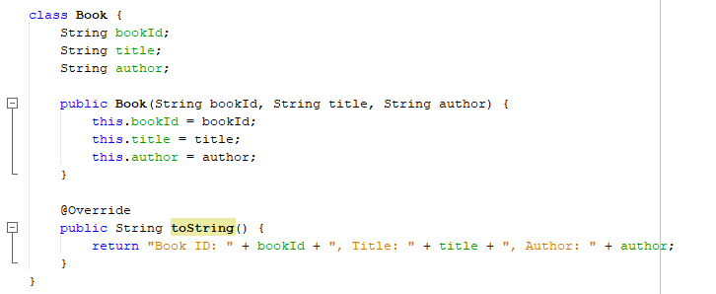

1. **Implementation:**

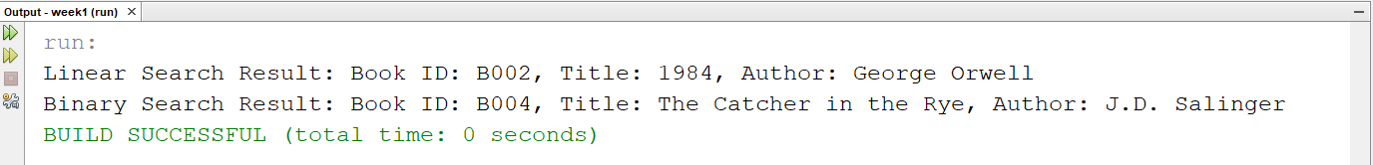

1. **Analysis:**
   * Compare the time complexity of linear and binary search.

**Linear Search**

* **Best Case:** O(1)

The target element is found at the first position.

* **Average Case:** O(n)

The target element is located somewhere in the middle of the list, and on average, half of the elements need to be checked.

* **Worst Case:** O(n)

The target element is found at the last position or not found at all, requiring a check of all elements.

**Binary Search**

* **Best Case:** O(1)

The target element is found at the middle position on the first check.

* **Average Case:** O(logn)

The target element is located after several divisions of the list, with the number of divisions proportional to the logarithm of the list size.

* **Worst Case:** O(logn)

The target element is found after the maximum number of divisions, requiring logn comparisons.

* + Discuss when to use each algorithm based on the data set size and order.

**Linear Search**

**Use Linear Search When:**

1. **Unsorted Data:** Linear search does not require the data to be sorted. It works on both sorted and unsorted arrays.
2. **Small Data Sets:** For smaller datasets where n is relatively small, the difference in performance between linear and binary search may be negligible.
3. **Simple Implementation:** It is straightforward to implement and does not require additional steps like sorting.

**Example Scenarios:**

* Searching through a list of user names in an unsorted array.
* Finding an item in a small list where sorting is not feasible or necessary.

**Binary Search**

**Use Binary Search When:**

1. **Sorted Data:** Binary search requires the data to be sorted. If the data is not sorted, you must sort it first, which incurs O(nlogn) complexity.
2. **Large Data Sets:** For large datasets, binary search is more efficient than linear search due to its logarithmic time complexity.
3. **Frequent Searches:** If you perform multiple searches on the same sorted dataset, binary search is advantageous because of its efficiency.

**Example Scenarios:**

* Searching for a book in a sorted catalog of books by title.
* Looking up a contact in a sorted phone book.

**Exercise 7: Financial Forecasting**

1. **Understand Recursive Algorithms:**
   * Explain the concept of recursion and how it can simplify certain problems.

**Definition:** Recursion is a programming technique where a function calls itself directly or indirectly to solve a problem. The function typically performs a simpler version of the original problem, which helps in breaking down complex problems into more manageable parts.

**How It Works:**

1. **Base Case:** The recursion must have a base case, which is a condition under which the recursion stops. This prevents the function from calling itself indefinitely and ensures that the recursion eventually terminates.
2. **Recursive Case:** The function calls itself with a modified argument, moving towards the base case. Each recursive call should simplify the problem or reduce its size, making progress towards the base case.

**General Structure of a Recursive Function:**

recursiveFunction(parameters):

if(baseCaseCondition){

return result;}

else{

return recursiveFunction(modifiedParameters);}

**Simplifying Problems with Recursion**

1. **Divide and Conquer:**
   * **Concept:** Recursion is useful in problems that can be divided into smaller, similar subproblems. Each recursive call deals with a smaller part of the problem.
   * **Example:** Sorting algorithms like Merge Sort and Quick Sort use recursion to sort smaller segments of the array, and then combine or partition these segments to produce the final sorted list.
2. **Problem Decomposition:**
   * **Concept:** Recursion allows you to decompose a complex problem into simpler subproblems that are easier to solve. This often makes the code cleaner and more intuitive.
   * **Example:** Calculating Fibonacci numbers, where each number is the sum of the two preceding ones. This can be elegantly solved using a recursive approach.
3. **Backtracking:**
   * **Concept:** Recursion is often used in algorithms that explore all possible solutions, such as pathfinding and puzzle-solving. It explores a solution path, and if it fails, it backtracks to try alternative paths.
   * **Example:** Solving the N-Queens problem or maze traversal problems, where the algorithm tries different configurations and backtracks when it reaches a dead end.
4. **Simplified Code:**
   * **Concept:** Recursive solutions can simplify the code by reducing the need for iterative constructs and making it easier to read and understand. The recursive approach naturally mirrors the problem's structure.
   * **Example:** Tree traversals (pre-order, in-order, post-order) are naturally recursive due to the hierarchical nature of trees.
5. **Setup:**
   * Create a method to calculate the future value using a recursive approach.

Code attached in FinancialForecasting.java file

Output:

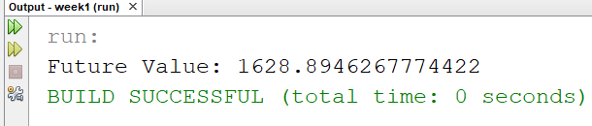

1. **Implementation:**
   * Implement a recursive algorithm to predict future values based on past growth rates.

Code attached in FutureValuePredictor.java file

Output:

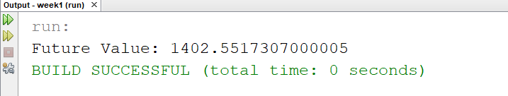

1. **Analysis:**
   * Discuss the time complexity of your recursive algorithm.

**Time Complexity:**

* **Worst-Case Time Complexity:** O(n)

This is because the function predictFutureValue makes n recursive calls, where n is the number of periods. Each recursive call performs a constant amount of work (multiplying and passing parameters), so the time complexity grows linearly with the number of periods.

* **Space Complexity:** O(n)

Due to the depth of the recursion stack. Each recursive call adds a new frame to the call stack, and the maximum depth of the recursion is equal to the number of periods.

* + Explain how to optimize the recursive solution to avoid excessive computation.

Recursive solutions can often be optimized to avoid excessive computation and improve efficiency. Here are some strategies to optimize the recursive approach:

1. **Iterative Approach:**
   * **Concept:** Convert the recursive solution into an iterative solution using loops. This avoids the overhead of recursive calls and the risk of stack overflow.
   * **Example:** The future value calculation can be implemented using a loop instead of recursion.

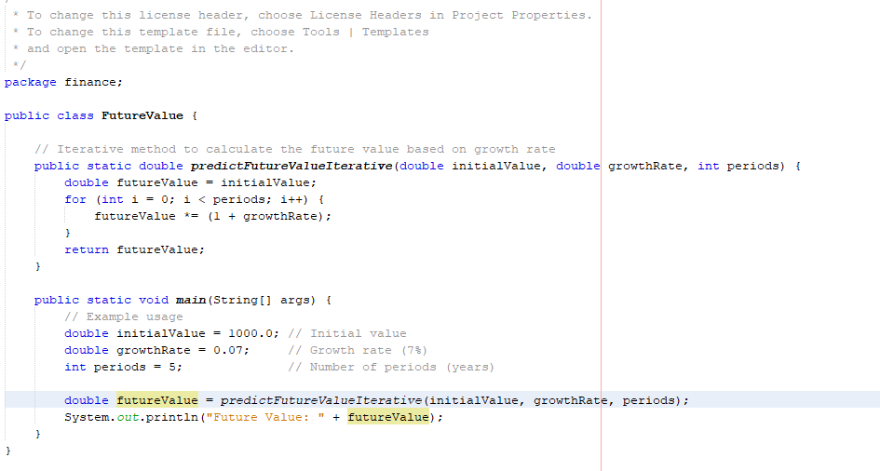

1. **Tail Recursion Optimization:**

**Concept:** Convert the recursive function into a tail-recursive function, where the recursive call is the last operation in the function. Tail recursion can be optimized by some compilers and languages into iteration, which reduces the overhead of maintaining the call stack.

