目标：

在现有activeX视频插件基础上，支持chrome45之后版本浏览器

采用的技术：

Chrome Native Messaging，

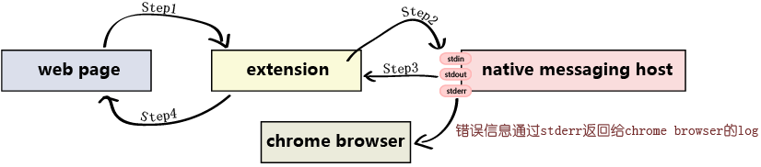

开发一个exe应用程序接收NativeMessaging消息，按照加载对应ActiveX控件，并子窗口化将画面附加到chrome浏览器中。

Chrome页面向nativehost发送消息，exe客户端解析并执行采用stdout返回消息，一次最多能向native messaging host发送4GB字节的请求，native messaging host一次最多能返回1M字节的消息。

需要实现的API

|  |  |  |
| --- | --- | --- |
| 命令 | 形式 | 返回 |
| ATTACH | {type: 'ATTACH' ,right:0,buttom:0,width: 1300,height: 800,param:’xml’} | { type: 'ATTACH' ,msg:’success’} |
| RESIZE | {type: 'RESIZE',left:0,top:0,width: 1300,height: 800} | { type: ' RESIZE ' ,msg:’success’} |
| DETACH | { type: 'DETACH' } | { type: ' DETACH ' ,msg:’success’} |
| VERSION | { type: 'VERSION' } | { type: 'VERSION' ,version:’1’} |
| CMD | {type: 'CMD',method:’preview’,param:’xml’ } | {type: 'CMD',method:’preview’,param:’success’ } |
|  |  |  |

**参考资料**

http://www.cnblogs.com/o--ok/archive/2015/07/22/4668817.html

<http://blog.csdn.net/lee353086/article/details/49362811>  
[1]《Native Messaging》  
https://developer.chrome.com/extensions/nativeMessaging#examples      
[2]《Alternative Extension Distribution Options》  
https://developer.chrome.com/extensions/external_extensions  
[3]Chrome 插件: 起动本地应用 (Native messaging)   
http://blog.csdn.net/talking12391239/article/details/38498557  
[4]extension Packaging  
https://developer.chrome.com/extensions/packaging  
[5]extensions的示例代码  
https://developer.chrome.com/extensions/samples#search:  
[6]html和js的学习资源  
http://www.w3school.com.cn/tags/tag_input.asp  
[7]分享Chrome Extension（扩展程序/插件）开发的一些小经验   
http://www.cnblogs.com/dudu/archive/2012/11/22/chrome_extension.html  
[8]sending message to chrome extension from a web page  
http://stackoverflow.com/questions/11431337/sending-message-to-chrome-extension-from-a-web-page  
[9]Chrome Extension how to send data from content script to popup.html  
http://stackoverflow.com/questions/20019958/chrome-extension-how-to-send-data-from-content-script-to-popup-html  
[10]如何开发extension的官方文档  
https://developer.chrome.com/extensions  
[11]JavaScript 自定义事件  
http://kayosite.com/javascript-custom-event.html  
[12]《如何在Chrome浏览器安装第三方扩展》  
http://www.williamlong.info/archives/3160.html