 Semester I 2025/2026
Subject: Technology and Information Systems (SECP1513)
Task: Design Thinking (Group 1)
Lecturer: Dr Azurah

  Name: Lily Amira Batrisya binti  Shahrul Sham  Matrics: A25CS0082 |   Name: Chen Xin Yan  Matrics: A25CS0049
  Name: Muhammad Adib bin  Mohd Soffee  Matrics : A25CS0258 |   Name: Sivaraam A/L Murukan  Matrics: A25CS0355
Table of Contents
1.0 INTRODUCTION 2
1.1 Empathize 2
1.2 Define 3
1.3 Ideate 3
1.4 Prototype 3
1.5 Test 4
2.0 DETAILED STEPS 4
2.1 Empathize 4
2.2 Define 6
2.3 Ideate 7
2.4 Prototype 8
2.5 Test 9
3.0 DETAILED DESCRIPTION 10
3.1 Problem 10
3.2 Solution 10
3.3 Team Working 11
4.0 DESIGN THINKING ASSESSMENT POINTS 12
5.0 DESIGN THINKING EVIDENCE 13
5.1 Empathy Phase 13
5.2 Define Phase 13
5.3 Ideate Phase 14
5.4 Prototype Phase 14
5.5 Prototype Testing Phase 15
6.0 REFLECTION 16
7.0 TASK DISTRIBUTIONS 19
8.0 REFERENCES 19

1.0 INTRODUCTION
Design thinking is a problem-solving and innovative design process that emphasizes meeting user requirements. It is an innovative process used for improving existing products, applications, or developing new products, applications. Design thinking follows steps, including empathize, define, ideate, prototype, and deploy. Design thinking, being widely applied, is used in software design too. There are steps involved in design thinking research methodology, which include problem identification, carrying out empirical studies, data analysis, experiments, and assessing results.
The target group that we, as researchers, will focus upon is children suffering from Attention Deficit Hyperactivity Disorder or ADHD. ADHD may be described as a neurodevelopmental disorder that influences attention, control over impulses, and activity levels. This disorder mostly affects learning, behavior, and performance, which mostly occurs in a classroom. After conducting several interviews, we found out that children suffering from ADHD generally experience problems regarding focus, organizing tasks, and the learning processes they follow, which is mostly by existing applications that fail to deliver well. Therefore, our proposed solution will attempt to tackle these problems differently by catering to their needs.

1.1 Empathize

Within this phase, we aimed at understanding the circumstances facing children aged 5-9 years, particularly those who cannot sustain attention in a classroom setting when it comes to learning. During our observation, we realized that children lose attention easily when it comes to current teaching approaches used in classrooms. We interacted with teachers and parents to understand children’s behavior when it comes to learning, attention span, and issues they face when reading, writing, and performing arithmetic operations. During our immersion in current applications used in teaching children, we realized the need to develop something that can help children based on their attention spans.

1.2 Define
In this phase, we worked on creating a clear statement or perspective that sums up the specific users, insights, and needs uncovered during the Empathy phase.
Problem Statement:
Children aged 5–9 years are often found inattentive in the class, and they subsequently lag other children in learning basic skills like reading, writing, and arithmetic.
Point of View:
It is from this perspective that an interactive child-friendly learning application that can keep children engaged through interactive mini-games, focused on their work, and in return help them grasp concepts in a playful and easy manner.

1.3 Ideate
In this ideation phase, various concepts were evaluated to tackle problems of learning faced by young children. The aim was to generate learning activities that are engaging, understandable, and effective.
Ideas Generated:
- Alphabet tracing mini games to improve writing ability
- Games involving pronunciation to aid reading and learning phonics
- Games of basic mathematics based on addition and subtraction
- Use reward systems such as points or stars to engage learners

1.4 Prototype
By the end of the prototype stage, the objective was to translate concepts into a functional application. In this phase, a lowfidelity prototype was designed, which included activities in the form of mini games related to alphabet tracing, pronouncing the alphabet, basic arithmetic calculations like addition, and subtraction. This application should have a design showcasing bright colors, a simple layout, large touch areas, and a significant emphasis placed on non text content to suit the requirements of the targeted group of users between the ages of 5 to 9 years.
The prototype facilitated the test of realistic usage situations and the determination of possible improvement opportunities in terms of design aspects. Screens available on the application contained different tasks pertaining to learnings and thus helped determine ease of understanding, navigation, and engagement of the users. It is this stage that helped the development of a simple and engaging application to suit the intellect of the users before engaging in further development stages.

1.5 Test
During the testing phase, the prototype was evaluated using the observation method involving the children as they used mini games in the application. Feedback from the children, parents, and teachers was used to determine the level to which the application managed to promote learning and engagement. Factors considered during the observation included the length of time the children engaged in using the application, the ease of understanding of the application's instructions, and overall enjoyment of using the application.

Based on the data gathered and results, improvements were introduced to make the product more user-friendly and effective with regards to learning outcomes. The improvements included the simplification of the instructional matter, visual aids, and matching the level of difficulty with the learning process speed of the children to make the product more engaging and effective in the process of directing the attention and learning of the children.

2.0 DETAILED STEPS

2.1 Empathize
The table shows all the questions asked in the survey:

Questions | Answer
Do you know what ADHD is ? | Yes, I'm completely aware of it.
Tell me your background. | I know someone with ADHD
How old are you ? | > 18
Do you think kids struggles with ADHD more than adults or vice versa? | Both are the same
What is the main struggles for people with ADHD ? | Not be able to focus for too long
What is your biggest concern about ADHD ? | Being left behind in classes / work space
What’s the biggest challenge in getting kids excited about learning? | to stay focused
Do you think digital solutions could help people with ADHD ? | Yes
What subjects or skills would you like the app to focus on? | Creativity
What game feature can help kids with ADHD the most? | Puzzles & Brain Teasers
What function do you think is important to be included in the website | -
What’s one feature you’ve always wanted in a learning app? | Timer
What's the most annoying part of any application ? | Advertisement

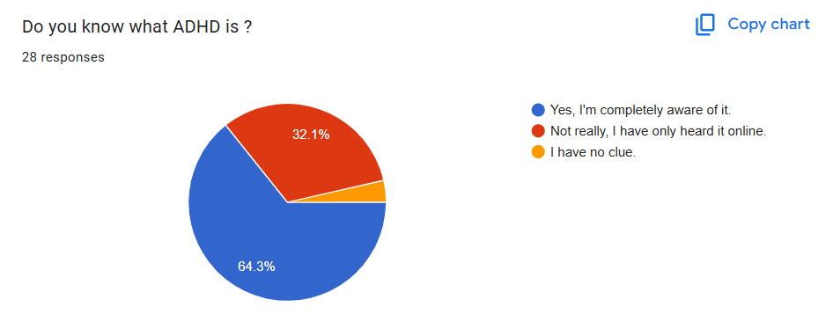 | 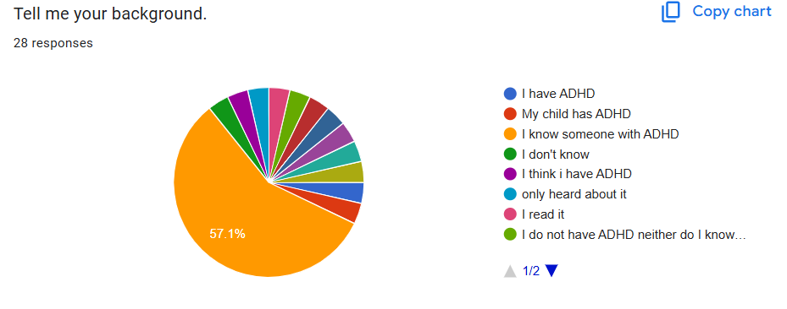
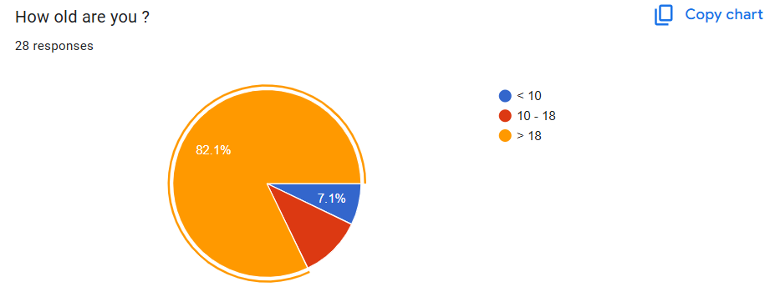 | 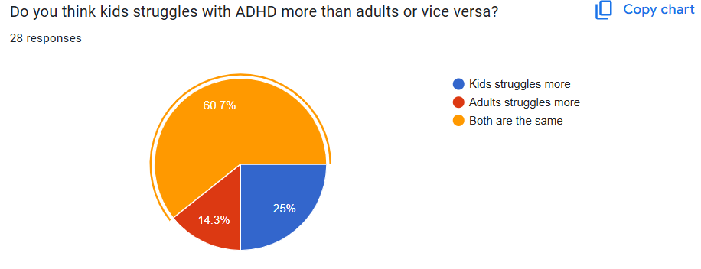
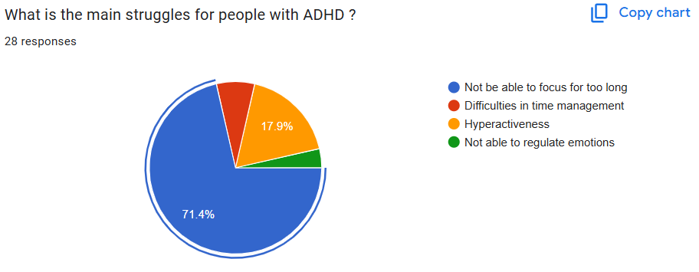 | 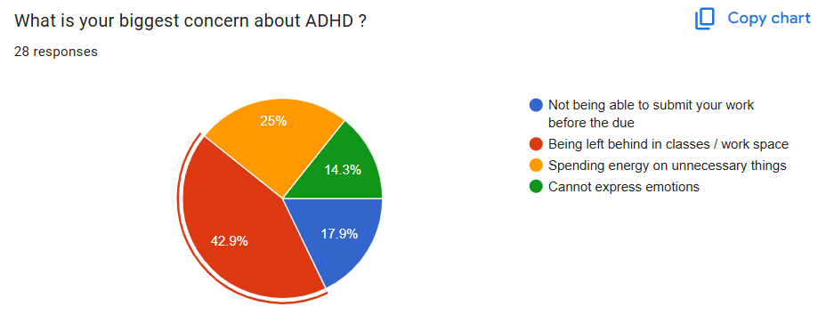
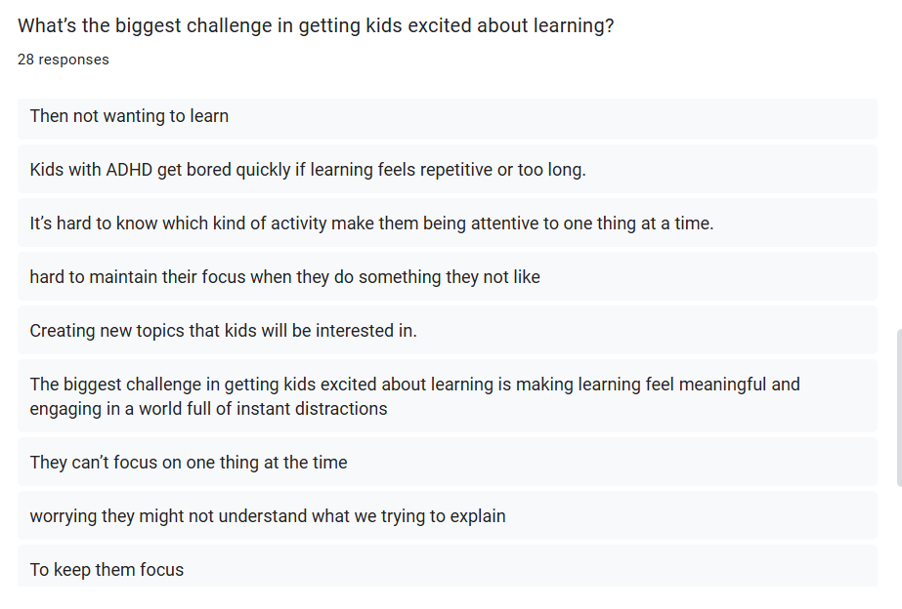 | 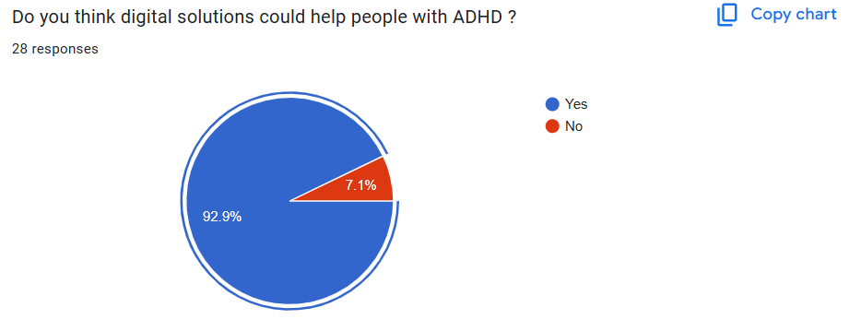
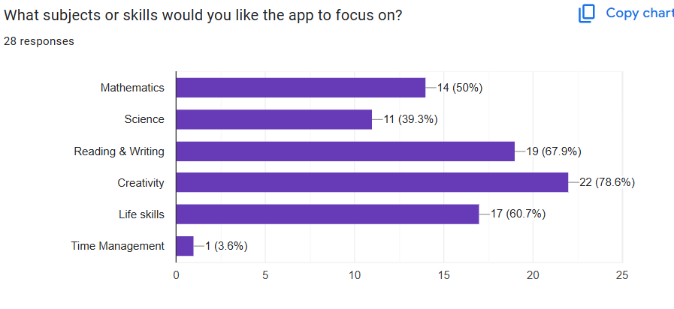 | 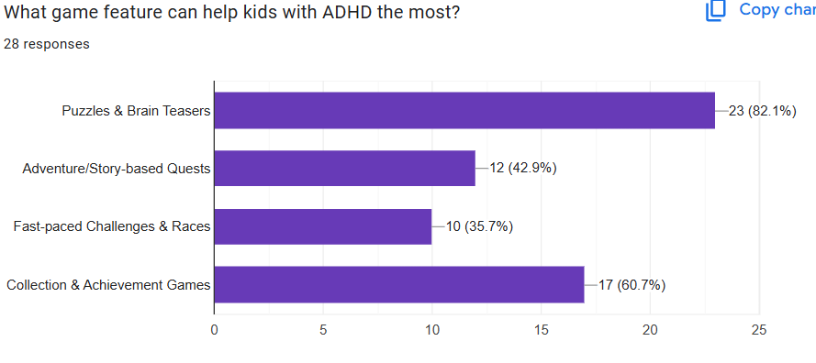
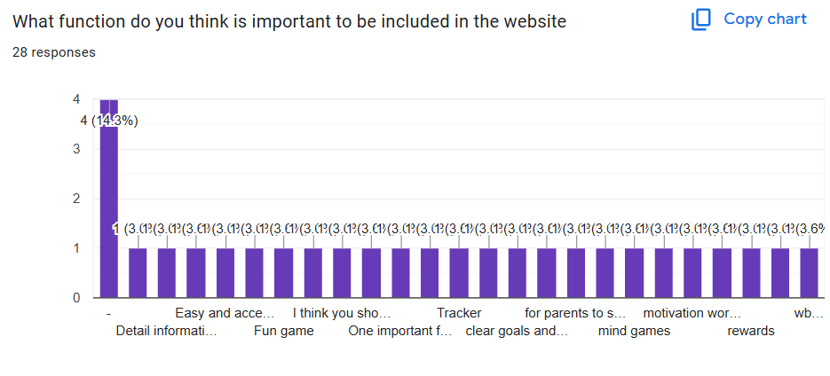 | 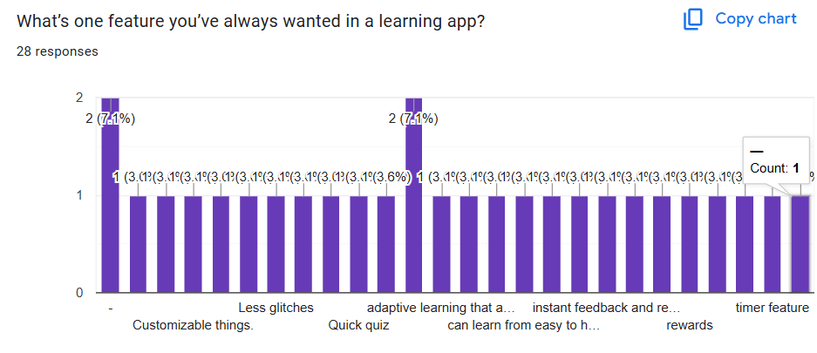

2.2 Define
The table shows the problem and description for each problem

Problem | Description
Children aged 5–9 years are often found inattentive in the class | ADHD screening tools and classroom observation checklists often mistakenly identify normal childhood energy and shorter attention spans as surefire signs of ADHD, leading to false positives. This can result in youngsters, age 5-9, being diagnosed unnecessarily as inattentive or having ADHD,leading sometimes to inappropriate medication, lowered expectations by teachers and parents, and unnecessary stress for the child-sometimes seriously fucking up their self-esteem and confidence during those super important early school years.
The children are subsequently lag other children in learning basic skills like reading, writing, and arithmetic | The ADHD tests, as well as the early childhood school evaluations, will give a false positive on kids that are a little behind in reading, writing, or math, thinking that the significant problem of academic failure is due to ADHD. When in fact most of these kids are just late developers, immature for their age, or haven’t yet had the chance to learn enough. Kids 5 to 9 years old are being diagnosed with developmentally delayed.

2.3 Ideate
Solution Idea | Description
Alphabet tracing mini games to improve writing ability | Alphabet tracing minigames that would be apt for ADHD children and would help improve their writing skills. This would allow them to have enhanced focus and fine motor skills.
Games involving pronunciation to aid reading and learning phonics | Games for practicing pronunciation should be developed for ADHD children to support reading and phonics skills development. This will enhance phonological and speech skills by completing short exercises with instant feedback and rewards for children when building skills.
Games of basic mathematics based on addition and subtraction | Design simple mathematical games that focus on addition and subtraction, specially targeted at ADHD children. This will develop number sense and mental math fluency through fast-paced, visually stimulating mini-challenges including frequent rewards, short rounds, and immediate feedback to help them maintain attention while building confidence and automaticity in core arithmetic skills.
Use reward systems such as points or stars to engage learners | Use reward systems such as points or stars to engage those with ADHD. This will not only motivate but also increase focus in academic tasks to counter distractions.

2.4 Prototype
The table encapsulates essential steps in crafting a user-friendly prototype, from initial ideation to hands-on testing, highlighting the iterative nature of the design process and the creation of tangible representations for effective solutions

Step | Action | Purpose
Empathize | Observe and do a survey to understand challenges | Gather insights on user needs
Define | Clearly articulate the problem and need | Define the scope of the design challenge
Ideate | Prioritize ideas for effective solutions | Brainstorm potential solutions.
Prototype | Use CANVA or sketch our prototype on paper | Create tangible representations for testing.
Test | Conduct hands-on testing | Validate the prototype

Characteristics | Description
Home Page | Make user friendly interface home page for user because they can access easily
Playground | Contain three types of activities for user . Each activity contains three different levels.
Contact | Bottom to help the user to contact us if they face any issues on website or need help

2.5 Test
While assessing the efficiency of our ADHD oriented learning site, we also performed an in-depth usability and functionality analysis. Through observation of user activity, comments from parents and guardians of child users, and functionality testing of critical functionality such as focus mode functionality, tracking of progress, and role based access functionality, we were able to identify possible usability related issues that need improvement. Furthermore, the newly added functionality of 'Playground' was used for assessing the usability of providing interactive learning options like letter tracing activities, speaking practice exercises, and basic math skills in the site to determine the efficiency of the site in helping ADHD kids stay engaged and focused throughout the activities using visual presentations that are easy to follow and understand.

Moreover, the Contact functionality was also evaluated for accessibility and response, which helps parents and guardians connect effectively with the support services in case help is needed. This functionality is paramount in building user confidence, which is a critical aspect in ensuring sustained usage of the platform. Based on the evaluation process, it can be ascertained that the website is effective in supporting children with ADHD by providing a distraction-free environment, facilitating organized learning, incorporating interactive participation, and allowing for constant progress checks. Based on the test outcome, it is evident that the platform is effective in providing a helpful online learning environment for children with ADHD, in addition to being a valuable resource for their guardians.

3.0 DETAILED DESCRIPTION

3.1 Problem
In early childhood education, they usually face problems maintaining focus for a long time, especially children between the ages of 5-9 with ADHD. ADHD children find it difficult to pay attention for a long time, as well as complete tasks in a traditional learning environment.
Learning methods that rely heavily on textbooks and lengthy teacher explanations can be said to be quite unsuitable for them. This type of learning method causes ADHD children to feel uninterested in learning. As a result, they will fall behind in their learning. Their basic skills such as reading, writing and arithmetic are also affected.
Therefore, alternative learning methods are needed to overcome this problem. This project aims to support their learning so that it is more enjoyable and easier to understand for ADHD children.

3.2 Solution
To overcome this problem, our team proposed to create an application with mini games that help ADHD children in their learning. This application has interesting games and features to make them more interested and enthusiastic.
This application includes mini games that help improve their basic skills such as tracing letters, and basic calculations. The difficulty of the game can also be adjusted according to the children's development, and there are also many interesting visuals and audio provided. It helps children to improve their basic skills while maintaining their interest and focus.
Overall, this mini-game application offers a more effective and child-friendly learning approach. By combining both learning and games, this application can improve focus, motivation, and academic development of ADHD children aged 5 to 9 years.

3.3 Team Working
This project was developed through the different skills of each team member. Good cooperation and communication among our team members played an important role in the success of this project.
At the early stage, we held a meeting to share our experiences and knowledge regarding ADHD. We identified the main problems they faced, especially ADHD children between the ages of 5-9.
Next, we conducted a brief study regarding ADHD children through several articles. We also interviewed several students from the psychology department to learn more about ADHD. With the information we obtained, we were able to find suitable and interesting application features to help them.
In creating this application, each team member worked together to create a mini-game concept such as basic calculations. This application emphasizes visuals and audio that can interest them.
Finally, we conducted internal tests on the application to evaluate the functions of the mini games created. The test results were used to make improvements before the final version was produced. Through effective team cooperation, this project was successfully developed with the objective of providing a more fun and effective learning platform for ADHD children.

4.0 DESIGN THINKING ASSESSMENT POINTS
Our assessment aimed to ensure that the proposed prototype would effectively support Attention Deficit Hyperactivity Disorder (ADHD) individuals in disadvantaged communities. The goal was to validate whether the features included such as gamified lessons and parents’ dashboards would help the real struggles faced.

For the Empathize Stage, we conducted an interview via Google Meet with several people who have knowledge about ADHD to gain ideas about the disorder while also getting insights into their needs and challenges faced. On the other hand, we simultaneously did a survey through Google Forms to gather information from possible users. Despite that, we did several readings on articles related to ADHD and its difficulties.
Moving to the next step, it is Define Phase where our team members analyzed the problems mentioned based on the information gathered during Empathize Stage. We have concluded the problems and move forward to finding solutions that could lighten the burden from the difficulties they faced in their daily life.

Next, in the Ideate Phase we brainstormed potential solutions to help solve the problems identified. After looking thoroughly at all the ideas we have, we agreed on one best solution. We ask our lecturer to gain more insights and opinions before taking the next step.

Finally, we proceed to the Prototype Phase by using the solution we all agreed upon during the previous phase. Our prototype is to create an application with mini gamified lessons to help kids around the age of 5-year-old to 10-year-old, who struggle to stay updated in classes which leads them to fall behind. For instance, the application will help them in basic calculations like addition and subtractions. Other than that, it will help them to write better and even pronounce words.

5.0 DESIGN THINKING EVIDENCE

5.1 Empathy Phase
https://drive.google.com/file/d/12k-rZqIJBKCv2sVQPX-qVme-7t_0g_v-/view?usp=sharing
(Interview with Psychology student)

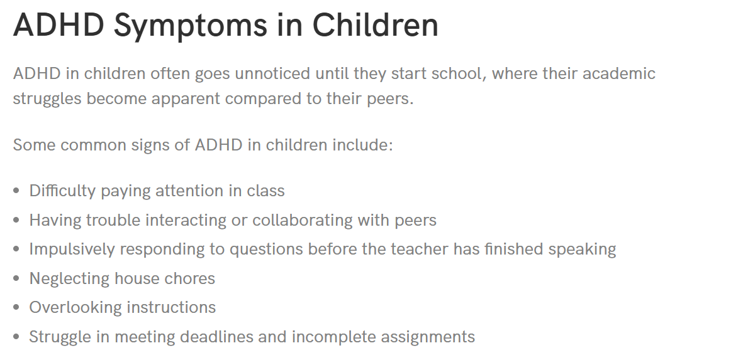
(Understand the difficulties in ADHD children)

5.2 Define Phase
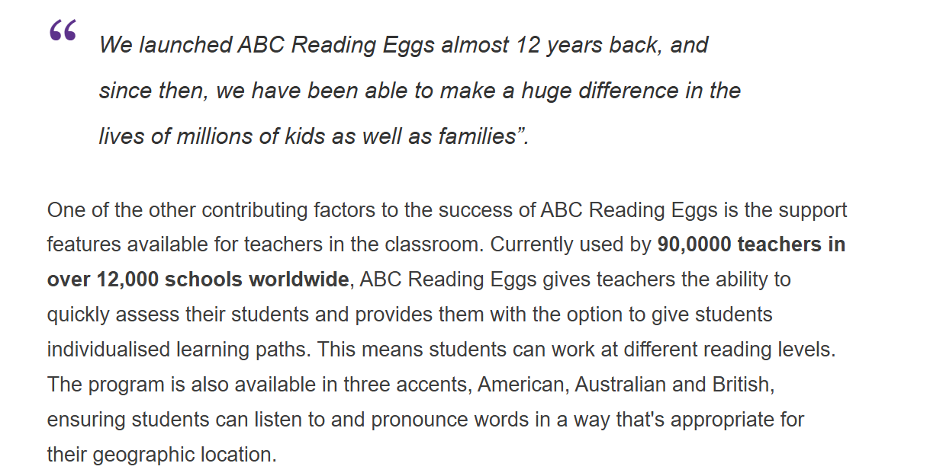
(Research to prove that our ideas are feasible)

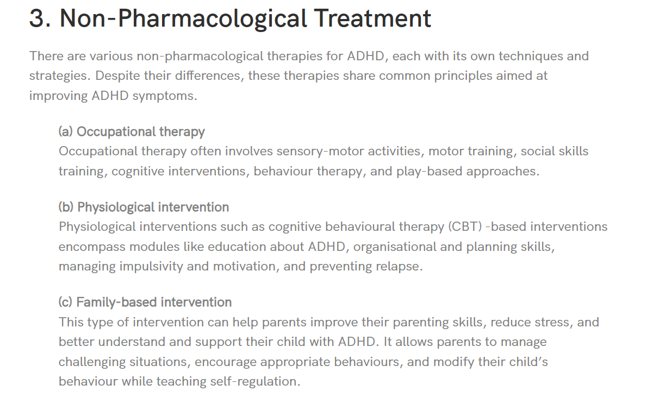
(Decide the area to focus: Non-pharmacological Treatment that involves motor training and play-based approaches)

5.3 Ideate Phase
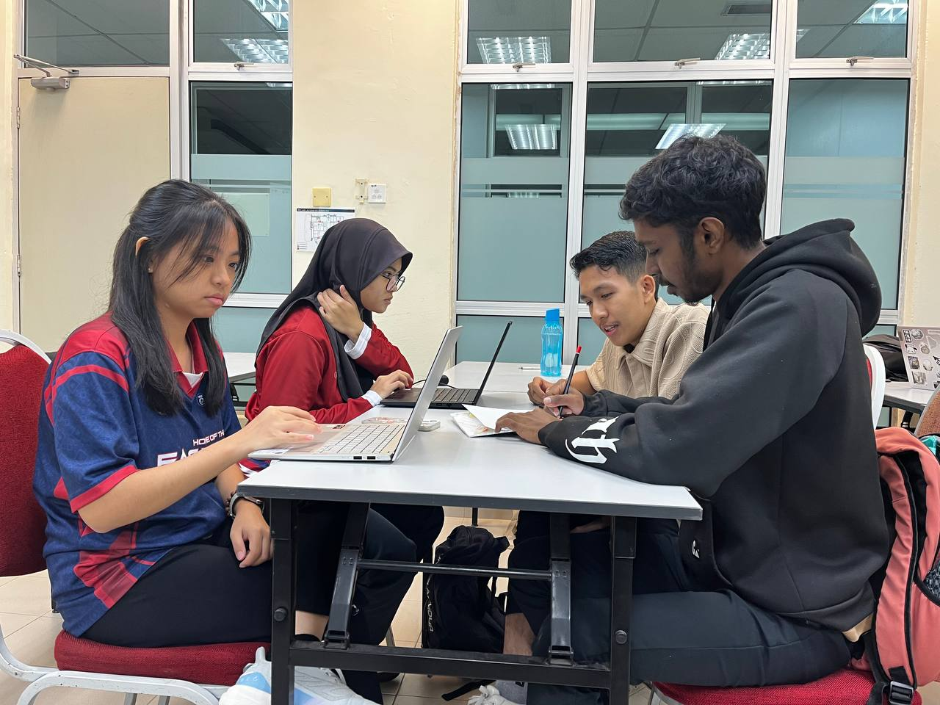
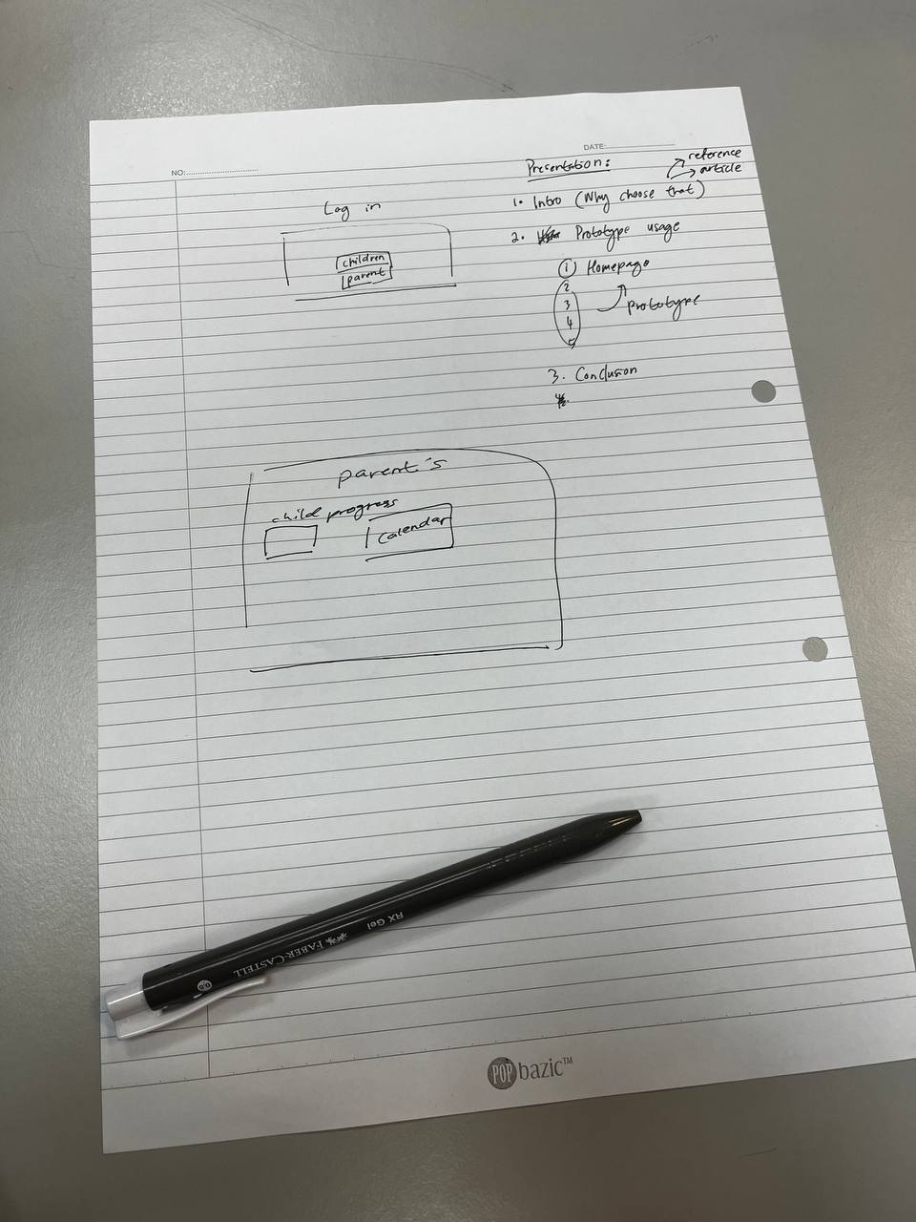

5.4 Prototype Phase
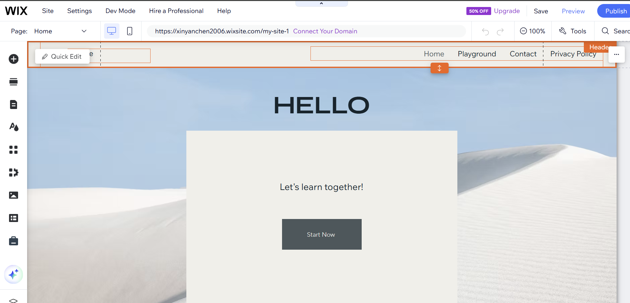https://xinyanchen2006.wixsite.com/my-site-1

5.5 Prototype Testing Phase
https://drive.google.com/file/d/1Dm9HjEnASZCB-tqsAxsyjxYJEFiJpiyU/view?usp=sharing
(to test the function of the application)

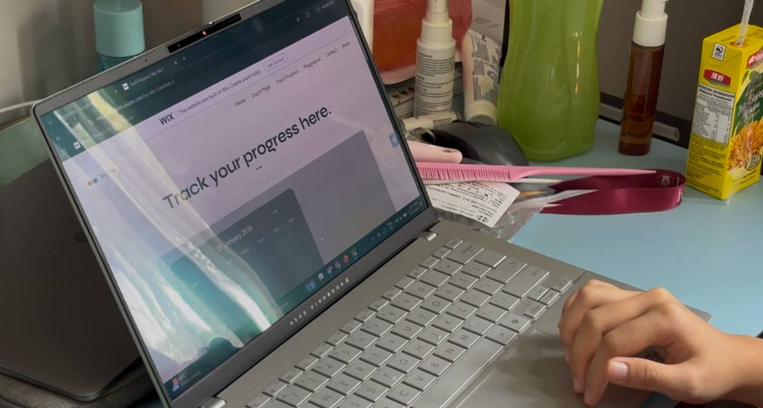

6.0 REFLECTION
1) LILY AMIRA BATRISYA BINTI SHAHRUL SHAM (A25CS0082)

- What is your goal/dream regarding your course/program?
I dream to achieve success by being able to help others in having easier daily life with my own application or website. Not only that, but I also wish to become an individual who is brave enough to stand out while generating new ideas to help the world evolves. Also, I hope I will be able to be a great leader who can guide the team while sharing knowledge and be an inspiration for others.

- How does this design thinking impact on your goal/dream regarding your program?
Throughout the process of this design thinking project, I learned to sharpen my communication skills. It has also helped me to use my imaginations more during brainstorming to solve problems. Additionally, I have come to listen, appreciate and look at all points of views to get the best answer as a solution.

- What is the action/improvement/plan necessary for you to improve your potential in the industry?

I must polish my knowledge more on the current updates on technologies since it is evolving quickly. I do have to learn more programming language like Python, HTML, CSS, Java and even JavaScript to increase skills and increase my value in the job market. It may sound difficult, but it can be learned through exercise and joining boot camp.

2) CHEN XIN YAN (A25CS0049)
- What is your goal/dream regarding your course/program?
My goal regarding this course is to apply the knowledge I have learned into a real-world industry project. I aim to figure out and develop the feasible solutions to practical problems. For instance, I hope to create a digital solution that can support and benefit the minority communities.

- How does this design thinking impact on your goal/dream regarding your program?
Design thinking can support my goal for this project by guiding me to understand real users' needs before developing solutions. Extensive research must be carried out to create an efficient application for the target users. Besides, I have also learned the importance of considering other aspect, such as marketing. Through this design thinking project, I am better prepared to develop meaningful solutions that align with industry practices and my future career goals.

- What is the action/improvement/plan necessary for you to improve your potential in the industry?
There are two key areas I must strengthen to improve my potential in the industry, which is technical skliis and soft skills. In terms of technical skills, I should equip myself with advanced programming knowledge and skills in network security. For soft skills, I should enhance my communication abilities to support effective teamwork and most importantly time management. By staying updated with industry trends and continuously learning new technologies, I can better prepare myself to contribute effectively and grow in my future career.

3) MUHAMMAD ADIB BIN MOHD SOFFEE (A25CS0258)
- What is your goal/dream regarding your course/program?

My dream for this course is that I hope I will have a deep understanding and knowledge of today's technology. I also hope to improve my skills and cooperation in doing group work.

- How does this design thinking impact on your goal/dream regarding your program?
Throughout this project, I was able to practice my communication skills through discussions. This project also helped me hone my thinking skills while generating
ideas to finish the project.

- What is the action/improvement/plan necessary for you to improve your potential in the industry?

I need to always be aware and adapt to the developments in the world of technology that are developing rapidly. I also need to improve my skills in programming languages since it is the most important to have a good career in the IT world.

4) SIVARAAM A/L MURUKAN (A25CS0355)
- What is your goal/dream regarding your course/program?
My dream in pursuing this program is to become a professional capable of transforming complex problems into simple and effective digital solutions. I want to leverage knowledge from this course in building technology that would support communities, enhance efficiency, and create positive change. I aim to develop strong self-confidence, independence, and leadership skills simultaneously for meaningful contributions in individual and team-based environments.

- How does this design thinking impact on your goal/dream regarding your program?
Design thinking changed my approach to challenges by allowing me to look beyond technical perspectives and think about real human needs. Design thinking taught me to look at multiple possibilities for one solution and not be dogmatic about one's opinions even in a team environment. This made me a more open minded, creative, adaptive person the so called essential qualities for my long-term goals in this program and my future career.

- What is the action/improvement/plan necessary for you to improve your potential in the industry?
First, to improve my capability in this field, I must work on developing both my skill sets and professional attitudes. These skills range from enhancing my problem solving skills to being familiar with tools in this field and working on coding projects. Moreover, I should develop my communication skills, time management, and working under pressure. Therefore, by learning continuously, getting feedback, and exposing myself to different experiences, I can prepare myself for a life in the technology field.

7.0 TASK DISTRIBUTIONS

No. | Team Members | Task
1 | LILY AMIRA BATRISYA BINTI SHAHRUL SHAM (A25CS0082) | - Google Form  - Report (design thinking assessment point)  - Video (design thinking assessment point)
2 | CHEN XIN YAN (A25CS0049) | - Report (design thinking evidence)  - Video (design thinking evidence)  - Prototype design
3 | MUHAMMAD ADIB BIN MOHD SOFFEE (A25CS0258) | - Report (detailed description & reference)  - Video (detailed description & reference)
4 | SIVARAAM A/L MURUKAN () | - Report (introduction & detailed steps)  - Video (introduction & detailed steps)

8.0 REFERENCES

- Island Hospital. (2024, December 18). A guide to living with ADHD: Challenges and solutions. Island Hospital. https://islandhospital.com/adhd-malaysia/
- Mayo Clinic Staff. (2025, March 7). Attention-deficit/hyperactivity disorder (ADHD) in children: Symptoms and causes. Mayo Clinic. https://www.mayoclinic.org/diseases-conditions/adhd/symptoms-causes/syc-20350889
- Hours, C., Recasens, C., & Baleyte, J.-M. (2022). ASD and ADHD comorbidity: What are we talking about? Frontiers in Psychiatry, 13, 837424.
https://doi.org/10.3389/fpsyt.2022.837424
- Learning to Read for Kids | Learn to Read with Phonics | Free Trial. (n.d.).
https://readingeggs.com.au/

