**Website Design: Brainy Biography**

Lily Hagan

7138490

IASC1P02: Web Media Production

Tynan Manuel

**Rational**

The concept for this website is a “biography with a creative twist”. To make a website enjoyable for a viewer, it should carry a creative concept throughout, so I wanted to create something that incorporated various aspects of who I am through a common theme. To do this, I have decided to “design my brain”. Being a Medical Sciences student has influenced this idea as the viewer will get to know me through visiting different lobes and learning a bit about what each region does. The homepage of the website will have an interactive diagram, with each lobe label being a link to another page. The interactive text that moves viewers from page to page is underlined, and non-interactive text is not underlined. This contrast makes navigation more accessible. These pages will contain a brief description of how that area of the brain has an effect on areas of my life. The lobe pages have repeating design features to create consistency and visual unity: the header, footer and information box on each page remain the same. A specific element is the anchor link to return to the main page in the footer of each page. Once the user finds on one page, they will find it in the exact same spot on the next, creating easy navigation throughout the Site. Another element that remains consistent is the colour scheme. I have created a triadic colour scheme using Paletton in which all 3 colours are of equidistant distribution based upon the homepage main image. This will ensure viewers they are still within the same publication. Because this website will include lots of details, it must be organized in a way that it is still pleasing to a viewer. To make pages interesting, textboxes, images and interactive features are different sizes, but their edges are aligned, and they are spaced evenly. Title and description text will be aligned to the center of their headers, whereas general text will be aligned to the left. Centering provides a sense of importance, and aligning along a hard vertical edge will create stronger body text. Each page has multiple different subsections as each lobe has a magnitude of different functions. To make the page make sense, each subsection is grouped together and set apart from the others. A title and/or description is placed in a location the viewer will see first (above or to the left of content – the way we read). Each subsections title is a different colour (within the scheme) to indicate the change in content. This website will also incorporate interactive games that represent what each area of the lobe of the brain is capable of. Users will be able to input specified content into provided text boxes and use buttons to navigate different options. These are used to create user engagement, make the site interesting as well as provide experiential learning. Overall, my “brainy biography” follows this design to make visually pleasing, easy to navigate and fun for user engagement.

Home Page

<https://wireframe.cc/dueLEh>

Frontal Lobe Page

<https://wireframe.cc/2EN8jO>

Temporal Lobe Page

<https://wireframe.cc/yUQOMz>

Brainstem Page

<https://wireframe.cc/RjfgiQ>

Parietal Lobe Page

<https://wireframe.cc/GjKyrH>

Occipital Lobe Page

<https://wireframe.cc/NvNFAp>

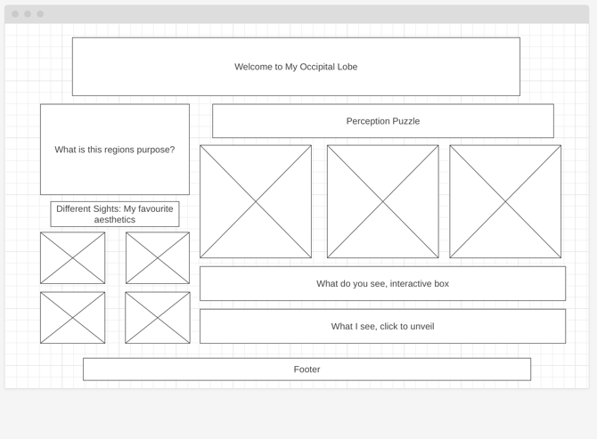

Cerebellum Page

<https://wireframe.cc/yz96mr>

Colour Palate:

<https://paletton.com/export/index.php>

