**Project 4**

- Group members: Lily Wang, Xueying Ding, Hanwen Ling

**- Instructions**

1. Install Webstorm(<https://www.jetbrains.com/webstorm/>) and Node.js (<https://nodejs.org)>
2. Download the files and make sure all the files are saved in one folder
3. Open the project using Webstorm (click on “open” and choose the folder which contains all your files)
4. In the Webstorm terminal, type in npm install to install the related nodeJS modules
5. Click the drop down button next to the run button and choose edit cofigurations
6. Click the "+" sign and add a Node.js configuration and in Configuration, select sudoku.js to be the Javascript file and make sure the working directory is correct
7. Open "Preferences" and select "Language&Frameworks", then choose the "JavaScript" and set the JavaScript language version to ECMAScript 6 to support let definition.
8. Close the configuration page and hit the run button!
9. Alternative Way:  
   1. Install Node.js(https://nodejs.org/en/download/)  
   2. Setup the Command line environment(for more information, check https://www.tutorialspoint.com/nodejs/nodejs_environment_setup.htm)  
   3. Download sudoku.js along with a blank sudoku sample txt file.  
   4. Open command line, cd to the directory of sudoku.js and sample txt file  
   5. Type "node sudoku.js"  
   6. A solution should appear on command line.

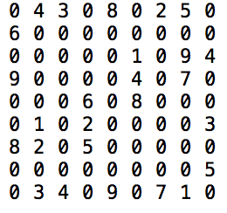**- Input file format is a .txt file with 9 lines of numbers, such as**

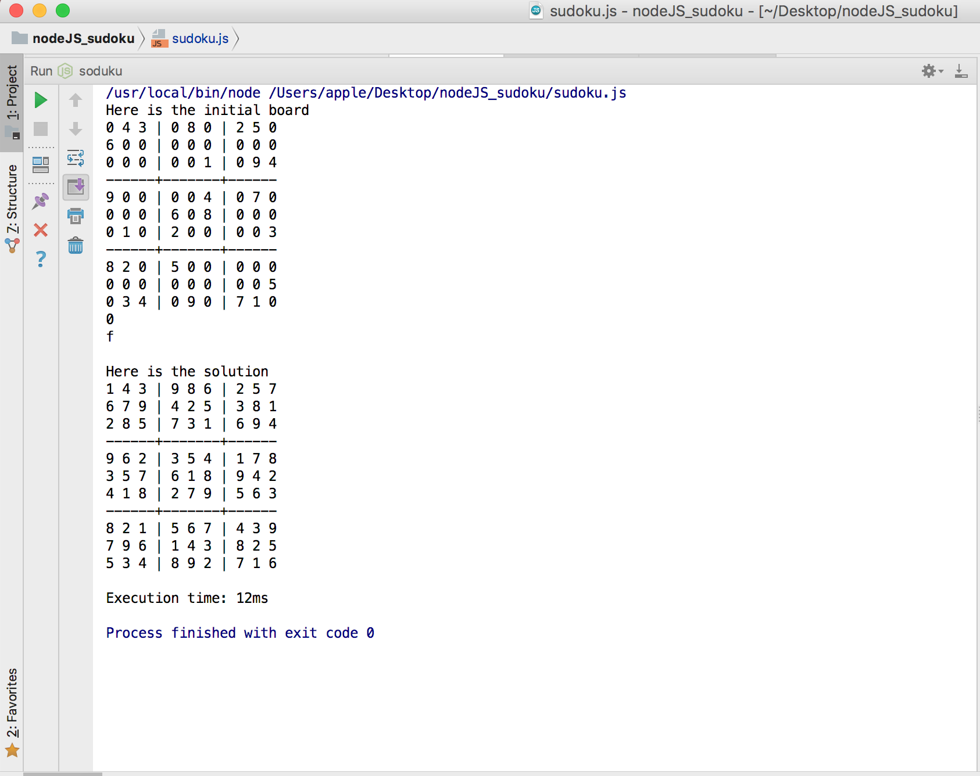**- Screenshot of result**