Lab 4

# Page 42 (s1-s2 link up)

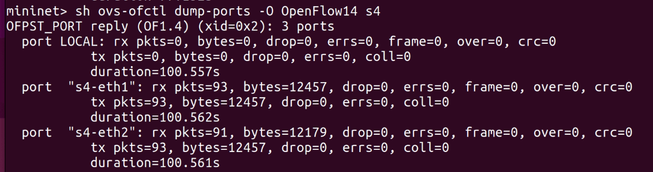

Since the link between s1 and s2 is up, most of the traffic will go through s1’s port 2 as we can see from the huge traffic of tx of “s1-eth2” compared to that of “s1-eth3”.

# Part 43 (s1-s2 link down)

Since the link between s1 and s2 is down, traffic can only go through s1’s port 3 as we can see from the huge traffic of tx of “s1-eth3” compared to that of “s1-eth2”. Moreover, the tx of “s4-eth2” is much lower than the rx of “s4-eth1”, meaning that the rate limit applied in the Meter entry of s4 is working as expected.