# **Babbel Challenge: Team Conjugator**

Lily Zhang

Prototype: <https://lilyxl8.github.io/conjugator>

# **Problem**

When learning a new language, verb conjugations are so important yet so tedious. You have no other choice but to memorize a set of patterns.

Why not automate this learning? Even make it fun and gamify it ☺

# Impact

All Indo-European languages have verb conjugations…

* English, French, Spanish, Italian, Portuguese, German, Dutch, Swedish, Norwegian, Russian, Yiddish, Afrikaans, Icelandic, Faroese, Latvian, Bulgarian, Bosnian, Serbo-Croatian, Polish, Slovenian, Macedonian, Urdu, Hindi, Persian, Turkish, Latin, Albanian, Armenian, Irish, Ukrainian, Greek =-O
* 44% of the world population, or 2.5 billion people, speak a language in the Indo-European family[1]
* Billions of language learners

Pronouns and verbs account for about 25% of human expression.[2] And they are the most meaningful parts of speech – with only these two, you can already have an entire conversation!

# Design

** 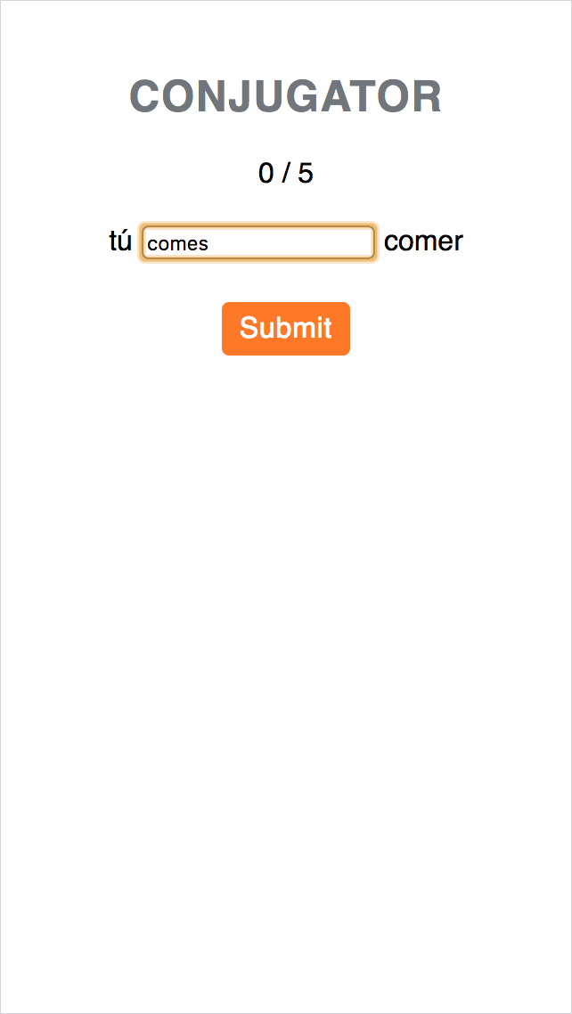 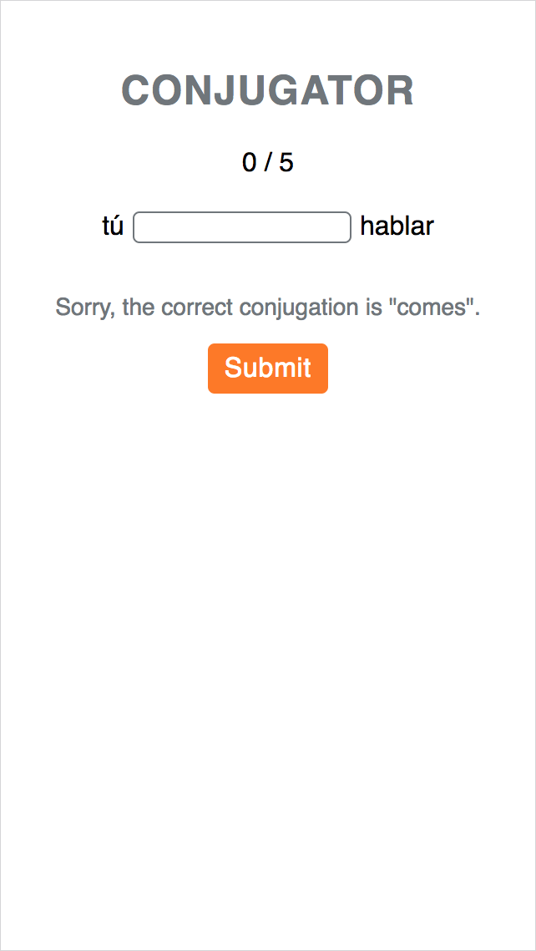 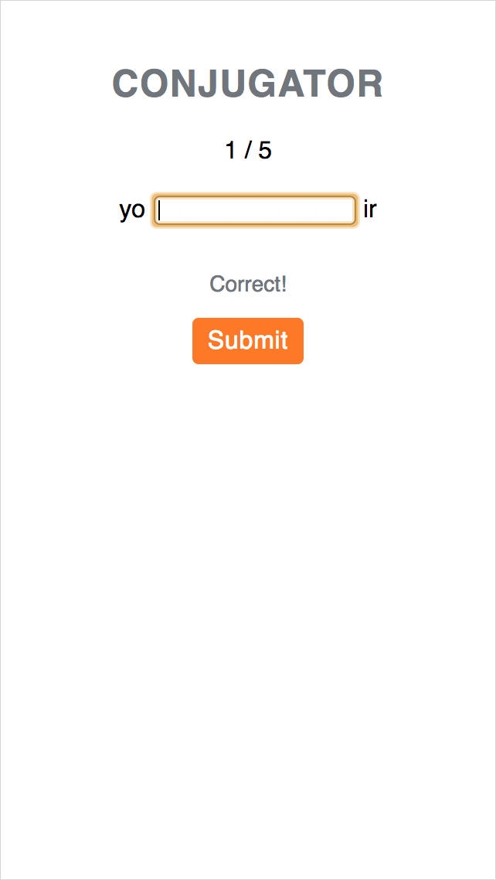 

Variations

* Speech recognition
* Chatbot
* Multiple verb tenses (past, past perfect, conditional, subjunctive…)
* Social gamification

1. <http://www.vistawide.com/languages/language_families_statistics1.htm>
2. <https://isenseproject.org/visualizations/1177> See ratio of verbs and pronouns out of all words from Brigham Young University's massive Corpus of Contemporary American English, which contains 180,000 contemporary texts totaling some 520,000,000 words.