Tab 1

TECHNICAL SPECIFICATION DOCUMENT

SISTEM INFORMASI PEMBELAJARAN ADAPTIF BERBASIS ANALITIK KEMAJUAN SISWA


Disusun Oleh :
Stefani Ayudya Prasetyo (L0224011)
Jocelyn Louisa (L0224034)
Talitha Sukma Mahardika (L0224037)
Adrian Farrel Aziz Yatyoga (L0224040)

PROGRAM STUDI S1 SAINS DATA
FAKULTAS TEKNOLOGI INFORMASI DAN SAINS DATA
UNIVERSITAS SEBELAS MARET
2026

BAGIAN 1

SYSTEM ARCHITECTURE SPECIFICATION

1.1 Arsitektur 3 - Tier
Sistem L-Platform / SIPANDA dirancang menggunakan pola arsitektur 3-tier yang memisahkan tanggung jawab sistem ke dalam tiga lapisan independen: Presentation Tier, Application Tier, dan Data Tier. Pemisahan ini memastikan skalabilitas, kemudahan pemeliharaan, dan keamanan sistem secara menyeluruh.

- Presentation Tier (Client Layer)
Lapisan ini merupakan antarmuka pengguna yang diakses langsung melalui web browser. Dibangun menggunakan React.js 18 + TypeScript dengan dukungan PWA (Progressive Web App) sehingga dapat diakses melalui browser desktop maupun mobile tanpa instalasi native.
UI dibagi menjadi empat panel sesuai role pengguna:
- Panel Siswa: akses materi, kuis adaptif, riwayat nilai
- Guru Panel: monitoring siswa, kelola materi & soal, laporan mingguan
- ParentHub: pantauan progress anak, grafik kemajuan, pesan guru
- Admin Panel (Kepala Sekolah): overview sekolah, manajemen pengguna, audit keamanan

Komunikasi antara Presentation Tier dan Application Tier dilakukan melalui HTTP/HTTPS menggunakan REST API dengan format JSON. JWT access token disertakan di setiap request melalui cookie HttpOnly untuk keamanan.

- Application Tier (Business Logic Layer)
Lapisan ini menangani seluruh logika bisnis sistem dan berjalan di server menggunakan Next.js 16 App Router dengan route handlers sebagai REST API endpoint.
Lapisan ini bertanggung jawab atas:
- Auth Service: validasi kredensial, penerbitan JWT (HS256), RBAC enforcement, mekanisme lockout (5 kali gagal dalam 10 menit → block 15 menit), token blacklist di Redis
- Content Management Service: CRUD materi pembelajaran, validasi embed URL YouTube, pengelolaan bank soal dengan kapasitas adaptif (10 Easy / 25 Medium / 15 Hard)
- Adaptive Assessment Engine: branching logic berbasis streak jawaban siswa, getHarderQuestion() / getEasierQuestion() / getSameLevelQuestion()
- Analytics Service: agregasi data progress siswa per kelas dan per sekolah, komputasi KPI (rata-rata nilai, ketuntasan KKM)
- Forum & Notification Service: direct message guru-orang tua, notifikasi in-app, pengiriman laporan mingguan via Nodemailer SMTP
- Audit Log Service: pencatatan immutable seluruh aktivitas sistem (LOGIN_OK, REGISTER, PASSWORD_CHANGE, UPLOAD_SUCCESS, REPORT_SENT, dll.)

- Data Tier (Persistence Layer)
Lapisan ini mengelola seluruh penyimpanan dan pengambilan data sistem:
- PostgreSQL 15+: database relasional utama menyimpan tabel Users, Students, Teachers, Parents, Classes, Subjects, ClassSubjects, Materials, Videos, Questions, QuizSessions, QuizAnswers, StudentProgress, WeeklyReports, Messages, Notifications, AuditLog, PointLogs, VideoWatches
- Redis 7: menyimpan session store JWT, cache soal adaptif per sesi kuis, token blacklist saat logout, dan cache agregasi metrik sekolah (diperbarui pukul 00.00 WIB)
- MinIO Object Storage: penyimpanan file PDF materi (S3-compatible, self-hosted)
- Backup: pg_dump harian otomatis dengan retensi 30 hari

Diagram antar tier

Browser / PWA

^

| HTTPS / REST API (JSON)
v

Next.js App Router : Business Logic

^ ^

| Prisma ORM | ioredis
v v

PostgreSQL 15+  ^  | MinIO SDK  v | Redis 7

MinIO Object Storage

1.2 Auth Service Architecture

AUTH SERVICE
JWT Issuer (HS256)
RBAC Middleware
bcrypt Hash (cost 12)
Lockout Manager
Token Blacklist (Redis)
Refresh Token Handler

| |
V V
PostgreSQL  Questions  Progress | Redis 7  Session  Cache Soal

1.3 Adaptive Assessment Engine Architecture
ASSESSMENT ENGINE
Adaptive Branching Logic
Streak Evaluation Engine
Session State Manager (Redis)
Lives System (3 hearts)
Score Calculator
Progress Recorder

|
V

PostgreSQL
Questions
Progress

Redis 7
Session
Cache Soal

1.3.1 In-Scope
Dokumen ini mencakup elaborasi fungsional untuk 6 (enam) modul utama:
- FSD-01 : User Management & Auth
- FSD-02 : Manajemen Konten Pembelajaran
- FSD-03 : Adaptive Assesment Engine
- FSD-04 : Monitoring Dashboard & Analytics
- FSD-05 : Forum Kolaborasi & Notifikasi
- FSD-06 : System Monitoring (Kepala Sekolah)

1.3.2 Out-of-Scope
- Integrasi dengan sistem dinas pendidikan eksternal (Dapodik, Rapor Digital)
- Fitur video conference atau pembelajaran sinkron secara langsung
- Modul keuangan, absensi, atau administrasi non-akademik
- Aplikasi mobile native (Android/iOS)
- Generasi soal otomatis dengan AI generatif

1.4 References Document
Dokumen | Keterangan | Versi
SRS L-Platform | Software Requirements Specification | v1.0(2026)
Architecture Doc | High Level Design (3 Tier Architecture) | v1.0(2026)
IEEE 830 | Standar untuk SRS | 1998
OWASP Top 10 | Referensi Security | 2021

2. ROLE PENGGUNA DAN HAK AKSES

2.1 Deskripsi Role
Role | Aktor | Deskripsi
SUPER_ADMIN | Kepala Sekolah | Kepala Sekolah sebagai administrator tertinggi mengelola semua akun, mengaudit keamanan, dan melakukan overview performa sekolah.
ADMIN_GURU | Guru/ Wali Kelas | Guru/Wali kelas berperan untuk mengelola konten pembelajaran, memantau siswa di kelasnya, dan mengirim laporan ke orang tua.
PARENT | Orang Tua / Wali Murid | Orang Tua/Wali memiliki hak untuk memantau perkembangan akademik anak dan berkomunikasi dengan guru melalui portal ParentHub
STUDENT | Siswa | Siswa dapat mengakses materi pelajaran dan mengerjakan asesmen adaptif sesuai level kemampuan.

2.2 Matriks Hak Akses
Simbol: v = Akses Penuh | x = Tidak Ada Akses | ; = Akses Terbatas
Modul / Fitur | Siswa | Guru | Orang Tua | Kepala Sekolah
Login & Auth | v | v | v | v
Ubah Password Sendiri | v | v | v | v
Kelola Akun User | x | x | x | v
Akses Beranda Siswa | v | x | x | x
Lihat Materi Pembelajaran | v | v | v | v
Kerjakan Kuis Adaptif | x | x | x | v
Lihat Riwayat Nilai Sendiri | v | x | x | x
Upload/ Kelola Materi | x | v | x | x
Kelola Bank Soal Adaptif | x | v | x | x
Monitoring Siswa (Kelas Sendiri) | x | v | x | x
Kirim Laporan ke Orang Tua | x | v | x | x
Lihat Progress Anak Sendiri | x | x | v | x
Terima Laporan Mingguan | x | v | v | x
Kirim Pesan ke Guru | ; | x | v | x
Overview Performa Sekolah | x | x | x | v
Audit Log Keamanan Sistem | x | x | x | v
Reset Password Pengguna Lain | x | x | x | v

BAGIAN 2

TECHNOLOGY STACK & ENVIRONMENT SPECIFICATION

2.1 Environment Comparison (Dev / Staging / Production)
Spesifikasi | Development | Staging | Production
Hardware | Local machine | VPS 1 vCPU/2 GB RAM | VPS 2 vCPU/4 GB/50 GB SSD
WebServer | Nodemom (live reload) | Nginx 1.24 | Nginx 1.24
PHP | 20.x (local) | 20.x LTS | 20.x LTS
Database | PostgreSQL 16 (Docker) | PostgreSQL 16 | PostgreSQL 16
Cache | Redis 7 (Docker) | Redis 7 | Redis 7
Email | Mailtrap | Gmail SMTP | Gmail SMTP
URL | localhost:3000 | staging.sipanda.id | sipanda.id
SSL | Tidak ada | Let’s Encrypt | Let’s Encrypt
Tujuan | Coding & unit test | Integration test & UAT | Live system (presentasi)

2.2 Supporting Tools
Kategori | Tool | Kegunaan dalam proyek
API Testing | Postman | Uji semua endpoint, buat koleksi test, dokumentasi API
DB Management | DBeaver/pgAdmin 4 | Kelola PostgreSQL, reverse-engineer ERD, debug query
Diagramming | draw.io | Membuat ERD, deployment diagram, flowchart
API Docs | Swagger Editor | Dokumentasi API hidup
Version Control | GitHub | Source control, branching strategy, code review
CI/CD | GitHub Actions | Auto-limit dan unit test ketika push ke branch main/staging
Deployment | SSH + PM2 | Deploy ke VPS, process manager untuk Node.js
SSL | Certbot | Auto-renew Let’s Encrypt SSL
Scheduler | node-crom | Trigger cache refresh Redis setiap 00.00 WIB (BR-28)

BAGIAN 3

API ARCHITECTURE & ENDPOINT HIERARCHY

3.1 RESTful Standards
Base URL: /api/v1/ - masing-masing endpoint menggunakan prefix ini
Resources plural noun: /users, /materi, /questions, /sessions
Semua response menggunakan envelope JSON: {status, data, message, errors}
Protected routes memerlukan JWT Bearer Token: Authorization: Bearer <token>
HTTP Methods: GET (baca), POST (buat), PATCH (update parsial), DELETE (hapus)
Rate limiting: 5 kali gagal login dalam 10 menit per IP → Block 15 menit (BR-02, ERR-AUTH-02)

3.2 Endpoint Index
Method | Auth | URL | Fungsi/Referensi FSD
POST | Public | /api/v1/auth/login | Login - FSD-01.1
POST | JWT | /api/v1/auth/logout | Logout, invalidasi refresh token di Redis
POST | SUPER_ADMIN | /api/v1/admin/users | Buat pasangan akun siswa+orangtua - FSD-01.2
GET | SUPER_ADMIN | /api/v1/admin/audit-logs | Lihat audit log - FSD-06.1
POST | ADMIN_GURU | /api/v1/konten/materi | Upload materi baru - FSD-02.1
GET | ADMIN_GURU, STUDENT | /api/v1/konten/:materi* | Guru dan siswa membaca materi
PATCH | ADMIN_GURU | /api/v1/konten/materi/:materiId | Guru menambah materi
DELETE | ADMIN_GURU | /api/v1/konten/materi/:materiId | Guru menghapus materi
POST | ADMIN_GURU | /api/v1/konten/soal | Guru menambah soal ke question_bank
POST | STUDENT | /api/v1/kuis/engine/next | Inisialisasi, menjawab soal, kalkulasi branching, dan finish kuis
GET | ADMIN_GURU | /api/v1/monitoring/kelas/* | Guru melihat dashboard kelas dan siswa yang mempunyai nilai dibawah KKM
GET | PARENT | /api/v1/monitoring/anak/* | Orang tua melihat perkembangan anaknya di ParentHub
GET | ALL ROLE | /api/v1/pesan | Melihat riwayat pesan
POST | ALL ROLE | /api/v1/pesan | Mengirim atau membalas pesan

3.3 Endpoint Specification Card
- POST /api/v1/auth/login
Method | POST
URL | /api/v1/auth/login
Authentication | Public (tidak diperlukan token)
Request Body (JSON) | { username: string(required, max:50), password: string(required, min:8) }
Response 200 (Sukses) | { status:'success', data:{ accessToken: string, refreshToken: string, expires_in: 86400, user:{ userId, role, username } } }
Response 400 | { status:'error', error_code:'ERR-VAL-01', message:'Field tidak boleh kosong.' }
Response 401 | { status:'error', error_code:'ERR-AUTH-01', message:'Username atau password salah.' }
Response 423 | { status:'error', error_code:'ERR-LOCK-01', message:'Akun sementara dikunci. Coba lagi dalam 15 menit.' }
DB Tables Terpengaruh | users (R, U last_login), audit_logs (C)
Redis Terpengaruh | `ratelimit:{ip}` (R, C, U), `refresh:{userId}` (C)
DB Trigger/SP/Function/View | Trigger: `trg_audit_login`
Referensi FSD | FSD-01.1
Referensi Error Handling | BR-01, BR-02, ERR-AUTH-01, ERR-LOCK-01

- POST /api/v1/auth/logout
Method | POST
URL | /api/v1/auth/logout
Authentication | JWT Token (All Roles)
Request Body | –
Response 200 | { "status": 'success', "data": null, "message": 'Logout berhasil, sesi telah dihapus.' }`
Response 401 | { "status": 'error', "error_code": 'ERR-AUTH-02', "message": 'Token tidak valid atau telah kedaluwarsa.' }
DB Tables Terpengaruh | audit_logs` (C)
Redis Terpengaruh | `refresh:{userId}` (D), `blacklist:{token}` (C, TTL 1 hari)
DB Trigger/SP/Function/View | –
Referensi FSD | FSD-01.1
Referensi Error Handling | ERR-AUTH-02

- POST/api/v1/admin/users
Method | POST
URL | /api/v1/auth/logout
Authentication | JWT Token (Role: SUPER_ADMIN)
Request Body | { "nama_siswa": "string(required)", "kelas": "string(required)", "nama_ortu": "string(required)", "email_ortu": "string(required)" }
Response 201 | { "status": 'success', "data": { "student": { "username": "budi.4b", "passwordDefault": "XyZ79WqP" }, "parent": { "username": "santoso.budi", "passwordDefault": "KjM21RtV" } }, "message": 'Pasangan akun berhasil dibuat.' }
Response 400 | { "status": 'error', "error_code": 'ERR-REG-02', "message": 'Format email orang tua tidak valid.' }
Response 409 | { "status": 'error', "error_code": 'ERR-REG-01', "message": 'Username dasar sudah terpakai, sistem gagal mengonfigurasi suffix unik.' }
DB Tables Terpengaruh | users` (C)
Redis Terpengaruh | –
DB Trigger/SP/Function/View | Trigger: `trg_generate_username_suffix`
Referensi FSD | FSD-01.2
Referensi Error Handling | BR-03, BR-04, ERR-REG-01, ERR-REG-02

- GET /api/v1/admin/audit-logs
Method | GET
URL | /api/v1/admin/audit-logs
Authentication | JWT Token (Role: SUPER_ADMIN)
Request Body | –
Response 200 | { "status": 'success', "data": [ { "logId": "log-001", "userId": "usr-12", "activity": "CREATE_USER", "timestamp": "2026-06-01 10:00:00" } ] }
Response 403 | { "status": 'error', "error_code": 'ERR-AUTH-03', "message": 'Akses ditolak. Hak akses Admin diperlukan.' }
DB Tables Terpengaruh | `audit_logs` (R)
Redis Terpengaruh | –
DB Trigger/SP/Function/View | –
Referensi FSD | FSD-06.1
Referensi Error Handling | ERR-AUTH-03

- POST /api/v1/konten/materi
Method | POST
URL | /api/v1/konten/materi
Authentication | JWT Token (Role: ADMIN_GURU)
Request Body | { "judul_materi": "string(required)", "link_video": "string(required)", "poin_materi": "array(string)", "difficulty_tag": "string", "chapter": "integer" }
Response 200 | { "status": 'success', "data": { "materiId": "mat-101" }, "message": 'Materi baru berhasil diunggah.' }
Response 401 | { "status": 'error', "error_code": 'ERR-CNT-01', "message": 'URL video materi harus berupa link YouTube embed yang valid.' }
Response 503 | { "status": 'error', "error_code": 'ERR-DB-503', "message": 'Gagal menyimpan materi. Koneksi basis data terputus.' }
DB Tables Terpengaruh | Learning_Materials` (C)
Redis Terpengaruh | cache:materi:chapter:{chapter}` (D)
DB Trigger/SP/Function/View | –
Referensi FSD | FSD-02.1
Referensi Error Handling | BR-07, ERR-CNT-01, ERR-DB-503

- GET /api/v1/konten/materi/*
Method | GET
URL | /api/v1/konten/materi/:materiId
Authentication | JWT Token (Role: ADMIN_GURU, STUDENT)
Request Body | –
Response 200 | { "status": 'success', "data": { "materiId": "mat-101", "judul_materi": "Fotosintesis", "link_video": "[https://youtube.com/embed/](https://youtube.com/embed/)..", "poin_materi": ["Klorofil", "Cahaya"], "chapter": 2 } }
Response 404 | { "status": 'error', "error_code": 'ERR-CNT-02', "message": 'Materi tidak ditemukan atau bab belum aktif.' }
DB Tables Terpengaruh | Learning_Materials` (R)
Redis Terpengaruh | cache:materi:{materiId}` (R, C jika cache miss)
DB Trigger/SP/Function/View | –
Referensi FSD | FSD-02.3
Referensi Error Handling | ERR-CNT-02

- PATCH /api/v1/konten/materi/:materiId
Method | PATCH
URL | /api/v1/konten/materi/:materiId
Authentication | JWT Token (Role: ADMIN_GURU)
Request Body | { "judul_materi": "string(optional)", "poin_materi": "array(optional)" }
Response 200 | { "status": 'success', "data": null, "message": 'Konten materi berhasil diperbarui.' }
Response 404 | { "status": 'error', "error_code": 'ERR-CNT-02', "message": 'Gagal memperbarui. Materi tidak ditemukan.' }
DB Tables Terpengaruh | `Learning_Materials` (U)
Redis Terpengaruh | `cache:materi:{materiId}` (D)
DB Trigger/SP/Function/View | –
Referensi FSD | FSD-02.1
Referensi Error Handling | ERR-CNT-02

- DELETE /api/v1/konten/materi/:materiId
Method | DELETE
URL | /api/v1/konten/materi/:materiId
Authentication | JWT Token (Role: ADMIN_GURU)
Request Body | –
Response 200 | { "status": 'success', "data": null, "message": 'Materi berhasil dihapus dari sistem.' }
Response 401 | { "status": 'error', "error_code": 'ERR-CNT-02', "message": 'Materi tidak ditemukan.' }
DB Tables Terpengaruh | `Learning_Materials` (D)
Redis Terpengaruh | `cache:materi:{materiId}` (D)
DB Trigger/SP/Function/View | –
Referensi FSD | FSD-02.1
Referensi Error Handling | ERR-CNT-02

- POST /api/v1/konten/soal
Method | POST
URL | /api/v1/konten/soal
Authentication | JWT Token (Role: ADMIN_GURU)
Request Body | { "chapter": 2, "question_text": "Zat hijau daun disebut?", "difficulty": "EASY", "choices": { "A": "Klorofil", "B": "Xilem", "C": "Stomata", "D": "Akar" }, "correct_answer": "A" }
Response 201 | { "status": 'success', "data": { "questionId": "que-550" }, "message": 'Soal baru berhasil ditambahkan ke bank soal.' }
Response 409 | { "status": 'error', "error_code": 'ERR-BANK-01', "message": 'Gagal menyimpan. Kuota maksimal distribusi tingkat kesulitan bank soal terpenuhi.' }
DB Tables Terpengaruh | `Question_Bank` (C)
Redis Terpengaruh | –
DB Trigger/SP/Function/View | Function: `fn_check_question_quota`
Referensi FSD | FSD-02.2
Referensi Error Handling | BR-08, BR-09, ERR-BANK-01

- POST /api/v1/kuis/engine/next
Method | POST
URL | /api/v1/kuis/engine/next
Authentication | JWT Token (Role: STUDENT)
Request Body | { "sessionId": "string(nullable)", "chapter": "integer", "lastQuestionId": "string(nullable)", "jawabanSiswa": "string(nullable)" }
Response 200 (Next) | { "status": 'success', "data": { "sessionId": "sess-88", "is_finished": false, "nextQuestion": { "questionId": "que-102", "question_text": "Fungsi klorofil pada tumbuhan adalah?", "currentLevel": "HARD", "choices": { "A": "Menyerap cahaya", "B": "Menyerap air" } } } }
Response 200 (Finish) | { "status": 'success', "data": { "sessionId": "sess-88", "is_finished": true, "skorAkhir": 85, "rekomendasi": "Lanjut ke bab berikutnya" } }
Response 409 | { "status": 'error', "error_code": 'ERR-BANK-01', "message": 'Alur soal terhenti. Kuota soal adaptif pada bank soal belum terpenuhi oleh Guru.' }
Response 504 | { "status": 'error', "error_code": 'ERR-ENG-01', "message": 'Kalkulasi mesin adaptif timeout. State kuis diserialisasi di lokal.' }
DB Tables Terpengaruh | `Progress_DB` (C/U), `Quiz_Sessions` (C/U), `Question_Bank` (R)
Redis Terpengaruh | `quiz:session:{sessionId}:state` (R, C, U)
DB Trigger/SP/Function/View | Stored Procedure: `sp_process_adaptive_branching`, Function: `fn_calculate_final_score`
Referensi FSD | FSD-03.1
Referensi Error Handling | BR-10, BR-11, BR-12, BR-ADAPT-02, ERR-BANK-01, ERR-ENG-01

- GET /api/v1/monitoring/kelas/*
Method | GET
URL | /api/v1/monitoring/kelas/:kelasId
Authentication | JWT Token (Role: ADMIN_GURU)
Request Body | –
Response 200 | { "status": 'success', "data": { "kelas": "4B", "rata_rata_skor": 76.2, "siswa_under_kkm": [ { "userId": "usr-51", "nama": "Andi", "last_active_chapter": 3 } ] } }
Response 403 | { "status": 'error', "error_code": 'ERR-AUTH-03', "message": 'Anda tidak memiliki hak akses untuk menginspeksi kelas ini.' }
DB Tables Terpengaruh | `Quiz_Sessions` (R), `users` (R)
Redis Terpengaruh | `cache:monitoring:kelas:{kelasId}` (R)
DB Trigger/SP/Function/View | Function: `fn_classify_performance`
Referensi FSD | FSD-04.1
Referensi Error Handling | ERR-AUTH-03

- GET /api/v1/monitoring/anak/*
Method | GET
URL | /api/v1/monitoring/anak/:siswaId
Authentication | JWT Token (Role: PARENT)
Request Body | –
Response 200 | { "status": 'success', "data": { "nama_anak": "Roni Santoso", "progress_akademik": [ { "chapter": 1, "skor_tertinggi": 88, "status": "LULUS" } ] } }
Response 403 | { "status": 'error', "error_code": 'ERR-MSG-01', "message": 'Akses ilegal. Akun Anda tidak terikat dengan data siswa yang diminta.' }
DB Tables Terpengaruh | `Quiz_Sessions` (R), `users` (R)
Redis Terpengaruh | –
DB Trigger/SP/Function/View | Function: `fn_check_kkm_threshold`
Referensi FSD | FSD-04.2
Referensi Error Handling | ERR-MSG-01

- GET /api/v1/pesan
Method | GET
URL | /api/v1/pesan
Authentication | JWT Token (Role: ADMIN_GURU, PARENT)
Request Body | –
Response 200 | { "status": 'success', "data": [ { "messageId": "msg-901", "pengirim": "Guru IPA", "konten": "Laporan mingguan Roni", "timestamp": "2026-06-01" } ] }
Response 503 | { "status": 'error', "error_code": 'ERR-DB-503', "message": 'Gagal memuat pesan. Masalah koneksi basis data.' }
DB Tables Terpengaruh | `Messages` (R)
Redis Terpengaruh | –
DB Trigger/SP/Function/View | –
Referensi FSD | FSD-05.2
Referensi Error Handling | ERR-DB-503

- POST/api/v1/pesan
Method | POST
URL | /api/v1/pesan
Authentication | JWT Token (Role: ADMIN_GURU, PARENT)
Request Body | { "parentId": "string(nullable)", "replyToId": "string(nullable)", "konten": "string(required)" }
Response 201 | { "status": 'success', "data": { "messageId": "msg-902" }, "message": 'Pesan berhasil terkirim.' }
Response 403 | { "status": 'error', "error_code": 'ERR-MSG-02', "message": 'Akses ditolak. Orang tua hanya diizinkan untuk membalas thread pesan yang diinisiasi oleh Guru.' }
DB Tables Terpengaruh | `Messages` (C)
Redis Terpengaruh | –
DB Trigger/SP/Function/View | –
Referensi FSD | FSD-05.2
Referensi Error Handling | BR-21, BR-22, ERR-MSG-02

3.4 Appendix – API → DB Impact Mapping
API Endpoint | Tables (CRUD) | Stored Proc | Views | Functions | Triggers
POST /auth/login | users(R,U), audit_logs(C) | - | - | - | trg_audit_login
PATCH /auth/change-password | users(R,U), audit_logs(C) | - | - | - | trg_audit_users
POST /admin/users | users(C×2), student_parent_links(C), audit_logs(C) | sp_create_student_parent_pair | - | - | trg_audit_users
GET /admin/audit-logs | audit_logs(R), users(R) | - | v_audit_log_detail | - | -
GET /admin/school-overview | Redis cache (R), progress_db(R fallback) | - | v_school_metrics | fn_calc_school_avg | -
POST /guru/materi | learning_materials(C), audit_logs(C) | - | - | - | trg_audit_materi
POST /guru/questions | question_bank(C), audit_logs(C) | - | - | fn_check_quota_bank | -
GET /guru/monitoring | progress_db(R), users(R) | - | v_class_monitoring | fn_classify_status | -
POST /guru/laporan | progress_db(R), weekly_report_logs(C), audit_logs(C) | - | v_weekly_progress_per_siswa | - | trg_audit_report
POST /siswa/kuis/:babId/start | quiz_sessions(C), question_bank(R) | - | - | - | -
POST /siswa/kuis/answer | quiz_sessions(R,U), question_bank(R), progress_db(U) | - | - | fn_adaptive_next_question | -
POST /siswa/kuis/finish | quiz_sessions(U), progress_db(C/U) | sp_finalize_quiz_session | - | fn_calc_final_score | trg_audit_progress
GET /ortu/dashboard | progress_db(R), users(R) | - | v_parent_child_summary | fn_check_kkm_alert | -
POST /pesan | messages(C), notifications(C) | - | - | - | trg_notify_message

BAGIAN 4

DATABASE DESIGN SPESIFICATION

ERD (Entity Relationship Diagram)
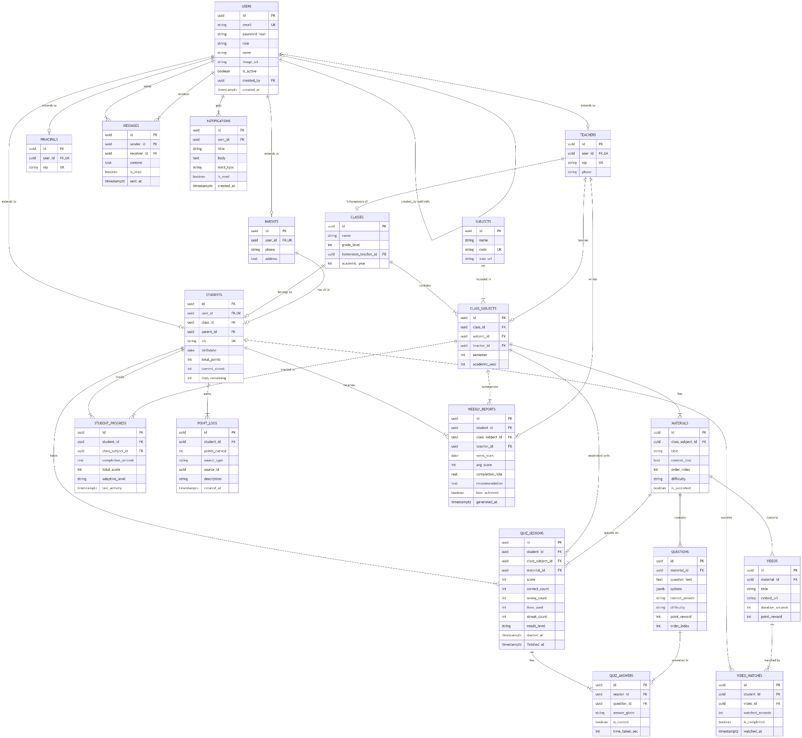
- Class Diagram
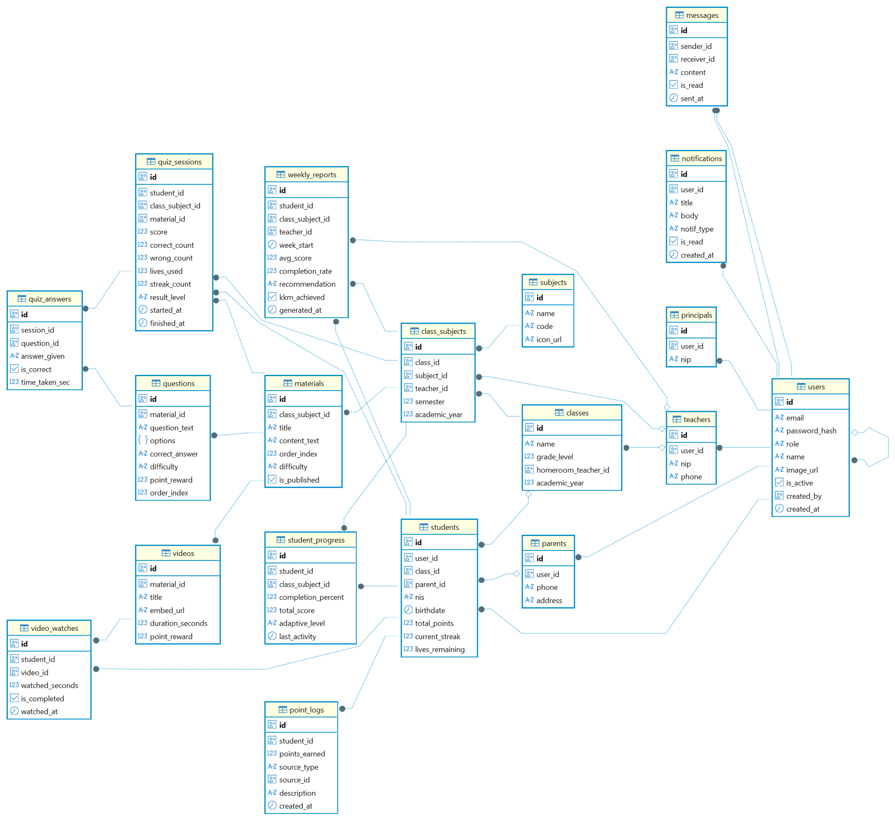

Table Definition
- Table: users
Kolom | Tipe Data | Null? | Default | Constraint/  Keterangan
user_id | UUID | NOT NULL | gen_random_uuid() | PRIMARY KEY
username | VARCHAR(50) | NOT NULL | - | UNIQUE - auto-generate (FSD-01.2)
email | VARCHAR(100) | NOT NULL | - | UNIQUE
password_hash | VARCHAR(255) | NOT NULL | - | Hashed menggunakan bcrypt cost=12 Tidak permah plaintext
role | ENUM(‘STUDENT’, ‘ADMIN_GURU’, ‘PARENT’, ‘SUPER_ADMIN’) | NOT NULL | - | RBAC enforcement
status | ENUM('ACTIVE','INACTIVE') | NOT NULL | 'ACTIVE' | Soft-disable akun
force_password_change | BOOLEAN | NOT NULL | TRUE | Wajib ganti saat login pertama (BR-04)
kelas_id | UUID | NULLABLE | NULL | FK → classes(kelas_id), diisi untuk role STUDENT & ADMIN_GURU
last_login | TIMESTAMP | NULLABLE | NULL | Diperbarui saat login sukses
created_at | TIMESTAMP | NOT NULL | NOW() | -

- Table: student_parents_link
Kolom | Tipe Data | Null? | Default | Constraint/  Keterangan
link_id | UUID | NOT NULL | gen_random_uuid() | PRIMARY KEY
student_id | UUID | NOT NULL | - | FK → users(user_id), UNIQUE — satu siswa satu pasangan
parent_id | UUID | NOT NULL | - | FK → users(user_id), UNIQUE — satu ortu satu anak (BR-16)
created_at | TIMESTAMP | NOT NULL | NOW()

- Table: Classes
Kolom | Tipe Data | Null? | Default | Constraint/  Keterangan
kelas_id | UUID | NOT NULL | gen_random_uuid() | PRIMARY KEY
nama_kelas | VARCHAR(20) | NOT NULL | - | Contoh: '4-B', '6-A'
tahun_ajaran | VARCHAR(10) | NOT NULL | - | Contoh: '2025/2026'

- Table: learning_materials
Kolom | Tipe Data | Null? | Default | Constraint/  Keterangan
materi_id | UUID | NOT NULL | gen_random_uuid() | PRIMARY KEY
kelas_id | UUID | NOT NULL | - | FK → classes(kelas_id)
subject_id | UUID | NOT NULL | - | FK → subjects(subject_id)
judul_materi | VARCHAR(150) | NOT NULL | - | Max 150 karakter (FSD-02.1)
link_video | VARCHAR(500) | NULLABLE | NULL | Harus embed URL YouTube/Google Drive (BR-07)
poin_materi | TEXT[] | NOT NULL | - | Array poin-poin materi
difficulty_tag | ENUM('Easy','Medium','Hard') | NOT NULL | ‘Medium’ | Tag untuk referensi level
created_by | UUID | NOT NULL | - | FK → users(user_id), harus role ADMIN_GURU
created_at | TIMESTAMP | NOT NULL | NOW() | -

- Table: question_bank
Kolom | Tipe Data | Null? | Default | Constraint/  Keterangan
question_id | UUID | NOT NULL | gen_random_uuid() | PRIMARY KEY
materi_id | UUID | NOT NULL | - | FK → learning_materials(materi_id)
question_text | TEXT | NOT NULL | - | Teks pertanyaan
choice_a | VARCHAR(255) | NOT NULL | - | -
choice_b | VARCHAR(255) | NOT NULL | - | -
choice_c | VARCHAR(255) | NOT NULL | - | -
choice_d | VARCHAR(255) | NOT NULL | - | -
correct_answer | ENUM('A','B','C','D') | NOT NULL | - | Kunci jawaban
difficulty | ENUM('Easy','Medium','Hard') | NOT NULL | - | Level soal
created_by | UUID | NOT NULL | - | FK → users(user_id)
created_at | TIMESTAMP | NOT NULL | NOW() | -
Constraint tambahan: CHECK (difficulty = ‘Easy’ → max 10 per materi_id) – diimplementasi via fn_check_quota_bank yang dipanggil sebelum INSERT (BR-08)

- Table: quiz_sessions
Kolom | Tipe Data | Null? | Default | Constraint/  Keterangan
id | UUID | NOT NULL | gen_random_uuid() | PRIMARY KEY
student_id | UUID | NOT NULL | - | materials(id)  students(id)
class_subject_id | UUID | NOT NULL | - | FK → class_subjects(id)
material_id | UUID | NOT NULL | - | FK → materials(id)
score | INT | NULLABLE | 0 | Skor sekarang
correct_count | INT | NULLABLE | 0 | Hitungan jawaban benar
wrong_count | INT | NULLABLE | 0 | Hitungan jawaban salah
lives_used | INT | NULLABLE | 0 | -
streak_count | INT | NULLABLE | 0 | -
result_level | VARCHAR(20) | NULLABLE |  | CHECK (result_level IN ('FAILED', 'PASSED', 'EXCELLENT'))
started_at | TIMESTAMP | NULLABLE | NOW() | -
finished_at | TIMESTAMP | NULLABLE | - | -

- Table: progress_db
Kolom | Tipe Data | Null? | Default | Constraint/  Keterangan
progress_id | UUID | NOT NULL | gen_random_uuid() | PRIMARY KEY
siswa_id | UUID | NOT NULL | - | FK → users(user_id)
materi_id | UUID | NOT NULL | - | FK → learning_materials(materi_id)
session_id | UUID | NOT NULL | - | FK → quiz_sessions(session_id)
score | DECIMAL(5,2) | NOT NULL | - | Skor akhir kuis
level_akhir | ENUM('Easy','Medium','Hard') | NOT NULL | - | Level saat sesi selesai
materi_dibuka | BOOLEAN | NOT NULL | FALSE | Flag untuk unlock tombol Kerjakan Kuis (BR-29)
completed_at | TIMESTAMP | NOT NULL | NOW() | -

- Table: messages
Kolom | Tipe Data | Null? | Default | Constraint/  Keterangan
id | UUID | NOT NULL | - | PRIMARY KEY
sender_id | UUID | NOT NULL | - | FK → users(id)
receiver_id | UUID | NOT NULL | - | FK → users(id)
content | TEXT | NOT NULL | - | -
is_read | BOOLEAN | NULLABLE | FALSE | -
sent_at | TIMESTAMP | NULLABLE | NOW() | -

- Table: audit_logs
Kolom | Tipe Data | Null? | Default | Constraint/  Keterangan
log_id | UUID | NOT NULL | gen_random_uuid() | PRIMARY KEY
user_id | UUID | NULLABLE | - | FK → users, SET NULL jika user dihapus
user_email | VARCHAR(100) | NOT NULL | - | Denormalisasi — preserve saat user dihapus
action_type | VARCHAR(50) | NOT NULL | - | LOGIN_OK, LOGIN_FAIL, REGISTER, PASSWORD_CHANGE, UPLOAD_SUCCESS, REPORT_SENT, dll
resource_type | VARCHAR(50) | NULLABLE | - | Nama tabel/entitas yang terpengaruh
resource_id | UUID | NULLABLE | - | ID entitas
old_values | JSONB | NULLABLE | - | State sebelum mutasi
new_values | JSONB | NULLABLE | - | State setelah mutasi
ip_address | INET | NOT NULL | - | IP address request
user_agent | TEXT | NULLABLE | - | Browser/client info
created_at | TIMESTAMP | NOT NULL | NOW() | Default

BAGIAN 5

STORED PROCEDURE, DML & DB OBJECTS
- Stored Procedures (SP)
sp_create_student_parent_pair
Deskripsi: Untuk pembuatan 2 akun sekaligus yaitu akun siswa dan orang tua. Jika salah satu gagal, maka keduanya akan di rollback sehingga tidak akan ada akun orphan.
Parameter IN | p_nama_siswa VARCHAR, p_kelas_id UUID, p_nama_ortu VARCHAR, p_email_ortu VARCHAR, p_created_by UUID
Parameter OUT | P_result VARCHAR (‘SUCCESS’ / ‘EMAIL_EXISTS’ / ‘ERRORS’)
Logic/Pseudocode | 1. Cek email_ortu belum ada di tabel users → jika ada, return 'EMAIL_EXISTS'.  2. Generate username_siswa = {nama_siswa}.{kelas}(lowercase, suffix angka jika duplikat).  3. Generate username_oortu = ortu.{nama_siswa}  4. Generate random password 8 karakter.  5. BEGIN TRANSACTION.  6. INSERT INTO users (siswa, role=STUDENT, force_password_change=TRUE).  7. INSERT INTO users (ortu, role=PARENT, force_password_change=TRUE).  8. INSERT INTO student_parent_links.  9. COMMIT → return 'SUCCESS'.  10. EXCEPTION → ROLLBACK → return 'ERROR'.
Dipanggil oleh | POST /api/v1/admin/users

sp_finale_quiz_session
Deskripsi: Menjamin penyimpanan hasil akhir kuis: update session + insert/update progress_db + hapus cache sementara.
Parameter IN | p_session_id UUID, p_siswa_id UUID
Parameter OUT | p_final_score DECIMAL(5,2), p_result VARCHAR
Logic/Pseudocode | 1. SELECT session dari quiz_sessions WHERE session_id = p_session_id.  2. Panggil fn_calc_final_score{correct_count, total_answered}  3. BEGIN TRANSACTION.  4. UPDATE quiz_sessions SET score, status='COMPLETED', completed_at=NOW().  5. INSERT INTO progress_db (atau UPDATE jika ada record sebelumnya untuk materi yang sama).  6. COMMIT → return score.  7. EXCEPTION → ROLLBACK → return 'ERROR'.
Dipanggil oleh | POST /api/v1/siswa/kuis/:sessionId/finish

- Database Functions
fn_calc_final_score
Parameter IN | p_correct_count INT, p_total_answered INT
Returns | DECIMAL(5,2)
Formula/Logic | ROUND((p_correct_count::DECIMAL / NULLIF(p_total_answered, 0)) * 100, 2) – mengembalikan 0 jika total_answered = 0 (BR-12)
Digunakan di | Sp_finalize_quiz_session, v_class_monitoring

fn_adaptive_next_question
Parameter IN | p_session_id UUID, p_last_answer_correct BOOLEAN
Returns | UUID (question_id dari soal berikutnya)
Formula/Logic | 1. SELECT streak_benar, streak_salah, current_level dari quiz_sessions.  2. Jika last_answer_correct = TRUE: increment streak_benar, reset streak_salah. Jika streak_benar >= 2 DAN current_level != 'Hard' → naik level (BR-11).  3. Jika last_answer_correct = FALSE: increment streak_salah, reset streak_benar. Jika streak_salah >= 2 DAN current_level != 'Easy' → turun level (BR-11).  4. Pilih soal dari question_bank WHERE materi_id = session.materi_id AND difficulty = new_level AND question_id NOT IN soal yang sudah dijawab sesi ini.  5. Jika tidak ada soal di level tersebut → fallback ke level terdekat yang tersedia (ERR-ASS-01).  6. UPDATE quiz_sessions SET current_level, streak_benar, streak_salah.  7. Return question_id terpilih.
Digunakan di | POST /api/v1/siswa/kuis/answer

fn_check_quota_bank
Parameter IN | p_materi_id UUID, p_difficulty ENUM
Returns | BOOLEAN (TRUE = kuota tersedia, FALSE = penuh)
Formula/Logic | SELECT COUNT(*) FROM question_bank WHERE materi_id = p_materi_id AND difficulty = p_difficulty. Jika Easy ≥ 10 / Medium ≥ 25 / Hard ≥ 15 → return FALSE (BR-08)
Digunakan di | POST /api/v1/guru/questions (sebelum INSERT)

fn_classify_status
Parameter IN | p_avg_score DECIMAL
Returns | VARCHAR ('SangatBaik' / 'Normal' / 'ButuhPerhatian')
Formula/Logic | Jika avg_score ≥ 85 → 'SangatBaik'. Jika 75 ≤ avg_score < 85 → 'Normal'. Jika avg_score < 75 → 'ButuhPerhatian' (BR-14)
Digunakan di | v_class_monitoring

fn_check_kkm_alert
Parameter IN | p_siswa_id UUID
Returns | BOOLEAN (TRUE = ada mapel di bawah KKM)
Formula/Logic | SELECT EXISTS (SELECT 1 FROM progress_db WHERE siswa_id = p_siswa_id GROUP BY materi_id HAVING AVG(score) < 75) — BR-17
Digunakan di | v_parent_child_summary, GET /api/v1/ortu/dashboard

- Views
v_class_monitoring
Tujuan | Menyederhanakan query dashboard monitoring guru — gabung data siswa, progress, dan status performa
Tabel Sumber | users u JOIN progress_db p ON u.user_id = p.siswa_id JOIN learning_materials m ON p.materi_id = m.materi_id JOIN classes c ON u.kelas_id = c.kelas_id
Kolom Output | siswa_id, nama_siswa, kelas_id, mapel_id, avg_score, fn_classify_status(avg_score) AS status_performa, last_activity
Digunakan oleh | GET /api/v1/guru/monitoring, GET /api/v1/guru/monitoring/:siswaId

v_weekly_progress_per_siswa
Tujuan | Menyiapkan data laporan mingguan per siswa lengkap dengan email ortu untuk dikirim via Nodemailer
Tabel Sumber | progress_db p JOIN quiz_sessions q ON p.session_id = q.session_id JOIN users s ON p.siswa_id = s.user_id JOIN student_parent_links l ON s.user_id = l.student_id JOIN users o ON l.parent_id = o.user_id JOIN learning_materials m ON p.materi_id = m.materi_id
Kolom Output | siswa_id, nama_siswa, kelas_id, email_ortu, mapel_nama, score, status_kkm, week_of
Digunakan oleh | POST /api/v1/guru/laporan

v_parent_child_summary
Tujuan | Data ringkasan anak untuk ParentHub — rata-rata per mapel + flag KKM
Tabel Sumber | student_parent_links l JOIN users s ON l.student_id = s.user_id JOIN progress_db p ON s.user_id = p.siswa_id JOIN learning_materials m ON p.materi_id = m.materi_id
Kolom Output | parent_id, siswa_id, nama_siswa, kelas, mapel_nama, avg_score, fn_check_kkm_alert AS alert_kkm
Digunakan oleh | GET /api/v1/ortu/dashboard

v_school_metrics
Tujuan | Agregasi statistik makro sekolah — dipakai sebagai sumber data sebelum disimpan ke Redis cache
Tabel Sumber | users, progress_db, classes – multi-level aggregation
Kolom Output | total_students, total_teachers, school_avg_score, highest_class (nama+avg), lowest_class (nama+avg), last_calculated
Digunakan oleh | GET /api/v1/admin/school-overview (fallback jika Redis miss – ERR-OVR-01)

v_audit_log_detail
Tujuan | JOIN audit_logs dengan users untuk menampilkan nama pelaku (bukan hanya UUID)
Tabel Sumber | audit_logs a LEFT JOIN users u ON a.user_id = u.user_id
Kolom Output | log_id, user_id, username, role, action_type, resource_type, resource_id, ip_address, user_agent, old_values, new_values, created_at
Digunakan oleh | GET /api/v1/admin/audit-logs

- Triggers
trg_audit_login
Event | AFTER INSERT ON audit_logs (dipanggil oleh AuthService saat LOGIN_OK / LOGIN_FAIL)
Alternative Implementasi | Karena Node.js/Express, trigger ini diimplementasi sebagai Middleware audit di layer application — setiap call ke POST /auth/login otomatis mengeksekusi AuditService.log(event, userId, ip) tanpa bisa di-skip oleh Controller
Logic | INSERT INTO audit_logs(user_id, user_email, action_type='LOGIN_OK'/'LOGIN_FAIL', ip_address, user_agent, created_at=NOW())
Tujuan | Menjamin setiap percobaan login tercatat — bahkan jika kode Controller punya bug

trg_audit_users
Event | AFTER INSERT / UPDATE pada tabel users
For Each | ROW
Logic | INSERT INTO audit_logs(user_id=current_user_id, action_type= TG_OP+'_USER', resource_type='users', resource_id=NEW.user_id, old_values=row_to_json(OLD), new_values=row_to_json(NEW), ip_address=current_setting('app.ip_address'), created_at=NOW())
Tujuan | Catat semua perubahan akun — REGISTER, STATUS_CHANGE, ROLE_CHANGE

trg_notify_message
Event | AFTER INSERT pada tabel messages
For Each | ROW
Logic | INSERT INTO notifications(recipient_id=NEW.recipient_id, message_id=NEW.message_id, is_read=FALSE, created_at=NOW()). Jika recipient online (cek Redis presence key) → push notifikasi via WebSocket/SSE dalam ≤5 detik (BR-22)
Tujuan | Menjamin notifikasi in-app terbuat untuk setiap pesan baru

BAGIAN 6

SECURITY SPECIFICATION

6.1 Security Layers

Layer | Mekanisme | Keterangan
Transport | HTTPS / TLS 1.3 | Semua komunikasi dienkripsi. HTTP redirect ke HTTPS otomatis.
Authentication | JWT (HS256) + Cookie HttpOnly | Token tidak bisa diakses JavaScript (XSS-safe). Refresh token di Redis.
Authorization | RBAC Middleware | Setiap route handler memvalidasi role sebelum logic dieksekusi.
Password | bcrypt (cost = 12) | Hash + salt unik per password. Tidak ada plaintext di database.
Brute Force | Rate limiter + lockout | ≥5 gagal login dalam 10 menit → block IP 15 menit. Alert ke SUPER_ADMIN.
Input Validation | Zod schema validation | Semua input divalidasi di server sebelum menyentuh database.
Injection | Prisma ORM | Query selalu parameterized, SQL injection tidak dimungkinkan.
Audit | Immutable Audit Log | Semua aksi kritis dicatat. Hanya SUPER_ADMIN yang bisa membaca.
CORS | Whitelist Origin | Hanya domain sipanda.id dan staging.sipanda.id yang diizinkan.

6.2 Security Specifications Detail
- JWT Token Management
- Access Token: HS256, expiry 24 jam, payload: userId, role, iat, exp,
- Refresh Token: opaque string (UUID), expiry 7 hari, disimpan di Redis dengan key format rt:userId, tokenId
- Token Blacklist: saat logout, access token yang tersisa dimasukkan ke Redis key bl, jti dengan TTL = sisa expiry
- Cookie: Secure=true, HttpOnly=true, SameSite=Strict untuk semua environment production
- RBAC Implementation

Endpoint | Student | Admin_Guru | Parents | Super_Admin
POST /api/v1/auth/login | ALLOWED | ALLOWED | ALLOWED | ALLOWED
POST /api/v1/admin/users | DENIED | DENIED | DENIED | ALLOWED
POST /api/v1/guru/materi | DENIED | ALLOWED | DENIED | ALLOWED
GET /api/v1/konten/materi/* | ALLOWED | ALLOWED | ALLOWED | ALLOWED
POST /api/v1/siswa/kuis/engine/next | ALLOWED | DENIED | DENIED | DENIED
GET /api/v1/guru/monitoring/kelas/* | DENIED | ALLOWED | DENIED | ALLOWED
GET /api/v1/ortu/monitoring/anak/* | DENIED | DENIED | ALLOWED | ALLOWED
GET /api/v1/admin/audit-logs | DENIED | DENIED | DENIED | ALLOWED

6.3 Audit Log Schema

Event | Dicatat saat
LOGIN_OK | “Login berhasil”
LOGIN_FAIL | “Login gagal (username/password salah)”
LOGOUT | "Pengguna logout"
REGISTER | "Akun baru dibuat oleh SUPER_ADMIN"
PASSWORD_CHANGE | "Password diubah (wajib maupun opsional)"
UPLOAD_SUCCES | "Materi berhasil diunggah guru"
REPORT_SENT | "Laporan mingguan terkirim ke orang tua"
QUIZ_COMPLETE | "Sesi kuis diselesaikan siswa"
ACCOUNT_STATUS_CHANGE | "Akun diaktifkan / dinonaktifkan"

BAGIAN 7

PERFORMANCE & SCALABILITY
- Response Time Targets
Tipe Operasi | Contoh Endpoint | Target Waktu | Prioritas
Auth (login) | POST /api/v1/auth/login | <500 ms | Critical
Read Statis (Materi) | GET /api/v1/siswa/materi/:babId | < 300 ms | High
Adaptive Engine (soal berikutnya) | POST /api/v1/siswa/kuis/answer | < 200 ms | Critical
Dashboard Analytics (Guru) | GET /api/v1/guru/monitoring | < 800 ms | High
Dashboard Analytics (Kepsek) | GET /api/v1/admin/school-overview | < 1500 ms | Medium
Kirim Laporan (email) | POST /api/v1/guru/laporan | < 3000 ms | Medium
Audit Log Read | GET /api/v1/admin/audit-logs | < 1000 ms | low

- Pagination Strategy
- Semua endpoint yang mengembalikan list data menggunakan cursor-based pagination
- Default page size: 20 item; maksimum: 100 item
- Parameter: ?cursor=<last_id>&limit=<n>
- Audit log: default 100 item terbaru, descending by created_at
- Monitoring siswa: dikelompokkan per kelas, pagination per kelas

