OOP Assignment #2

2015004957

임현택

1. Assignment summary

Operate with Matrix.

2. Code

Matrix.java

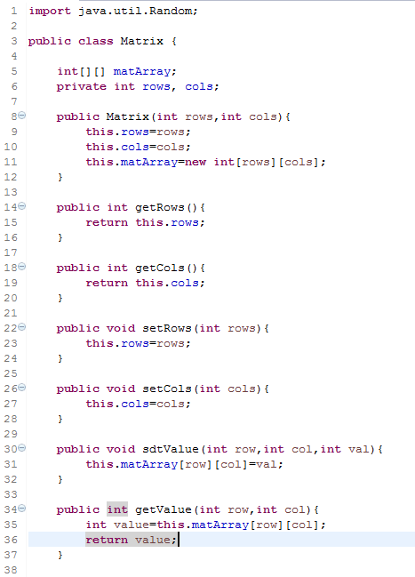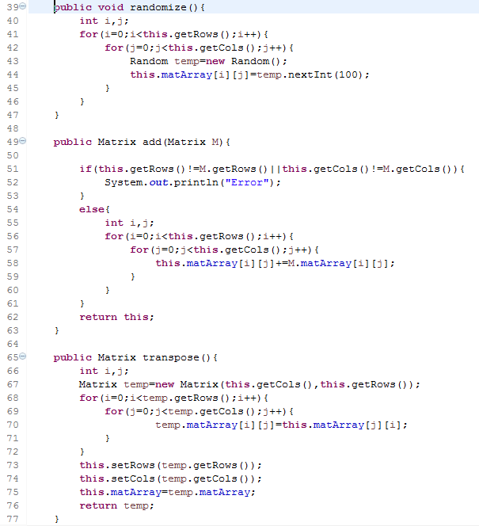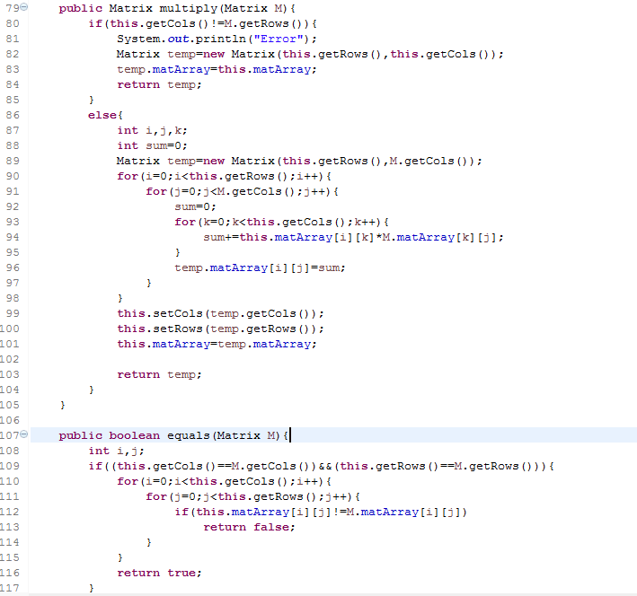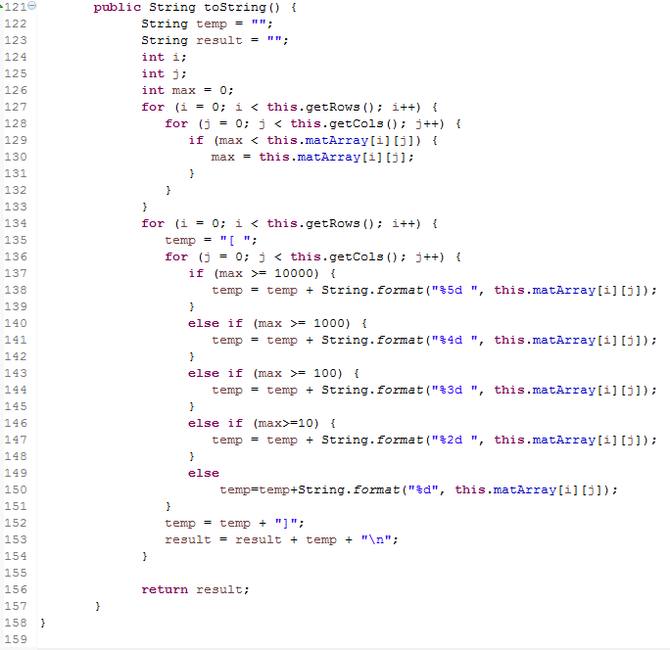

SquareMatrix.java

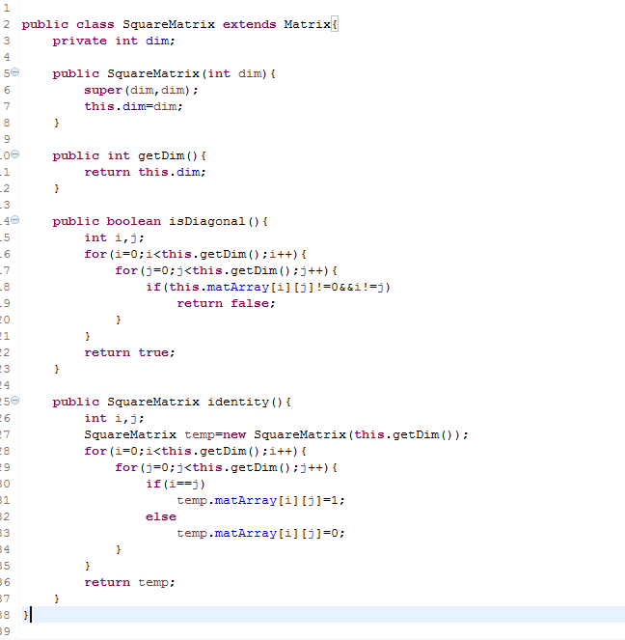

Vector.java

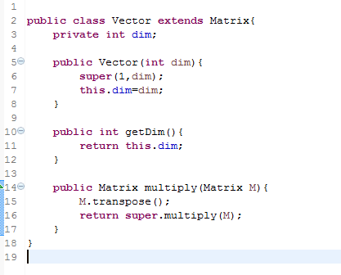

test.java

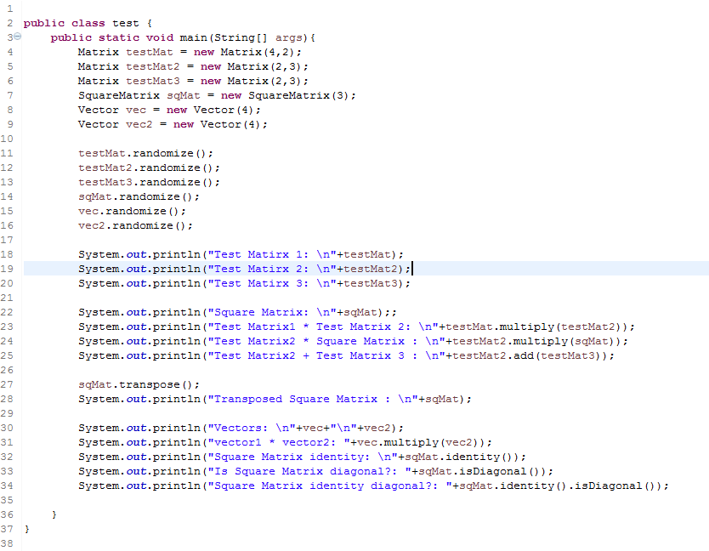

3. Results of implementation

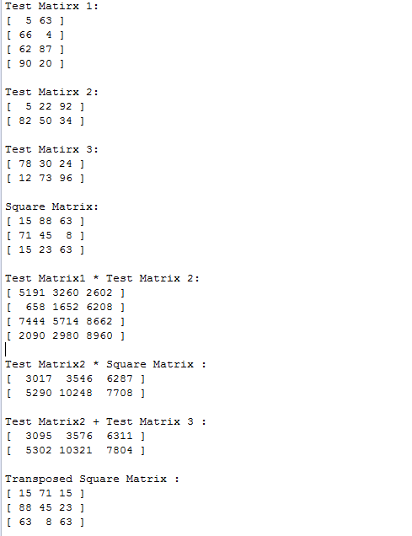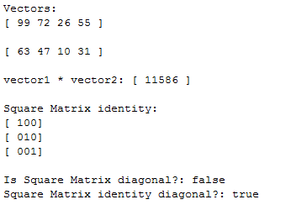

4. Code Explain

Matrix

1)add : Do add operation between two matrix

2)transpose : Change the matrix to transpose matrix that the rows and columns are exchanged

3)equals : Return true if two matrix are equal completely else return false

SquareMatrix

1)isDiagonal : return true if all members except diagonal members are not 0, else false

2)identity : return the matrix that the diagonal members are 1 and others are 0

Vector

1)multiply : transpose the latter matrix and operate multiply operation.