OOP Assignment #1

2015004957

임현택

1. Assignment summary

Calculate e^x by using an infinite series expansion.

2. Code

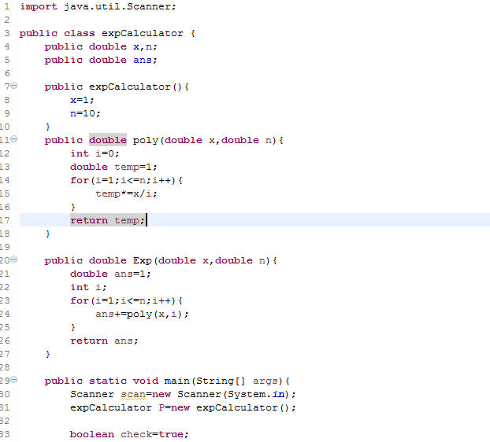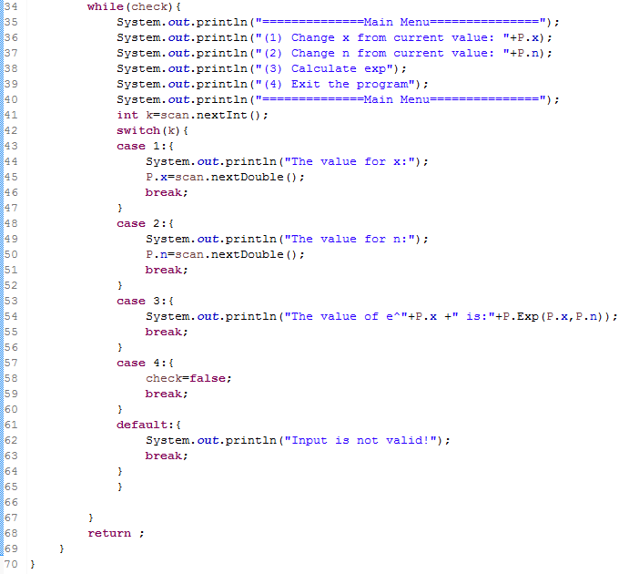

3. Results of implementation

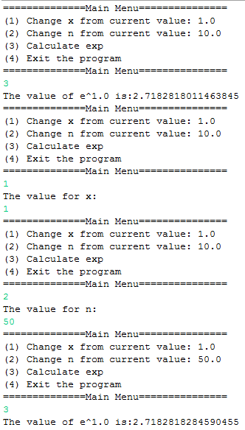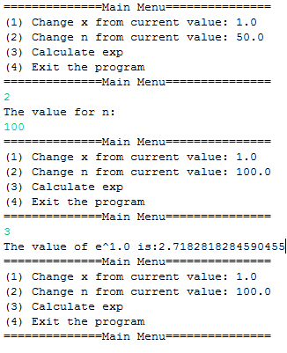

4. Code Explain

poly method : poly method calculate x^n/n!.

Exp method : Exp method invoke poly method and sum all the series and return calculate value of e^x .