Individual Recode Documentation

Tanzania (DHS-IV) Version 1 Doc 01 TZ4

Name of Survey | Tanzania Demographic and Health Survey 2004
Executing Agency | National Bureau of Statistics (NBS)
Year of Fieldwork | 2004
Universe | All women 15-49
Coverage | National, 100%
Size | 9,735 households completed
 | 49,921 household members
 | 10,329 individual women’s surveys completed
 | 2,635 individual men’s surveys completed
 | 1,244 couples
 | 8,564 children < 60 months
 | 30,557 all births
Weights | Weighted by sample area (cluster)
Contents | MEASURE DHS+, anemia testing, AIDS and other sexually transmitted diseases, Maternal mortality
Language | English and Swahili
Anthropometry | Women 15-49 years  Children aged 0-59 months
Calendar | 4 columns calendar
Supplementary Data Files | Household  Male Recode
Recode Structure | DHS-IV
Maximum entries in household schedule: | 20

NOTE ON RECODE:

- There are 10 cases in variable Q508 “Number of husband’s wives including yourself” where the respondent said “one”. Those 10 cases where recoded into “0” in V505.

- HV040: Altitude variable was adjusted by Livia Montana base on the information collected from GPS units and papers.

- Assistance during delivery (Q426): the raw frequency for Q426 do not agreed with variables M3A-N in the recode frequency. This is because a typo in the individual questionnaire, see below (letter “D” is missing in column 2 & 3). Specifics variables were created in the raw data in order to solve the problem. Q426 should not be used, instead S426A-Y.

- There are 22 cases of women who had sex before age 10, after imputation (one case at age 6, three cases at age 7, six cases at age 8 and 12 cases at age 9). See V531.

- Variables V789/V790 “ number of injections administered last 3 months” were set to Not Applicable because for Tanzania DHS the variables refer to last 6 months (See specific variables S499B/S499C).

- Husband’s education V702: Primary and post primary = Primary; post-secondary and superior = Higher

- The variables V3A00A-Z were recoded from Q330 as followed (specific variable were created also, see variables S330A-X).

V3A00A = (B) Referral/spec. hospital,
(C) Regional hospital,
(D) District hospital
V3A00B = (E) Health centre
V3A00C = Not applicable
V3A00D = Not applicable
V3A00E = (H) CBD worker
V3A00F = (F) Dispensary
V3A00G = (G) Village health post
V3A00H = Not applicable
V3A00I = Not applicable
V3A00J = (M) Private specialized hospital
(N) Private Health Centre
(O) Private dispensary
V3A00K = (P) Pharmacy
V3A00L = Not applicable
V3A00M = Not applicable
V3A00N = Not applicable
V3A00O = (I) Religious/voluntary referral hospital
V3A00P = (J) Religious/voluntary district hospital
V3A00Q = (K) Religious/voluntary health centre
V3A00R = (L) Religious/voluntary dispensary
V3A00S = (P) Pharmacy
V3A00T = Not applicable
V3A00U = (V) Friend, relative, neighbors
V3A00V = (Q) NGO
V3A00W = (R) VCT center
V3A00X = (X) Other
(T) Bar
(U) Guest house/ hotel

Time in Swahili:
24 hours
system time Swahili time
1 AM 7
2 8
3 9
4 10
5 11
6 12 Usiku
7 1
8 2
9 3
10 4
11 5 Azubihi
12 PM 6 Mchana
13 7
14 8
15 9
16 10
17 11 Jioni
18 12
19 1 Usiku
20 2
21 3
22 4
23 5
24 6

Education:

0 = Preschool (0-3)
1 = Primary (1-8)
2 = Primary training (1-4)
3 = Secondary (1-4)
4 = Secondary training (1-6)
5 = University (1-10)
Questionnaires design problem:

Question 426: Columns 2,3,4 or more different categories than Column 1
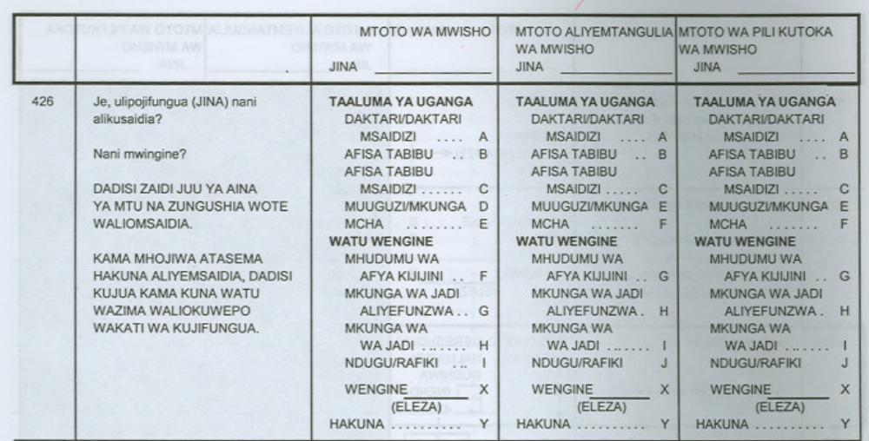
Question 482: Columns 2,3,4 or more different categories than Column 1
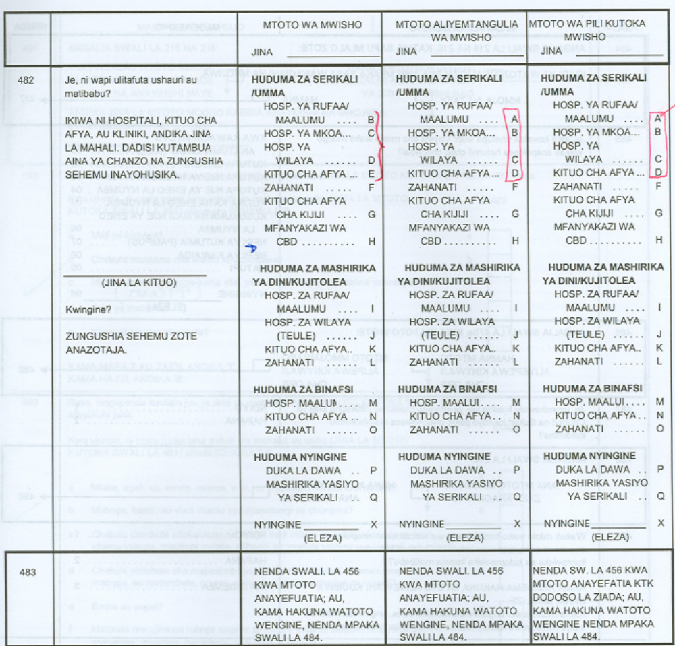

Problem in the number assigned to each row of the calendar.
Sections and Variables Unused

HOUSEHOLD – RECH0:

HV043 HV044

HOUSEHOLD – RECH1:

HV115 HV116

HOUSEHOLD – RECH2:

HV230 HV231 HV232 HV233 HML15

HOUSEHOLD – RECH5:

HA58 HC58

HOUSEHOLD – RECH7:

HML3 HML5 HML7 HMLG HMLH HMLI
HMLJ

INDIVIDUAL WOMEN – REC01:

V043 V044

HOUSEHOLD – REC11:

V131 V162 V163 V164 V165

INDIVIDUAL WOMEN – REC31:

V304 (abstinence) not asked.
V305 (abstinence) not asked.
V306 (abstinence) not asked.

INDIVIDUAL WOMEN – REC32:

V375A V379 V380
V3A00C V3A00D V3A00H V3A00I V3A00L V3A00M
V3A00N V3A00T V3A08U V3A08V V3A08W

INDIVIDUAL WOMEN – REC41:

M2J M2L M2M M3J M3L M3M
M37B M37D M37E M37G M37I M37J M37K
M37P M37S M37T M37XX M37XY M37XZ

M40A M40B M40C M40D M40E M40F M40G
M40H M40I M40J M40K M40L M40M M40N
M40O M40P M40Q M40R M40S M40T M40U
M40V M40W M40X M40Y M40Z M40XX
M40XY M40XZ

M49D M49E M49F M49G
M55J M55K M55L M55M M55N M56

INDIVIDUAL WOMEN – REC42:

V420 V421 V458 V462 V463D V463E V463F
V463G
M469B M469D M469E M469G M469I M469J
M469K M469P M469S M469T M469XX M469XY
M469XZ

M470A M470B M470C M470D M470E M470F
M470G M470H M470I M470J M470K M470L
M470M M470N M470O M470P M470Q M470R M470S
M470T M470U M470V M470W M470X M470Y
M470Z M470XX M470XY M470XZ

INDIVIDUAL WOMEN – REC43:

H12H H12I H12L H12N H12S H12T H12W
H15A H15E H15F H15G H15H
H32H H32I H32L H32N H32R H32S H32T
H36A H36B H36C H36D H36E H36F
H37H

INDIVIDUAL WOMEN – REC44:

HW58

INDIVIDUAL WOMEN – REC61:

V630J V630K V630L V630M V630N V630O
V633E V633F V633G

INDIVIDUAL WOMEN – REC75:

V754A V754P V754Q V754R V754S V754T V754U
V754V

V759A V759B V759C V759D V759E V759F V759G
V759H V759I
V762AC V676AI V762AL V762AT
V762BC V676BI V762BL V762BT
V763D V763E V763F V763G
V765A V765B V765C
V770A V770B V770C V770D V770E V770F V770G
V770H V770I V771 V772 V773A V773B V773C
V773D V773E V773F V773X V774 V776 V782
V785M V785N V785O V785P V785Q
V786M V786N V786O V786P V786Q
V787 V788 V789 V790

INDIVIDUAL WOMEN – REC81

MM5 MM10 MM11 MM12 MM13 MM15
MMC3 MMC4

INDIVIDUAL WOMEN – REC94

M57B M57C M57D M57L M57P M57Q M57R
M58

INDIVIDUAL WOMEN – REC95:

ML13F ML13G ML13H ML13K ML13L ML13M
ML19D ML19E ML19F
ML23A ML23B ML23C

INDIVIDUAL WOMEN – RECFG:

FG117A FG117B FG117C FG117D

FG119A FG119B FG119C FG119D FG119E FG119F
FG119G FG119H FG119I FG119J FG119X FG119Y
FG119Z
FG120A FG120B FG120C FG120D FG120E FG120F
FG120G FG120H FG120X FG120Y FG120Z
FG121 FG122 FG124

INDIVIDUAL WOMEN – RECWS:

W118E W118F W118G W118H W118I
W122F W122G W122H W122I W122J
W123F W123G W123H W123I W123J

NEW CATEGORIES:

V327 0 - Religious/voluntary hospital/centre

New section added

HOUSEHOLD - RECH3

HV270 Wealth index
HV271 Wealth index factor score (5 decimals)
HML1 Number of mosquito nets
HML1A Number of mosquito nets with specific information
HML2 Number of children under bednet previous night
SHDIST District
SHWARD Ward
SHEA EA number
SH25B A paraffin lamp
SH25F An iron
SH26A Main source of energy for lighting in the house
SH27C Rooms for sleeping
SH28D A bank account
SH28AF Acres of land for farming
SH28AG Acres of land for grazing
SH28BB Your household use land for farming or grazing
SH28CF Acres of land for farming (land does not own)
SH28CG Acres of land for grazing (land does not own)
SH28DD How far is the nearest market place?
SH28E How many meals does your house usually have each
SH28F How many days consume meat (last week?)
SH28G How often have problems in satisfying the foods

HOUSEHOLD – RECH4

IDXH4 Index to household schedule
HML12 Type of bednet(s) person slept under last night
HML13 1st net number for net person slept under last
HML14 2nd net number for net person slept under last
HML15 3rd net number for net person slept under last
HML16 Corrected age from individual questionnaire
HML17 Flag for AH07 age from individual file
HML18 Pregnancy from individual questionnaire
HML19 Person sleep under an ever treated bednet
SH20AA Main activity last 12 months
SH15A Level of education attended
SH15B Highest grade completed
SH18A Level of education attending
SH18B Grade attending
SH20A Level of education last year
SH20B Grade attended last year

INDIVIDUAL – REC91

V190 Wealth index
V191 Wealth index factor score (5 decimals)
AWFACTW All woman factor - wealth index
ML101 Type of bednet(s) slept under last night
V820 Condom used at first sexual intercourse
V821A Last sexual partner younger, the same age or ol
V821B Next to last sexual partner younger, the same a
V821C Second to last sexual partner younger, the same
V822 Wife justified to ask husband to use condom if
V754BP Reduce risk of getting AIDS by not having sex a
V823 Can get AIDS by witchcraft or supernatural mean
V824 Drugs to avoid AIDS transmission to baby during
V825 Would buy vegetables from vendor with AIDS
V826 When was last time you were tested
V827 Last test was on your own, offered or required
V828 Did get the test results
SDIST District
SWARD Ward
SEA EA number
S101A Morning or afternoon
S108 Highest educational level
S109 Highest grade at that level
S117 Numbers of trips away during last 12 months
S118 Away for more than one month
S330B Source for FP: Referral/ specialized hospital
S330C Source for FP: Regional hospital
S330D Source for FP: District hospital
S330E Source for FP: Health centre
S330F Source for FP: Dispensary
S330G Source for FP: Village health post
S330H Source for FP: CBD worker
S330I Source for FP: Religious/voluntary hospital
S330J Source for FP: Religious/voluntary district hospital
S330K Source for FP: Religious/voluntary health centre
S330L Source for FP: Dispensary
S330M Source for FP: Private specialized hospital
S330N Source for FP: Private health centre
S330O Source for FP: Private dispensary
S330P Source for FP: Pharmacy
S330Q Source for FP: NGO
S330R Source for FP: VCT centre
S330S Source for FP: Shop/ kiosk
S330T Source for FP: Bar
S330U Source for FP: Guest house/ hotel
S330V Source for FP: Friends, relatives, neighbors
S330X Source for FP: Other
S334 Seen or heard a message about Mama Ushauri
S335A Where did you see or hear the message about Mam
S335B Where did you see or hear the message about Mam
S335C Where did you see or hear the message about Mam
S335D Where did you see or hear the message about Mam
S335Z Where did you see or hear the message about Mam
S490H Care factors: Unfriendly providers
S499B Number of injection last six months
S499C Number of injection administered by a heath pro
S499D Where did you go for the injection the last time?
S499E A new syringe was used?
S515 How did your previous marriage end?
S516 Who did most of your late husband's property go
S517 Did you receive any of your late husband's asse
S520 Will way until marriage to have first sex
S523 Age of partner first sex
S524 Partner older than you
S525 Partner 10 year or more older than you
S529A Drank alcohol during last sex
S529B Drank alcohol during last sex
S529C Drank alcohol during last sex
S530A Drunk while having sex last 12 months
S530B Drunk while having sex last 12 months
S530C Drunk while having sex last 12 months
S542 First sexual intercourse was because you wanted
S543 Paid/received money for sex last 12M
S545B Source of condom: Referral/ spec. hospital
S545C Source of condom: Regional hospital
S545D Source of condom: District hospital
S545E Source of condom: Health centre
S545F Source of condom: Dispensary
S545G Source of condom: Village health post
S545H Source of condom: CBD worker
S545I Source of condom: Referral/ spec. hospital
S545J Source of condom: District hospital
S545K Source of condom: Govt. health centre
S545L Source of condom: Dispensary
S545M Source of condom: Specialized hospital
S545N Source of condom: Health centre
S545O Source of condom: Dispensary
S545P Source of condom: Pharmacy
S545Q Source of condom: NGO
S545R Source of condom: VCT
S545S Source of condom: Shop/ kiosk
S545T Source of condom: Bar
S545U Source of condom: Guest house
S545V Source of condom: Friends
S545X Source of condom: Other
S545Z Source of condom:
S616A To get information about FP who would you like
S616BA Is acceptable FP information on the radio
S616BB Is acceptable FP information on the TV
S616BC Is acceptable FP information on the newspaper
S617D Heard FP from a poster last months
S617E Heard FP from billboard last months
S617F Heard FP from community events last months
S617G Heard FP from live drama last months
S617H Heard FP from a doctor or nurse last months
S617I Heard FP from community health worker last month
S618A Listened on radio drama series: Zinduka
S618B Listened on radio drama series: Twende na Wakat
S618C Listened on radio drama series: Other
S618BB How often do you listen to Zinduka?
S618CC Any action taken as a result of Zinduka?
S618DA What did you do as a result: talked to partner?
S618DB What did you do as a result: talked to health worker?
S618DC What did you do as a result: talked to someone?
S618DD What did you do as a result: visited a clinic?
S618DE What did you do as a result: begin using a modern method?
S618Df What did you do as a result: continuing using a ..?
S618DX What did you do as a result: other?
S618F How often do you listen to Twenda na Wakati?
S631 Can you say no to your husband if you don't want?
S632 Could you ask your husband to use condom if you
S814 Any special medication people infected from AID
S816 Had antenatal care last pregnancy
S817A Anyone talked to you about babies getting the A
S817B Anyone talked to you about things you can do to
S817C Anyone talked to you about getting tested for A
S818 Test for AIDS offered during ANC visits
S819 Were you tested for the AIDS?
S820 Did you get the results of test?
S821 Where was test done?
S834A Male teacher with AIDS allowed continuing teach
S844 Believe young men should wait until married to
S845 Believe young women should wait until married t
S846 Believe married men should only have sex with t
S847 Most men you know have sex only with their wives
S848 Believe married women should only have sex with
S849 Most women you know have sex only with their husband
S860B STI treatment: Referral/ spec. hospital
S860C STI treatment: Regional hospital
S860D STI treatment: District hospital
S860E STI treatment: Health centre
S860F STI treatment: Dispensary
S860G STI treatment: Village health post
S860H STI treatment: CBD worker
S860I STI treatment: Religious Referral/ spec. hospital
S860J STI treatment: Religious district hospital
S860K STI treatment: Religious health centre
S860L STI treatment: Religious dispensary
S860M STI treatment: private specialized hospital
S860N STI treatment: Private health centre
S860O STI treatment: Private dispensary
S860P STI treatment: Pharmacy
S860Q STI treatment: NGO
S860R STI treatment: VCT centre
S860X STI treatment: Other

INDIVIDUAL – REC94

IDX94 Index to birth history
M57A Antenatal care: your home
M57B Antenatal care: other home
M57C Antenatal care: CS home
M57D Antenatal care: CS home
M57E Antenatal care: govt. hospital
M57F Antenatal care: regional hospital
M57G Antenatal care: district hospital
M57H Antenatal care: health center
M57I Antenatal care: dispensary
M57J Antenatal care: village health post
M57K Antenatal care: CBD worker
M57L Antenatal care: other public
M57M Antenatal care: private specialized hospital
M57N Antenatal care: private health center
M57O Antenatal care: dispensary
M57P Antenatal care: CS private
M57Q Antenatal care: CS private
M57R Antenatal care: other private
M57S Antenatal care: religious/voluntary spec. hospital
M57T Antenatal care: religious/voluntary district ho
M57U Antenatal care: religious/voluntary health cent
M57V Antenatal care: religious/voluntary dispensary
M57X Antenatal care: other
M58 Information about AIDS given at antenatal visit
M59 Child registered at birth
S428A Health facility gives you a birth notification f
S428B Did you get a birth notification form from any
S432A Did you get a birth notification form?
S432B Birth was registered

INDIVIDUAL – REC95

IDX95 Index to birth history
ML0 Type of bednet(s) child slept under last night
ML1 Times took Fansidar during pregnancy
ML2 Type of visit at source for antimalarial during
ML11 Child has fever now
ML12 Child has had convulsions in last 2 weeks
ML13A Fansidar taken for fever/convulsion
ML13B Chloroquine taken for fever/convulsion
ML13C Amodiaquine taken for fever
ML13D Quinine taken for fever/convulsion
ML13E Aspirin taken for fever/convulsions
ML13F Panadol taken for fever/convulsion
ML13G Ibuprofen/Acetaminophen taken
ML13H Panadol, paracetamol, aspirin, calpol
ML13I Artesunate taken for fever/convulsion
ML13J Ibuprofen/acetaminophen taken for fever/convulsion
ML13K CS taken for fever/convulsion
ML13L CS taken for fever/convulsion
ML13M CS taken for fever/convulsion
ML13X Other taken for fever/convulsion
ML13Y Nothing taken for fever/convulsion
ML13Z Don't know if or what was taken for fever/convulsion
ML14A Injection for fever/convulsion
ML14B Suppository for fever/convulsion
ML14Y No suppository or injection for fever/convulsion
ML14Z Don't know if suppository or injection for fever
ML15A When started Fansidar
ML15B Days child took Fansidar
ML15C First source for Fansidar
ML16A When started Chloroquine
ML16B Days child took Chloroquine
ML16C First source for Chloroquine
ML17A When started Amodiaquine
ML17B Days child took Amodiaquine
ML17C First source for Amodiaquine
ML18A When started Quinine
ML18B Days child took Quinine
ML18C First source for Quinine
ML19A For fever/convulsion: Consulted traditional healer
ML19B For fever/convulsion: Gave tepid sponging
ML19C For fever/convulsion: Gave herbs
ML19D For fever/convulsion: CS
ML19E For fever/convulsion: CS
ML19F For fever/convulsion: CS
ML19X For fever/convulsion: Other
ML19Y For fever/convulsion: Gave nothing
ML19Z For fever/convulsion: Don't know if something else was
ML20A Took first line medication
ML20B When started 1st line medication
ML20C Duration of 1st line medication
ML21A Took second line medication
ML21B When started 2nd line medication
ML21C Duration of 2nd line medication
ML22A Took other anti-malarial medication
ML22B When started other anti-malarial medication
ML22C Duration of other anti-malarial medication
ML23A When started other anti-malarial
ML23B Days child took other anti-malarial
ML23C First source for other anti-malarial
HB1 Received DPT-HB 1
HB1D DPT-HB 1 day
HB1M DPT-HB 1 month
HB1Y DPT-HB 1 year
HB2 Received DPT-HB 2
HB2D DPT-HB 2 day
HB2M DPT-HB 2 month
HB2Y DPT-HB 2 year
HB3 Received DPT-HB 3
HB3D DPT-HB 3 day
HB3M DPT-HB 3 month
HB3Y DPT-HB 3 year

NOTE ON RECODES FILES

HOUSEHOLD:

- There are 121 cases of children where the age listed in the household schedule is different from the age listed in the Height & Weight section (HV020 inconsistent with HV105). Message #11015.
- There are 75 cases where the line number for the parent/caretaker is missing (HA51 / HC51 / HW51). Message #12012.
- There are 435 cases where the age of the woman in the Height & Weight section differs from her age in the household listing by more than 2 years. Message #15204.
- There are 164 cases where the age of the women (from height & weight section) differs from the age as calculated from HV008 (date of interview) and HA32 (date of birth of the women). The difference is by a year because the months of birth are the same of the month of the interview. Message #15207.
- There are 421 cases where the Weight/Height/Lying or standing information is not given. Message #16201.
- There are 431 cases where the Height of the child (HC3) does not match the Lying or standing information (HC15). Message #16230.
- There are 571 cases of children who were either under age 2 (HC1 < 24) and were measured standing up (HC15=2) or were older than 2 and were measured lying down. Message #20006.
- There are 5 households with no de-jure adult household members (HV012 = 0). Message #20012.
- There are 1170 cases of women and 459 cases of children where their ages in the household schedule are different from age listed in HA1/HC1 (height/weight section), because the age as listed in the individual questionnaire is used. Message #20015/20016.

INDIVIDUAL WOMEN:

- There are 4 cases where the number of years living in the place of residence (V104) is greater than the current respondent’s age (V012). Message #1101.
- There are 171 cases where the duration (in minutes) of woman interview has negative values and 103 cases where the duration is greater than 180 minutes (MV801). Message #20003/20004.
- There are 5 cases of women who started school before age 5. Message #1103.
- There are 14 cases where the respondent has no education (V106=0) and had never participated in a literacy program (V156=0), but had a response on V157 (frequency of reading newspaper or magazines). Message #1122.
- There are 4 dead children where the age at death was reported outside ranges (40, 33 days). Message #2115.
- There is one case of a woman who has her first child before age 10. Message #2119.
- There are 78 cases of children where the age reported in the household differs for more than 2 years from the age reported in the birth history. Message #2127.
- There are 84 cases where age at death of the child was reported as one year. Message #20011
- There are 107 cases where the date of vaccination was 7 days after previous vaccination. Message #20010.
- There are 163 cases of women who have never menstruated but they have at least one birth. Message #2215.
- There is one case where the month of a termination is missing. Information from calendar was used to replace the missing data. Message #2228.
- There is one case of women who had used male sterilization (one previous husband) but she is not currently using any method. Message #3207.
- There are 12 cases of women who are currently using a method where the duration of use reported in V337 differ by one month from the duration reported in the calendar. Message #3222.
- There are 2 cases of women with information on variables V3A02/V3A05 but they started using the current method before the cutoff date (1999). Those 2 cases were set to inconsistent = 9997 and the imputation program assigned a year before the cutoff date. Message #3262/3265.
- There are 89 cases of pregnancies where the duration of amenorrhea overlaps next pregnancy. For most of the cases the difference is by one month. There are also 22 cases where the duration of abstinence overlaps next pregnancy. Message #4107/4108.
- There are 8 cases of twin where some variables related to pregnancy do not have the same answer. Message #4109.
- There are 3 cases of children that are still breastfeeding but they are not the last child. Message #4111.
- There are 20 cases of women who reported that their period has not returned since last pregnancy but a date of last period was given in specific question about menstruation (V226). Message #4113.
- There is one case where the interval for duration of breastfeeding (M4) is greater than age at death and Flag not set to 3. Message #4123.
- There are 282 cases of children that receive solid food the night before of the interview (M39) but not food specified in M37A-Z and vice-verse. Message #4129.
- There 2 cases where the timing for first antenatal care visits (M13) was after last antenatal check (M41). Message #4134.
- There are 3 pairs of twins where one of the twins had died and the mother is still breastfeeding the second child. Message #4203/4216.
- There are 16 cases of women where only one of the measurements (height/weight) was taken (V437 / V438) and the result of measurements is code 6 (“other”). Message #4215.
- There are 8 cases of children that started breastfeeding during the first 3 days of birth (V426) but the information about duration of breastfeeding is missing (M4). Message #4218.
- There are 39 cases of women currently pregnant according to household anemia module (V454) but they are not pregnant according to information in individual questionnaire (V213) and vice-versa. Message #4228.
- There are 31 cases where the age listed in the Height/weight section (HW1) is different from the age in the individual questionnaire. Message #4414.
- There are 7 cases of women who got married before age 10. Message #5106.
- There are 218 cases where the respondent’s age at first sex after age at first birth. For most of the cases the difference is by a year. Message #5118.
- There are 36 cases of women who said they discussed about family planning with their husband (V630A) but they’ve never been married or are not currently married (V502). Message #6118.
- There are125 cases where the age of the respondent’s husband is different from the age in the household schedule by more than 2 years. Message #7102.
- There are 20 cases where the occupation codes “962 / 963” where recoded into code “0”, variable V717 (decision taken by DE supervisor Buberwa in Tanzania). Message #7105.
- There are 295 cases where the respondent did not spontaneously mention any way to avoid or reduce their chances to get AIDS but says “yes” to some probe question about AIDS transmission (V754CP, V754DP,V754JP, V754WP). Message #7506.
- There are 105 cases of women where after imputing the date of birth of respondent’s siblings in Maternal Mortality section, the number of respondent’s preceding sibling differs from the number stated by respondent in Q903. Message #8402.
- There are 270 cases where the gestation length for births in the calendar is different than 9 months. Out of 270, there are 11 cases with gestation length of 11 months, 3 cases with 12 months and 3 cases with 6 months. Message #9103.

MALE RECODE

Note on recode

Variable occupation has 23 cases in the raw data with code “11” that were recoded into “111” in the recode data.

Variable MV762AA/MV762BA “Public hospital/clinic” includes codes “B”, “C”, “D” from main variable QM440/QM449. And variable MV762AJ/ MV762BJ “Private hospital/clinic” includes codes “M” and “N”. The original variable was also kept as country specific.

Sections and Variables Unused

MREC11:

MV131 MV463D MV463E MV463F MV463G

MREC22:

MV225 MV246

MREC31:

MV304( Abstinence) not asked
MV305( Pill ) not asked
MV305(IUD) not asked
MV305(Injection) not asked
MV305(Diaphragm) not asked
MV305(Female sterilization) not asked
MV305(Other) not asked
MV305(Norplant) not asked
MV305(Abstinence) not asked
MV305(LAM) not asked
MV305(Female condom) not asked
MV305(Foam/jelly) not asked

MV307 not applicable
MREC32:

MV312 MV313 MV362 MV363 MV364 MV367
MV376 MV376A MV3B0 MV3B1 MV3B2A MV3B2B
MV3B2C MV3B2D MV3B2E MV3B2F MV3B2G MV3B2H
MV3B2I MV3B2J MV3B2K MV3B2L MV3B2X MV3B2Z

MV3B3A MV3B3B MV3B3C MV3B3D MV3B3E MV3B3F
MV3B3G MV3B3H MV3B3I MV3B3J MV3B3K MV3B3L
MV3B3M MV3B3N MV3B3X MV3B3Z

MV3B12F MV3B12G MV3B12H

MV3B13 MV3B14A MV3B14B MV3B14C MV3B14D MV3B14E
MV3B14F MV3B14G MV3B14H MV3B14I MV3B14J MV3B14X
MV3B15A MV3B15B MV3B15M MV3B16 MV3B17 MV3B18
MV3B19 MV3B20

MV3B23A MV3B23B MV3B23C MV3B23D MV3B23E MV3B23F
MV3B23G MV3B23H MV3B23I MV3B23J MV3B23K MV3B23X

MV3B24J MV3B24K MV3B24L MV3B25C

MREC51:

MV534A

MREC61:

MV610 MV611
MV621 MV630K MV630L MV630M MV630N MV630O
MV631 MV633E MV633F MV633G MV635 MV636
MV637 MV638 MV642 MV643 MV644 MV645
MV646 MV647 MV649A MV649B MV649C

MREC71:

MV719 MV721 MV732 MV743A MV743E

MREC75

MV753 MV754A MV754P MV754Q MV754R MV754S
MV754T MV754U MV754V

MV759A MV759B MV759C MV759D MV759E MV759F
MV759G MV759H MV759I

MV762AC MV762AG MV762AH MV762AI MV762AL MV762AN
MV762AO MV762AR MV762AT

MV762BC MV762BG MV762BH MV762BI MV762BL MV762BN
MV762BO MV762BR MV762BT

MV763D MV763E MV763F MV763G
MV770A MV770B MV770C MV770D MV770E MV770F
MV770G MV770H MV770I
MV771 MV772 MV773A MV773B MV773C MV773D
MV773E MV773F MV773X
MV477 MV478 MV479 MV480
MV776 MV782 MV784
MV785M MV785N MV785O MV785P MV785Q
MV786M MV786N MV786O MV786P MV786Q
MV787 MV788 MV789 MV790 MV793 MV793A
MV793B MV793C

New sections added:

MV190 Wealth index
MV191 Wealth index factor score (5 decimals)
MV820 Condom used at first sexual intercourse
MV822 Wife justified to ask husband to use condom if
MV754BP Reduce risk of getting AIDS by not having sex a
MV823 Can get AIDS by witchcraft or supernatural mean
MV824 Drugs to avoid AIDS transmission to baby during
MV825 Would buy vegetables from vendor with AIDS
MV826 When was last time you were tested
MV827 Last test was on your own, offered or required
MV828 Did get the test results
MV3B21F Buying condoms is embarrassing
FGM100 Ever heard of female circumcision
FGM103 Respondent circumcised
FGM123 Should circumcision continue?
MV477 Number of injections in last 12 months
MV478 Injections administered by a health worker
MV479 Source for injection by health worker
MV480 Syringe and needle from new, unopened package
SMDIST District
SMWARD Ward
SMEA EA number
SM110 Highest educational level
SM111 Highest grade at that level
SM127 Who mainly decides how the money you earn will
SM128 Share used for household expenditures
SM401A Is your partner living with you now?
SM410A_GRP Line numbers of wives, partners
SM410A Partner's age
SM416A Do you intend to wait until get married to have
SM416D Age of partner had first sexual intercourse?
SM420A Use condom every time had sex: last sex
SM420B Use condom every time had sex: second-to-last s
SM420C Use condom every time had sex: third-to-last se
SM426A Last time had sex drank alcohol with: last part
SM426B Last time had sex drank alcohol with: second-to-last
SM426C Last time had sex drank alcohol with: third-to-last
SM427A Were you or your partner drunk last time had se
SM427B Were you or your partner drunk last time had se
SM427C Were you or your partner drunk last time had se
SM431A Last sexual partner's age
SM431B Second-to-last sexual partner's age
SM431C Third-to-last sexual partner's age
SM436A Did you pay for sex last 12 months?
SM436B The last time pay for sex was condom used
SM436C Did you use condom every time you paid for sex
SM438 In total, how many different people have you had sex?
SM440B Source of condom: Referral/ spec. hospital
SM440C Source of condom: Regional hospital
SM440D Source of condom: District hospital
SM440E Source of condom: Health centre
SM440F Source of condom: Dispensary
SM440G Source of condom: Village health post
SM440H Source of condom: CBD worker
SM440I Source of condom: Referral/ spec. hospital
SM440J Source of condom: District hospital
SM440K Source of condom: Govt. health centre
SM440L Source of condom: Dispensary
SM440M Source of condom: Specialized hospital
SM440N Source of condom: Health centre
SM440O Source of condom: Dispensary
SM440P Source of condom: Pharmacy
SM440Q Source of condom: NGO
SM440R Source of condom: VCT
SM440S Source of condom: Shop/ kiosk
SM440T Source of condom: Bar
SM440U Source of condom: Guest house
SM440V Source of condom: Friends
SM440X Source of condom: Other
SM440Z Source of condom: DK
SM449B Source of female condom: Referral/ spec. hospital
SM449C Source of female condom: Regional hospital
SM449D Source of female condom: District hospital
SM449E Source of female condom: Health centre
SM449F Source of female condom: Dispensary
SM449G Source of female condom: Village health post
SM449H Source of female condom: CBD worker
SM449I Source of female condom: Referral/ spec. hospital
SM449J Source of female condom: District hospital
SM449K Source of female condom: Govt. health centre
SM449L Source of female condom: Dispensary
SM449M Source of female condom: Specialized hospital
SM449N Source of female condom: Health centre
SM449O Source of female condom: Dispensary
SM449P Source of female condom: Pharmacy
SM449Q Source of female condom: NGO
SM449R Source of female condom: VCT
SM449S Source of female condom: Shop/ kiosk
SM449T Source of female condom: Bar
SM449U Source of female condom: Guest house
SM449V Source of condom: Friends
SM449X Source of condom: Other
SM449Z Source of condom: DK
SM508A Is acceptable FP information on the radio
SM508B Is acceptable FP information on the TV
SM508C Is acceptable FP information on the newspaper
SM508AD Heard FP from a poster last months
SM508AE Heard FP from billboard last months
SM508AF Heard FP from community events last months
SM508AG Heard FP from live drama last months
SM508AH Heard FP from a doctor or nurse last months
SM508AI Heard FP from community health worker last month
SM509A Listened on radio drama series: Zinduka
SM509B Listened on radio drama series: Twende na Wakat
SM509C Listened on radio drama series: Other
SM509BB How often do you listen to Zinduka?
SM509CC Any action taken as a result of Zinduka?
SM509DA What did you do as a result: talked to partner?
SM509DB What did you do as a result talked to health worker?
SM509DC What did you do as a result: talked to someone else
SM509DD What did you do as a result: visited a clinic?
SM509DE What did you do as a result: began using a modern method
SM509DF What did you do as a result: continued using a m
SM509DX What did you do as a result: other?
SM509F How often do you listen to Twenda na Wakati?
SM602 Sex of last born child
SM603M Time of last birth (Month)
SM603Y Time of last birth (Year)
SM604 Child still alive
SM605U Age at death (Unit)
SM605N Age at death (Number)
SM606 Line number of mother of last born
SM609 Relationship with last born’s mother
SM610A Mother received advice or care
SM611A Main provider of money, goods to pay for care
SM612A Reason did not receive care
SM610B Mother received advice or care
SM611B Main provider of money, goods to pay for care
SM612B Reason did not receive care
SM610C Mother received advice or care
SM611C Main provider of money, goods to pay for care
SM612C Reason did not receive care
SM613 Talked to health provider about mother's health
SM615 Child lives in the household
SM616A Who decides what to do if child ill: respondent
SM616B Who decides what to do if child ill: child's mother
SM616C Who decides what to do if child ill: wife/ part
SM616D Who decides what to do if child ill: female relative
SM616E Who decides what to do if child ill: male relative
SM616X Who decides what to do if child ill: other
SM616Y Who decides what to do if child ill: child never sick
SM617A Signs pregnancy complications: vaginal bleeding
SM617B Signs pregnancy complications: high fever
SM617C Signs pregnancy complications: abdominal pain
SM617D Signs pregnancy complications: swelling of hand
SM617E Signs pregnancy complications: difficult labor
SM617F Signs pregnancy complications: convulsions
SM617X Signs pregnancy complications: other
SM617Z Signs pregnancy complications: DK any signs or
SM618 Drinking pattern for diarrhea
SM619 Ever heard of ORS product
SM623 Number of injection last six months
SM624 Number of injection administered by a heath pro
SM625 Where did you go for the injection the last time?
SM626 A new syringe was used?
SM728 Where was test done?
SM730B Place HIV test: Referral/ spec. hospital
SM730C Place HIV test: Regional hospital
SM730D Place HIV test: District hospital
SM730E Place HIV test: Health centre
SM730F Place HIV test: Dispensary
SM730G Place HIV test: Village health post
SM730H Place HIV test: CBD worker
SM730I Place HIV test: Referral/ spec. hospital
SM730J Place HIV test: District hospital
SM730K Place HIV test: Govt. health centre
SM730L Place HIV test: Dispensary
SM730M Place HIV test: Specialized hospital
SM730N Place HIV test: Health centre
SM730O Place HIV test: Dispensary
SM730Q Place HIV test: NGO
SM730R Place HIV test: VCT
SM730X Place HIV test: Other

NOTE ON MALE RECODE DATA:

INDIVIDUAL MEN:

- There are 28 cases where the duration (in minutes) of man interview has negative values and 4 cases where the duration is greater than 180 minutes (MV801). Message #20003/20004.
- There is 1 man who started school before age 5. Message #1103.
- There are 11 cases where the respondent has no education (MV106=0) and had never participated in a literacy program (MV156=0), but had a response on MV157 (frequency of reading newspaper or magazines). Message #1122.
- There are 16 cases of men who have never used contraception according to the contraceptive table (MV302) but they have used some according to MV312A/B/C. Message 3202.
- There are 26 cases of men who had their last sexual intercourse with their wives (MV767A/B/C) and used contraception during their last sex (MV312A/B/C) and their partner is currently pregnant (MV213). Message #3203.
- There are 37 cases of men with inconsistent information in the ever used in the contraceptive table (MV305) and the most recent method used (MV312A/B/C). Message #3204.
- There are 2 cases of men who are sterilized. One said that he did not use any method during the most recent sexual relation and the other one said he used pill during the most recent sexual relation. Message #3207.
- There are 15 cases of men who have not used condom according to the contraceptive table (MV305 (condom)) but age at first use of condom was given (MV3B11). Message #3271.
- There are 10 cases of men where the age at first sexual intercourse is inconsistent with the age when they started the first time to used condoms (MV3B11). The age at first time use of condoms was before they initiated their sexual intercourse (MV525). Message #3272.
- There is one case of a man who got married before age 10. Message #5106.
- There are 11 cases of men where the age at first sexual intercourse is inconsistent with the age at first child (MV212). The age at first child before they initiated their sexual intercourse (MV525). Message #5118.
- There is one case of a man who is sterilized and would like to have a child (MV602). Message #6101.
- There are 22 cases of men who said they discussed about family planning with their wife (V630A) but they’ve never been married or are not currently married (V502). Message #6117.
- There are 8 cases where the occupation codes “962 / 963” where recoded into code “0”, variable MV717 (decision taken by DE supervisor Buberwa in Tanzania). Message #7105.
- There is one case of a men who works in agriculture but MV740 = not applicable. Message #7111.

