### H3C路由与交换配置命令

**前言：**

1.蓝色字体表示命令行命令，正式执行时不要复制前面的> # []号，> # []号只是提示符

2.绿色字体表示注释，有时注释太多就不用绿色表示了

3.注意：本文档的所有操作请先在测环境进行实践，请不要直接在真实的服务器中操作！

**版权声明**：

本文档以开源的形式发布，所有条款如下：

（1）无担保：作者不保证文档内容的准确无误，亦不承担由于使用此文档所导致的任何后果

（2）自由使用：任何人可以出于任何目的而自由地 阅读/链接/打印/转载/引用/分发/再创作 此文档，无需任何附加条件

若您 阅读/链接/打印/转载/引用/分发/再创作 本文档，则说明接受以上2个条款。

作者：李茂福

时间：2024-05-22

**★第0章、安装HCL模拟器及基础配置**

**★安装HCL**

HCL是H3C Cloud Lab的简称，先到h3c官网下载安装包：

https://www.h3c.com/cn/d_202404/2116237_30005_0.htm

建议在windows 10下安装，安装前先卸载virtualBox（如果有安装的话），HCL会使用自带的virtual box 6.0.14

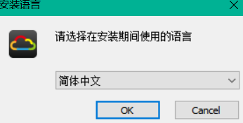

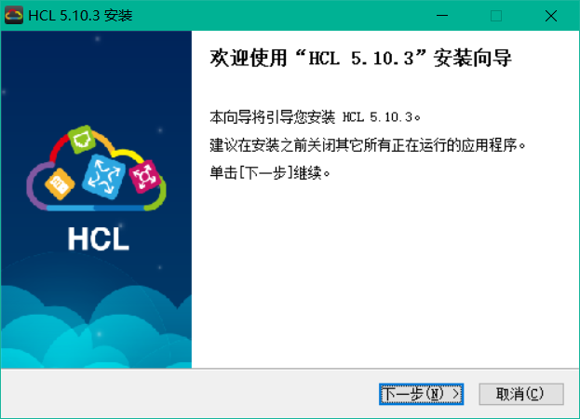

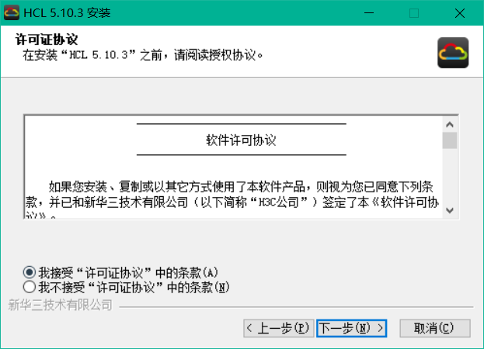

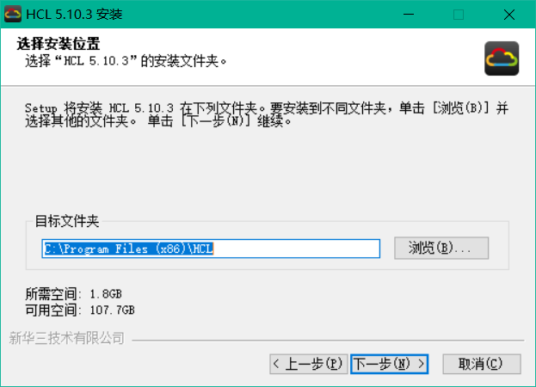

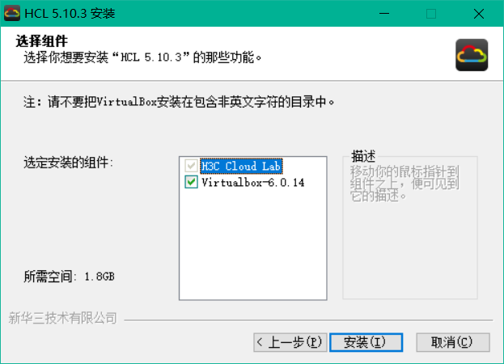

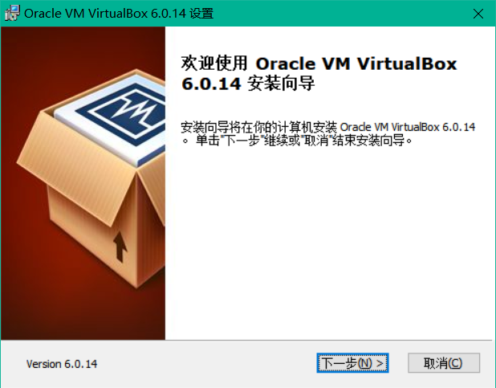

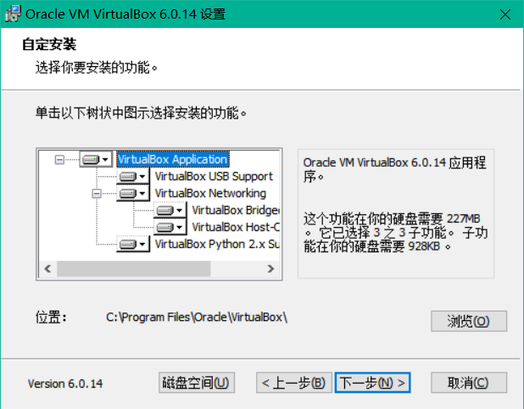

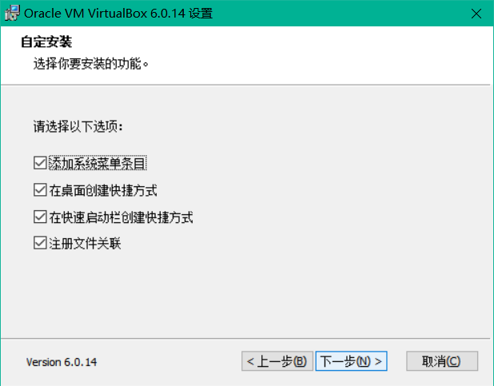

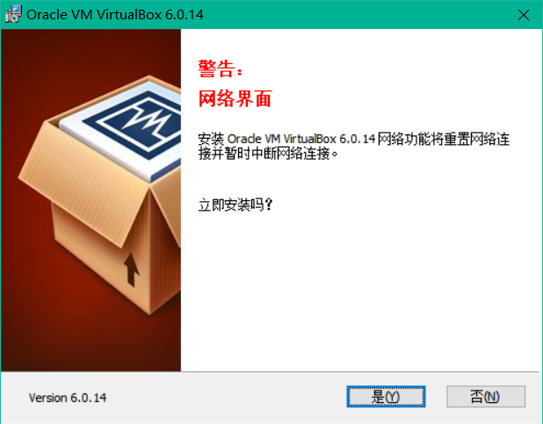

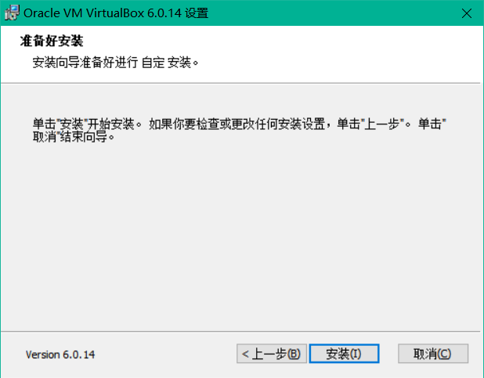



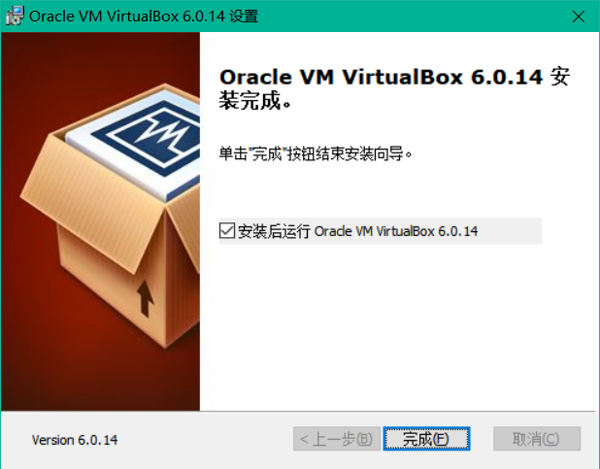

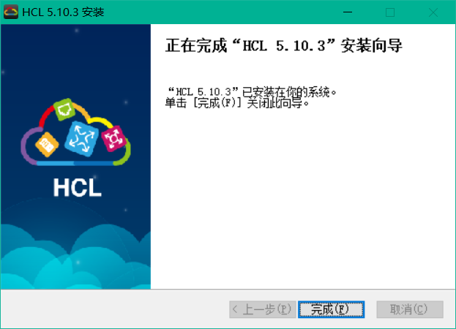

启动HCL模拟器，创建几个交换机，启动：

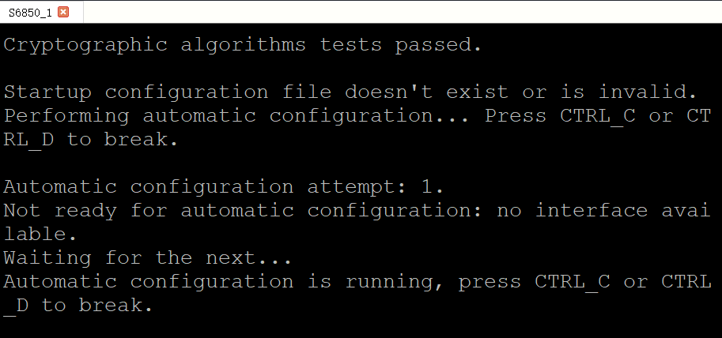

启动时，会进入自动配置阶段，可以按下Ctrl+D跳过自动配置阶段，再按下回车进入手动配置界面

**★第1章、设备基础信息操作**

**★设备基础信息查看**

<H3C> disp version #查看设备版本信息

H3C Comware Software, Version 7.1.070, Alpha 7170

Copyright (c) 2004-2022 New H3C Technologies Co., Ltd. All rights reserved.

H3C S6850 uptime is 0 weeks, 0 days, 0 hours, 2 minutes

Last reboot reason: User reboot

Boot image: flash:/s6850-cmw710-boot-t7064p15.bin

Boot image version: 7.1.070, Alpha 7170

Compiled Nov 21 2022 11:00:00

Boot image: flash:/s6850-cmw710-system-t7064p15.bin

Boot image version: 7.1.070, Alpha 7170

Compiled Nov 21 2022 11:00:00

Slot 1:

S6850 with 2 Processors

BOARD TYPE: S6850

DRAM: 512M bytes

FLASH: 1024M bytes

PCB 1 Version: VER.C

Bootrom Version: 908

CPLD 1 Version: 002

CPLD 2 Version: 002

Release Version: H3C S6850

Patch Version: None

Reboot Cause: User reboot

[SubSlot 0] 48SFP Plus+4QSFP Plus

<H3C> disp license #查看License许可信息

<H3C> disp device slot 1 #查看slot板卡信息

Slot Type State Subslot Soft Ver Patch Ver

1 S6850 Master 0 S6850-7170 None

**★查看配置**

<H3C> disp saved-configuration #查看保存的配置

<H3C> disp current-configuration #查看当前运行的配置

<H3C> disp current-configuration interface vlan1 #查看接口上的配置

**★保存配置**

[H3C] return #返回到<>一般模式

<H3C> save #配置完毕**一定要记得保存配置**，在一般模式下保存；默认保存到 startup.cfg

The current configuration will be written to the device. Are you sure? [Y/N]:y #输入y确定

Please input the file name(*.cfg)[flash:/startup.cfg]

(To leave the existing filename unchanged, press the enter key): #直接回车

Validating file. Please wait...

Saved the current configuration to mainboard device successfully.

<H3C>

<H3C> save xxx.cfg #保存到指定的文件名xxx.cfg

The current configuration will be saved to flash:/xxx.cfg. Continue? [Y/N]:y #输入y确定

Now saving current configuration to the device.

Saving configuration flash:/xxx.cfg.Please wait...

Configuration is saved to device successfully.

<H3C>

**★文件目录操作**

<H3C> pwd #查看当前所在路径

flash:

<H3C> cd ? #查看可进入的根路径

STRING [drive][path]

flash: Device name

slot1#flash: Device name

<H3C> cd flash: #进入flash:

<H3C> dir #查看当前路径下的文件及子目录

<H3C> mkdir back #在当前路径下创建一个子目录，名为 back

<H3C> cd back #进入名为back的子目录

<H3C> save back-xxx.cfg #保存配置到当前路径下，名为back-xxx.cfg

<H3C> dir

Directory of flash:/back

0 -rw- 6580 May 08 2024 22:31:41 back-xxx.cfg

1 -rw- 188793 May 08 2024 22:31:41 back-xxx.mdb

1046512 KB total (1045808 KB free)

<H3C> copy back-xxx.cfg flash:/back-yyy.cfg #复制文件

Copy flash:/back/back-xxx.cfg to flash:/back-yyy.cfg? [Y/N]:y #输入y确定

Copying file flash:/back/back-xxx.cfg to flash:/back-yyy.cfg... Done.

**★启动文件选择**

<H3C> display boot-loader

Software images on slot 1:

Current software images:

flash:/s6850-cmw710-boot-t7064p15.bin

flash:/s6850-cmw710-system-t7064p15.bin

Main startup software images:

flash:/s6850-cmw710-boot-t7064p15.bin

flash:/s6850-cmw710-system-t7064p15.bin

Backup startup software images:

flash:/s6850-cmw710-boot-t7064p15.bin

flash:/s6850-cmw710-system-t7064p15.bin

<H3C> boot-loader file boot flash:/s6850-cmw710-boot-t7064p15.bin system flash:/s

6850-cmw710-system-t7064p15.bin all main

<H3C> boot-loader file boot flash:/s6850-cmw710-boot-t7064p15.bin system flash:/s

6850-cmw710-system-t7064p15.bin all backup

<H3C> display startup #查看启动时加载的配置文件

MainBoard:

Current startup saved-configuration file: NULL

Next main startup saved-configuration file: flash:/startup.cfg

Next backup startup saved-configuration file: NULL

<H3C> startup saved-configuration xxx.cfg #指定启动时加载的配置文件

<H3C>disp startup

MainBoard:

Current startup saved-configuration file: NULL

Next main startup saved-configuration file: flash:/xxx.cfg

Next backup startup saved-configuration file: NULL

<H3C> startup saved-configuration xxx.cfg main #指定启动时加载的主配置文件

<H3C> startup saved-configuration xxx.cfg backup #指定启动时加载的备配置文件

<H3C>disp startup

MainBoard:

Current startup saved-configuration file: NULL

Next main startup saved-configuration file: flash:/xxx.cfg

Next backup startup saved-configuration file: flash:/xxx.cfg

**★恢复出厂配置**

<H3C> erase startup.cfg #删除配置文件（需要提前确认startup指定的启动配置文件为此文件）

Delete flash:/startup.cfg? [Y/N]:y #确定删除配置

Deleting file flash:/startup.cfg... Done.

<H3C> reboot #删除配置文件后，得重启系统才恢复出厂的运行状态

Start to check configuration with next startup configuration file, please wait.........DONE!

Current configuration may be lost after the reboot, save current configuration? [Y/N]:n #这里问是否要保存配置，**不保存**

This command will reboot the device. Continue? [Y/N]:y #确定要重启

Now rebooting, please wait....%May 6 22:55:44:496 2024 H3C DEV/5/SYSTEM_REBOOT: System is rebooting now.

**或者：**

<H3C> reset saved-configuration

The saved configuration file will be erased. Are you sure? [Y/N]:y

Configuration file in flash: is being cleared.

Please wait ...

MainBoard:

Configuration file is cleared.

<H3C> reboot #重启后才清空配置

Start to check configuration with next startup configuration file, please wait.........DONE!

This command will reboot the device. Continue? [Y/N]:y

Now rebooting, please wait....%May 6 22:58:22:686 2024 H3C DEV/5/SYSTEM_REBOOT: System is rebooting now.

**★定时重启**

<H3C> scheduler reboot at 23:30 2024/05/06 #到了指定的时间就重启

Specified time is in the past.

Reboot system at 23:30:00 05/06/2024(in 0 hours and 27 minutes). Confirm?[Y/N]:y #输入y确定

<H3C>%May 6 23:02:47:907 2024 H3C SCH/5/SCH_REBOOT_SCHEDULED: console0 set schedule reboot parameters at 23:02:45 05/06/2024, and system will reboot at 23:30:00 05/06/2024.

<H3C> scheduler reboot delay 2:00 #在2小时之后重启

Specified time is in the past.

Reboot system at 01:03:35 05/07/2024(in 2 hours and 0 minutes). Confirm?[Y/N]:y

<H3C>%May 6 23:03:41:489 2024 H3C SCH/5/SCH_REBOOT_SCHEDULED: console0 set schedule reboot parameters at 23:03:35 05/06/2024, and system will reboot at 01:03:35 05/07/2024.

**★设置系统时间**

[H3C] display clock

22:24:37.296 UTC Mon 05/06/2024

[H3C] clock protocol none #默认是ntp

[H3C] quit

<H3C> clock datetime 22:25:00 2024/05/06 #设置时间，年/月/日

<H3C> clock datetime 22:25:00 05/06/2024 #同上，月/日/年

**★终端信息设置**

**★关闭console终端信息输出**

<H3C> undo terminal monitor

The current terminal is disabled to display logs.

<H3C> undo terminal debugging

The current terminal is disabled to display debugging logs.

**★终端显示行数**

<USG6300E> screen-length ?

INTEGER<0-512> Display the number of lines on a screen (the value 0

indicates none split screen, and the default value is 24)

<USG6300E> screen-length 0 temporary # 0表示一次性显示完，不分页

Info: The configuration takes effect on the current user terminal interface only.

[USG6300E] user-interface console 0

[USG6300E-ui-console0] screen-length 24 #console登录时分页显示，一页24行

[USG6300E] user-interface vty 0 4

[USG6300E-ui-vty0-4] screen-length 0 #vty远程登录时不分页显示

**★查看历史执行命令**

[USG6300E] disp history-command all-users

**★第2章、设备登录管理配置**

**★带内管理（console本地登录）**

①**仅使用密码登录console**

[H3C] user-interface console 0

[H3C-line-console0] authentication-mode password

[H3C-line-console0] set authentication password simple passwdxx123

②**使用用户名和密码登录**

[H3C] user-interface console 0

[H3C-line-console0] authentication-mode scheme

**★带外管理（telnet，ssh远程登录）**

①**Telnet仅密码登录**

[H3C] telnet server enable

[H3C] user-interface vty 0 4

[H3C-line-vty0-4] authentication-mode password

[H3C-line-vty0-4] set authentication password simple passwdxx123

[H3C-line-vty0-4] user level-15

②**Telnet用户名和密码登录**

[H3C] telnet server enable

[H3C] user-interface vty 0 4

[H3C-line-vty0-4] authentication-mode scheme

**★禁用telnet服务（不建议使用不安全的连接方式）**

[H3C] undo telnet server enable

③**SSH用户名和密码登录**

[H3C] ssh server enable

[H3C] user-interface vty 0 4

[H3C-line-vty0-4] authentication-mode scheme

**★虚拟终端vty数量限制**

[

**★查看当前登录用户及踢除某用户**

[

**★aaa创建用户（及密码策略）**

[H3C] local-user admin

New local user added.

[H3C-luser-manage-admin] password simple passwdxx123

[H3C-luser-manage-admin] authorization-attribute user-role network-admin

[H3C-luser-manage-admin] service-type telnet ssh terminal http https

创建的用户默认加入的是manage组

删除用户：

[H3C] undo local-user admin class manage

**★登录超时设置**

[

**★用户登录提示语**

[

**★第3章、文件传输**

**★TFTP客户端**

[

**★FTP服务器**

把交换机或路由器当作FTP服务器

[

**★FTP客户端**

<

**★第4章、端口操作**

**★端口速率及模式**

[H3C] int g1/0/1

[H3C-GigabitEthernet1/0/1] duplex full

[H3C-GigabitEthernet1/0/1] speed 1000 #设置速率，默认单位Mbps，auto为自适应

[H3C-GigabitEthernet1/0/1] bandwidth 1000000 #带宽，默认单位 kbps

[H3C-GigabitEthernet1/0/1] combo enable copper #光电复用口，使能电口模式

[H3C-GigabitEthernet1/0/1] combo enable fiber #光电复用口，使能光口模式

**★查看接口ip及状态**

[H3C] display ip interface brief #查看接口的up/down状态及接口上的ip

*down: administratively down

(s): spoofing (l): loopback

Interface Physical Protocol IP address/Mask VPN instance Description

GE1/0/1 up up 10.99.1.99/24 -- --

MGE0/0/0 down down -- -- --

[H3C] disp interface brief

Brief information on interfaces in route mode:

Link: ADM - administratively down; Stby - standby

Protocol: (s) - spoofing

Interface Link Protocol Primary IP Description

GE1/0/1 UP UP 10.99.1.99

GE1/0/2 DOWN DOWN 10.99.2.2

InLoop0 UP UP(s) --

MGE0/0/0 DOWN DOWN --

NULL0 UP UP(s) --

REG0 UP -- --

Brief information on interfaces in bridge mode:

Link: ADM - administratively down; Stby - standby

Speed: (a) - auto

Duplex: (a)/A - auto; H - half; F - full

Type: A - access; T - trunk; H - hybrid

Interface Link Speed Duplex Type PVID Description

FGE1/0/53 DOWN 40G A A 1

FGE1/0/54 DOWN 40G A A 1

[H3C-GigabitEthernet1/0/2] disp this #查看端口本身配置

#

interface GigabitEthernet1/0/2

port link-mode route

combo enable fiber

ip address 10.99.2.2 255.255.255.0

#

**★二层口设置为三层口**

[H3C] int g1/0/2

[H3C-GigabitEthernet1/0/2] port link-mode route #设置为路由口（三层口）默认为二层口bridge

The configuration of the interface will be restored to the default. Continue? [Y/N]:y

[H3C-GigabitEthernet1/0/2] ip address 10.99.2.2 24 #设置为路由口才可配置ip

**★交换机三层子接口配置vlan**

**★清空某端口上的所有配置**

**★DDM光口功率检测**

（Digital Diagnostic Monitoring）数字诊断检测是由SFF Committee制定，遵循SFF-8472多源协议定义的标准参数，规范了光模块和网络设备的软硬件所需遵循的标准数值或范围。

实时测量参数：工作电压、工作温度、接收光功率、发射光功率和激光器偏置电流

[H3C] display transceiver interface g1/0/2

GigabitEthernet1/0/2 transceiver information:

Transceiver Type : SFP-GE-LX-SM1310

Connector Type : LC

Wavelength(nm) : 1310

Transfer Distance(km) : 10(9um)

Digital Diagnostic Monitoring : YES

Vendor Name : H3C

<H3C> disp transceiver diagnosis interface Ten-GigabitEthernet 1/0/36

Ten-GigabitEthernet1/0/36 transceiver diagnostic information:

Current diagnostic parameters:

Temp.(°C) Voltage(V) Bias(mA) RX power(dBm) TX power(dBm)

27 3.36 12.84 -6.48 -5.50

Alarm thresholds:

Temp.(°C) Voltage(V) Bias(mA) RX power(dBm) TX power(dBm)

High 80 3.63 60.00 -1.00 -1.00

Low -10 2.97 0.00 -22.01 -11.00

**★VCT电口检测**

（virtual-cable-test）VCT是利用TDR（Time Domain Reflectometry-时域反射测试）来检测网络线缆的物理状态。

TDR检测原理类似于雷达，它工作方式是通过主动向导线发射一个脉冲信号并检测所发送的脉冲信号的反射结果来检测电缆故障。当发送的脉冲信号通过电缆的末端或电缆的故障点时，就会引起部分或全部的脉冲能量被反射回来到达原来的发送源，VCT技术根据测量脉冲信号在导线中的传输获得信号到达故障点或返回的时间，然后根据公式将相应时间换算为距离值。通过VCT可以检测电缆状态、故障距离是否极性交换、插入信号衰减、返回信号衰减等。

**★端口聚合Eth-Trunk**

**★lacp模式**

[H3C] int Bridge-Aggregation 1 #创建聚合口1

[H3C-Bridge-Aggregation1] link-aggregation mode dynamic #聚合模式为lacp

[H3C-Bridge-Aggregation1] link-aggregation load-sharing mode source-ip destination-ip

**★成员口加入聚合口**

[H3C] int range g1/0/9 to g1/0/12

[H3C-if-range] port link-aggregation group 1

[H3C-if-range] lacp mode passive

[H3C-if-range] lacp period short

[H3C] disp link-aggregation verbose Bridge-Aggregation 1

[H3C] disp link-aggregation summary

★聚合口里直接添加成员口

**★端口安全（mac地址绑定及过滤）**

端口安全是对进入端口的报文源mac地址进行过滤

[

**★IP和MAC绑定（可绑到端口上）**

[

**★端口环路检测**

[

**★广播抑制**

[

**★端口error-down自动恢复**

[

**★端口镜像**

[

**★第5章、VLAN及STP操作**

**★创建vlan及查看vlan**

[H3C] vlan 10

[H3C-vlan10] name vlan-work10

[H3C-vlan10] description vlan 10

[H3C-vlan10] port g1/0/3

[H3C] interface Vlan-interface 10 #创建SVI三层虚拟接口

[H3C-Vlan-interface10] ip address 10.99.3.1 24 #配置ip

**★删除某个vlan**

int 目标接口

undo port trunk allow-pass vlan 71 #首先在trunk口里undo要排除通过的vlan

#

undo vlan 71 #删除目标vlan

#

commit

#

**★trunk口新增一个允许通过的vlan**

port trunk allow-pass vlan 22 23 24 58 33 #在原有配置上追加一个33，

port trunk allow-pass vlan 33 #华为设备可直接添加要新增的那个vlan，原有配置不会被清空

**★二层口模式（access, trunk）**

[H3C] int g1/0/4

[H3C-GigabitEthernet1/0/4] port link-type access

[H3C-GigabitEthernet1/0/4] port access vlan 10

[H3C] int g1/0/5

[H3C-GigabitEthernet1/0/5] port link-type trunk

[H3C-GigabitEthernet1/0/5] port trunk permit vlan all

[H3C-GigabitEthernet1/0/5] port trunk pvid vlan 10

**★vlan-mapping（vlan转换）**

[

**★STP**

[

**★第6章、ARP及MAC相关命令**

**★ARP操作**

<

**★MAC操作**

[

**★第7章、DHCP配置**

**★DHCP服务器**

[

**★DHCP中继**

[

**★DHCP保存地址分配信息**

[Huawei] dhcp server database enable #开启保存地址分配信息的服务

Info: The operation may take a few seconds, please wait.

done.

[Huawei] dhcp server database recover #使用单一文件保存

[Huawei] dhcp server database write-delay 300 #每分配一个地址后延迟300秒再保存

[Huawei] disp dhcp server database #查看database信息

Status: enable

Recover from files after reboot: enable

File saving lease items: flash:/dhcp/lease.txt #分配信息保存的文件

File saving conflict items: flash:/dhcp/conflict.txt #地址冲突信息保存的文件

Save Interval: 300 (seconds)

[Huawei]

**★DHCP Snooping**

[

**★第8章、访问控制及Qos流量控制**

**★ACL访问控制列表**

**★ACL编号及基础配置**

|  |  |  |
| --- | --- | --- |
| acl number | 类型 | 匹配对象 |
| 2000~2999 | 基本acl | 源ip |
| 3000~3999 | 扩展acl | 源ip，目的ip，tcp/udp的源port，目的port，IP上层协议号 |
| 4000~4999 | 二层acl | mac地址，vlanID |

★默认最后有一条permit any，记得必要时请在末尾一条rule添加deny any

[

**★第9章、VRRP（要配合mstp）**

VRRP只有advertisment报文，报文传播使用组播地址224.0.0.18，报文封装在IP报文中，上层协议号为118

Virtual Router的mac地址为0000-5E00-01-vrid

优先级默认为100，越大越优先

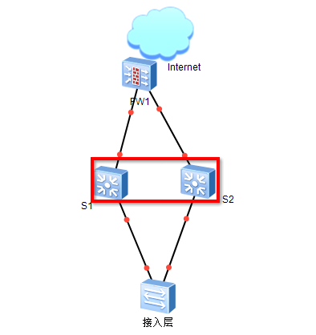

拓扑如上图

S1（10.10.1.1）和S2（10.10.1.2）虚拟成一个网关（10.10.1.254）vlan10

S1上的配置如下（S2上的配置省略）

[

**★第10章、路由配置**

**★vpn实例（VRF虚拟路由表）**

vpn-instance <==> Virtual Routing Forwarding

**★静态路由配置**

[H3C] ip route-static 10.1.1.0 24 10.99.1.1 preference 60 #优先级指定为60，缺省是60

**★单臂路由**

[H3C] int g1/0/6.1

[H3C-GigabitEthernet1/0/6.1] vlan-type dot1q vid 10

[H3C-GigabitEthernet1/0/6.1] ip addr 10.99.10.1 24

[H3C] int g1/0/6.2

[H3C-GigabitEthernet1/0/6.2] vlan-type dot1q vid 20

[H3C-GigabitEthernet1/0/6.2] ip addr 10.99.20.1 24

**★黑洞路由**

[H3C] ip route-static 10.1.0.0 16 null 0

**★RIP**

Routing Information Protocol距离矢量路由选择协议

[

**★OSPF**

[

**★BGP**

AS（Autonomous System）在2009年1月之前，使用2字节的AS号，即1到65535，

公有AS号为1~64511，私有AS号为64512~65535

在2009年1月后，IANA决定使用4字节长度的AS号，范围65536到4294967295

**★eBGP**

拓扑图：

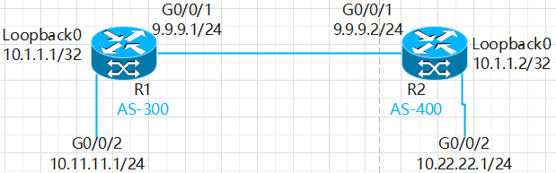

*首先配置好各接口ip，过程省略

[

**★路由策略**

路由策略的操作对象是路由信息，主要实现路由过滤和路由属性设置等功能，通过改变路由属性（包括可达性）来改变网络流量所经过的路径

一条route-policy可有多个node组成，一条node匹配通过后，不再匹配剩下的node

一条node中可if-match匹配多个目标，各if-match之间为AND关系，各条if-match都通过才认为通过此node

（即node之间为OR关系，同一node内的各if-match为AND关系）

**★策略路由**

# 策略路由的操作对象是数据包，在路由表已经产生的情况下，不按照路由表进行转发，而是根据需要按照某种策略改变数据包的转发路径

[