# Alkalinity generation in the coastal area, the case of the Wadden Sea

**Correspondence:** Shamil Yakubov, yakubov.sha@gmail.com

## Abstract

High alkalinity values on the seaside can influence the exchange of carbon dioxide between seawater and the atmosphere. Still, there are many uncertainties about biogeochemical processes responsible for alkalinity generation in the coastal area.

One example of coastal areas with high alkalinity is the German Bight. The German Bight is the south-east part of the North Sea. The literature suggests that high summer alkalinity values in the German Bight result from the exchange of the German Bight with the Wadden Sea (an intertidal zone along Dutch, German, and Danish coasts). We show that the main reason for high alkalinity values in the German Bight can be sulfate reduction and that it can increase alkalinity from March to August up to approximately . Also, we show that nitrogen compounds ( and ) cannot explain the German Bight's high alkalinity values, but these elements are responsible for the alkalinity flux from the Wadden Sea to the German Bight.

## Introduction

Alkalinity defines seawater buffer capacity, and the carbonate system is the natural buffer for the seawater pH (Zeebe and Wolf-Gladrow, 2001). Carbon dioxide is a component of the carbonate buffer system, so alkalinity defines seawater ability to absorb (or emit) carbon dioxide. Understanding the processes of carbon dioxide atmosphere-seawater transfer is essential in light of climate change. Some coastal zones have much higher alkalinity variability than the open ocean and therefore increase the variability of carbon dioxide transfer between seawater and the atmosphere near the coast.

The Southern North Sea area is an example of a coastal system with high alkalinity variability. Seasonal total alkalinity (TA) variations in the German Bight (South-east of the North Sea) are much larger than in the center of the North Sea (Thomas et al., 2009; Voynova et al., 2019). The measured surface alkalinity values in the German Bight show significant deviations (up to 200 μM) during a year (Fig. I1, blue line). The values calculated from salinity according to the salinity-alkalinity relationship (Millero et al., 1998) do not show such seasonality (Fig. I1, orange line). It means that the TA is affected by local specific processes and cannot be approximated by the salinity-alkalinity relationship, which is valid for the open ocean.

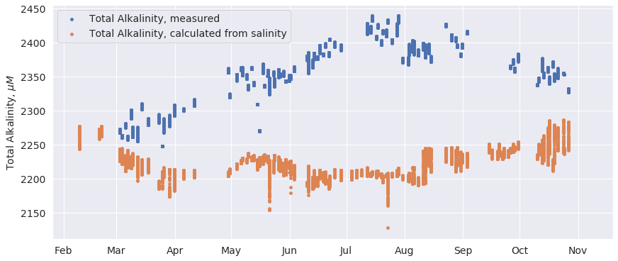

**Figure I1.** Surface water TA measured and calculated from the alkalinity-salinity relation (Millero et al., 1998); Ferry Box measurements (Voynova et al., 2019) have been observed at 54.19 N, 6.99 E (the German Bight, north of the Ems estuary) during 2017.

Several factors could lead to the seasonal increase of alkalinity in the German Bight:

1. Riverine influence. This factor is strongly geographically dependent and can cause both an increase and a decrease in TA values. Several authors discussed the riverine influence on TA in the German Bight (Schwichtenberg, 2013; Voynova et al., 2019) and derived that the riverine factor cannot cause the increase of TA observed at the end of summer (Fig I1) because that time the riverine influence is the smallest.
2. Influence of the pelagic and benthic activities in the adjoining Wadden Sea (it is an intertidal zone in the German Bight). (Thomas et al., 2009) proposed, based on observed alkalinity values, that the alkalinity flux from the Wadden Sea is one of the main drivers of the seasonal southeastern North Sea alkalinity variability. The authors concluded that the primary biogeochemical process responsible for alkalinity generation in the Wadden Sea is anaerobic organic matter degradation in sediments. Some other studies also confirm that alkalinity can come from sediments of the Wadden Sea (Hoppema, 1990; Brasse et al., 1999; Beck et al., 2008; Beck and Brumsack, 2012; Schwichtenberg, 2013).
3. Influence of the pelagic and benthic activities in the German Bight. (Brenner et al., 2016) studied alkalinity input into the North Sea water column from the North Sea sediments. They estimated a sedimentary mean alkalinity flux from the southern North Sea sediments to be 6.6 ± 5.2 in September 2011, and 5.7 ± 3.7 in June 2012. Also, (Brenner et al., 2016) estimated the total net generation of alkalinity in the southern North Sea to be 2.4 suggesting that sedimentary alkalinity generation exceeds pelagic alkalinity consumption. (Voynova et al., 2019) showed that these fluxes explain the observed seasonal cycle in the regions with minimal influence of the Wadden Sea (west of 4) but not in the German Bight.

In this study, we focus on the alkalinity release from the Wadden Sea. The Wadden Sea is a heterotrophic reservoir where organic matter (OM) degradation prevails over OM production (van Beusekom et al., 1999), stimulating anaerobic alkalinity production in coastal areas sediments. The Wadden Sea has strong tides. They induce additional mixing in sediments resulting in additional input of OM to sediments. Therefore, tides can enhance alkalinity fluxes through the sediment-water interface (SWI) (Beck et al., 2008). It makes the Wadden Sea the right candidate to explain high alkalinity values in the German Bight.

In this work, we use the term "Irreversible alkalinity" to describe a concept suggesting alkalinity generation from anaerobic organic matter degradation in coastal sediments, which favors the seawater CO uptake capacity. We introduce this term since we could not find a specific name for this process in the literature, but sometimes it is called a net alkalinity gain due to irreversible biogeochemical processes. (Thomas et al., 2009) defined it as alkalinity generated due to "denitrification, and to some extent, sulfate reduction, … if their products are buried or escape to the atmosphere". (Hu and Cai, 2011; Brenner et al., 2016) also used the concept of 'Irreversible alkalinity,' but they proposed methods of its calculation different from (Thomas et al., 2009).

The notion of 'Irreversible alkalinity' is interesting because it is used to calculate CO absorption by seawater. (Thomas et al., 2009) described the effect of 'Irreversible alkalinity' this way: "… anaerobic degradation of organic matter constitutes a net total alkalinity gain at the annual scale. This net gain of total alkalinity then facilitates net CO uptake from the atmosphere." Thus, the term 'Irreversible alkalinity' utilizes the idea that the generation of alkalinity can exceed the consumption of alkalinity in some areas, and carbon dioxide input from the atmosphere fills this difference in such case.

(Thomas et al., 2009) used 'Irreversible alkalinity' to explain why the Wadden Sea is the source of alkalinity for the German Bight (denitrification, sulfate reduction with consequent burying or degassing sulfides are the reasons for alkalinity generation in the Wadden Sea).

The current study's main idea is to check whether the Wadden Sea can be a source of alkalinity to the German Bight and to identify to most important processes, influencing alkalinity there. To answer these questions, we need to complete several tasks:

1. To estimate the alkalinity flux from the Wadden Sea to the German Bight and to study which biogeochemical processes determine it.
2. To estimate the contribution of 'Irreversible alkalinity' to this flux.
3. To estimate the maximum possible increase of TA, the Wadden Sea can generate.

To study the proposed tasks, we developed a modeling set consisting of a 1-D transport model and a biogeochemical model.

## Methods

The modeling set bases on the concept of "explicitly conservative form of total alkalinity" () (Wolf-Gladrow et al., 2007):

, where , , , , and .

Increase or decrease of concentrations of any of the compounds changes alkalinity. For example, an increase of concentration of by 1 mole will increase TA by 2 moles. Or an increase of concentration of by 1 mole will decrease TA by 1 mole.

In order to estimate alkalinity generation in the Wadden Sea, we should consider all processes in the Wadden Sea that can change the concentrations of species in . These processes (Zeebe and Wolf-Gladrow, 2001; Follows et al., 2006; Wolf-Gladrow et al., 2007) are: 1) biogeochemical transformations in the water column and sediments of the Wadden Sea (OM production, OM degradation, etc.) 2) transport processes in the water column and sediments of the Wadden Sea and transport between them 3) compounds exchange between the Wadden Sea and the surrounding areas 4) allochthonous OM input to the Wadden Sea (to supply OM degradation reactions). We must consider both the water column and sediments since the activity of some of the biogeochemical transformations affecting TA in the coastal area varies in the water column and sediments. For example, denitrification typically occurs in the sediments, in the absence of oxygen, but primary production is often higher in the water column, where sunlight is more available (Libes, 2011).

This study uses a vertically resolved 1-D box as a proxy for the Wadden Sea water column and sediments to satisfy the mentioned requirements. The box is split into different layers to calculate the necessary biogeochemical reactions increments for each layer and evaluate the mixing between them. Also, we consider allochthonous OM input to the modeling domain and the exchange of the water column of the 1-D box with an external pool (the Wadden Sea surrounding areas).

The modeling set for calculations consists of the 1-D Sympagic-Pelagic-Benthic transport Model, SPBM (Yakubov et al., 2019), and a biogeochemical model. Both SPBM and the biogeochemical model share the following state variables: autotrophs, ; heterotrophs, ; ; ; ; ; ; ; ; ; ; ; dissolved inorganic carbon, ; particulate OM (); dissolved OM (); . These are the main bricks of the modeling set. Each time step (300 sec. in our calculations), the transport model and the biogeochemical model recalculate the state variables' concentrations.

SPBM is a governing program resolving a transport equation (diffusive and vertical advective (sinking, burying) terms) between and within the water column and sediments for all state variables. Also, SPBM parameterizes horizontal exchange with the external pool (the Wadden Sea surrounding areas) and OM input. The original SPBM model has an ice domain, which we disabled for the current study. The biogeochemical model parametrizes OM production, OM respiration, reactions of nitrogen and sulfur cycles, etc. Ultimately, it calculates TA update according to expression. Both models have parameters that need to be identified for a specific task.

We identified standard input parameters to make the modeling set results fit a seasonal profile of Chlorophyll-a and OM degradation rates measured in the Wadden Sea. A thorough explanation of the biogeochemical model and explanations of the modeling set initialization, validation, and standard input parameters identification are available in the supplementary materials.

We use modeling scenarios, where we run the modeling set with different input parameters to answer specific questions. We have three scenarios in total. Scenarios 1 and 2 study the alkalinity transfer and the effect of 'Irreversible alkalinity' on it, both of them have , but in Scenario 2, we disabled denitrification. Scenario 3 estimates the maximum possible value of TA the Wadden Sea can generate. It is a set of 10 model runs with different dispersion coefficients, without horizontal exchange of the modeling domain with the external pool in all runs. All scenarios are spun up until a quasi-stationary solution.

## Results and discussion

### Alkalinity transfer from the Wadden Sea to the North Sea and processes determining it

The transport model calculates the horizontal exchange of nutrients and sulfates between the modeling domain (which is a proxy of the Wadden Sea) and the external pool (the German Bight). Nutrients and sulfates are components of and we can evaluate their contributions to the TA flux. We use Scenario 1 results to calculate the sum of fluxes for , , , and from all layers of the water column, aggregate them by month, and get the total flux per year. (Table R1).

**Table R1.** Scenario 1. The fluxes of TA components integrated through the water column (between the modeling domain and the external pool), in per month and year for the 'Total' column. Positive values represent alkalinity flux from the external pool to the modeling domain, negative - alkalinity outflows from the modeling domain to the external pool.

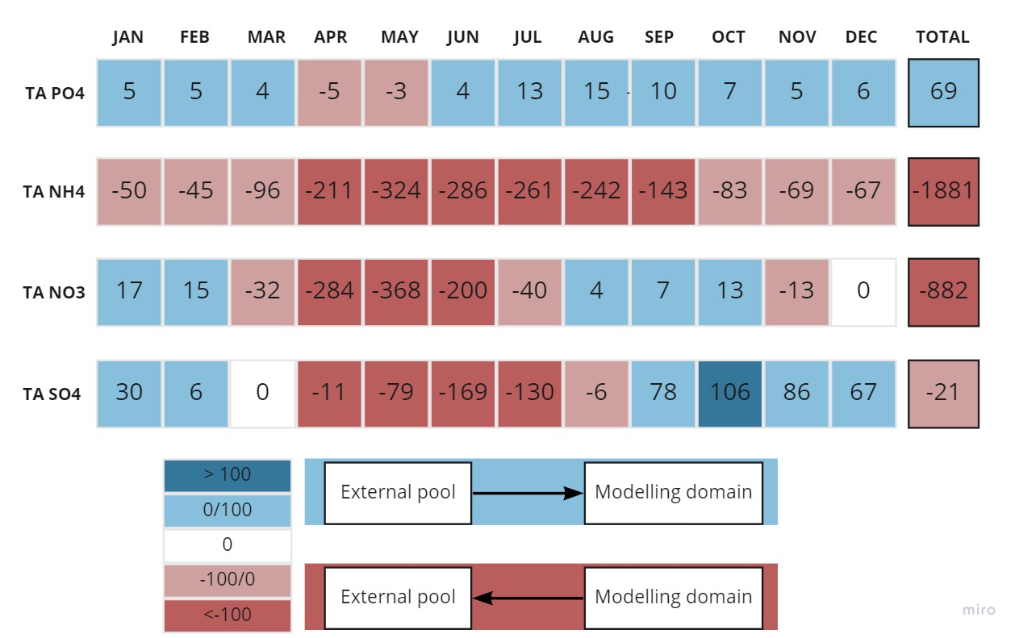

|  |  |  |  |  |  |  |  |  |  |  |  |  |  |
| --- | --- | --- | --- | --- | --- | --- | --- | --- | --- | --- | --- | --- | --- |
| Parameter | Jan | Feb | Mar | Apr | May | Jun | Jul | Aug | Sep | Oct | Nov | Dec | Total |
|  | 5 | 5 | 4 | -5 | -3 | 4 | 13 | 15 | 10 | 7 | 5 | 6 | 69 |
|  | -50 | -45 | -96 | -211 | -324 | -286 | -261 | -242 | -143 | -83 | -69 | -67 | -1881 |
|  | 17 | 15 | -32 | -284 | -368 | -200 | -40 | 4 | 7 | 13 | -13 | 0 | -882 |
|  | 30 | 6 | 0 | -11 | -79 | -169 | -130 | -6 | 78 | 106 | 86 | 67 | -21 |

The year fluxes of and are relatively close to zero and can be neglected. The year fluxes of both and are directed from the modeling domain to the external pool. So, only nitrogen compounds can contribute to the yearly influx of alkalinity from the Wadden Sea to the German Bight.

Since is the highest, it may seem that is the main source of alkalinity in the external pool. But there are many factors changing its effect on alkalinity: the autotrophs actively consume , reducing its effect on alkalinity. Also, it reacts with oxygen and turns ultimately into which has a negative charge, so an increase in concentration leads to a decrease in alkalinity. As a result, the flux into the external pool has only a temporal effect.

If not , then nitrates can be the most important component of TA flux. The direction of its flux changes during the year. However, summing fluxes over a year gives us an alkalinity outflow from the modeling domain to the external pool. flux is the strongest in May; therefore, there is a significant spring input of nitrates. Two main sinks of nitrates in the modeling domain are consumption by autotrophs and denitrification.

The overall flux is 2.7 per year. Assuming the area of the Wadden Sea to be 5000 (Thomas et al., 2009), we can estimate that the amount of alkalinity transported from the Wadden Sea to the German Bight is approximately 13.5 GM per year. This estimation has the same order of magnitude as the values reported by (Thomas et al., 2009), 72.5 GM and (Schwichtenberg, 2013), 40 GM.

### The effect of 'Irreversible alkalinity' on alkalinity generation

(Thomas et al., 2009) proposed that the alkalinity flux from the Wadden Sea to the German Bight is due to irreversible alkalinity generation processes, and denitrification is the most critical contributor to the irreversible alkalinity. Scenario 2 is the same as Scenario 1 but does not include denitrification reactions. It allows us to evaluate the effect of 'Irreversible alkalinity' on the alkalinity transfer. In this scenario, the alkalinity transport from the modeling domain to the external pool is 12.5 GM per year. It is only slightly lower compared with Scenario 1 (13.5 GM). In our modeling, autotrophs' consumption of nutrients is a more influential part of alkalinity generation than denitrification. It matches the conclusions of (Schwichtenberg 2013), who proposed that alkalinity in the Southern North Sea is generated during nutrients assimilation before denitrification, here we have a similar observation for the Wadden Sea.

### High summer alkalinity values in the German Bight

TA in the German Bight varies from 2250 μM in spring to 2450 μM at the end of August (see Fig. I1). Thus, the year difference (or relative alkalinity value) is 200 μM. First, we want to evaluate which parameters can cause such a difference.

The biogeochemical transformations of nitrogen species cannot provide such increase of TA. The year maximum concentration is around 40 μM in spring (van Beusekom et al., 2009). So, even if all nitrate will be consumed, it will increase TA by no more than 40 μM up to 2290 μM, according to . maximum concentration is 10 μM in spring (van Beusekom et al., 2009). Its consumption will decrease TA by 10 μM. The overall effect from nitrogen species can increase alkalinity by no more than 30 μM.

Calcium carbonate precipitation/dissolution cannot explain the year TA difference of 200 μM either. TA increase by 200 μM from spring by august needs a dissolution of 100 μM . But production prevails over its dissolution during spring and summer (Beukema, 1982; Libes, 2011), therefore the effect of dissolution is compensated by its production.

is another important element for TA generation. It is the major ion with concentration in seawater around 25000 μM. The consumption of one mole of increase TA by two moles due to its charge (2-). So, theoretically, sulfate reduction can increase TA by 50000 μM. It makes one of the main candidates to explain high summer TA values in the German Bight.

### The maximum possible increase of TA, the Wadden Sea can generate

To extract effect on TA values, we perform a serial of 10 runs (Scenario 3) with different dispersion coefficients and without horizontal exchange of the modeling domain with the external pool (Fig. R1). Without supply, we can track the maximum alkalinity gain due to sulfate reduction. We calculate two quantities daily: 1) flux between the water column and sediments of the modeling domain and 2) relative (a value minus the year minimum value) in the water column.

An increase of vertical advection in sediments (higher dispersion coefficients values) results in increased fluxes at the SWI (Fig. R1 **A**). Relative concentrations in the water column grow with the values of the dispersion coefficients until reaching the (Fig. R1 **B**). values stop growing after reaching this threshold and do not result in higher alkalinity concentrations in the water column. Therefore, we do not calculate fluxes at the SWI and relative concentrations in the water column for the dispersion coefficients higher than .

The maximum alkalinity flux from sediments to the water column reaches approximately in July (Fig. R1 **A**). The maximum relative concentration is approximately in August (Fig. R1 **B**). – This is the maximum possible year increase of TA that can be supplied by the Wadden Sea sediments.

### Effect of alkalinity fluxes through SWI on Alkalinity values

One can expect that positive TA fluxes through SWI always increase TA concentrations in the water column. However, our calculations show that relative concentrations in the water column do not always increase, although fluxes are positive during the entire year. For example, the fluxes are approximately the same in May and November (~10 ) (Figs. R1 **A** and **B**, red line). But in November, the relative decreases despite the high and positive TA flux. Below we will try to understand what can be a reason for it.

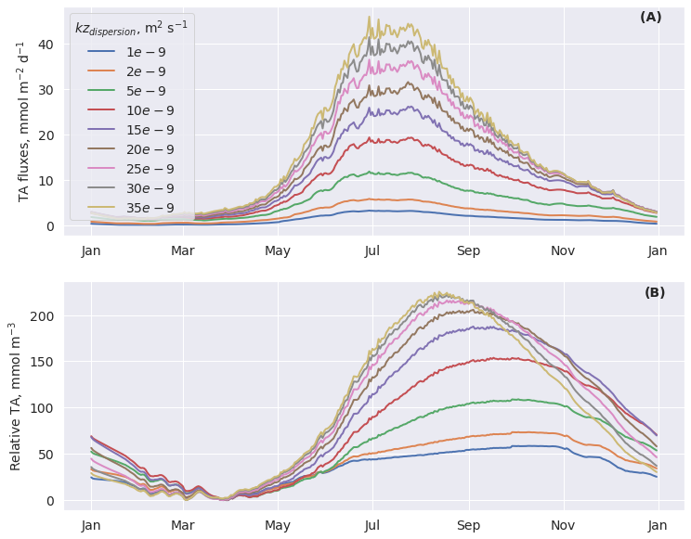

**Figure R1.** Year profiles of fluxes at the SWI (**A**), relative concentrations (a value minus the year minimum value) (**B**) in the water column surface layer for the different dispersion coefficients ().

Alkalinity fluxes consist of the following compounds . It is directed upward from the sediments when the flux of is upward, and the fluxes of ,,, and are downward. There can be several possible reasons that positive fluxes at the SWI can result in either increase or decrease of alkalinity in the water column:

1. The change in the ratios between 's component fluxes can ultimately change the resulting alkalinity in the water column. For example, additional appeared due to an increase of the flux can be then consumed by primary producers or oxidized to , which can ultimately decrease in the water column.
2. A strong flux of sulfates to sediments should coexist with a strong flux of reduced sulfur compounds in the opposite direction. The oxidation of reduced sulfur compounds to sulfate in the water column will reduce alkalinity. Therefore, the ratio of the flux to the reduced sulfur compounds flux should determine the resulting change in the water column. Roughly we can assume that if the flux prevails over the reduced sulfur compounds flux (with a multiplier of 2 according to ) then in the water column will increase; otherwise, in the water column will decrease.

Table 2 shows the flux fluxes due to and reduced sulfur compounds fluxes () at the multiplied by 2. We can now examine the previous example where fluxes are approximately the same in May and November (Fig. R1 **A, B**), but the relative decreases in November. In November the alkalinity flux is smaller then reduced sulfur compounds flux (Table R2), while in May the situation is the opposite.

Thus, according to our calculations, the positive alkalinity fluxes can accompany not only an increase but also a decrease of alkalinity concentration in the water column. It happens if the actual release during sulfate reduction is accompanied by the strong reduced sulfur compounds flux.

**Table R2.** Approximate fluxes ( fluxes due to ) and reduced sulfur compounds fluxes () at the (calculated as to demonstrate the future decrease of in the water column) for the dispersion coefficient during the year, flux values are in .

|  |  |  |  |  |  |  |  |  |  |  |  |  |
| --- | --- | --- | --- | --- | --- | --- | --- | --- | --- | --- | --- | --- |
| Parameter | Jan | Feb | Mar | Apr | May | Jun | Jul | Aug | Sep | Oct | Nov | Dec |
|  | 2 | 1 | 1 | 2 | 7 | 14 | 17 | 14 | 11 | 8 | 6 | 4 |
|  | 3 | 2 | 2 | 2 | 5 | 10 | 13 | 12 | 10 | 8 | 7 | 5 |

### The composition of the flux at the SWI

Here we show the values for kz=… since according to our calculations, the results do not change significantly with different dispersion coefficients. The TA flux composition at the SWI changes during the year (see Table R3). The sulfate part prevails during the entire year with the smallest influence in late winter and early spring. The other compounds are still important since the influence of the component on alkalinity is compensated by the concomitant flux of the reduced sulfur compounds. Even with a large contribution of the term to the flux at the SWI in some months, the value in the water column can be determined by the and terms.

**Table R3.** The composition of the flux at the in different months, normalized to one for each month. The values shown are the contributions of each term. The contributions can be positive (alkalinity flux from the sediments to the water column) or negative; the contributions sum up to one for each month. Note that the corresponding fluxes can be in the opposite direction, e.g., a positive contribution of is a flux from the sediments and a positive contribution of is a flux into sediments. For example, contribution in January is positive and equal 0.56, so it causes the increase of alkalinity in the water column, but it corresponds to the sulfate flux from the water column to the sediments.

|  |  |  |  |  |  |  |  |  |  |  |  |  |
| --- | --- | --- | --- | --- | --- | --- | --- | --- | --- | --- | --- | --- |
| Parameter | Jan | Feb | Mar | Apr | May | Jun | Jul | Aug | Sep | Oct | Nov | Dec |
|  | -0.01 | -0.02 | -0.02 | -0.01 | -0.01 | -0.01 | -0.01 | -0.01 | -0.01 | -0.01 | -0.01 | -0.01 |
|  | 0.28 | 0.32 | 0.34 | 0.28 | 0.18 | 0.15 | 0.14 | 0.13 | 0.13 | 0.13 | 0.14 | 0.19 |
|  | 0 | 0 | -0.01 | -0.01 | 0 | 0 | 0 | 0 | 0 | 0 | 0 | 0.01 |
|  | 0.17 | 0.22 | 0.22 | 0.13 | 0.03 | 0 | 0 | 0 | 0 | 0 | 0.02 | 0.08 |
|  | 0.56 | 0.48 | 0.47 | 0.61 | 0.80 | 0.86 | 0.87 | 0.88 | 0.88 | 0.88 | 0.85 | 0.73 |

Eventually, oxidation of reduced sulfur compounds limits sulfate reduction contribution to the maximum alkalinity value. With some mixing regimes in sediments, reduced sulfur compounds oxidation prevails sulfate reduction. In our calculations, sulfur transformations cannot provide an increase of TA more than 220 μM.

## Conclusions

The calculated amount of alkalinity transported from the Wadden Sea to the German Bight of the North Sea is approximately 13.5 GM per year. This estimation includes only local biogeochemical reactions sources but does not include other possible sources of alkalinity in the Wadden Sea (like terrestrial influence).

According to our calculation, nitrogen compounds ( and ) are almost exclusively responsible for the TA flux from the Wadden Sea to the German with the minor impact of . Denitrification supposedly has a minor influence on TA flux from the Wadden Sea to the German Bight since the year TA flux is only slightly lower in the modeling scenario with disabled denitrification than with it (12.5 GM per year and 13.5 GM per year, respectively). These values suggest that irreversible processes of sulfate reduction and denitrification probably do not have primary importance to TA transfer from the Wadden Sea to the German Bight.

According to our calculations, the maximum year TA increase that can be supplied by the Wadden Sea is approximately . It is comparable with the measured surface alkalinity deviations in the German Bight (up to 200 μM) during a year (Fig. I1, blue line). We calculated alkalinity generation in the Wadden Sea sediments, taking local OM production and OM advective inflow into account. Sulfate reduction is the main contributor to this TA increase. Oxidation of reduced sulfur compound does not allow sulfate reduction to increase TA more than .

From the answers to the goals of the study, we see the counterintuitive result. While the nitrogen compounds are responsible for TA flux from the Wadden Sea to the German Bight, sulfates can be responsible for the high alkalinity values measured in the German Bight.

Apart from the goals of the study, we revealed a feature important considering alkalinity generation in the coastal area. Positive alkalinity fluxes at the SWI do not always result in increasing alkalinity in the water column. concentration in the water column depends on the ratio of flux through the SWI to the reduced sulfur compound flux through the SWI. This ratio changes with mixing regimes and through time and can cause either an increase or decrease of in the water column.

## References

Beck, M., and Brumsack, H.-J. (2012). Biogeochemical cycles in sediment and water column of the Wadden Sea: The example Spiekeroog Island in a regional context. *Ocean & Coastal Management* 68, 102–113. doi:10.1016/j.ocecoaman.2012.05.026.

Beck, M., Dellwig, O., Holstein, J. M., Grunwald, M., Liebezeit, G., Schnetger, B., et al. (2008). Sulphate, dissolved organic carbon, nutrients and terminal metabolic products in deep pore waters of an intertidal flat. *Biogeochemistry* 89, 221–238. doi:10.1007/s10533-008-9215-6.

Beukema, J. J. (1982). Calcimass and carbonate production by molluscs on the tidal flats in the Dutch Wadden Sea: II the edible cockle, cerastoderma edule. *Netherlands Journal of Sea Research* 15, 391–405. doi:https://doi.org/10.1016/0077-7579(82)90066-7.

Brasse, S., Reimer, A., Seifert, R., and Michaelis, W. (1999). The influence of intertidal mudflats on the dissolved inorganic carbon and total alkalinity distribution in the German Bight, southeastern North Sea. *Journal of Sea Research* 42, 93–103. doi:10.1016/S1385-1101(99)00020-9.

Brenner, H., Braeckman, U., Le Guitton, M., and Meysman, F. J. R. (2016). The impact of sedimentary alkalinity release on the water column CO₂ system in the North Sea. *Biogeosciences* 13, 841–863. doi:10.5194/bg-13-841-2016.

Follows, M. J., Ito, T., and Dutkiewicz, S. (2006). On the solution of the carbonate chemistry system in ocean biogeochemistry models. *Ocean Modelling* 12, 290–301. doi:https://doi.org/10.1016/j.ocemod.2005.05.004.

Hoppema, J. M. J. (1990). The distribution and seasonal variation of alkalinity in the Southern Bight of the North Sea and in the Western Wadden Sea. *Netherlands Journal of Sea Research* 26, 11–23. doi:10.1016/0077-7579(90)90053-J.

Hu, X., and Cai, W.-J. (2011). An assessment of ocean margin anaerobic processes on oceanic alkalinity budget. *Global Biogeochemical Cycles* 25. doi:10.1029/2010GB003859.

Libes, S. (2011). *Introduction to Marine Biogeochemistry*. Elsevier Science Available at: https://books.google.de/books?id=KVZJUw4nORgC.

Millero, F. J., Lee, K., and Roche, M. (1998). Distribution of alkalinity in the surface waters of the major oceans. *Marine Chemistry* 60, 111–130. doi:10.1016/S0304-4203(97)00084-4.

Schwichtenberg, F. (2013). Drivers of the carbonate system variability in the southern North Sea: River input, anaerobic alkalinity generation in the Wadden Sea and internal processes.

Thomas, H., Schiettecatte, L.-S., Suykens, K., Koné, Y. J. M., Shadwick, E. H., Prowe, A. E. F., et al. (2009). Enhanced ocean carbon storage from anaerobic alkalinity generation in coastal sediments. *Biogeosciences* 6, 267–274. doi:10.5194/bg-6-267-2009.

van Beusekom, J. E. E., Brockmann, U. H., Hesse, K.-J., Hickel, W., Poremba, K., and Tillmann, U. (1999). The importance of sediments in the transformation and turnover of nutrients and organic matter in the Wadden Sea and German Bight. *Deutsche Hydrografische Zeitschrift* 51, 245–266. doi:10.1007/BF02764176.

van Beusekom, J. E. E., Loebl, M., and Martens, P. (2009). Distant riverine nutrient supply and local temperature drive the long-term phytoplankton development in a temperate coastal basin. *Journal of Sea Research* 61, 26–33. doi:10.1016/j.seares.2008.06.005.

Voynova, Y. G., Petersen, W., Gehrung, M., Aßmann, S., and King, A. L. (2019). Intertidal regions changing coastal alkalinity: The Wadden Sea-North Sea tidally coupled bioreactor. *Limnology and Oceanography* 0. doi:10.1002/lno.11103.

Wolf-Gladrow, D. A., Zeebe, R. E., Klaas, C., Körtzinger, A., and Dickson, A. G. (2007). Total alkalinity: The explicit conservative expression and its application to biogeochemical processes. *Marine Chemistry* 106, 287–300. doi:https://doi.org/10.1016/j.marchem.2007.01.006.

Yakubov, S., Wallhead, P., Protsenko, E., Yakushev, E., Pakhomova, S., and Brix, H. (2019). A 1-Dimensional Sympagic–Pelagic–Benthic Transport Model (SPBM): Coupled Simulation of Ice, Water Column, and Sediment Biogeochemistry, Suitable for Arctic Applications. *Water* 11. doi:10.3390/w11081582.

Zeebe, R. E., and Wolf-Gladrow, D. (2001). *CO2 in seawater: equilibrium, kinetics, isotopes*. Gulf Professional Publishing.