7. Reverse Integer:
class Solution:
# @return an integer
def reverse(self, x):
result = 0

if x < 0:
symbol = -1
x = -x
else:
symbol = 1

while x:
result = result * 10 + x % 10
x /= 10

return 0 if result > pow(2, 31) else result * symbol

output:
case 1
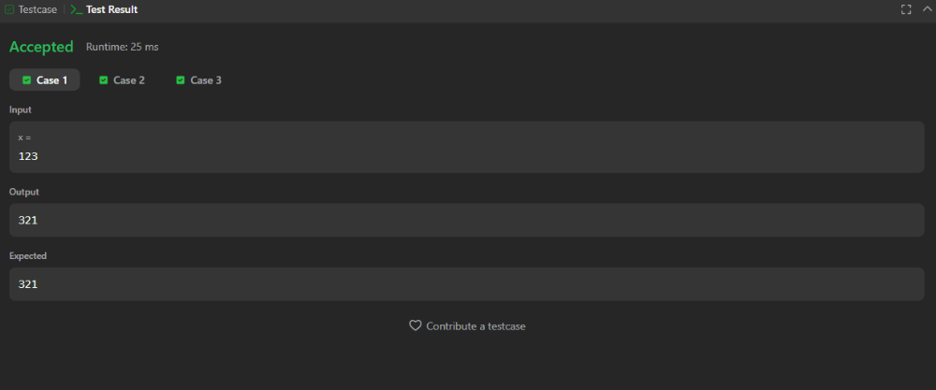

case 2
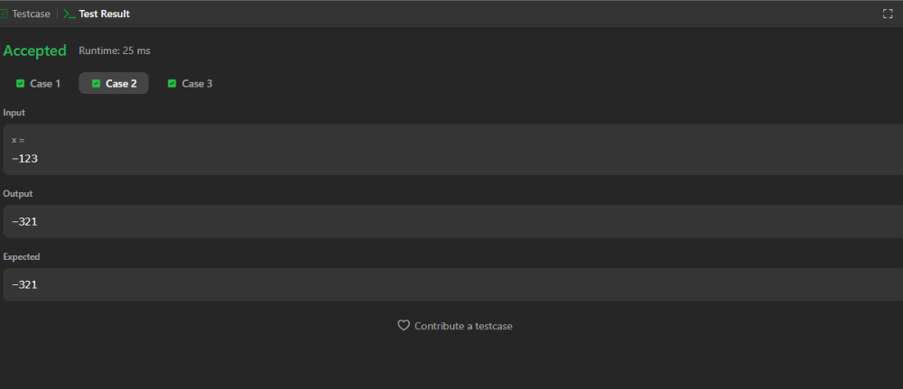

case 3
