

**Project’s Name:** Purchases andSales Record System.

**Team Name:** Duke’ children

**Names:**

* Gutierrez Limber
* Lituma Jhonatan (Project leader)
* Loachamin Christopher
* López Andrés
* Maigua Jonathan.

**Problem:**

There is an entrepreneur who at the end of each month, always has account problems in his clothing store. It doesn't have a record system of purchases made by its customers, and the expenses you make also do not take account.

So, he keeps the beads on paper as he did before, but this is tedious to him, due to the excess paper that is easily lost or damaged. To understand what the program needs to do, you first need to understand a little bit about the sales and products of the store.

**Overview:**

As we all know we are in a new era where everything needs to be digitized and in addition to being backed up.

Through this program it is intended to offer the user the best management of buying and selling and in turn facilitate the maintenance of the company's data in an orderly manner such as: inventory, sales data, returns, discounts and promotions for either seasons, special occasions and thus save time.

Our vision is to bring all this information to a database, where all this is accessible and user-friendly.

**Background:**

To make this registration we need to know fundamental things, such as basic accounting for the organization of this data, which is described by the process related to the acquisition and payment of products or services.

Every entrepreneur should keep an orderly accounting so his business can be successful for which he must keep track of the purchases and sales he makes, also he should make a periodic elaboration of inventories, balance sheets and financial statements.

The sales record is a book in which you enter all the details of sales that the company makes. The entrepreneur should detail: date, bill number, National identity document, quantity, description, code, total VAT included.

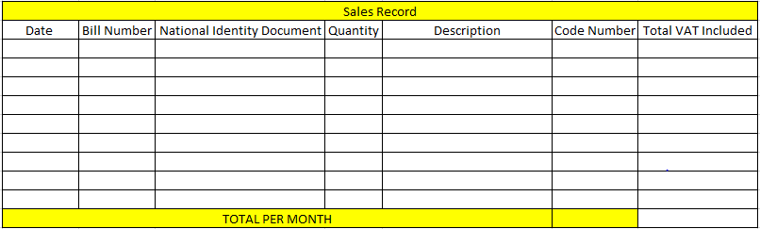

The purchase record is a book in which you enter all the details of purchases or expenses that the company does in order to acquire some implements as fabrics, work tools, machinery, and so forth.  The details in this record must be: Date, Bill number, provider, quantity, description and total.

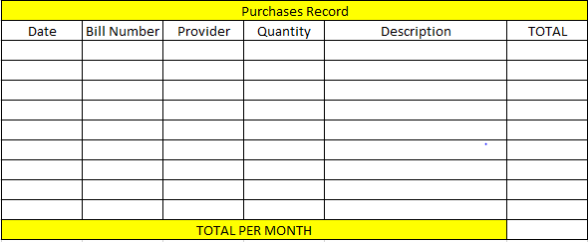

This clothing store must have their inventory controlled, supervised, and ordered since the proposal is to distribute and adequately supply that available material.

The inventory is detailed for the characteristics of each of the elements that make up the equity are specified. Undoubtedly, inventories are necessary for any type of company, since it is these that will allow:

* Have control of the merchandise.
* Generate reports on the economic situation of the business.

Inventory changes in real time while sales increase.

* Use Case Diagram:

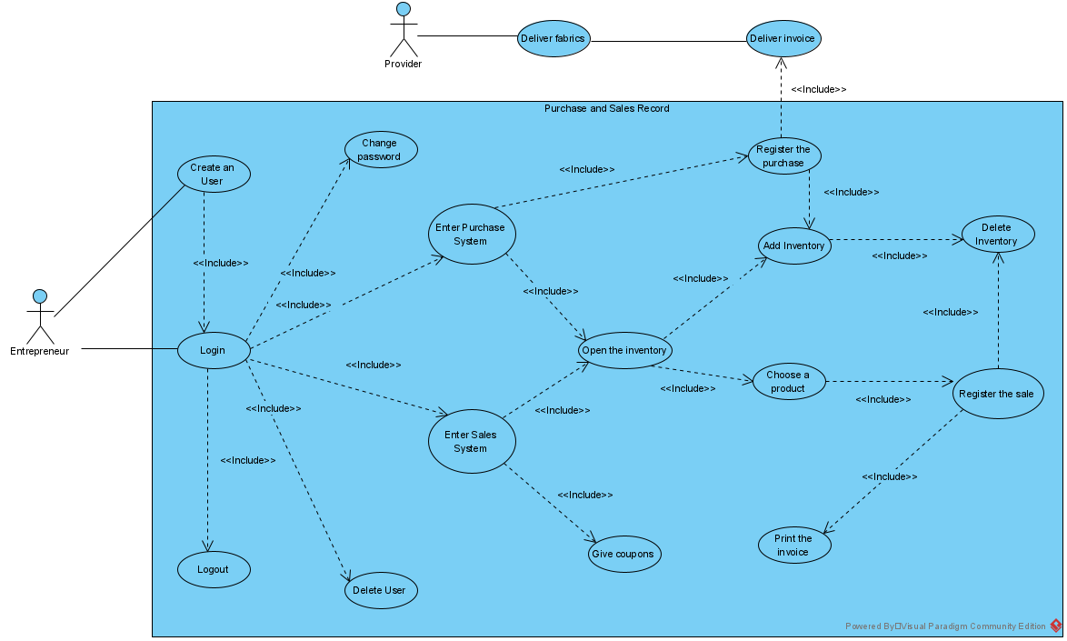

* Class Diagram

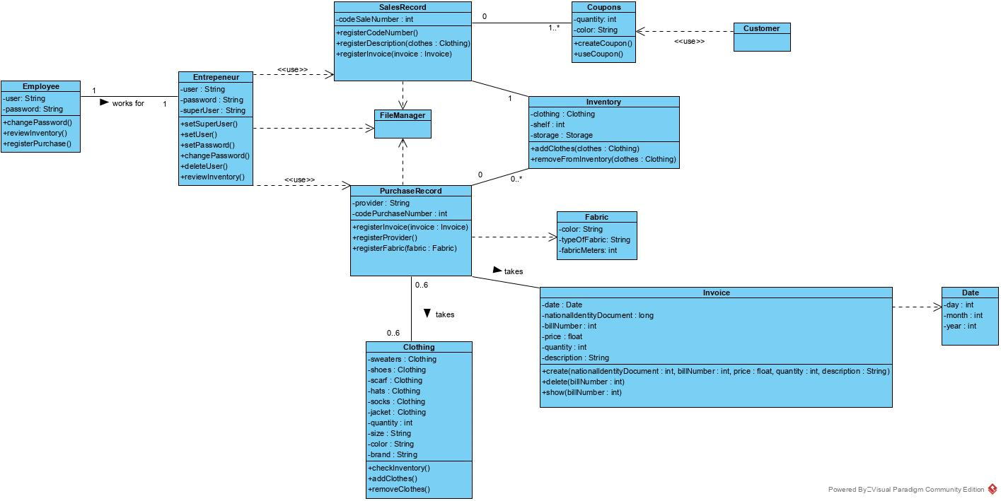

Video:

<https://www.youtube.com/watch?v=d-7smww13Vo>