SPRINT MEETING MINUTES
Reusable Template

PROJECT INFORMATION

Project Name | Presentia: An AI-Powered Virtual Classroom Attendance Management System Using Facial Recognition and Liveness Detection for Cebu Eastern College, Incorporation
Sprint Number | 4
Sprint Goal | Complete, revise, and finalize Research Chapter 1 based on the adviser’s feedback and recommendations.
Meeting Date | August 19, 2026
Time | 1:00 – 3:00 PM
Venue | MS Teams
Facilitator | Clark Kent Gomez
Note Taker | Samantha Ongue

ATTENDEES

Name | Role
Clark Kent Gomez | Project Leader
Kian T. Berong | Assistant Leader
Samantha Ongue | Q.A Tester
Limuel M. Brasona Jr. | BackEnd Developer
Kevin Jheazer P. Villaro | FrontEnd Developer

SPRINT GOAL
Complete, revise, and finalize Research Chapter 1 based on the adviser’s feedback and recommendations, ensuring that all required revisions are applied and the chapter is ready for the next research phase.

SPRINT PROGRESS

User Story | Assigned To | Status | Progress
Complete the draft of Research Chapter 1 | Kian | Completed | Chapter 1 was completed, organized, and prepared for adviser review.
Review Chapter 1 with the adviser | Clark | Completed | Chapter 1 was submitted to the adviser and the feedback and recommendations were documented.
Apply adviser revisions and suggestions | Kevin | Completed | All required revisions and suggestions from the adviser were applied to the appropriate sections.
Finalize Chapter 1 | Limuel | Completed | The revised Chapter 1 was reviewed by the team and finalized after applying the adviser’s recommendations.
ACCOMPLISHMENTS

- Completed and finalized Research Chapter 1 after incorporating the adviser’s feedback.
- Reviewed and organized all required sections of Chapter 1.
- Reviewed the revised content for clarity, consistency, and alignment with the approved research topic.
- Applied all revisions and suggestions provided by the adviser.
- Completed the final review of Chapter 1 after applying the adviser’s recommendations.

BLOCKERS / ISSUES

Issue | Owner | Impact | Resolution
Adviser feedback required revisions and additional clarification in some sections of Chapter 1. | Project Team | Required changes could delay finalization. | The team reviewed the adviser’s comments and applied all required revisions and clarifications.
Final review was needed to ensure that all adviser suggestions were addressed. | Project Team | Unaddressed comments could affect the completeness of Chapter 1. | Members checked the revised chapter and confirmed that the identified revisions and suggestions were applied.

DECISIONS MADE

- The team completed the required revisions and finalized Research Chapter 1 based on the adviser’s feedback.
- All team members participated in reviewing and checking the revised Chapter 1.
- The revised Chapter 1 was completed after the adviser’s review and recommendations were addressed.
- All comments and suggested revisions from the adviser were documented and addressed in the current sprint.

SMART ACTION ITEMS

Ensure each action item is Specific, Measurable, Achievable, Relevant, and Time-bound.

Action | SMART Goal | Owner | Deadline | Status
Review adviser feedback | Review and document all comments and recommendations provided for Chapter 1. | Clark | August 19, 2026 | Completed
Apply required revisions | Update all sections identified by the adviser and ensure the recommendations are properly addressed. | Kian | August 19, 2026 | Completed
Final team review | Check the revised Chapter 1 for grammar, consistency, organization, and completeness. | Kevin | August 19, 2026 | Completed
Finalize Chapter 1 | Complete the final version of Chapter 1 after all adviser revisions have been applied. | Limuel | August 19, 2026 | Completed

RISKS
- The required revisions were completed within the sprint, minimizing the risk of delay.
- The adviser’s feedback was received and the required revisions were completed.
- Team coordination was maintained to complete the final review and revisions.

NEXT SPRINT PRIORITIES
- Prepare for the next research chapter or succeeding research requirements.
- Coordinate team responsibilities for the next research phase.
- Continue documenting adviser feedback and project decisions.
- • Conduct regular review and quality checking of succeeding research outputs.
- Prepare for the next research chapter and succeeding research requirements.

MEETING SUMMARY

The team reviewed the progress of Research Chapter 1 after receiving feedback and recommendations from the capstone adviser. The members discussed the required revisions, applied the suggested changes to the appropriate sections, and conducted a final review for clarity, consistency, and completeness. All identified revisions were completed, and Chapter 1 was finalized for the next phase of the research project.

DOCUMENTATION PICTURE ( SCREENSHOT OF THE MEETING )

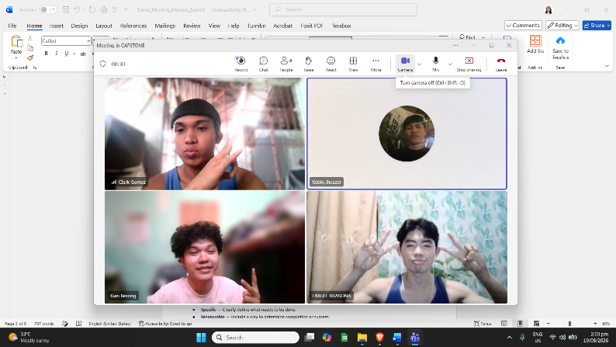

APPROVAL

Capstone Adviser: Jade Louis Cabucos Project Manager: Clark Kent Gomez
Date: August 19, 2026
SMART GOAL GUIDE (REFERENCE)
When creating action items, ensure they are:
- Specific — Clearly define what needs to be done.
- Measurable — Include a way to determine completion or success.
- Achievable — Ensure the task is realistic given available resources and time.
- Relevant — Align the task with the sprint goal and project objectives.
- Time-bound — Assign a clear deadline.
This format is suitable for Agile Scrum documentation in academic capstone projects and professional software development teams.

