IAP

1. you need to activate unity IAP service and import IAP plugin

don't forget to add ADDIAP scripting symbol

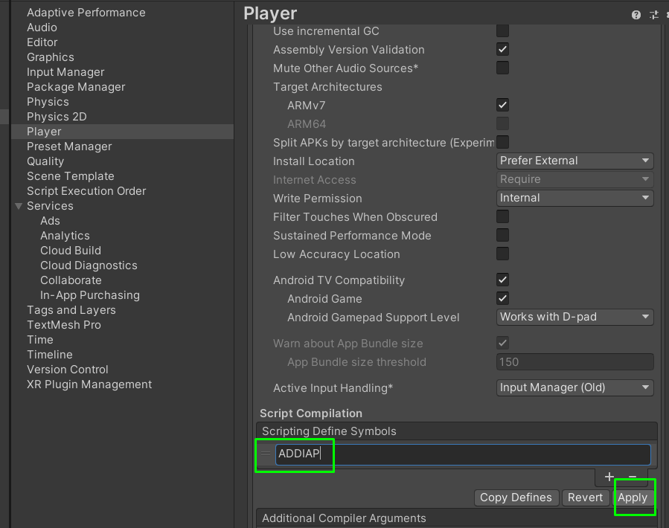

2) add your iap IDs to google play side (unity manual <https://docs.unity3d.com/Manual/UnityIAPGoogleConfiguration.html>)

<https://docs.unity3d.com/Manual/UnityIAPAppleConfiguration.html>

 you need to add full id, as example:

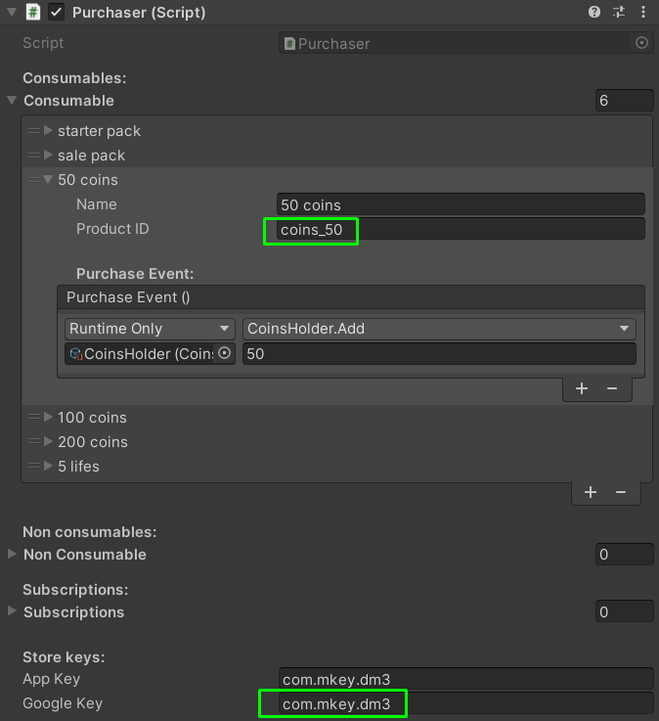

full product ID: com.mkey.dm3.coins_50

3) IAPs work only after publishing and submitting your app on google play

how to test read here: https://docs.unity3d.com/Manual/UnityIAPGoogleConfiguration.html