**cNotes**

# UML class diagrams

__________________________________________________

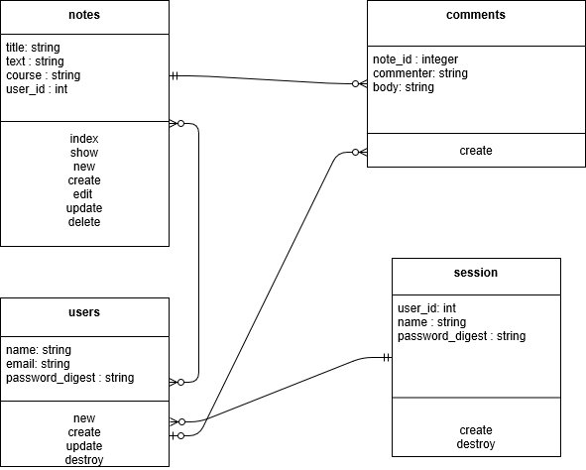

# User Stories

__________________________________________________

# 

# 

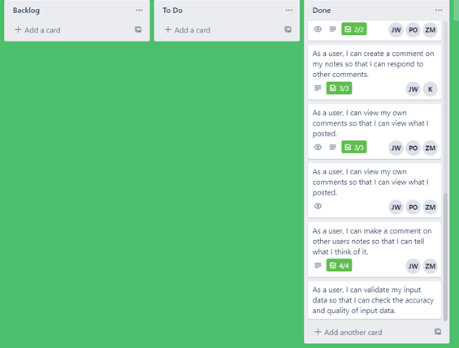

# Current and Future Features

__________________________________________________

Currently, users have the option to sign up for an account in cNotes. This provides the user with full CREATE, READ, UPDATE and DELETE functionality regarding the notes they make. When users add a new note the note displays under the user dashboard. The dashboard is designed to only show the notes made by the currently signed in user.

After creating an account users now have access to contribute to the “collaborative” portion of the app by making and reading note comments. The app was designed to only allow registered users to take advantage of the collaborative portion of the app.

Another feature of the app allows users to decide whether or not they want to post their notes in class A or class B. Currently, only two classes utilize cNotes: however, in the future more classes will be available. When a user visits a class homepage, only notes made for that class displays on the page.

In the future, we hope to see cNotes used more broadly among the university. Eventually we professors would provide access codes to sign up for adding notes to the course. We would also like to implement a thumbs up or thumbs down system so that when users make suggestive edit comments, the professors and TAs could endorse comments for legitimacy.

Users will also have the ability to edit or delete their comments later as well as report inappropriate comments and notes.

# 

# 

# 

# Testing the App

__________________________________________________

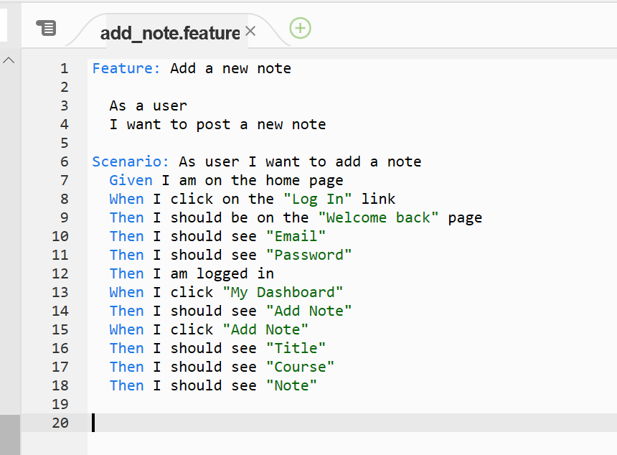

For testing our app we decided to do automatic testing with Cucumber. We found Cucumber to be quick and what we needed to do the testing we required.

<- This test makes sure we can add a new note

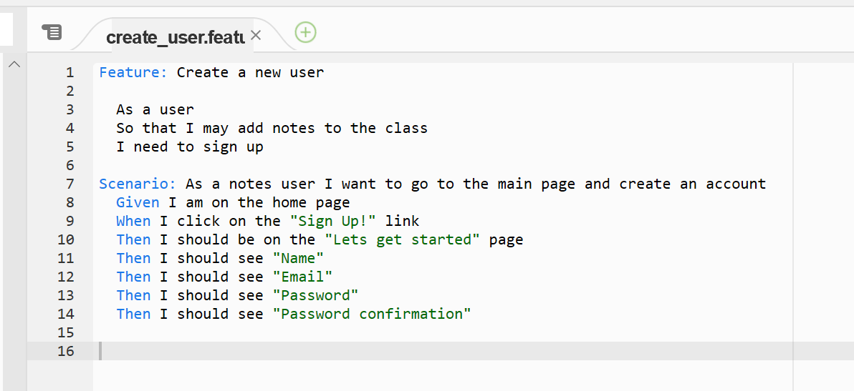

This test make sure we can get to the new user page ->

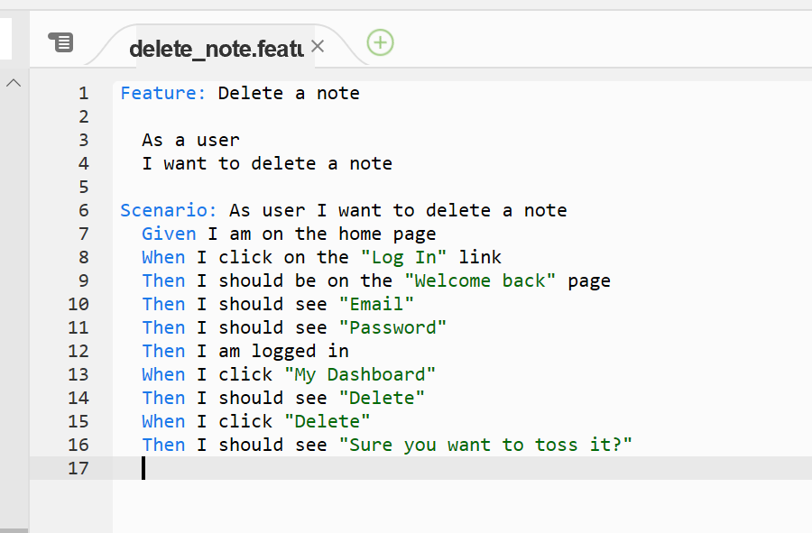

<- This test makes sure we can delete notes

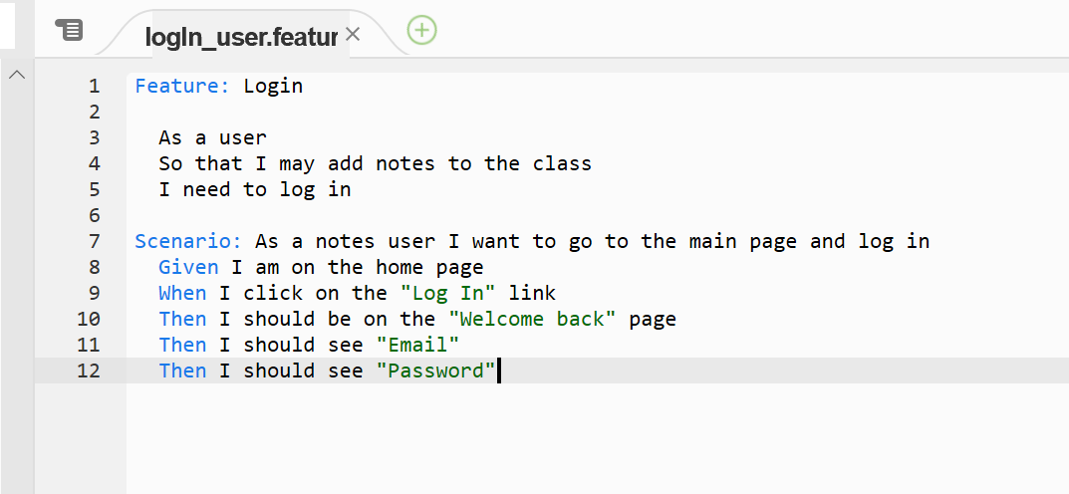

Finally, this test makes sure the user can get to login ->

# 

# Ethical Considerations

__________________________________________________

Our project centered around the collaborative creation and storage of notes for students taking a class. Like most apps that allow for the creation and storage of things, there is typically a way to delete things. In our discussions of the app and its features, the question arose of what happens if a rogue student were to try and delete all notes in the class? We all decided this was a possibility that should be eliminated. We decided to limit the ability to delete a note to the student that wrote the note, or the professor or TAs.

Another concern we had was a student’s ability to create unwanted notes. In our original discussions, we thought about providing students with the ability to upload files from their computer as notes along with a note editor within the app that would allow for a note’s creation. Upon discussion of the idea of uploading notes, we realized the danger that a student could upload an inappropriate note or even try and upload a book’s pdf. We decided to try and mitigate these issues by only allowing users to create notes via our in app note editor. In a future version of this app, we were going to add a way for users to flag notes for being inappropriate. After flagging a note, a notification of some type would be sent to the professor or TA to let them take any action regarding the flagged note.

The last ethical concern we had was that of editing notes. We were concerned that allowing any user to edit notes was liable to misuse, so we restricted this ability to the note’s creator. If other users see that a note has incorrect information in it they are able to comment on the note letting the note’s viewers know their concerns. The note’s creator can decide at that point to edit the note or not.