Task3:

Lineal correlation is not observed from 18:25 (19 minute from the start of the test)

CPU on local machine

CPU on virtual machine

CPU starts to grow from 8:25(19 minute from start of the test)

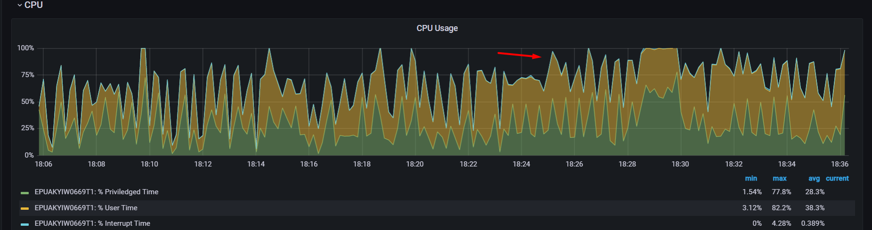

Saturation point is reached at 19 minutes with 20 users (threads)

